FOR IMMEDIATE RELEASE

MAYOR MELINDA E. BARRETT LAUNCHES FOOD DRIVE
AT HAVERHILL CITIZEN CENTER
October 28, 2025 – Due to the Federal government shutdown, thousands of residents of the City of Haverhill are at risk of not receiving their November SNAP benefits. In an effort to ensure residents of Haverhill do not go hungry, Mayor Barrett has launched a food drive at the Haverhill Citizen Center located at 10 Welcome Street. She encourages people who already donate to their local pantry to continue to do so. If you do not currently donate, Mayor Barrett asks those residents to please consider participating in the City’s food drive. All food donations will be delivered to local food pantries for distribution.

Starting Wednesday, October 29, 2025, residents can drop off non-perishable foods in jars, cans, and sealed packaging at the Haverhill Citizen Center. The Citizen Center is open Monday through Friday from 8:00am to 4:00pm. Suggested food donations include shelf stable milk, rice, beans, oil, salt, sugar, and flour. In addition to food donations, residents can also donate Market Basket gift cards. All questions about donations can be directed to 978-374-2390 extension 3915.

In addition to the Citizen Center, Wellness Hot Yoga, located at 34 Merrimack Street, will also serve as a drop-off location for food donations. Wellness Hot Yoga can receive donations Monday through Friday from 8:30am to 12:00pm and 4:00pm to 7:00pm as well as Saturday and Sunday from 7:00am to 12:00pm.

“We know there is a lot of uncertainty ahead. I want to do all I can to ensure that no family in Haverhill goes hungry. The City of Haverhill already funds many nonprofits and churches that provide food resources to the community. We will leverage all the resources we have to help Haverhill families and individuals in need during these times. Many people have reached out to my office to ask how they can help. We are asking people to donate what they can, so their neighbors have food on their tables,” said Mayor Barrett.

If you are a resident in need of food assistance, please contact the Project Bread FoodSource Hotline at 1- 800-645-8333 or refer below to the Haverhill Meal and Pantry schedule and locations compiled by Emmaus, Inc. with the Interfaith Network of Compassion (INC) and other Haverhill community organizations.
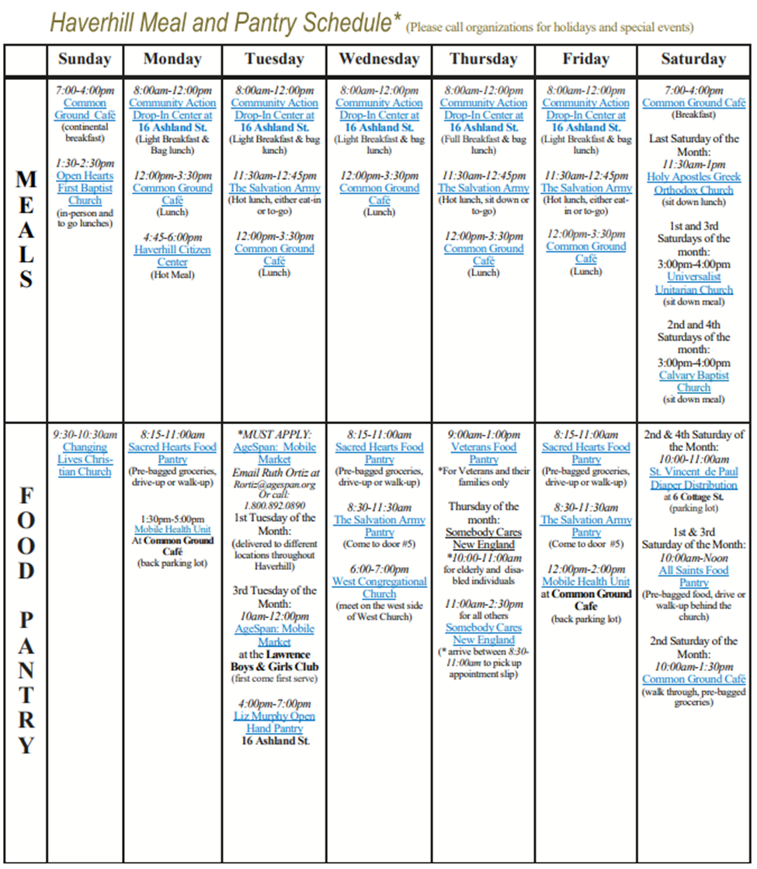

AgeSpan (Mobile Market)  - ROrtiz@agespan.org  - 978-946-1279 | Somebody Cares New England  - 358 Washington St.  - 978-912-7626
All Saints  - 120 Bellevue Ave. (Rectory)  - 978-372-7721 ext. 30 | Universalist Unitarian Church (UUCH)  - 16 Ashland St.  - 978-372-5173
Changing Lives Christian Church  - 17 Newcomb St.  - 978-373-7373 | Community Action Drop-In at UUCH  - 978-241-9621
Common Ground Café  - 194 Winter St.  - 978-372-3336 ext. 2 | Liz Murphy Open Hand Pantry at UUCH  - 978-372-0260
Holy Apostles Greek Orthodox Church  - 154 Winter St.  - 978-373-3311 | Veterans Food Pantry (For Veterans & Families Only)  - 10 Reed St.  - 978-372-3626
Open Hearts First Baptist  - 217 Main St.  - 978-374-7491 | West Congregational Church  - 767 Broadway  - 978-373-3034 ext. 3
Sacred Hearts Parish (Pantry is beside the rectory)  - 6 Carleton Ave., Bradford  - 978-372-5824 | Haverhill Citizen’s Center  - 978-374-2390 ext. 3
Salvation Army Church  - 395 Main St.  - 978-420-4192 ext. 2 | Calvary Baptist Church  - 12 Ashland St.  - 978-373-6466

###

