The regular meeting of the Haverhill Board of Appeals was held on Wednesday evening, July 15, 2020 at 7:00 P.M. at City Hall

Those Present: Chairman George Moriarty
Member Theodore Vathally
Member Joseph Sullivan
Member Ronald LaPlume
Member Louise Bevilacqua
Assoc. Member Lynda Brown

Also, Present: Jill Dewey, Board Secretary
Tom Bridgewater, Building Inspector

Jeffrey A. Saab for 0 West Lowell Ave (Map 540, Block 466, Lot 13) Applicant seeks a variance for 0 feet frontage where 200 feet is required in a RR Zone. Lot will have 108.04 feet frontage on an Access Easement. Applicant also requests a variance from the definition of lot frontage, purpose of. (BOA 20-24)

Attorney Robert Harb (17 West St, Haverhill MA): I am here with the applicant Jeff Saab, his cousin Greg Saab who is a direct abutter and also the engineer for this project. Greg will be talking after me to explain the environmental topographical reasons why we need this variance. First, I would like to give a little history as I did in my first partition brief and then follow up with my supplemental brief that address the environmental and topographical issues. I had already filed with the board; approvals for a driveway variance by 3 abutters, one being Mr. Saab and two other abutters would prefer the variance be granted. As you know from the plan, we have a driveway, instead of attempting to create a one lot subdivision with a definitive plan to create this humongous street which Greg will talk about. I also want to file today, which you probably haven’t had a chance to see, a copy of a plan that shows those two lots, one with no frontage that was granted a variance for frontage in 2000 by this board. The engineer Greg Saab tells me he found two other situations, about 3 lots away from this one that has no frontage and they were granted access. The history of this lot is interesting, it appears that it has always been land locked, it has been owned in the Saab family since the 60’s. I did submit to you with my original brief a picture of the 1950 accessor map that shows it being out there. This is not a situation, I think this is important especially with the environmental and topographical issue, this is not a situation where you find us asking to create a zero frontage, this is a situation where I ‘had” a zero frontage lot and I’m trying to do the best thing for the environment and community based on the topography on this property and have access on a right of way, it’s not a street because if I was to develop it to the size and specifications to the street; Greg will go into that issue and all the harm, that that’s going to cause in the area. I agree that that’s why the abutters would rather have a driveway. This lot is not going to access any place else; this is an 8-acre dead-end lot that is not going anywhere. It’s not going to have an adverse effect on anybody there, to allow a reasonable size driveway that would meet all the specifications of the fire department, we would agree on that. And be able to have one house on this 8-acre lot that’s way in the back of nowhere. The Saab family has owned this property since 1962. The brother just recently conveyed his to Jeff and Jeff wants to build a house there. As I said we will meet all the fire department approvals. This lot is larger than any, it is already in existence, the only reason it is not Grandfathered is because you need access on the way, and we don’t have access on the way. Don’t ask me why, probably in the 1800’s they created a lot with no frontage, but they did as you know if you look back in the old accessors maps and maps that I have in my office of the City of Haverhill, it was quite customary to have wood lots back then, people used to just cut down wood and they accessed it for that, so they are in the middle of no place with no place to get there. At least here when the subdivision when in, in front of it a right-way easement was created, actually on Greg’s land, to access out back so we didn’t want to leave it forever in perpetuity with no frontage. We believe it’s not going to be a determent to the neighborhood and it’s nothing this applicant did to create this lot; it’s been there at least since 1950 I’m guessing in the 1800’s. This is unique, it’s probably the only lot in the area with no frontage and we have environmental reasons and the engineer Greg will get into that in more detail. It won’t be a special privilege, there is other properties in the area that have zero frontage. But to enable access through a driveway other than going through planning and requesting numerous waivers. Greg will talk about; this is not anything that will hurt the neighborhood, the public, nothing that Mr. Saab did will. We believe because of part two of my presentation; that we meat the requirements of the zoning ordinance section 79 because it says specifically, and this was pointed out to me by Mr. Brobrowski prior to filing or when we were about to file the partition that the variance needs to retain too soil conditions, size, shape or topography of the land. That effects this land and not the lands of others in the area. I believe we meet that, and I put in my supplemental brief; that this is a habitat for wildlife, it is wetlands, and in order to build a road to make it a one lot subdivision. Greg will talk about what needs to be done, the walls; everything else to make sure we don’t disturb the environment. This is all mandated because of the topography and the wetlands of the lot; not because he just wants to create this lot with no frontage, we are trying to do the best we can without hurting the environment or hurting the neighbors and complying with. We need some access. I was told the application had to say zero frontage, but we have frontage on the right of way, quite a bit of frontage, but it is not a road. Greg will talk about, what we need to do to create a road, so it is our opinion myself, Greg’s and the applicant that we do have specific environmental and environmental reasons to justify this zero front frontage lot has wetlands. We are trying to minimize its crossing for its conservation, it is a high priority habitat for rare species. Greg will go into this, our ordinance says if I happen to be on a road, that it allows a shared driveway; I know you have seen many of those partitions, I have brought some. You can have a side by side on a road and use the same driveway and not even accesses the road. Basically, we would be using a driveway that is not shared running over Greg’s property to get to this lot. I know you have a big agenda, so I’m going to turn this over to Greg because he is going to specify the topographical and conditions of the property; that dictated the purpose of this variance.

Greg Saab (7 Baily Court): this is what we are proposing; the driveway coming through an existing trail to minimize the disturbance to the wetlands. If you look at the plan, the driveway you could have a turnaround with a maximum wetland would be 5000 sf, the driveway would be 1600sf of a fill. We would be disturbing 6000 sf of land to build the house roadway and walls. First plan, as you can see the property does drop off a little bit; so we would have to raise the land with retaining walls 14ft in this areas, so if you went this way we would just be doing a driveway with a nice little turn for the fire department to get down there and it would be a lot less disturbance. I think I pretty much covered it, let me know if you have any questions.

Chairman Moriarty: Attorney, would you approach the podium and identify yourself

Attorney Christopher Alphen (From Blatman & Brobrowski): I am Brobrowski’s associate and was asked to speak on this particular application. I just want to make sure that it is clear to the board; when we are talking about variances, that this is controlled by statue 40A section 10, the board needs to find a fining that there’s a is a problem, that the hardship is created by soil conditions or topography. It is the duty of the applicant to provide that detriment, they should know that there is a hardship related to soil conditions or topography. I think the argument that the petitioner is making is that the other legal avenue to try and get the access to this property is getting subdivision approval is going to cause more topographical issues is a creative augment, but it is not how the court views this for an issue for this lot. How did the dimensional deficiency, and that is clearly what the applicant is arguing that this dimensional deficiency is their hardship. The courts have argutely and consistently said dimensional deficiency’s is not a hardship related to soil deficiency’s topography and shape. So, I will be here to answer any questions the board might have.

Chairman: Thank you. Any comments or questions from the board?... Attorney Harb, do you want to respond?

Attorney Harb: As I’m sure you all know; lawyers have different opinions. My opinion is we are not saying the hardship is for zero frontage; we are saying the hardship is for the topography of the property that would be a hardship to create a road. That’s what is creating our hardship, otherwise the lot would become unusable, unbuildable and stuck out there forever for perpetuity. That is why we ask for relief. Your job I think, and you fulfill it greatly I believe, is to help with relief when we need it. This is the best plan for this 8-acre lot. And I think you can in all honestly put in your decision that it relates to the topography and wetlands of the lot, not the frontage but the lot. We would ask your approval, thank you.

Chairman: Any other comments or questions from the board?

Member Brown: I just wanted to see if I could have you come a little closer with the plan, as I wasn’t able to see. So, I can go over the different plans, if you don’t mind.

(Laplume & Sullivan speaking in the background regarding septic and land being steep, while looking at plan).

Member Laplume: So, you are giving your brother a 50-foot right of way?

Greg Saab: Correction my cousin. That’s right

Member Laplume: And he knows all the rules and regulations of the fire department? I think it’s over 200 feet of driveway and it has to sprinkle the house.

Greg Saab: Yes, and all the houses in that arear are sprinkled

Member Sullivan: The additional cul-de-sac on the other side the plan, that’s what you would have to do to create your frontage?

Greg Saab: Yes, and the turn around.

Member Sullivan: Ok, that is the issue I am struggling with a little bit. I am cautious creating president where you have a land marked parcel and then you have frontage there, it seems that it is a lot a relief to grant. Can I ask a question to Attorney Harb? So, you have this lot that’s probably as you mentioned, probably a wood lot historically, pre-date zoning right.

Attorney Harb: Yes

Member Sullivan: Are you familiar with this being done in a similar fashion before?

Attorney Harb: Yes. In fact, I was looking at one other partition that I was approved by the board and I mentioned this to Mr. Pillsbury and his concern was that it was 20 years ago. And then there might have been some a little bit earlier, or a little after that. It has been a while since this board has heard it or that someone has did it. Mr. Sass is going to grant him 50 feet, so he will have more of an easement access, so I think a real number is going to be 70 something, 80 something. So, it is going to be wider that the size of a street. And I think Mr. Sullivan, you really put your finger on it. I mean we really don’t want to create 14-foot walls and cement and pavement for that turn around. But the board I think would be justified in my opinion to say well he’s got 108 feet on the right of way, so I’m not coming saying I don’t have access in any other place and just let me build, I have 108 feet right of way; it’s just not a street. Because of the requirements of planning to make it a street.

Member Sullivan: I think if I was sitting on the conservation comity that I would rather see the right of way than a cul-de-sac, but my issue is I’m sympathetic to it. I would like to add one other thing to it, the two direct abutting lots also come in on the common driveway, so that driveway serves 4 houses and it has 20 feet of frontage on Broadway, am I right? Which is very common for this area.

Member Vathally: So, if he sells the property, how does that follow that house?

Member Sullivan: An easement plan will be put on record

Attorney Harb: The easement follows the land. It is not a license recorded easement like you get at telephone companies. We already have one on record, but Greg is going to expand it, so that we go to that 100 and something feet of right of way.

Chairman: Any other comments or questions?

Chairman: Is anyone here on opposition for this?

Chairman asked to enter motion. Member Vathally said I make a motion that we approve the variance for 0 West Lowell Ave, 2nd’ed by Member Sullivan

Sullivan: Yes
Vathally: No
LaPlume: Yes sighting 255-79 a, b & c
Bevilacqua: No
Chairman: No

Motion Denied 3-2

Chairman: Does not pass

REMAND FROM COURT
Marleen Stasinos for 22 South Cross Road (Map 759, Block 3, Lot 2): Applicant seeks a special permit for accessory apartment in a RR zone. (BOA-20-6)

Chairman Moriarty: Hello, we are going to have our attorney do a quick background on this as it was remanded back from court, so he can put it in a context for all of us.

Attorney Christopher Alpen: Just for the board as a reminder as it has been awhile since we last spoke about this. I just wanted to give a brief background of what has been going on. In September of 2019 this application was originally denied. Then the applicant appealed and went to the Land Court and there was a special with the land court and an agreeing parties, that because there wasn’t enough evidence in the decision about why the application was denied, that they would remand the application and that is why we are here today. We were going to meet in March and then we got continued delayed till today. But this is a remained application, it is treated as a normal application. The only thing that we are here to do is to make sure that we apply the bylaw. The applicant has resubmitted the application that has the bylaw that they need to meet. The decision wither we grant or denied the decision will address the bylaw. Now I just want to make clear to the board, that the denial wasn’t wrong, it wasn’t right, we just needed to clear the public record. The board can obviously make a decision either way.

Chairman: Thank you very much I appreciate it. Could the attorney please give us a brief overview of what is being proposed here.

Attorney Frank DiLuna (Smolak and Vaughan 21 High Street North Andover): First off, my client would like to audio the proceedings. We fully understand that it is not the official record, but for the sake of sharing it with her husband, we would like permission to audio it.

Chairman: Any objections from the board?... It is being recorded anyway

Attorney Frank DiLuna: I do have Mike Dulong here to speak on accessory apartments and Marleen Stasinos is here also to answer any questions. I know time is short, I want to refer you to my memorandum that I submitted the last time I was here, setting out what the standards are. Also, we did submit 2 articles on accessory apartments, I would hope that’s in your record. One thing we have not submitted is that there is another house in the area that does have an accessory apartment, I believe the last time that it was said that there are no others. I have a field card record of that house, if I may enter that into record too. So I am not reading directly from my memoranda to save some time. The first page of my memoranda just sets out the previsions of Haverhill zoning code section 255-86 which is the deprovision that sets out the standards for an accessory unit. Previously, and I think this is why the board may have been in some confusion is the last time MS. Stasinos brought this before us was for a duel request, one for a fence and one for an accessory apartment. The fence is off the table, this is just the accessory apartment. So, if there is any confusion about the denial based on the fencing, please that is not part of this application. She testified earlier that she purchased the house in 1994 and her Dad became ill in 1996. She brought him into the bedroom that was in the basement and he did some modifications back then. The modifications was the access to the outside, which remain the same and he did some plumbing work. This all came to light when the Stasinos went to hook up to the sewer and what they wanted to do was make everything compliant. The tenant that has been living there has always been a family member. Currently it is a cousin and she is 70 years old and she is handicap. This is a perfect type unit for her. So at all times as my memoranda states, this unit was always inspected, if you go to exhibit B the 3rd page in, it lists all the inspection dates. The Stasinos did nothing to conceal this, it has been inspected by the building inspector, so there was nothing here that they were trying to hide. If we go to page 4 in my memorandum, page 4 sets out the standards
-The building must retain the appearance of a single-family residence. This conversion has no change in appearance from the outside of the house at all, there is one additional window. That I believe the building inspector recommended to be installed, that has been installed. But other than that, there is not additional roofing, no additional changes to the exterior. Everything is exactly the same as it would have been, if it were a single-family unit.
-The second entrance may not be facing the lot frontage. There is a picture of the frontage if you go to exhibit F. The top picture is the front door to the house, not to the unit. The second picture, the one on the bottom is of the entrance to the unit, that has been in place since 1996, no alterations to that al all.
-The apartment shall not exceed 800 sf or 30%. We are shy of that, barley but it is still shy of the 30%.
-The conversion must be within the existing footprint of the building. There is a plan of the structure, Exhibit G and you can see the unknit would be entirely in the existing structure. No additional buildouts are required to accommodate this.
-It has to be owner occupied, and it is owner occupied.
-Must have appropriate water and sewer. And if you look, we have included that certificate.
We believe we have met all the requirements for the special permit for this unit. I would like to turn it over to Mike Dulong, he has some comments about the modern concept of accessory units.

Mike Dulong: Good evening, I have been a realtor in this area for 28 years. I was asked by the Stasinos to do a little research on the effect of what is now known as accessory units, in-law apartments on neighborhoods. There hasn’t been a lot of research done, but there has been some, specifically by the American Planning Association. With today’s shortage of housing and people getting older, the baby boomers getting older, they need some help and younger people can’t afford, so they move in with Mom & Dad and they make an accessory apartment. What happens is some people in the neighborhood have fears about overcrowding and different things, but research says that the fears are not supported about lower property values or parking shortages or overcrowding. Conversely there are some indications that the apartments do increase the supply of affordable housing and do make significantly economic contributions to their communities, to construction activities, to ex our property taxes. In my 28 years in the business, I have dealt with some in-law apartments and personally I have my Mother (My Farther passed away) they made an in-law in my Mothers house, there has been no complaints. My Niece lives there, she helps take care of Mom and helps with the maintenance. So that was the whole thing, she asked me if I would do a little research of what the effect is, and I do not find any negative effect.

Chairman Moriarty: Thank you very much. There is some opposition I believe. Would you like to speak? And I remind everyone, that we are talking about an accessory apartment which is covered by section 255-92 A through F. The attorney went through each one of those points there, so I would ask that you keep your comments specific to the zoning ordinance, that would be great.

Gary Shahinian (30 South Cross Road): My property abuts the applicant. I hope the facts I present to the board tonight, show that the applicant has not met the requirements of 255-80 and 255-92, which are required for an accessory apartment. I would also like to stat that I am against the special permit for the accessory apartment. I will remind the board that 16 other residents in the neighborhood signed the partition against the accessory apartment. There is also a letter written by a long-time neighbor Mark Defusio who was instrumental in the original master plan over 20 years ago and keeping the neighborhood as single-family homes, never multifamily units. I believe these signatures do not fulfill the requirement of 255-80, 83. The request use is essential for the needs of welfare. Pursuing to the provisions of 255-84, grant the special applicant for the accessory apartment will not be in conformity with the goals and policy of the master plan since art does not allow accessory apartments. Where is the general benefit for the city as a whole? I spoke to the Mayor and he said illegal apartments are a major problem in our city that need to be stopped. Granting the applicant, a special permit would only open the door for other illegal apartments to come forward to the board to make their apartments legal. Approving the accessory apartment will affect the character of the neighborhood. Property owners purchased their homes in this section of Haverhill because the neighborhood consisted of single-family homes and not apartments, many of the people who signed the partition said this. In Scott Calhoun’s opposition letter to the board that you have dated April 12, 2020 “quote my wife and I moved to the area of Bradford for the reason that this is a single-family neighborhood and allowing the special permit would change the character of this neighborhood and quote also Patricia Fanale opposition letter dated April 13, 2020 stated quote is was with the upmost importance to us to buy in a neighborhood that is only single family homes, no apartments or apartment buildings. I would like to now discuss 255-92 section A, B and C which must be met. So, on A the building must remain its character, characteristic single-family appearance. What the petitioners drawing shows a egress in the front of the house for the apartment, that does not presently exist when the applicant 19-30 was heard. In addition, the present cellar window shown in that drawing was 24x12 yet the building permit number 68421 created on March 17 this year states a window opening of 48x36 thus the appearance has changed and does not met section 255-92 section A. When the window was installed, they dug out the earth and used cement blocks so a person can escape from the basement thus changing the footprint or buildout. 255-92 section B, a separate entrance must be constructed, again when the board heard 19-30 their drawing showed a egress at the front of the house for the apartment that does not presently exist. Thus, one of two main entrances face the front of the house, there for the egress at the front submitted on the board of appeals 19-30 does not meet 255-92 section B. The judges order states ‘quote the board shall reconsider the evidence in the proceeding in the original partition, the judge want adequate bases for referencing 255-92 or 255-80 why the board denied 19-30. I am not reading any order of the remand where the applicant can change the facts of 19-30 when it was heard, and the location of the egress from the front to the side. In granting a special permit for an accessory apartment A, B&C may not be waived. On 255 section C I have some questions in regard to the living space, there seems to be some conflict on the dimensions. I was supplied a freehand drawing showing 28x11 or 308 sf when I visited Lannie Patel at the zoning office in regard to 19-30. There is also an engineering drawing showing 39x11 which is 429 sf. The applicant filed for both online 20-6 and 19-30 stating that the existing building was 24x28 thus 672 sf so 30% of that would be 202sf. According to patriot property, the first-floor living is 1,236 sf. The finished basement is stated at 520, but this was all built without a permit, so I don’t know if it is correct to include the 520 in the basement. Thus 1236 at 30% is 371 sf and if 429 is the dimension of the apartment, it does not meet the requirements of 255-92 section C. 255-92 section B the conversion must occur entirely in the existing footprint of the building. The footprint of the building did change, since again they installed the window, they had to dig out the earth and use cement blocks so a person could escape. There is also a question on the application in regard to parking. Is there adequate parking, the attorneys brief states 3 bedrooms on the ground floor and a bedroom in the finished basement. The brief shows 5 parking spots. I just want to make sure that if the board does approve this, that these are paved. This is a paved area, because recently the property owner just spread what appears to be ground up asphalt, but it’s not paved. Presently the parking location is referenced on that drawing from RAM engineering, the only spot that is paved is spot number 5. Spot 1, 2, 3 and 4 is not paved with hot asphalt. Special permits are supposed to be granted responsibly.

Chairman: With all do respect could you move on and wind up pretty quickly. You have covered a lot of territory there.

Gary Shahinian: After your last decision, the same woman that was living in the basement for months, she returned. The (didn’t catch name) sent her a letter of opposition dated June 10th saying several times, I have seen the lights blazing in the basement in various hours of the evening this leads me to believe to question wither somebody is living in the basement, while this matter is on appeal. I also sent an email on both June 4th and June 24th to the building inspector and I applied pictures with the lights on. One final thing according to the RAM engineering drawing, this property is 60,942 sf, I hope the board understands there is also horses on here and under the city ordinances

Chairman: Excuse me for a minute, excuse me but you need to stick to the accessory apartment issues. I don’t know what the horses have to do with that.

Gary Shahinian: I was trying to reference the horses require 40,00 sf

Chairman: That is a different issue then. I’m sorry but that’s a different issue.
Gary Shahinian: I was just trying to tell you

Chairman: I’m sorry that is a different issue. Please

Gary Shahinian: Ok I accept

Chairman: Ok thank you very much. I appreciate it. Any comments or questions from the board, before we hear rebuttal?

Member Brown: I would like to ask the attorney something. You mentioned that you were around 30%. Do you have an exact square footage of that apartment, the exact number?

Attorney Frank DiLuna: In section 4 of my memorandum are the numbers I pulled off of the city record and it comes down to 29.6%, that’s why I said it’s really close, but it is under the 30%.

Chairman: Any other questions?

Member: LaPlume: Question for the commissioner, we did talk about this today because we are no accessing the basement. I talked to you and I believe you stated this appeared to all building codes and regulations.

Tom Bridgewater: It certainly appears that we, yes.

Chairman: Ant other questions from the board?

Member Bevilacqua: I don’t know if Tom or who can answer this but, is there any other accessory apartment in the area?

Attorney Frank DiLuna: I gave you a field card of 85 South Cross Road showing an accessory apartment.

Member Bevilacqua: Ok and that is the only one.

Attorney Frank DiLuna: It was the only one I could find on South Cross Road.

Member Bevilacqua: So, there is one, so it wouldn’t be the first.

Attorney Frank DiLuna: It would not be the first, correct.

Chairman: Do you want to rebut any of the comments the gentlemen made?

Attorney Frank DiLuna: I’m not going to rebut it, as most of it was hear say. My memorandum contains the facts. I’ve backed every fact up, with an exhibit. It’s a hostile neighbor, I’m sorry. But I believe this unit meets all criteria that the City of Haverhill ordinance requires. Respectfully we request you grant the special permit.
Chairman asked to enter motion. Member Vathally said I make a motion that we approve the special permit for 22 South Cross Road, 2nd’ed by Member Sullivan

Vathally: Yes 255-92 A-F
LaPlume: Yes sighting 255-92 A-F, 255-80 1-8
Brown: Yes
Sullivan: Yes
Chairman: Yes

Motion Granted 5-0

Chairman: Motioned pass

Diamond Properties Trust for 452 Lake Street (Map 571, Block 1, Lot 13) Applicant seeks frontage variances to divide existing parcel into 2 building lots in RM zone (rear of proposed lots located in RR zone). Variances sought for frontage of 100 feet for one lot and 103.5 feet for the other lot where 150 feet is required. If approved, the existing structures on the property would be razed and two new single-family dwellings shall be constructed. (BOA 20-12)

Chairman: Please tell us your name and address

Attorney Caitlin Masys (Downey Law Group LLC 452 Boston Street Topsfield): I am here representing the applicant Carlos Pereira, Trustee of Diamond Properties Trust. We are before he boards today seeking two variances and they are both for frontage. This particular property on Lake Street was a long time ago part of a much larger parcel that had been steadily subdivided through the years. However, because of the 150-sf frontage requirement, as divided the lots were given large amount of frontage and so the rear of the lots are all smaller with appropriate frontage. What is left is our current lot which has more than enough area in the rear but is limited in the frontage due to having been carved up along the way. 150feet of frontage is required in this particular zone, each of the proposed lots would have 100 feet of frontage so we are seeking variance for just 50 feet for each of the lots. My client only recently purchased this property, so he is not responsible for the carving that happened in the past. So that was not a hardship that he created on his own. The benefit that this would provide to the City of Haverhill, I’m sure most of the board members have gone out and driven by the property. You can see that there is an existing single-family home, a detached 2-storey garage and a shed. Those properties have not necessarily been maintained to the best of its ability up to this point. The applicant is proposing to raise those structures and construct two new single-family homes, that our architect designed, so they are not speck houses where you typically see in a subdivision where they all look the same. You can see by the architect renderings here that they are very nice houses, that will fit in with the neighborhood. Almost seamlessly. In terms with all other zoning requirements, these homes would meet every requirement, including area and all setbacks. So the only thing that is preventing this from being an approval not required is a lack of 100 feet in total of frontage. The architect and the property owner are here if the board has any questions that they would like to direct to them specifically.

Chairman: Thank you. First is there anybody here speaking in opposition?...Ok if you could come up one at a time and tell us your name and address. Again, looking at the zoning regulation, let us know what you think.

Bernie Nagle (406 Lake Street): Just a little history, and I know you don’t want a lot of history. I have lived there for 47 years and half of this property we originally sold a little piece, to the original owners, so they could build their garage. After that the original owners prior to you folks, they sold part of the parcel so someone could build a house there. The new owners now are kind of at a disadvantage because of the way this piece has been carved out. But if we look at the neighborhood, I own the abutting property a few acres plus, our own house is on an acre. The traffic on the street right now is unbelievable, with the lights at the foot of the hill and there is some conservation issue. The conservation agent came and looked at the wetlands in the back, because when I tried to subdivide my property 15 years ago, I was informed I was on wetlands. So I just wanted to make the appeals board aware of the\at and thank you.

Neil Caliver (457 Lake Street): Good evening board, I have been an abutter for 43 years. Nice neighborhood. When I first bought 5 cars a day was a busy day for that street. Built a development behind of 452 Lake Street and it seems like a lot of water did come towards Lake Street after. During the winter months and Fall a huge runoff behind the garage area. Previous owners did try and make a trench, and I wouldn’t say it comes out of there like the Merrimac, but I would say a little river yes. The street was recently paved, within the year and it’s already washing out. The amount of water that does come out of that area. I did meet with rob Moore at 462, the gentleman had an issue with some trees, it is marked natural resource protected area of the city of Haverhill. They had to take a couple of those trees down as they are very hazard trees. There are no sidewalks on that street, the cars are going 50 miles an hour when the speed limit is 30. A lot of traffic, a lot of kids, and a lot of people are walking in that area now. Now one house on that lot is sufficient but if you put two its going to densify that area drastically. Wildlife, there’s a lot of wildlife in that area, deer crossings, turkeys, bob cats, fox. We start taking away all our rural routes and our countryside is disappearing quick. I know if just one beautiful home was going in there and they are going to have a nice lot and anyone who likes gardening and planting trees, we can keep some of that. But if we keep going and taking away all of our rural areas to build homes on a lot that is not suitable, I don’t think it is right. I think we need to take care of what is going on now and our future, to keep our countryside. Thank you.

Chairman: Thank you, I appreciate your time. Anyone else?

Diane Nagle (406 Lake Street): The board has rules for a reason. If the board has a rule of 150 feet, then that’s what it should be. It shouldn’t be changed, just because someone wants to do something different. Originally that was the rule, and most of the houses on the street, I looked at all of them and they have that kind of frontage. I agree with Neil, to just put one house, 4 bedrooms would be lovely. But you put 2 and have 8 bedrooms there, then there would be a whole bunch of more kids and it is a very dangerous. I personally and I don’t do this often, but I personally called the police a couple times because they are going 50 miles an hour. I am concerned for the kids. It seems like on Lake Street, that they built on every bit of available land. Directly across from us is nine houses and lots of kids. Very nice houses and lovely neighbors, they are never a problem. But you don’t need to put two houses where one should be. That’s it for me.

Chairman: Thank you very much. Anyone else like to speak?

Steve Basilar (42 Glenview Road): I am actually here just as a piece of information. I got the letter in the mail as an abutter. I tried as hard as I could to find out where my property is in a relationship to this and I couldn’t do it, not using the web and have you. So I’m hoping I could just take a quick look at that plan and I’m hoping you guys could help me understand where that is in relation to me, that would be fantastic. I’m on Glenview Road, this is me right here. So Mr. Nagle my property is right behind here so I’m not actually an abutter to this?

Either Neil Caliver or Nagle: Yes, you are one house away

Steve Basilar (42 Glenview Road): Ok thanks very much, I appreciate the information.

Chairman: Thank you for coming in. Anyone else wish to speak, either in support or opposition?

Neil Caliver (457 Lake Street): The question I do have is what type of sewer is it a septic system? There are about 10 houses in the middle from Pamula Lane down that does not have sewer. And this area with two septic systems> I question that, are they doing them or tying into the sewer?

Chairman: can one of you answer that?

David Jaquith (Architect 81 Railroad Ave Rowley): We have had the area perked and if we could connect to the sewer, we would plane to do that, but the area is perked so we can have septic systems on both lots.

Chairman: Any other comments or questions from anybody or the board?

Debbie Caliver (457 Lake Street): I’m right across from the property. I just have a question about perc testing. Years ago, Charlie who owned the property, had that land tested and It didn’t perc. So, I am just wondering, how did that perc now?

David Jaquith: It depends on the area the perc test was taken, and it perked. I don’t know about its past history.

Member Vathally: What type of structures are you putting up?

Attorney Caitlin Masys (Downey Law Group LLC 452 Boston Street Topsfield): Mr. Jaquith can put up a rendering. There will be open living concept interior floor plans, there would be a 2-car garage on the side as you drive in, two stories with a little loft above the garage area

David Jaquith: Big master bedrooms, something I’m proud to drive by and hopefully someone is proud to live in. That is why they used an architect instead of using a stocked plan out of a magazine.

Attorney Caitlin Masys: These are architect designed houses, they are not going to be similar. They will fit in with the neighborhood very well, but they are designed with every detail in mind and no vinyl.

Chairman: Thank you. Any other comments or questions?

Member LaPlume: Could I address that gentleman over there? “David Jaquith”. During the perc test, there was a member of the health department there from the City?

David Jaquith: I don’t believe so, no. Just the engineer stated for our information.

Member LaPlume: Commissioner, isn’t that the standard that we send out a board of health representative to do the perc test with them?

David Jaquith: Yes, we will have to do another one, actually two as we just did it in one spot.

Neil Caliver (457 Lake Street): Is there a certain type of year a perc test should be done?

Chairman: To David can you answer that?

David Jaquith: Normally they do them in the Springtime, when the water table is high. So not in March April, just probably June and July? Don’t quote me on this.

Neil Caliver: Also, these two homes that we are in question about, where will their front entrance be?

Attorney Caitlin Masys: Shows plan, explains the old house is coming down, foundation and everything. Complete new construction. So, there are two separate driveways, we have a rendering. The existing home that’s there, the driveway for the first lot would be just to the left of where that structure is. That complete structure will be raised. And then several feet down the road, so sort of where the existing detached garage is, is sort of where the driveway for the second house will be.

Member LaPlume: Mr. Caliver when they do the perc test, they have a model in line, so even if it is dry, they can tell you where the high water is.

Attorney Caitlin Masys: As we said ideally connection to the sewer would be ideal for this project. A septic system would be a fall back if for some reason we were not able to get sewer connected to the property. But the number one option here would be to connect to the City sewer.

Chairman: Any other comments or questions?

Debbie Caliver: Can I just ask how you are hooking up to sewer when there is nothing to hook up to out front there. How does that happen?

Chairman: I am going to let that be a question you people talk about after, if you don’t mind.

Debbie Caliver: Oh ok.

Chairman: Thank you because it’s not operculate to us at this time. No other questions or comments?

Chairman asked to enter motion. Member Vathally said I make a motion that we approve the variances for 2452 Lake Street, 2nd’ed by Member Sullivan

Sullivan: No and the reason I’m going to vote no is the history with other lots taking frontage away appears to me that it is not a self-imposed hardship. The buyer of the property knew ahead of time, that it didn’t meet the required frontage a head of time. So, I’m voting no.
Vathally: Yes
LaPlume: Yes, from what I see it satisfies 255-75 C and 255-79 B and C
Bevilacqua: Yes
Chairman: Yes

Chairman: So, it is approved 4-1

Russell Channen for 48 Jasper Street (Map 647, Block 2, Lot 72 & 73) Applicant seeks following dimensional variances to create new building lot and construct new single-family dwelling in a RM zone. Requested variances for new lot (Lot 73) include lot area (7,320 sf where 20,000 sf is required), lot frontage (60 ft where 150 ft is required), lot width (60 ft where 112.5 ft is required), and side yard setback (11 ft where 15 ft is required). Proposed Lot 72 shall include existing single-family dwelling to be renovated. Requested variances for Lot 72 include lot area (7,320 sf where 20,000 sf is required), lot frontage (60 ft where 150 ft is required), lot width (60 ft where 112.5 ft is required). (BOA 20-27)

Chairman: We are going to hear Jasper next and I am going to rescues myself.

Member Ted Vathally (Filling in as Chairman): Ok we will continue to the meeting for 48 Jasper Street. Just for the record Chairman Moriarty has to rescues himself on this application. Will the applicant please state your name and address for the record.

Attorney Robert Harb (17 West Street, Haverhill): With me is the applicant Attorney Russell Channing and also the contractor Bradford Unlimited Defeo. We have submitted to the board via the internet the partition signed by 18-19 people who are in favor, you can find that under the attachments in the online filing that we do now. I want to make just a couple of general statements first that I thought was (couldn’t catch word he used) this application. A couple of years ago, Governor Baker was stating that we need incentives to communities to ease zoning, so that we can ease the states housing shortage. Recently Representative Andy Vargas said Haverhill is facing a significant housing crisis. I just mentioned that for the overall intent that we are trying to do here. We are asking for a variance due to the condition of the existing home, which is in great disrepair which is owned by the deceased and another party. I gave you pictures that I filed with my original brief to show what disrepair it was in, that it needs repairing. We also gave you numerous copies and pictures of plans, the original subdivision plans and the plan for this property, Jasper Street and Coral and some of Winona Ave; showing the original size of all of these lots which back in the early 1900’s and back in 1891 of course they didn’t comply to zoning, as we didn’t have zoning in 1891. If you look at the city interactive map there’s numerous, numerous lots in the area, on all the streets that have houses on small lots, about the same size as we would like to put a brand-new single-family which is about 7000 sf. It is not unique for this area for these size lots to be built. I gave you a picture of Jasper, pictures of Coral, I showed you the assessors list and marked out for you in yellow numerous, I can’t even count, I’m already up to 15 lots in the area that only have 6000 and some on feet or 7 like ours. The house is in need of work, the lot is empty, the lot needs to be taken care of. The ability to renovate the house and also to offer housing, which you will hear from an abutter across the street, which is already interested in buying the house that possibly would be built on the vacant lot, to stay on the street, and to stay there with his family. So, you are going to hear from him in favor of this partition. The neighbors who signed the application saying that they have a problem with it, they would really like to see the building fixed, renovated and no problem with a small single-family house next door. These lots that I mentioned were originally created in 1893 and because we didn’t have zoning then and they conformed to zoning. Many of them were built on in the early 1900’s. This house I believe was around 1914, there’s another house in the area about 1900, so it’s an old area part of town, even though up the street is 495. So, it is not inconsistent with the neighborhood. This certainly will bring needed tax values to our town. If this is unique, there are a few other lots in the area as pointed out by an abutter that are also vacant, but they don’t have abuilding with the assessed value as this one and the work that it needs. Some of those lots, one which I have found is attached to a two-family, we are only talking about a single-family, so they needed that extra lot to go with a two-family. The neighborhood is really only single-family as you can tell from all the abutters lists that I gave you and the cities assessors lists. This is consistent with the neighborhood, it’s consistent with the lots and even with our abutters, some of our direct abutters are also only on about 7000 sf. We think it would be a benefit to the neighborhood, it is not an action caused by the applicant. We think that based upon the condition of the building and as you know 255-79 says we have to have a hardship reason regarding the building and the land. And well our hardship with the land is the maintenance of an empty lot in an area that is pretty well built up. Our hardship with the building is the building is in great need of repair. So, this will be a benefit to the neighborhood and especially to the neighbors who already live there to take advantage of a new single-family house and allow us the opportunity to renovate the existing home. I am going to hold my comments now if the board doesn’t have any questions for me, and I’m sure there is people here to speak in favor.

Member Vathally (Speaking as Chairman): Is there anyone here who would like to speak in favor first:

Joseph & Bianca Delgrosso (47 Jasper Street): We live directly across the street from the open lot. We have 3 children and our family is growing. We want to stay in the neighborhood because we have lived there for seven years. We really like the street and unfortunately, we have to move because our house is too small. It’s perfect for someone with one or two small children but like we said we really like the street. We just want to say Mr. Defeo approached us with his plans with what he wanted to put in that open lot, and it would be beneficial to my family to purchase that house if you guys approve it. So, it will give someone else, another family a young family an opportunity to move into my house and a bigger family gets to move across the street.

Member Vathally (Speaking as Chairman): Anyone else wish to speak in favor?... Anybody like to speak in opposition?

Paul & Teressa Cox (52 Jasper St): A letter was submitted to the clerk last week, regarding a letter to oppose signed by 3 abutters. Is that something that is on record or is going to be read or do I need to read it, how does that work?

Board Clerk Jill Dewey: Each board member received a copy of it.

Member Vathally (Speaking as Chairman): Yes, we received a copy of it.

Paul Cox (52 Jasper St): Is that something that I can read? The one from Mr. Lynch.

Member Vathally (Speaking as Chairman): Sure, go ahead I have a copy here

Paul Cox (52 Jasper St): Before I read it I just want to say just for our edification, what is the intent or the purpose of the variance cover 255-79?

Member Vathally (Speaking as Chairman): Attorney Harb, would you be willing to clarify where you are going with 255-79

Attorney Robert Harb (17 West Street, Haverhill): 255-79 basically mimics the states statue chapter 48a and so our City put that statue into effect into our ordinance. I don’t understand the question to this. Other than what is says in the statue by the Massachusetts general laws chapters and notated in chapter 48a. It’s just the reputation of the requirements for zoning.

Paul Cox (52 Jasper St): Ok so under this current zoning ordinance there are regulations, there is 5 of them.
*Mr. cox is now reading the letter Submitted by Richard Lynch* He reads and explains the next 8 pages, which are the items submitted to the board by Richard Lynch

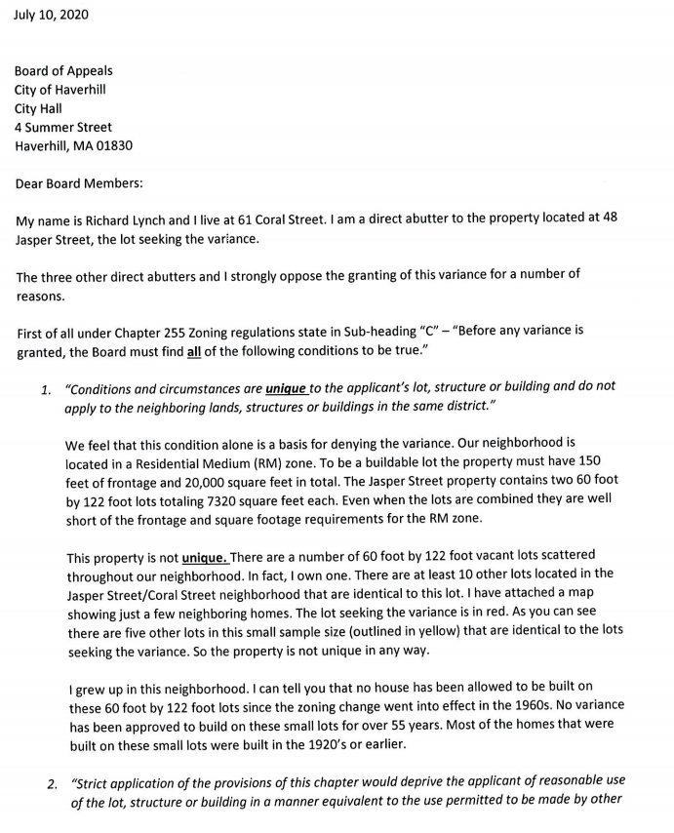
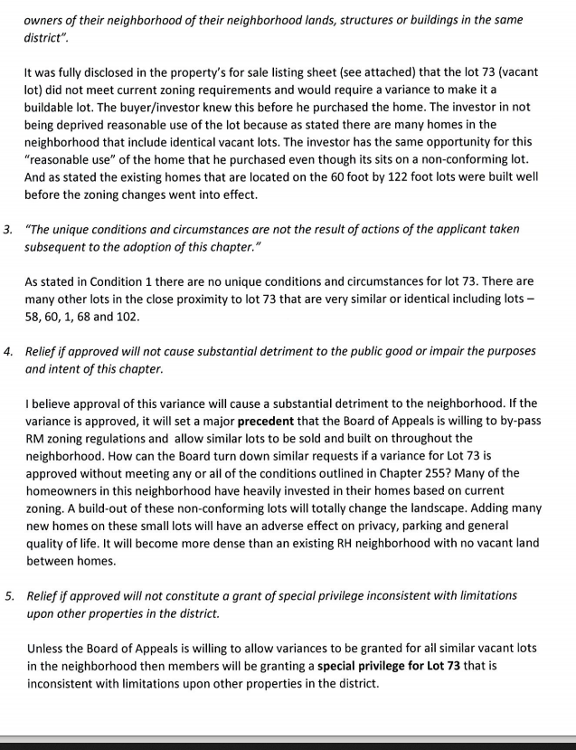
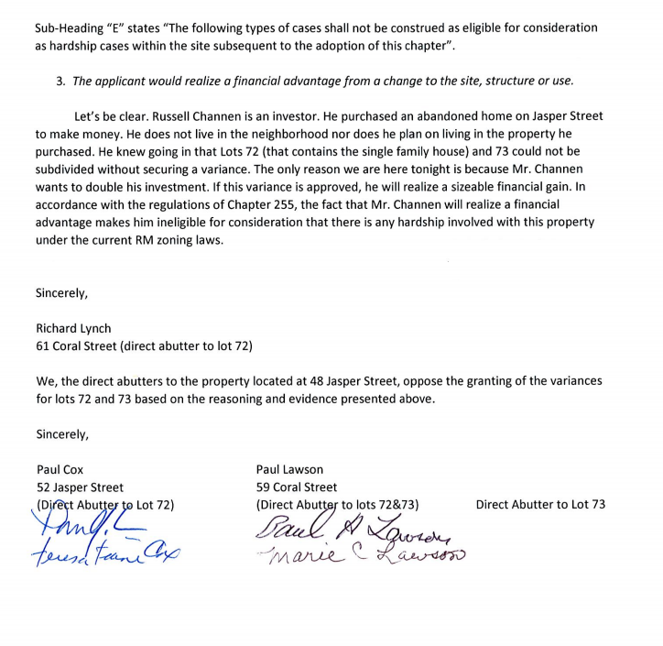

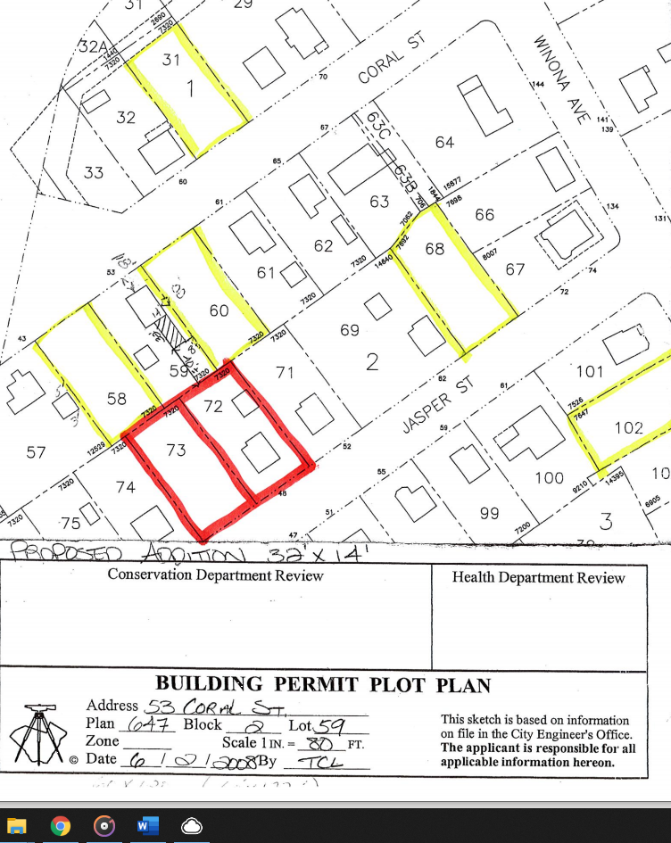
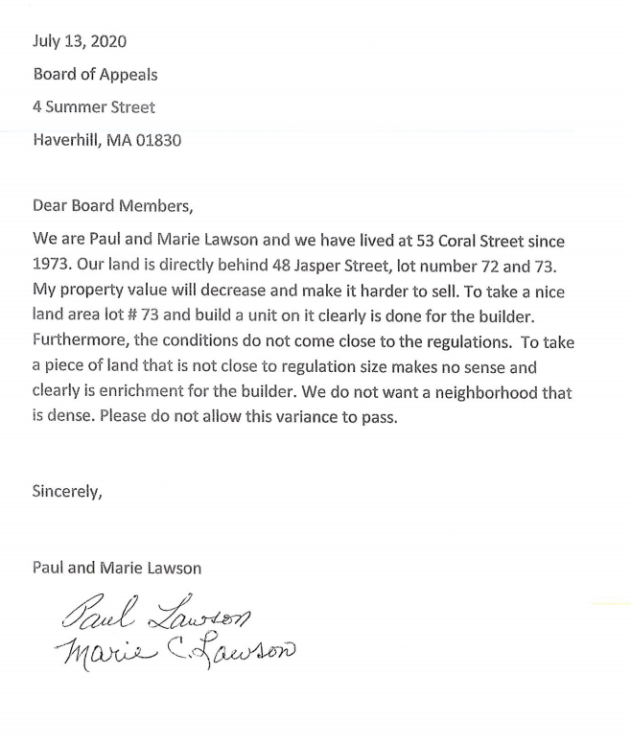
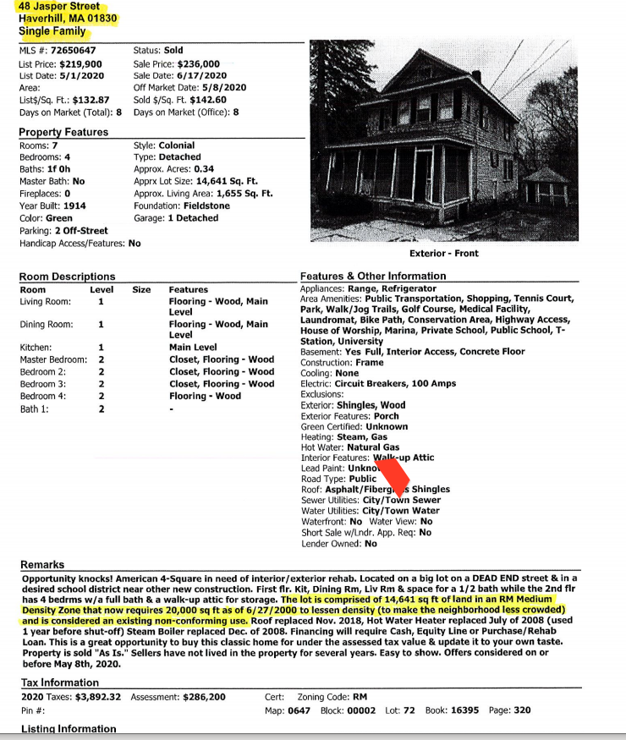
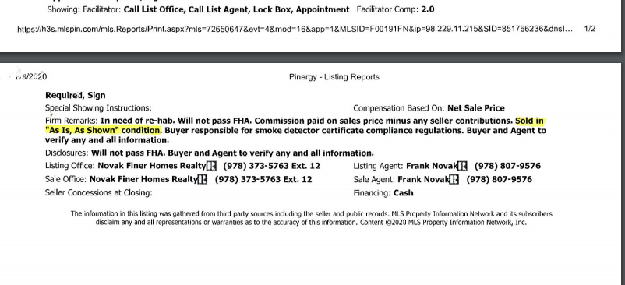

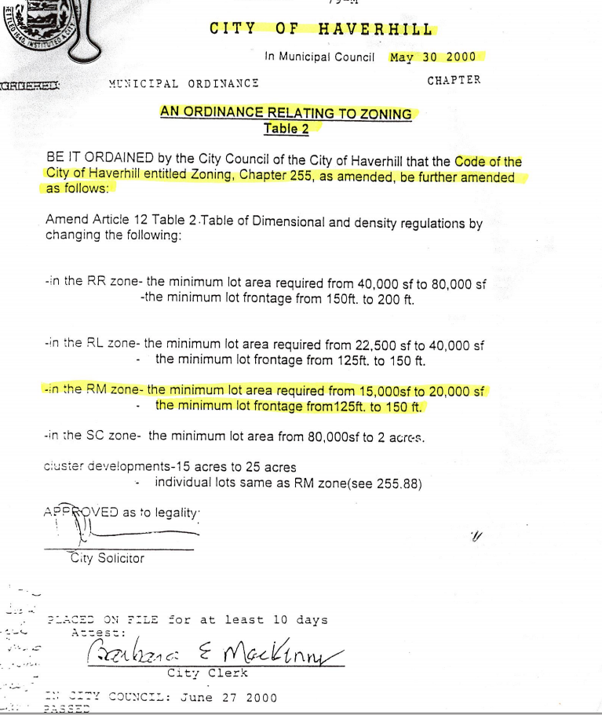

Member Vathally (Speaking as Chairman): Do you have anything else to say

Paul Cox: No that is it

Member Vathally (Speaking as Chairman): Is there anyone else who would like to speak in opposition or who has comments or questions?

Michael Bresnahan (104 Winona Ave): I am not a direct abutter to the property, but I live on the street that leads into Jasper. The 255 five issues were covered pretty well in the last letter, so I wont lead with that. But if this variance is approved and he builds a house on that lot that is 64% undersized according to today’s zoning tables. I was part of the last zoning change when I was on City Council and we enlarged the lots in this area from 1500 to 20000 to kind of keep the essence of that neighborhood as we brought the RM zone up, we increased all of the lots. And the same this happened in the previous changes which took this property and made it non-conforming to the old standards because it only had 14461 sf in a 15000-sf zone. As I’m sure all of you have been down the street, all these small lot homes have side yards which this one does. If the Demmer’s had to go for any enlargement of their home, they would have had to come to get a variance and that is what the variances are for, if zoning changes while you own your house. It makes it a situation where you are unable to get a building permit and you have lived there while the zoning changes took place, that’s what the variances are for. I came to this meeting about 3 months ago because my neighbor wanted to put on a accessory apartment an in-law apartment and this board approved it, as they had the land on the side for their house to do it. But they had to under a use, things like that are something people like to have. This situation going into it as was stated he knew the property; he knew what he bought. Russ is a great guy; I have known him for most of my life. Attorney Harb makes a great presentation, a great attorney who does his job well, knows the issues. Housing requirements are needed in this city but not so much the $400- & $500 thousand-dollar homes, they’re more for the affordable housing. I bought my house in that neighborhood 17 years ago for almost the exact same price I bought it for $232 thousand dollars, nice cape, standard lot, three lots combined into one. So, I didn’t need a variance to build on. I put my second floor on for $110 thousand dollars. My house is valued right now for $436 thousand dollars. So, they could probably put $150 thousand dollars into his property and cleanup the land and still make a good investment off of it, without having to get a variance to put another house on an undersized lot. We really have to think hard about wither we approve this or not, because it will change the integrity of the neighborhood. But I feel if I had a small house on a small lot that and adjacent lot, I would say to myself, I love the neigh hood but maybe I need to makeup some money for retirement, maybe I sell my house before that and put a bigger house on the lot and double my money. I just would appreciate it if this board would think about the effects long-term. We did when we did the zoning changes and knew situations like this would come up that the board hears.

Member Vathally (Speaking as Chairman): Thank you Mr. President. Is there anyone else that would like to speak in opposition?... Attorney Harb, would you like to rebut?

Attorney Robert Harb (17 West Street, Haverhill): Yes, and I will keep it brief because I know you have a big agenda. The deed to this property, describes these parcels as two separate lots. The accessor still as a comment say they still separate lots. On the maps I gave you, they are separate lots. If they didn’t own side by side, both of these lots would qualify as grandfathered in. My opinion is they were trying to keep it separate in the family for all these years, by describing them separate. So, I’m not asking you to create a new lot line between them, we are just saying give us the ability to go to the vacant lot. One issued was raised by the neighbor about do we need 255- subsection C,A,B I believe we showed you how we believe and I gave you pictures of the building, I believe it says conditions and circumstances are unique to the building. It is unique, the other buildings don’t have this disaster in them that needs fixing like this building. For objection to the neighborhood, 14 of those people are on the list that signed in favor and are on Jasper and Coral, not on Winona, they are right there on Jasper abutting Coral. As for it effecting the neighborhood, you heard the abutter across the street, he wants to live there. The neighbors in the area are not opposed to this. The objectors who filed this, Mr. lynch who signed the letter that the gentleman read; he is on about 7200 sf lot and that’s all he has. Yes, and when these lots were built, and one last thing the gentleman who read and spoke from the letter said no variances have been granted for a number of years. I have reviewed prior to filing partition; the board of appeals records for the variances; no variances have been granted since approx. 1976 because no one has applied for one. So that is why I can’t tell you, oh yea 17 variances were there, as they just haven’t applied. Again, you look at all the maps, this is consistent with the neighborhood. Consistent with the area. 14 of the neighbors have no problem. It’s lots that were built on this size, but for the fact that they owned both lots, they would be grandfathered in and you could build on the other lot. We would ask your approval to help us put this house up for the gentleman who works for the City that I believe is interested in buying it and we do believe it is consistent with the neighborhood; so we would like to ask you for your approval.

Member Vathally (Speaking as Chairman): Thank you Attorney. Anyone else who wishes to speak?

Richard Lynch (61 Coral Street): Hi I wrote that letter, I live at 61 Coral Street. Mr. Harb just said that I live on a 7000-sf lot, that is true, but I also have a 7000-sf lot identical to this one, that I also own. So that is why the property is not unique as there are a number of those 700 sf lots spread throughout the neighborhood. And I didn’t know this was going to become a popularity contest. The 3 direct abutters, that are adjacent to the property that is going for this variance are all opposed to this; Mr. Lawson, Mr. Cox and myself are all opposed, so I just wanted to get that on the record.

Member Vathally (Speaking as Chairman): Thank you. Questions from the board?... If not, I will entertain a motion

Member Vathally (Speaking as Chairman): asked to enter motion. Member Sullivan: I make a motion that we approve the variance for 48 Jasper Street, 2nd’ed by Member LaPlume

Sullivan: no; I think is a classic self-imposed hardship. A grant of relief here would be too extreme, given the non-conforming property
LaPlume: Yes, I feel as though we satisfied chapter 255- section 79
Member Brown: Yes
Bevilacqua: No

Member Vathally (Speaking as Chairman): Yes

Member Vathally (Speaking as Chairman): Yes, it passes, thank you.

**Commotion heard between members and others in the room**

Attorney Robert Harb: It needs 4 Mr. Chairman; I only count 3

Member Vathally (Speaking as Chairman): So, it failed for the record.

Motion Denied 3-2

Chairman: Does not pass

Francis Bevilacqua for 0 Edgehill Road (Map 684, Block 3, Lots 132 & 133A) Applicant seeks the following variances to build a single-family home in a RM zone. Variances sought for lot area (18,029 sf where 20,000 sf is required), frontage (73.02 sf where 150 sf is required), width (101.31 sf where 112.5 sf is required), front yard (15.5 sf where 25 is required). (BOA 20-21

Chairman Moriarty: Please tell us your name and address:

Fran Bevilacqua (14 Ordway Ave Haverhill, offices at 143 Essex St Haverhill): Since last month, I have met with multiple people and I have created a conceptual drainage system drawing, it was uploaded online for everyone to see it.

Chairman Moriarty: If you could just recap where we are with continuing from the previous meeting. Also, I know Member LaPlume has some items to talk about.

Fran Bevilacqua: So, you want me to just go over the specifics of it.

Chairman Moriarty: Yes, very briefly, I mean we have been trough a couple of it. So, I think if you could go through it very briefly. Member LaPlume has done a very extensive analogist and I know he has some strong points; he would like to point out.

Fran Bevilacqua: Ok so the variance is for lot frontage, lot width, lot area, front yard for a proposed single-family. We are in the RM zone. The lot area required is 20,000 sf and the project provides 18,029. The frontage is 150 and my lot has 73.02, the lot width is 112.5 and mine is 101.31 and the front yard required is 25 and we have 15.5. What is going to change is some of the characteristics of the lot. When I first bought it there were a lot more wetlands, but sense then some of the water has been being caught by the system that the city put in. All the wetlands in the front have all gone away. I have met with conservation and they kind of gave me a positive recommendation that they would consider a notice of intent if I would get board of appeal approval. That’s kind of the overall summary.
Chairman Moriarty: Ok good. Member LaPlume you did some extensive research, could you please speak.

Member LaPlume: Yes, I went out there and met with Fran Bevilacqua. I know Fran is a good builder, I know Fran’s family, so it’s very difficult for me. At one point I walked around with Fran and looked at the other houses near his lot. The road is very narrow and actually it’s fairly wide, but it’s only paved halfway. It’s approximately 12 feet or so. They have built walls around and they paved and now use those as driveways. There houses are sitting approx. 7 feet below the road surface. So, during the wintertime they can’t get out of their driveway. Since it has already been done on 2 or 3 of the homes and is a possibility, so I went down and looked at his property. When I looked at the property, there is a catch basin in front of his property. (LaPlume askes Fran to look at the pictures while he explains the next few things). There are 2 catch basins in front of his lot, everybody can see those there’s one on each side. You can see where the dotted lines are, that’s City property over to the front of his lot, where it says water overflow. The first catch basin, and I believe they put this system in after you bought the lot?

Fran Bevilacqua: Correct

Member LaPlume: Because there was so much water going down onto your property, so it was the responsibility to do something.

Fran Bevilacqua: Correct

Member LaPlume: So, they put these in, one catch basin on one side and the other on the other side. If you look upstream a little bit, it says SMH which stands for sewer manhole. Those two catch basins, which is illegal anyways but put fresh water into the catch basins or runoff water into the catch basins, but the City did this. Two 8-inch pipes from the catch basins, also going into one of those catch basins is another teenier craning into it. You can’t put two 8 inches in there, but yes that was done. Look on Tappan Street, I am showing you the arrows of the runoff, from the roadway and the driveways, there is 5 driveways on Tappan Street and all of those are almost 2 to 1 flow going up, so the water comes out of their driveways very fast. The street is very steep, and the water comes down there very fast. If you look to the left, I have arrows pointing down to the property, is 7 driveways flowing on to Edgehill and the roadway, if you measure all the roadway it is over 3000 feet. So; you have a flow going down there that is absolutely incredibly, I didn’t do a runoff study, maybe one should have been done by and engineer. All those houses facing his property, all sit up on a hill, all that water runs down. It’s a bad situation here. Let’s go through the pictures. The first picture shows an overflow which I showed Fran and that asphalt area you are looking at is approximately 16 inches high, so that means the water is flowing over that, so that means the roadway is flooded during heavy rainstorms. The next one I’m showing you, were done a few years ago those wetlands are 12 foot away from the road, so is basically right on the front of the property. It might not be in the same place, but when I spoke to Fran, I asked his if everything is put back up, especially the corner lots, I don’t know if anybody else has driven out there but they wouldn’t know where the lot was, what corner its on. The next picture is another wetland driven I think it was sitting in water. The next one, I was talking to Rob Moore about wither those are uplands or wetlands. If you go to the very next picture it looks like the same plan, and it’s obviously in the wetlands because there is water there. The next one Rob Moore from conservation said yes that is wetland confirmed. Days after the rain you can see where the water is sitting on this property. The next is labeled 7-15-20, I don’t know if you got that one Fran or not, I just took that tonight. I have gone over that berm, obviously the street was flooded one time since yesterday, I can see the rims of water where it started to go down, 2-3 inches at a time going all the way down till finally the catch basin well roadway was empty. But behind it you can see stones and gravel and exc that went down in and over that bank and down on your property, it had to be an enormous amount. The next picture shows you how high that berm is, so I have a question, we have a berm 16 inches. I don’t know how you can put a berm there 16 inches and drive over it with an automobile into your property. And I have got other notes. The wetland replication area according to the plan submitted, you moved the wetlands, moved it to the neighbors behind you. The runoff from the new house proposed would move the water further back so all the runoff from the house would go into a tank. I know that you have a sweal and I will get into that. There is a good possibility of more water entering from the road down the driveway, this is what I’m saying even if you built a 16-inch square there, it is just a terrible area for water. The water now goes over it during heavy rains, which these were taken yesterday, and I don’t know how many gallons went over it. “Quote” on that sketch did you submit it to us ‘quote” there is a drainage ware that would hold at least 7200 gallons of water. My rebuttal to that would be the drainage swale consists of crushed stone, which lets water flow through into the ground. At the end of June water was on top of the ground in many spots on the property, so if you dug down in the property and put in stone, there is an excellent possibility that you would be putting the stone into the water. I mean if it is on top of the property, how high the water table is no borings, no perc test was done. So, we don’t know the height of the water table. When the swale is excavated there is theoretically you could be installing the swale in the water table. At the very least we need plans from engineer applying the water table. The amount of excavated material to be removed, the amount of material that will be no hack the foundation and the surrounding area between the wall and the house. Now the reason I put that in there about the foundation is because you are probably going to put a double foundation in to fill the lower foundation, correct?

Fran Bevilacqua: When you say fill the lower foundation, what do you mean?

Member LaPlume: Well you are not going to put a single foundation 4 feet in the ground and 4 feet out

Fran Bevilacqua: No there is going to be a full wall in the ground

Member LaPlume: Right, there for a double foundation being 4 feet out of the ground, that would not put it 7 feet below the roadway.

Fran Bevilacqua: So, the elevations are shown on the plan and so the first-floor elevation would be 82 and the bottom floor would be 72 so that would make it on top of foundation walls 81 & 71 so there would be a 10-foot wall in the front.

Member LaPlume: There is nothing from an engineer. Let me read this to you. ‘Chapter 255 section 89 of zoning, the filling of any water or wetland area, there are rules and regulations if proposed a double foundation and backhoe in around the foundation, now I was assuming it was going to be a double foundation, so you should talk to your engineer about it also. A proposed double foundation and backhoeing around the foundation to lock routine wall so you can see the sf of fill or water, if it does the appropriate plans will need to be submitted to the building inspector for his review and approval of such conditions when applicable. Prior approval of Mayor of Haverhill, the Massachusetts department natural resources and the Massachusetts department of public works must be obtained under mass security one. Now 10,000 sf is not a lot of material but I’m saying when you dig the swale, what are you going to do with that? Is it imperiled raised material? Are you going to pile it in the back of your truck? You need to make an indication in order to put the swale in. So that would probably have to be removed. In order to put that house in there. So, I’m thinking you are going to have to put something solid down, you can’t go in there and perdue material. So, this is why I’m probably more than 4 feet, because you can’t have that kind of a material, you are going to have to put a gravel material. So, they are saying 10,000 sf feet, I just did a quick calculation and I was up to around 12-15. There’s a lot more to this than meets the eye. What I would recommend honestly, and I talked to you about drainage. There is an earie about putting drainage from that road to Edgehill to down below, that could start he ball rolling. But honestly you do need John Pettis to go over this.

Fran Bevilacqua: So, I have met with John Pettis and I explained to him the situation and he is well aware of it, he’s been around for a while and knows the history and that is the biggest issue in that neighborhood. And that is a legitimate issue for the people who live there, they are the ones who have dealt with it and whenever that development or anything in that area approved, there was never any consideration for stormwater. I understand the water goes everywhere but as far as this lot goes doing nothing with this lot, doesn’t solve anyone’s problems. The idea that I came with was just conceptual and as I go further down the road, I still need to get approval from conservation and go through site plan review, so this idea can potentially change, depending on what those other departments come up with. I’m not used to doing test pits and full drainage system plans for, usually just a simple plan talking about front yard setbacks and square footage and stuff like that, but I understand there is a drainage issue. What my plan shows is an attempt to help the people who are all below me. I’m not going to be able to solve all the problems on the street, it’s kind of unfair that the city has been dumping that much water in my land as it is and they have created this wetland. I have owned this property for 15 years, so some of the flags that you see are some flags that Kurt Young did when I first bought it. Then some flags were done by Seecamp Environmental and Rob walked it with Patrick less than a year ago. And we kind of verified all the spots that show it on this plan.

Member LaPlume: Right now, there is no flags out there. The blue ones I took pictures of are laying on the ground. And that was all I could find.

Fran Bevilacqua: That is what I am saying, is some of those are old flags and some of them are new flags. So the flags on this plan have been verified by Rob Moore because we all walked it Patrick Seecamp, Rob Moore and myself. So, these are all legitimate spots

Member LaPlume: Ok so the square on there is your building

Fran Bevilacqua: Correct

Member LaPlume: Ok even this sketch, well the first sketch that I did receive in color didn’t have RAM engineering’s name on it.

Fran Bevilacqua: Ya so all of this is kind of, you know I’m trying to move this along as fast as I can. So I had Ram designing some, and I wanted to get it to you as fast as fast as possible and then I put pressure on him to get something a little bit more professional for this meeting, so I’m trying to accommodate you guys as quick as I can get it. He drew something out and we talked about. But as far as some of these pictures go, I think the fact that there is so much water that comes into my lot, I think kind of helps my case. Because I’m not going to allow the city to keep dumping as much water as they have into my property. I am willing to do something about it, I’m willing to make the fix, I can afford to do that. So, I think everyone below me, I’m going to be able to help wither it be this plan that I drew up or wither it’s something that we come up with, with conservation and the other city departments. I am glad that you came up with the idea with the easement, because if that makes the most sense. It is hard for me to say what the city is going to allow me to do or not. But that would probably be a good scenario to look in to. I am willing to invest some money to fix a broken city problem, to make things better so we can try to create a win, win situation. Like some of these pictures, like this one picture here where you show the asphalt berm that some of the water comes over into my lot, you know it’s not fair. The pictures of all these leaf’s, I don’t know who that it, but that’s just people illegally dumping into my land.

Member LaPlume: That wasn’t a little water, you can see the rims on the path go right up to the

Fran Bevilacqua: And that kind of proves my point, right now the water is uncontrolled and everyone below me gets killed, they get wiped out in a huge storm. So, if I can provide something that can catch the water and I’m willing to do that, why wouldn’t people want that. I am willing to spend my own money to help people below me. It is not going to help everyone in the neighborhood, because when I net with Mr. Pettis he understood that there is a huge issue in the city at some point he has to do it, but it’s going to cost hundreds of thousands of dollars and he is basically saying hat the city don’t have that kind of money to put there at this moment.

Chairman Moriarty: Can I interrupt for a moment. Just coming to some point here. What is your recommendation Ron, you have some, much more experience than most of us?

Member LaPlume: He said that it’s going to be 2,000 sf and it’s going to catch but it’s stone, it doesn’t catch anything, it might slow it down a little bit. But my problem is, when I spoke to Bob in the engineering department that you use. I said Bob what are you going to do when the house is in. You have to do something with the water, where is the water going to go. Going to put dry wells at both of the ends of the house, that’s standard, I said Bob you can’t do that, there are wetlands. You know I have seen this before with engineers coming out and say they are going to put them in, and they do put them in. I have been there, and you dig the hole and now you are in the water, what do you do then? So, the swale part is below your wetlands, and not far from it. There is no deep hole, no perc test or just a deep hole to find out where the water table is. If the water table is almost at the top, because when I went through there are many spots that have water. You couldn’t go down there tonight.

Fran Bevilacqua: this isn’t a typical land. This has all been created, because everything gets converted to this one location. Like rob Moore, this is his words, this isn’t like the wetlands that you see on the autumn magazine page, this is a created wetland. When I fill this area in the ground water table is going to change. It is not going to be at the same elevation that it is now, there is going to be material above it.

Chairman Moriarty: Let me see if the other board members have any comments or questions because I’m afraid we are going around in circles on this. And I want to try to come to some kind of resolution on this in a fare way. Neighbors too, I believe some neighbors are here, so I want to make sure they have an opportunity to speak also. But Ron has done a lot of analogist on this. So I want to see if any of the board members have any comments or questions that they would like to clarify. Member Brown?

Member Brown: I was down there yesterday during that rainstorm and it was pretty bad. I have a pretty small sports car and it was really tuff trying to maneuver around on the narrow road. Can we talk about a little bit about if this was to be done to build a home there, there would be a lot of construction vehicles and it’s a very, very narrow road?

Fran Bevilacqua: Sure, and construction is done in the road every day in this City. Like today, I was down a street and there was sewer water work going on and gas National grid, there is was to be safe about all that kind of work. I am not doing anything that is out of the ordinary. Like the first thing I would do is, I would fill in the area that I’m going to be allowed to fill in and then that would give me area inside the property, to be able to work. I am pretty confidant that I can create a safe environment, I mean I work on multimillion dollar jobs, so I mean like a project like this is something that I feel like I can easily handle and make sure the neighborhood is safe, safety is first on my construction sites.

Member Brown: I drove probably to the end and it’s really difficult to turn around even with a regular car. And I’m just really concerned about all those construction vehicles and how it would impact neighbors, if they have to come in and leave on that really narrow road. So that is just a really big concern for me.

Fran Bevilacqua: The first thing that I would do in that area and I wouldn’t be in the road at all until you are doing the typical things like running the water and sewer line into the property. So, I don’t see any of those being issues.

Chairman Moriarty: Do other board members have any other comments right now? I would like to give the neighbors a chance to speak and then I think I’ll give my recommendation for what we should do here. It feels like there is a lot of information that is still outstanding, and I feel we wouldn’t be doing a good service if we completely voted on it tonight, but that is my opinion. But if there are neighbors who would like to speak very briefly? Just so we can get a prospective from the neighbors.

David Gerard (it’s now 37 Edgehill, it was 44 Newton Road): The property has been there since 1920 and we have been there 11 years. The Newman’s were there for 38 years prior to that and prior to that were the Bakers who originally built the home on Newton Road. Without going into the history and everything else, the only thing I, I understand what Francis wants to do. I have a lot of concern number 1; I have read the report for the wetlands from the 2007 decision. I don’t see or hear too much about what’s really being addressed about the wetlands itself other than maybe try to improve it. The insinuation that the City has been dumping water on it, on his land, that’s being going on probably way before he bought the land. The issue I have as well is out of the 150 feet for the frontage, it’s less than half and part of that is that one drain with a 16-inch berm on the corner. Anyone coming past Tappan Street on Edgehill is going to be affected by anything that is done in that corner one way or another. Even for a dead end off of a dead end, the amount of traffic that you see even in our neck of the woods is still a lot. The water department constantly uses Longview, up and down that street with all that massive construction going on, on 110, because they use the tower at the top as a pit and they keep dumping and dumping. There is plenty of construction work already going on and it has been going on for a number of years. But going back to Edgehill, fortunately the city has put some kind of berm system up. I know when we first moved there in 2010 when we had the water, we completely lost everything. The cellar and everything had to get gutted, with the amount of water it was just incredible. As far as the wetlands, even to go in and see where the old blue flags were, because I have been looking at that thing for 11 years. And then when I guess the Hydrology report that was done, orange flags were put down. When Mr. Bevilacqua had contacted me for the last meeting, evidently there is no difference between a survey flag being orange and the water situation being orange. Where it is if you go down by the water way by the mailboxes, it’s all blue. We have had a lot of people up here looking at the water, especially the water. The other issue is, it is not when it rains, its 3-4 days after it rains the water is still pouring off Tappan Street and coming down, it’s just the nature of that whole ledge or whatever is up there. The water keeps pushing up and hydrostatically coming down days after. Wintertime is an experience. The city has been doing a wonderful job, trying to plow as best they can around that corner. When temperature fluctuate over the past ten years up here, between the ice and melt, ice and melt, it’s a little tricky. I’m bringing these points up only because, if you live there day in and day out, it is a little more different than just looking at it or looking at reports. Again 2007 there was a major report done that was especially just dealing with wetlands. The appeals board wasn’t even addressed to make sure that this thing was a buildable lot to begin with. And that is why I believe we are here 13-14 years later. Because he has to get past a point of getting a buildable lot, once he gets that, then other issues can be addressed. Knowing that and Mr. Bevilacqua has even stated that in his report, that he knew exactly what he bought, as a surplus piece of land off the City back in 2006. He knew it, he even brought an extra piece of paper off the docket in the back to increase it up to 83,000 isn’t that correct.

Chairman Moriarty: I think we got your points and have been very helpful so far. Is there anybody else who wants to speak very briefly in opposition, two more people? The young lady first.

Jessica Dainis (42 Edgehill Road): I wanted to speak to Lynda’s point, it is a dead-end it is a very narrow road and a dead end. I live up the road from where the construction would take place and construction would be on the right, I live a couple houses up on the left. I don’t know how they would get in the trucks, the cranes to take down the trees, for all of the equipment that would be necessary without blocking that road. I don’t know how that would be possible, so for me I have two daughters and that would be a safety issue. Narrow road, all that equipment there, I just don’t see it happening and it is a dead-end. I am very concerned about the emergency vehicles coming in and out.

Chairman Moriarty: Thank you

David Adams (31 Edgehill): Hi I live at the property right next door and would like to voice my abjections. First of all, the variance is for frontage and also the proximity of the garage. It puts the building right there on the road. Also, I think that with Mr. Bevilacqua’s willingness to fix a problem with the drainage, I don’t know if he fully knows the extent of the problem and which he is willing to address. And I think that a 7200-gallon retention area on the property doesn’t come close to addressing the problem. Looking at the drainage of the road, I estimated that there is about 2000 feet of roadway which is about 18 feet wide, because it is narrow. And in a five-minute storm an annual five-minute storm about .3 inches, that dumps over or close to the 7000 gallons of water. So that storm yesterday dumped about that much water. So, it would be likely that any bigger storm which would likely happen, or any larger or longer storm are going to flood the property and the 7200 won’t take care of it. Also, the wetlands report from 2006 probably needs to be revisited, if you do want to look at it. Finally, once that lot becomes buildable, I don’t think it will be possible to make it nonbailable and I think it would be difficult for the City to use it, if you wanted to do any drainage for mediation.

Chairman Moriarty: Thank you very much.

Member LaPlume: George can I ask one question

Chairman Moriarty: Sure

Member LaPlume: When he said 2000 sf do you just measure

David Adams: From up Tappan Street

Member LaPlume: You did Tappan too?

David Adams: Yes, Tappan too, but I did not do the driveways, but I did do Tappan. Also, I understand that there is a catch basin at the end of the intersection of Tappan and Edgehill that also runs along the North side of Edgehill Road

Member LaPlume: I didn’t see that; I did see the water coming out of Tappan

David Adams: Ya there is also that, but there is another one that is a swale that runs along that property.

Member LaPlume: That’s a catch basin that has to empty into another catch basin

David Adams: There is all kinds of stuff out there. And it is a mess with the cross direction from the storm drain and the sanitary drain, plus there’s so much water up there that they also salt the day lights out of it.

Chairman Moriarty: Ok, thank you very much. Any questions or comments from the board? Entertain a motion

Member Vathally: I enter a motion to

Chairman Moriarty: Hold on one second.

Fran Bevilacqua: Do you mind if I make any comments?

Chairman Moriarty: very briefly if you could please.

Fran Bevilacqua: Some of the things I just want to clarify is when you are calculating some of the water that is coming off of this street, that amount wouldn’t be the entire amount coming into the property, because there is a catch basin in the street. So, that is collecting most of the water, so I’m talking about the water that goes above and beyond that. Like the backup system of the original system, like just the plan you guys showed me here, there is two catch basins on Tappan and then there is two in front of my property. And, the reason why I am back here, is because those things worked. All the wetlands that were in the front of my property are now gone, so that is telling you that those catch basins do work. They don’t work 100% but that is why I am also willing to create a system so that the drainage doesn’t go beyond my property like it does right now. Because right now it is a mess. And, that is what I want to say about the neighbors is that I feel bad that they have been struggling with this problem and it is legitimate. I owned this property for a long time, and I do understand the issues, they are right when they say if there is a change in temperatures, it goes from 3-inches of ice in front of the street to just thawing out and then back further again. But I think I can solve some of those problems. And when it comes to like wetland reports, that wetland report was done almost 15 years ago and things have changed since then, the information in that report frankly isn’t accurate anymore. After here if I ever got approved, I would need to satisfy conservation which I’m not even sure I would be able too, but that would be my next step so this isn’t like a done deal if I get approved from the Board of Appeals and this lot is exactly the kind of lot for the reason why we have a Board of Appeals. There are legitimate hardships with wetlands and topography and this lot has 5 sides, so that is one reason why I don’t have frontage. There are all kinds of legitimate issues here on why I need some relief. The size of the lot is very similar to all the other lots in the neighborhood, and other people I’m sure have come to this Board to get a variance to be able to build a house on that street. I am only asking for a single-family home, this isn’t going to wreck the neighborhood, this is going to make the neighborhood better.

Chairman Moriarty: Comments from Member Sullivan

Member Sullivan: Would you consider a continuation of this, just to investigate that easement issue?

Fran Bevilacqua: 100%. I want to make sure I get this right. I am not here to piss off the neighbors or anything like that. I legitimately want and know that I need to make a solution here to get something done, so I am willing to do that. But I think the one thing that I am kind of struggling with is

Member Sullivan: I am a little more sympathetic to your point because, the question I have is at what point does this become or taken by the city because they are dumping water on your lot and then saying, you can’t develop it because it is wet. But I think the one thing that I am kind of struggling with to be upfront and to be frank is the shape of the lot could speak in favor of a hardship, but the frontage is the thing that I am having a bit of an issue with. The fact that you are inquiring about inadequate frontage up front. But I think if you took some time to investigate this easement, I think this is a 6-inch clay and then it ends up in a 12-inch clay right here.

Member LaPlume: There is an easement on this area.

Fran Bevilacqua: I think the dotted green lines are the easement, my neighbor would actually know more about that.

Chairman Moriarty: If you are willing to request a continuance, we would entertain that

Fran Bevilacqua: I formally request a continuance

Chairman Moriarty: Do you need sixty days?

Fran Bevilacqua: No let’s try 30 days, I actually sent this plan to John Pettis earlier, I guess he has been out.

Chairman Moriarty: So, you are waiving the notification period also. Ok make a motion to accept a request for continuance.

Member Vathally: I make a motion to continue 0 Edgehill Road to the August meeting waiving the notification period.

Chairman: motion made by member Vathally seconded by member Sullivan

Member Sullivan: Yes
Member Vathally: Yes
Member LaPlume: Yes
Member Brown: Yes
Chairman: Yes

Chairman: So, it is continued to August

Christopher Zielinski + Joseph Ambrosino for 222 Washington Street (Map 501, Block 228, Lot 32) Applicant seeks a variance for lot area of 5851 S.F. where 20,000 S.F. are required to construct an 8-unit multifamily dwelling in a CG zone. (BOA 20-15)

Attorney Robert Harb (17 West Street, Haverhill): I represent the applicants and one of the applicants is here with Mr. Joseph Ambrosino to my right. You have may recall; we had a zoom meeting on this on 5/21/20. I would like to briefly go over some of what was said that evening and then discuss conditions that the applicant would agree to for the board, that we have worked out with Attorney Zizza. Attorney Zizza who you may recall represented herself and some others that were in opposition. This is a site; it is land court and the building has been on this site since 1934. It has always been the Polish Family Home although I’m not sure families ever lived in it. They have an auditorium. It has not been used for anything since The Polish Family left and the building has basically been deserted. The site is existing, the building is existing. In order to out multifamily housing in there, the building inspector and I discussed this the previous time. The existing setbacks are pre-existing, but the square footage you need for a multi-family of any nature over 3, requires this. This is only step one and we are only here for a variance for square footage. Because of the condition of the building, there is not much else that can be done. The use of a multi-family, is an allowed use there. This would be a good use and I understand from the applicant that the Planning Director he talked to is not opposed to the use. Originally for the record Mr. Chairman we asked for 8-units if you might recall that Attorney Zizza made the comment and rejection that the property is dense in that area and this is too dense a use for the building and that she had a concern about parking. So in the months since our hearing, we have worked with Attorney Zizza and she filed a letter with I will refer to as dated July 14,2020 in it she references four special conditions, I will read them quickly, because the applicant would like you to accept those conditions to make it part of your decision. And the applicant is asking that you allow 4-units there, not 8. So, we have reduced the density and you will see how we resolved the parking question. So, the applicant would ask, that if you were to vote on this, you would vote to approve a variance for 4-units multi-family, not 8. We were willing to downsize with these conditions that we have agreed on between all the parties.
- There will be no commercial units or any other type of units. Conversion is limited to conversion to a residential 4 -family building.
- At all times from now into perpetuity, the owner of the property shall provide off-street parking for 4 residential units. If it becomes individual condominiums the Association or individual owners must provide for off street parking spaces and the Tenants and/or condominium owners/occupants are required to use off street parking at all times.
- That a contact person's information is given so the neighbors can contact the owners if there are issues with parking or any other matter. (This information should be posted on the outside of the building.)
- That these terms become part of the BOA decision which will be recorded with the Registry of Deeds and then referenced in any Rental Agreement and/or Deeds.
As I have mentioned to Ms. Zizza, I always record the decisions and it is a requirement of our zoning ordinances and this board. So, when we ask that you put those 4 conditions in, we ask you do. The 5th is just Attorney Zizza’ s saying we made this deal in good faith and good negotiations with our neighbors. So, we would ask you to approve the application for a 4-family, reduced to a 4-family with these conditions 1-4. So the clerk really doesn’t have to remember them, you have the letter all set forth and would ask that you do that. With that I don’t believe we had any other opposition, at least not back when we had our Zoom meeting. And Attorney Zizza is here to comment.

Chairman Moriarty: Ms. Zizza, if you would like to comment that would be helpful.

Attorney Kimberly Zizza: Those are the terms and conditions that we negotiated to and would accept as a 4-family. That is pretty consistent with what is currently in the neighborhood. Obviously, this building needs to be used for something, some purpose and we as a collective group have decided that a 4-family would be acceptable to us with these conditions.

Chairman Moriarty: Thank you very much. I appreciate you coming here for this. Entertain a motion

Member Sullivan: I motion to approve the request for 222 Washington Street subject to the conditions which would be approved to our decision that are set forth in the July 14,2020 letter of Attorney Zizza

Chairman: Motion made by Member Sullivan, 2nd by Member Vathally.

Member Sullivan: Yes
Member Vathally: Yes
Member LaPlume: Yes 255-79 C 1-5
Member Bevilacqua: Yes
Chairman: Yes

5-0 So this passes/granted

Colleen McCann for 0 Arthur Street (Map 531, Block 376A, Lot 7) Applicant seeks a finding (lot area of 6,400 sf where 7,500 sf required and lot depth of 80 ft where 100 ft required) to rebuild house that was destroyed by fire in a RH zone. (BOA 20-20)

Attorney Michael Migliori (18 Essex Street, Haverhill): Good Evening Chairman and Members of the Board. I know you have a long agenda; I have been here watching it. I am representing Colleen McCann; we have a request for a finding on Arthur Street. The lot area is 6400 sf where 7500 would qualify for a lot of record. We have lot depth or 800 sf where 100 is required. We are looking to rebuild a home that was destroyed buy a fire in the RH zone. There are a couple of handouts that I have provided you with this evening. One is just to indicate and show you the lot size and also were the existing home was. You have a plan that shows you where the proposed house is. Which is not on the lot line, it is not approaching, it is centered in the middle of the lot. Without any Rapprochement and again the only issue here is the fact with the lot, which goes back way in time is an undersized lot compared to todays zoning ordinance. Otherwise the fact that the movement of the home to what is precisely as possible to the middle of the lot. Removes any of the existing nonconformities there. So, what we are actually doing is improving the situation, that existed prior to today. Now one of the other items I have provided you with is since this home was lost, drainage down the street took a natural path of least resistant so it now runs across the middle of this lot, as opposed to further down the street. The neighbors are concerned that if we go ahead and reconstruct the house on the lot, that the water is then going to cause a problem down the street. I think particularly for Mr. Mendoza so what that second handout is, shows with firm work that that has to be installed on the property, which will direct any runoff into the city catch basin. As opposed onto out\r property or our abutters property. So, we believe we can correct that situation with this curb. My client has had a number of issues, in addition to the fire at the house. She was involved with some health issues and involved with cancer which delayed moving forward. She had a lose of a son, on top of that that has created some havoc in her life. It has taken some time for everybody to regroup. We think it is reasonable, otherwise there is no use of this property. Also, you can see from this, this property in one of the handouts I gave you, this property is actually a fairly rather large lot for the neighborhood. It is a reasonable use for this property to reconstruct this home. Especially when we are going to take care of all the previous nonconformities, it is a reasonable use. If in fact, we had to build on the exact footprint we think it would be detrimental to the neighbors because it is literally sitting on the lot Line, which we can correct and rectify by this proposal this evening. With that I know that there are others here tonight, who wish to speak.

Chairman: Is there anyone else here who wishes to speak.

John Medonsa (2 Arthur Street): I have lived here since 1981. The house that was there burnt in 2014 and it was condemned by the building inspector in 2016 and torn down. They allied to rebuild in 2018 and it was denied, so they want to try again. The water problem is the main thing. We have water all on our street, us on the street are sick and tired of coming to City Counsel and showing them pictures, we have had the Mayor on the street, we have had the Eagle Tribute on the street. The water is unbelievable, I have a video on my phone of once the house was torn down, the water did make its way and stopped a lot of water from coming into my yard. I have had the city there, they built up the hot top to try to fix it, I built a wall in front of my house, a wall along the side of my house to keep the water from coming in. I have had my pool fill up with water, it is an inground pool. I have walls built around the pool and crushed stone. If you would like to see this video on my phone that we took, this is on a regular heavy rain, this isn’t the Springtime when the water is melting the snow. (they walk around and show members the video) of the water flowing through the yard. The water starts at Broadway and goes down to Bowmen drive and comes down through everyone’s property and ends up on Arthur Street. There is one picture and it is at the end, from that property, it would have to be about 250 feet for that water to keep flowing. I built a cobblestone wall to prevent it, and it came over that wall. I have asked the city to put in a berm, they said ya you are on the berm list. If the city supplied me with curbing, I would install it, they said you can’t do that. I have tried everything, other than a hard drain. The only thing I can say is if the city went up there and took care of the water. How are you going to put a house and sell a house, where when someone comes home there is 4 inches of water in it and their ceiler is full of water. It has just been an ongoing battel since I have been there and since this house has been gone. The water has made itself; you saw it. That is just a heavy rain, that is just a thunderstorm. You get a rain during the winter, when the snow is melting, and that water is going through the stream 8-inches deep.

Jared Medonsa (The Son); The stream freezes over in the winter. The Eagle Tribute has done a story on it. Personally, just living there in the Winter and trying to get out and drive down the street, my car actually got stuck in a ditch that was so thick, my tires couldn’t get out of it. It has always been an ongoing issue. In large storms you have to put sandbags in the driveway to block the water.

John Medonsa (2 Arthur Street): You call the city, you say I need sandbags, they say what street do you live on, I say Arthur, ok we will be right there, they bluntly know. I have had sandbags to try and divert the water away.

Member Brown: Where do you live compared to the applicant’s property.

John Medonsa: Right next door

Chairman: Ok I think we got the picture, that there is a real water problem. Would the attorney or applicant like to respond to these comments?

Attorney Michael Migliori: I would like to say, that the picture you saw go around, we also saw and that is what prompted us to go back to our engineer and propose the berm. This lot is not going to be a recipient of all the water for the neighborhood. We can correct the problem. But we are certainly not going to stand by and be the recipient of all of the water in the neighborhood and own a vacant lot. We can address the problem and work with the city to address it, by way of the proposed berm, that the city wont build, we will build it.

Sean Luke (16 Tremont Street Haverhill): I have been going through this for 6 or 7 years now. I did everything the city has asked us to. I own that property, I have been going through this for 6 years, I miss one of these and there is 2 years waiting list, here you go. I have been holding on to this property, paying my taxes and I can’t do anything with the property. You ask me to know down the house, I gave the city 20 grand to knock it down. After emptying it out, which they also asked me to do, with stuff that someone else put in there. I have never golfed a day in my life, I find about 12 golf trophies’ in my Livingroom. It is getting to the point that the lot is sitting there, and like the gentleman said it is not there to collect everyone’s water. The city should take care of the problem and they are willing to do it. Like I said I have been going through this for going on 7 years and I keep paying taxes, what am I paying taxes for, I can’t use my land. And if I can’t build on it, I will definitely find something to do with it, because it is not going to be used for their snow, the whole streets snow, parking lots, whatever they try to use it for, it is not going to continue to go on. I put up private property signs and every time I go back, they are gone. I am constantly down in that area. That’s really all I have to say. I have property just sitting there that I am paying for that I cannot use right now.

Chairman: Thank you.

Colleen McCann (16 Tremont Street Haverhill): I live there with my boyfriend and my kids. We have always gone by it and there are always cars on it, from the neighbors’ family and friends. We see their wood and their dogs are on it, I’m sure they have enjoyed using it. I don’t want to go off topic, but it’s been since 2014 after the house burned down, I was diagnosed with cancer, thyroid cancer, they took out 42 nods, I have had 3 surgeries, radiation and alcohol injections. My 28 years old son was kidnapped and murdered in Brazil at the hands of his wife for his social security. She buried him there because she wanted to hurt me more and I am still fighting to get him home. Because she buried him there, and I’m still trying to get him home and I’m trying to fight cancer and they took away my social security because I own this land. Because I can’t sell it and I have no income to help them, so we can live. And my son that is here, he has a 3 year old baby and all I want to do is sell this land, so I can rest and buy a new home in Haverhill for my grandchild, my kids, me and my boyfriend, so we can rest.

Chairman: Thank you very much. Any questions from the board?

Member Sullivan: I think, you know I kind of learned this in one of the earlier applications. The city has a water problem and how are we going to deprive an owner of property the right to use that property reasonably? The city is not addressing water issues, I think it is not fair. Is the berm something that could be constructed along the neighbor’s frontage, or do you already have a berm?

John Medonsa: I already have a berm. It would also direct the water down in front of my house and it will hook into my driveway and go through my yard, instead of following its natural path. Now why couldn’t the city, the city knows there’s a problem, why couldn’t they purchase the lot? Now they already have a way, they could go in behind across the street, which they said they were going to do four years ago and get some of that water and put a drainage easement between two houses and that would bring it down to the stream in back. And that would take care of it. And now the lot that she says is a mess, I have been taking care of it, I have been cleaning it the rubbish in there, I have been cutting the grass for the past 2 years, it makes my house look nicer, instead of a messy yard with trash, and when someone down the streets rubbish tips over and blows down the street, I’m out there cleaning it. You can not say I’m making a mess there.

Chairman: Ok thank you. Member Sullivan again.

Member Sullivan: this question is for the building commission. Is this the situation where the grandfather status with a house that was raised after a fire? But they can only reconstruct the house within 2 years. So why are we here on a variance instead of a finding?

Tom Bridgewater: I have been talking to (I couldn’t catch the name) and after reviewing it, we believe it should be a finding.

Member Sullivan: We don’t have to prove hardship for a finding, it just has to be not more detrimental than the prior. And from what I am seeing, they are proposing something that according to zoning, I mean we really don’t deal with water issues. Zoning wise the dimensional controls are going to be more in conformity with the code than the prior structure.

Member LaPlume: There is a water problem on this street, just like on the other one. For that whole section, the city is looking at a million dollars and, in your situation, now I’m not making this a stipulation or anything, but would your client maybe consider brining it back further to the stream? And let them pay for that, if you give them a good reason.

Attorney Michael Migliori: You know to be honest with you members, I don’t know the dynamics of the stream and such, we did go back to our engineer and asked, you know look there is a problem there, how can we make it beret. And this is the plan that he came back with, that tells us it will make it better, now if there is something else, we can do with the city, we would be happy to do it. It’s just I don’t want to commit to something this evening, that I don’t know about or understand. We believe, we would improve the situation significantly with this concrete curb that is supposed to feed into the existing basin. If there are other things we can do, certainty look at them but tonight, I just don’t know.

Chairman: Any other comments from the board members?

Member Sullivan: Attorney Migliori, would your client be willing to allow time to investigate with the city. I like the idea that LaPlume had. Where I assume, I probably shouldn’t assume, but I assume the property will be sold to a builder down the line? If the applicant or owner could come up with an easement with the city and have the city accrue the cost of putting a culvert in there or a drainpipe into this drain. I think it is worth looking at.

Attorney Michael Migliori: Sure, I mean in addition to us and the berm work on the street. Last time I asked the city to, we would grant you something, we would pay for everything, could you at least give us materials, he said no.

Member Sullivan: The city has really created, the problem. And they are telling the applicant, that they can’t use their property.

Attorney Michael Migliori: Right, I know. If you would like us to discuss it and come back in a month, I would be happy to. We will see what we can do, I just want to let you know that we haven’t been able to get the city to give us supplies, anywhere around the city. We are willing to do the work, but they want you to not only do all the work but to supply everything

Chairman: So, you are formally requesting a continuance?

Attorney Michael Migliori: Yes, we will do that and waive the time

Member Sullivan: Everyone call your city counselor.

Member LaPlume: Attorney; I think the best way to attack this honestly at this particular point would be to go to the Mayor, he could have a catch basin put there in no time. And that would help, the whole neighborhood. It would alleviate a lot of water.

Attorney Michael Migliori: We will explore that and see you in a month.

John Medonsa: You are going to be building a house next to a stream and isn’t the conservation rule 50 feet from a stream, before you can put a permit in and a foundation in? That’s conservation ruling. Away from wetlands.

Member Sullivan: That’s not our rule, I don’t even know

John Medonsa: Back when the house was originally built that was not an active stream. That was built back in the 40’s or something before they flagged wetlands.

Chairman: the applicant is requesting a continuance and waiving notification. Entertain a motion
Member Vathally: I make a motion to continue 0 Arthur Street, 2nd by member Sullivan

Member Sullivan: Yes
Member Vathally: Yes
Member LaPlume: Yes
Member Bevilacqua: Yes
Chairman: Yes

The motion to continue was granted 5-0

Michele Zammitti for 58 Lois Street (Map 429, Block 3, Lot 265. Applicant seeks a variance for installation of 8 ft fence in a residential zone where not more than 6 ft in height is permitted. (BOA 20-26)

Jill Dewey Board Clerk: Just for the record there was 4 letters in support from abutting neighbors.

Chairman: Could you give us your mane and address and tell us real briefly what you are looking for.

Michele Zammitti (58 Lois St Haverhill): I am looking for an approval to have an 8-foot privacy fence to keep my dog from going out in the neighborhood.

Chairman: Ok anything else?

Michele Zammitti: I don’t think so

Chairman: “Jokingly asks” what kind of dog is it, how old is he.

Michele Zammitti: Duke is a golden Retriever

Member Vathally: He was kidding

Chairman: Any questions or comments from the board?

Member Brown: I just want to ask, why an 8-foot fence as opposed to six foot.

Michele Zammitti: Um the topography for one, but mostly because I had this old reclaimed wood barn door and they have been hanging around a couple of years and I thought wow how cool would it be if they were sliding and I could slide them open when I wanted to invite my neighbors in and the dog was in the house, and I can slide them shut too. In order for the barn doors to slide as they are probably 7 and a half inches and then they would have a railing on top.

Member Brown: so basically, it’s because you want the barn doors as opposed to some kind of gate. And to open up, they have to be that tall.

Michele Zammitti: right I wanted it to use the wood, I thought I was going to save in retrospect it cost me a lot more money that I wanted to spend. And because of the topography, we live on a hill, so it adds a little bit more privacy. My 4 abutting neighbors sent in letters supporting this.

Member LaPlume: I went to your house and it is where your land drops off, that is where your fence is so it looks like a six-foot fence or even lower because it’s 4 feet below the road. And no body complanied in the neighborhood, I did ask some.

Chairman: Ok thank you. I would like to entertain a motion.

Member Vathally: I make a motion to approve a variance for an 8-foot fence for 58 Lois Street, 2nd by Member Sullivan.

Member Sullivan: Yes
Member: Vathally: Yes
Member LaPlume: Yes
Member Bevilacqua: Yes
Chairman: Yes

Chairman: Motion approved/passed 5-0

Susan Clark for 141 Cedar Street (Map 631, Block 499, Lot 10) Applicant seeks the following variances to convert a single-family dwelling into a two-family dwelling in a RH zone. Variances sought for lot area of 7,359 sf where 9,600 sf is required, lot frontage of 55.14 ft where 80 ft is required, side yard setback of 7.9 ft where 10 ft is required and building coverage of 26% where 25% is maximum. (BOA 20-36)

Chairman: Please tell us your name and address and give us a brief overview of what it is you are asking for

Paul Bergman (Bergman & Associates Haverhill): Susan Clark is the owner of the property. Susan has owned the house for 16 years since 2004. The reason for this request from the board of appeals is that she would like to build an addition on the back of her house for her parents that are in their 80’s. She wants to build this, so that they can move in with her. There is a long driveway that serves the property as it is and can handle 4 cars easily. Susan estimates that there wouldn’t be anymore than 3 cars. In your packets, I believe there are some letters of support from 3 abutters. Those abutters are in fact the two lines to the left and right of Susan’s and the folks in the back. As a side note, one of those abutters has 3 large trees on the abutter’s property and Susan is going to be paying to have those trees removed. I just wanted to mention that, even though I know trees aren’t part of this process. Virtually the entire neighborhood is 2 & 3 actually even a 4-family residence. Susan’s single-family home is just one of a small handful of single family’s that are left in the neighborhood. So, there is a precedence for 2 families, and they are allowed by right. We submitted plans that shows where it sits on the back of the property. We are requesting variances on lot area, building coverage, lot frontage, front yard set back and side yard setback. And four of those dimensions are already exceeded by the present dwelling, so technically there is just one new additional. Joe Gagnon has assembled an architectural plan, that is in part of your package. To respect Chairman Moriarty’s plea for 3.5 hours to keep things short and sweet, I tried. So, any questions?

Chairman: Thank you very much. Any comments or questions from the board? Ok make a motion

Member Vathally I enter a motion to approve the variances for 141 Cedar Street, 2nd by Member Sullivan

Vathally: Yes
Sullivan: Yes
LaPlume: Yes, it satisfies chapter 255-79
Bevilacqua: Yes
Chairman: Yes

Motion Approved/granted 5-0

Kaitlin Craig from 113 Seven Sister Road (Map 478, Block 1, Lot 26) Applicant seeks a special permit for an accessory apartment in basement in a RR zone. (BOA 20-28)

Kaitlin Craig (113 Seven Sister Road): I am here for a special permit for an in-law apartment.

Chairman Moriarty: Does it meet all of the specifications required for an accessory apartment? 255-92

Kaitlin Craig: Yes correct, it does. It is 705 sf, so it is less than 800. It is within our current house, so it is not changing any approved house plans or frontage or anything like that.

Chairman Moriarty: So, it meets all 5 specifications?

Kaitlin Craig: Oh yes

Chairman Moriarty: Any comments or questions from the board?...

Scott Hurst (117 Seven Sister Road): I am here with some of the other neighbors. We are not necessary opposed to the in-law apartment, but what we are concerned about is the fact that when that no longer becomes an in-law can that turn into a rental? It was listed as an accessory apartment, and we have questions. We have letters from two other neighbors as well, with the exact same worry and concern. Is could the language say blood relative or something like that, because down the line when the property is sold. Our worry would be a precedence that when this is sold, as this is a residential area and we don’t want one with an apartment.

Member LaPlume: I can explain this one. The accessory apartment can not have a kitchen in it. They actually have a bedroom and bath in it and then they share everything else in the house. So it wouldn’t be an apartment. (This is not the case per William Pillsbury and Tom Bridgewater per the definition of an accessory apartment and Tom called the neighbor the following day, also spoke with the contractor and advised they ARE allowed to construct a kitchen in the unit).

Scott Hurst (117 Seven Sister Road): Thank you, we weren’t exactly clear on what it meant.

Chairman: Entertain a motion

Member Vathally I enter a motion to approve the special permit for an accessory apartment for 113 Seven Sister Road, 2nd by Member Sullivan

Member Sullivan: Yes
Member Vathally: Yes
Member LaPlume: Yes, satisfies chapter 255-92 A-F
Member Bevilacqua: Yes
Chairman: Yes

Motion passed/granted 5-0

Ayad J. Maroun, Trustee of Maroun Family Trust for 68 Lafayette Sq (Map 516, Block 303, Lot 4) Applicant seeks a variance for rear yard setback of 7.7 ft where 20 ft is required to construct a 10x30 attached garage addition in a CG zone. (BOA 20-31)

Russel Channing (25 Kenoza Ave Haverhill): Good Evening Chairman and members of the board. I am here with Mr. Maroun the owner of the property at 68 Lafayette Sq., along with Jonathan Cody from Atlantis Investments. What we are looking to do is, we are requesting a variance for a rear set back of 7.7 where 20 ft is required, to allow for the construction of a garage, easier entrance and egress for the tenants at the property at 68-72 Lafayette Sq. Currently there is a garage for the commercial tenants that has access from the rear and it’s limited by allowing the variance and construction it will be easier to enter the property. I have noted the 3 existing nonconforming uses. We believe the construction of this property and the variances are consistent to the other properties in the area. We just ask the board to approve the request.

Chairman: Any questions from the board?

Member LaPlume: I have one question. I went down there and I looked at it, seemed rectified with the chapters, I’d like to ask you thought is the parking lot, that is a city parking lot and there are no lines drawn are there?

Johnathan Cody: There hasn’t been any lines printed there.

Member LaPlume: You are right because they would have to drive around them then, to go in that entrance.

Johnathan Cody: Now what is going to happen, is the bay is going to get extended in the back, and the door is going to face the side, so you can hold it straight in. That way here is no 13-point turn trying to get into the garage. Just making it a lot cleaner.

Chairman: Any questions from the board?...Anyone speaking in opposition? Ok enter a motion.

Member Vathally I enter a motion to approve the variances for 68 Lafayette Sq., 2nd by Member Sullivan

Member Sullivan: Yes
Member Vathally: Yes
Member LaPlume yes it does satisfy 255-79 section A-C
Member Bevilacqua: Yes
Chairman: Yes

Motion passes/granted 5-0

Atlantis Investments, LLC for 0 Lafayette Square (Map 516, Block 3030, Lot1)
Atlantis Investments, LLC for 0 Lafayette Sq. (Map 516, Block 3030, Lot 1) Applicant seeks the following dimensional variances for the construction of a 4-story building with 14 residential units and 2 commercial units in a CG zone. Variances sought for lot area (3,500 sf feet where 20,000 sf is required), lot depth (70 ft where 100 ft is required), side yard setback (5 ft where 20 ft is required), rear yard setback (0’ where 20’ is required), floor area ratio of 3.5 where 2.0 is maximum. (BOA 20-32)

Attorney Russell Channen of 25 Kenoza Avenue addressed the board on behalf of the applicant. We are here tonight for a number of variances to allow for the construction of a commercial residential property. My brief has outlined the history of this property. We did find out that the property was demolished by fire in 1997. It has sat vacant for 23 years. What we are looking to do is somewhat creative and frankly I think Mr. Cody is the only person who can pull this off. We not only have a purchase and sale agreement with Mr. Maroun to purchase the property, but we also have an agreement with the owner behind at 3 Hillside which is Mr. MaGuire to purchase his lot which will satisfy some of the residential parking. Because Mr. Cody owns a number of the properties in the area, we have provided the board color coded copies of the parking for both the residential requirements as well as the commercial. By using both the property that we have under agreement and Mr. Cody’s additional properties in the area we would satisfy the parking requirements. It’s 3,500 square feet where 20,000 square feet is required. If this variance is not approved, I am not sure what else can be done. It may stay vacant forever. We are asking to put up a building consistent with what was there before. Although there are a number of variances that are required, we are not asking to do anything different than what was there. Unfortunately there was fire. It is consistent with the neighborhood. It will allow the property to put on the tax rolls. We will get a commercial tenant on the first floor and residential tenants above and we were able to figure out the parking problem.
Mr. Cody: We are trying to keep a similar look to the old building. You will notice a number of bump-outs. It is one story taller than the previous building other than that it is the same dimensions.
Attorney Channen: Mr. Cody has some updated plans.
Chairman Moriarty: Any questions or comments from the board?
Member Sullivan: The plans/renderings are very tasteful. It’s a welcome redevelopment project for the City of Haverhill.
Member Vathally: I would also like to say that I like the plans very much. My question is on the parking, I notice where you have the property at 100 Lafayette Square. Is there somewhere that can be put in a covenant somehow in the event that the property gets sold the parking would still be guaranteed from that property?
Mr. Cody: We could give an easement to this property to allow parking over to that property. That way if anything ever happened to me and something does split up…I don’t plan on selling but you never know.
Member Vathally: This way they can enjoy that parking whoever…
Mr. Cody: We can accommodate that.
Member LaPlume: You are the developer that did the building right behind City Hall?
Mr. Cody: Yes, I did.
Member LaPlume: Very nice job.
Mr. Cody: Thank you.
Member LaPlume: Did you also buy property on 7th Avenue?
Mr. Cody: On the corner of 6th and Cedar.
Member LaPlume: You are selling that or sold it?
Mr. Cody: It’s a single family that I am going to be selling.
Chairman Moriarty: I will entertain a motion.
Member Vathally motioned to approve the variances for 0 Lafayette Square.
Seconded by Member Sullivan.
Member Sullivan – yes
Member Vathally – yes
Member LaPlume – no. I don’t feel it meets the conditions of Chapter 255- (TAPE CUT OUT)
Member Bevilacqua - yes

MOTION PASSED.

Jared Law for 46 Fermanagh Street (Map 741, Block 6, Lot 27A)
Mr. Jared Law of 46 Fermanagh Street addressed the board. I am the owner and resident along with my wife. I also have eight-year-old twins George and Emma. We have lived there since 2008. We are attempting just to add room for bedrooms. The house only has two bedrooms…in every direction we have attempted septic systems to the left. Conservation behind us. To the right where we are attempting to build the addition there is a paper street. I did bring along pictures to see what it looks like. We would still be on the property that we own. They eventually had built the neighborhood behind us. We extend Lexington Avenue instead. We are in fact just trying to build closer to that line. We enjoy a great relationship with all over our abutters. Mr. Portor is to my right. He attempted to cut up the land…I am by no means a zoning expert…buy the land for his own purpose. I had a conversation with Councilor Sullivan (email conversation) where he said there was no development plan for the street because it dead ends into drainage and wetlands. We would have had to build a bridge to go into that neighborhood in which they never did. We even tried the idea of getting rid of the septic system unfortunately the closet tie-in, I spoke with John Pettis (he was kind enough to give me a map of the closets wastewater tie-in was located) it’s actually over on Lexington Street and up further on Fernwood. We would have to look into trying to connect by either trenching the entire street and then the excavation cost to even build the other way. We are looking to separate the kids because they are sharing a bedroom right now. They are going to be nine years old (they go to Hunking) they desperately do not want to move. This is our last attempt to see if we can add to the house that we even paid a premium to go up. We had a local architect do a plan and when you get the first bids coming in at $265,000 it was unattainable not something that we can do or afford. This was much more cost effective but still requires a decision whether or not we can build towards that street.
Chairman Moriarty: Any questions or comments from the board?
Member Vathally: I went over to Mr. Law’s home. No additional construction is going to be made on the driveway? Its not going to infringe on the paper street?
Mr. Law: Correct. It will still be 6-7’ from the border of the paper street. The existing driveway will be cut near the house to provide for the foundation the remaining parking will be more than adequate for the residence. It will always be a single-family dwelling. Not an in-law apartment. Its just to add rooms for my kids.
Member LaPlume: I sat in the building inspector’s office and went over your plan…(in audible).
Chairman Moriarty: I would entertain a motion.
Member Vathally motioned to approve the variance for 46 Fermanagh Street.
Seconded by Member Sullivan.
Member Sullivan – yes
Member Vathally – yes
Member LaPlume – yes
Member Bevilacqua – yes
Chairman Moriarty – yes
Motion Passed.

John Bokarvich for 33 Powdermill Road (Map 469, Block 26, Lot 15) Applicant seeks a special permit for construction of an accessory apartment in a RR zone. (BOA 20-30)

Attorney Russell Channen addressed the board on behalf of the applicant. This is a request for an accessory apartment. He purchased the property in May 2019. His mother in currently residing with him at the house. She is 74 years old and has a number of medical issues that has made it difficult for her to reside where she currently stays, which is the living room. By allowing this accessory apartment it will provide her with her own independent space. This is why coming before the Board of Appeals is made for someone like the applicant’s mother. Again, it meets the requirements as far as the square footage (796 s/f). We have enclosed copies of the plan showing what would be constructed. The work would be done by both the owner as well as Atlantis Investments for the construction. We would ask that the board approve the special permit for the accessory apartment.

Chairman Moriarty: It meets all the requirements of Chapter 255 – 92 A-F?

Attorney Channen: Yes.
Chairman Moriarty: Any comments from the board? I will entertain a motion.

Member Vathally motioned to approve the special permit for 33 Powdermill Road.
Seconded by Member Sullivan.
Member Sullivan – yes
Member Vathally – yes- Chapter 255-92 A-F
Member LaPlume – yes
Member Bevilacqua – yes
Chairman Moriarty – yes
Motion Passed.

James Flaherty Jr. for 3 Holly Lane (Map 778, block 797, Lot 37AA) Applicant seeks a variance for a rear yard setback of 16 ft where 30 ft is required to construct a 12x20 bedroom addition onto existing single-family dwelling in a RL zone. (BOA 20-29)

Attorney William Early of 105 Kenoza Avenue addressed the board on behalf of the applicant. As I indicated in the memo that I filed with the board, the subject property on Holly Lane is owned by Mr. and Mrs. Flaherty. Mr. Flaherty is here tonight; Mrs. Flaherty sat this one out. They have owned the property for 25 years. They raised their family. Mr. Flaherty wishes to welcome into his house his 81-year-old mother in law. He decided to seek a variance because the bedroom that he wishes to construct on the first floor. The subject property has a deck on the back. The deck will be removed and in its place in the same footprint will be hopefully the construction of an additional bedroom. He is substituting the deck which will be removed and inserted in its place a bedroom for his mother in law. The purpose and reason for our coming here was the rear yard setback under the RL zoning. It calls for a 30’ setback where Mr. Flaherty has 16’ where 30’ is necessary. He is 14’ short or light of the 30’ necessary. For the reason cited in my memo he desires to seek this variance. Just briefly by way of background the bedroom that’s supposed to be built does not have a kitchen component to it. If you look at the proposed construction after the deck is done, hopefully its going to be a bedroom there is access into a den which is approximately 12x20. That is where the den remains today. Basically the bedroom will be connected to the den on the subject property. For those reasons we respectfully request the board to issue a variance for the reason cited in my memo.
Chairman Moriarty: The 16’ to the other property, whose property is that?
Attorney Early: Mr. Powers.
Chairman Moriarty: Have you talked to him?
Mr. James Flaherty, Jr. addressed the board. Yes, I spoke to Mr. Powers and he has no objection and wished me well.
Chairman Moriarty: Any comments or questions from the board?
Member LaPlume: You are proposing this one room, so you can come back for a variance for an accessory apartment for your grandmother? You are not here for the variance, it wasn’t advertised for the variance. I am just making it clear for the board.
Attorney Early: That is fine if we have to make a separate trip back. That is fine with us.
Chairman Moriarty: Just to be clear…
Member LaPlume: Is that correct?
Mr. Thomas Bridgewater, Building Inspector: He is seeking a variance for just a room.
Member LaPlume: It wasn’t explained to me like that.
Member Sullivan: Based on the odd shape of the lot, you can see with the curve gives us a basis for a hardship.
Chairman Moriarty: Any other comments for questions from the board?
Member Vathally: I just want to clarify that the deck is going away with the addition?
Attorney Early: yes, in the same footprint.
Member Vathally: Then the 16’ from the addition?
Mr. Flaherty: Yes.
Attorney Early: 16’ from the deck that is going to be razed and, in its place,, it will be the bedroom. It’s the same 16’ going back to the property.
Mr. Bridgewater: Are you adding the deck back on there?
Mr. Flaherty: Its gone.
Mr. Bridgewater: You are not adding another one back on there?
Mr. Flaherty: No. I am going to put a patio in.
Chairman Moriarty: Any other comments or questions? I will entertain a motion.
Member Vathally motioned to approve the variance for 3 Holly Lane.
Seconded by Member Sullivan.
Member Sullivan – yes
Member Vathally – yes- Chapter 255-79
Member LaPlume – yes – Chapter 255-79 C A-C
Member Bevilacqua – yes
Chairman Moriarty – yes
Motion Passed.

Apache Trucking for 0 Fondi Road (Map 585, Block 430, Lot 2E) Applicant seeks a special permit to build an interstate trucking terminal with an office building in a BP zone. (BOA 20-35)

Applicant’s name was inaudible we own Apache Trucking. We are here tonight for two lots on Fondi Road. We are looking to build our trucking terminal. Right now, we have truck rental for parking. We are looking for our family to build a trucking terminal on Fondi Road. It seems to already be zoned for trucking. We are just applying for a special permit to build an interstate trucking facility, a parking facility really.
Chairman Moriarty: This is way up on Hilldale Avenue, correct?
Applicant: Exactly.
Chairman Moriarty: There are a number of other…
Applicant: Yes, NETTS, Pella Windows.
Chairman Moriarty: Oh yes, NETTs has their stuff up there too. Any comments or questions, from the board? I will entertain a motion.
Member Vathally motioned to approve the special permit for 0 Fondi Road.
Seconded by Member Sullivan.
Member Sullivan – yes
Member Vathally – yes
Member LaPlume – yes (inaudible)
Member Bevilacqua – yes
Chairman Moriarty – yes
Motion Passed.

Approval of Minutes – June 17, 2020
Member Vathally motioned to approve the minutes for the June 17, 2020 meeting.
Seconded by Member Sullivan.
Member Sullivan – yes
Member Vathally – yes
Member LaPlume – yes
Member Bevilacqua – yes
Chairman Moriarty – yes
Motion Passed.

