License Commission Minutes
Tuesday, January 14, 2025, at 12 PM-Room 202
Virtual and In-Person Meeting

Attending: Chairperson Laura Angus, Commissioner Linda Koutoulas, and Lic. Comm Clerk Jennifer Sanchez

- PLEDGE OF ALLEGIANCE
- APPROVAL OF THE MINUTES
- CONTINUED BUSINESS
- MISCELLANEOUS APPLICATIONS/ REQUESTS
- ONE DAY APPLICATIONS
  - Allison Pistone Gagne
NECC
    - Elliott Street
-Application for one day beer and wine liquor license for the business mixer event on February 4, 2025, from 5pm -7pm.
-Has police and health approval.

Allison Pistone Gagne, applicant, was virtually present for this application. Commissioner Koutoulas noted that the City of Haverhill was not listed as additionally insured on liability insurance. Chairperson Angus requested the applicant to have the caterer, Sam Ambra, update the insurance to include City of Haverhill as additionally insured and update insurance policy to have current expiration date. The applicant said she would get updated requested documents and email them once available.

Commissioner Koutoulas motions to approve the One-Day Beer and Wine Liquor License. Seconded by Chairperson Angus.

Vote: 2-0-1 vote unanimous, motion passed.
  - Sarah Wescott
NECC
    - Elliott Street
-Application for one day all alcohol liquor license for the education conference on February 1, 2025, from 9am-3pm.
-Has police approval.

Sarah Wescott, applicant, was virtually present for this application. Commissioner Koutoulas noted that the City of Haverhill was not listed as additionally insured on liability insurance. Commissioner Koutoulas requested the applicant to have the caterer, Sam Ambra, update the insurance to include City of Haverhill as additionally insured. The applicant said she would get updated requested documents and email them once available.

Commissioner Koutoulas motions to approve the One-Day All Alcohol Liquor License. Seconded by Chairperson Angus.

Vote: 2-0-1 vote unanimous, motion passed.

- BUSINESS CERTIFICATES
- ENTERTAINMENT APPLICATIONS
- COMMON VICTUALLER APPLICATIONS
- OUTDOOR DINING APPLICATIONS
- ALCOHOL/ ABCC APPLICATIONS
- MOTOR VEHICLE APPLICATIONS
- CARRY IN LICENSE APPLICATIONS
- ITEM FOR DISCUSSION
- SHOW CAUSE HEARING
- COMMUNICATIONS
- PUBLIC PARTICIPATION
- OTHER BUSINESS
- ADJOURNMENT
Commissioner Koutoulas motions to adjourn. Seconded by Chairperson Angus. Adjourned at 12:08 PM.
Vote: 2-0-1 vote unanimous, motion passed.

Submitted by:

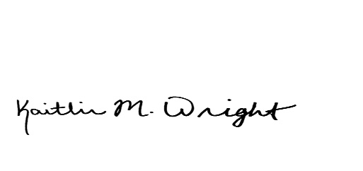

Kaitlin M. Wright
City Clerk

