CR-05 - Goals and Outcomes
Progress the jurisdiction has made in carrying out its strategic plan and its action plan. 91.520(a)
This could be an overview that includes major initiatives and highlights that were proposed and executed throughout the program year.

Program Year 2023 (PY23) took place from July 1, 2023- June 30, 2024. In reality, this PY23 report also covers a period of 90 days after June 30, 2024 through September 30, 2024, a more regular timeframe than the scheduling chaos that occurred due to the coronavirus pandemic in 2020 and 2021. The Community Development Department has essentially depleted all of the valuable CDBG-CV funds through the CARES Act to prevent, prepare for, and respond to coronavirus.
The after-effects of the Pandemic still altered performance toward some goals, some falling well short while other goals were being shattered. Most CDBG Public Services subrecipients met or exceeded Plan goals. A well-led Inspectional Services Department nearly met lofty Code Enforcement goals. Many homelessness goals were met or exceeded by talented and dedicated non-profits. The City also spent the greatest amount of CDBG funds on housing rehabilitation, as it traditionally has in prior years.
Other CDBG goal metrics were not close to being met due to post-COVID impacts and resulting product/labor shortages and inflation, particularly in regards to Housing Production and Public Improvements project goals. Due to dramatically rising housing prices, only two first-time homebuyers (due to the 80% Area Median Income limitations) were able to take advantage of CDBG-funded First Time Home Buyer project activities in line with reduced estimates.
The City managed to stay within the confines of its 20% Administrative activities cap, partly due to staff turnover and lag. The City originally stayed below the 15% maximum threshold for Public Services, but after review with HUD led to reclassification of certain economic development activities as Administrative and/or Public Services, the 15% threshold ended up being exceeded.
On a positive note, the City exceeded its goal of having 80% of PY23 CDBG funds spent within the CDBG Target Area (over 90.8%) and/or on Low-Income clients (over 86.7%).
Comparison of the proposed versus actual outcomes for each outcome measure submitted with the consolidated plan and explain, if applicable, why progress was not made toward meeting goals and objectives. 91.520(g)
Categories, priority levels, funding sources and amounts, outcomes/objectives, goal outcome indicators, units of measure, targets, actual outcomes/outputs, and percentage completed for each of the grantee’s program year goals.

Goal | Category | Source / Amount | Indicator | Unit of Measure | Expected – Strategic Plan | Actual – Strategic Plan | Percent Complete | Expected – Program Year | Actual – Program Year | Percent Complete
Expand Supply, Type and Diversity of Housing | Affordable Housing  Public Housing  Homeless | CDBG: $ / HOME: $256778 | Rental units constructed | Household Housing Unit | 400 | 48 | 12.00% | 8 | 48 | 600.00%
Expand Supply, Type and Diversity of Housing | Affordable Housing  Public Housing  Homeless | CDBG: $ / HOME: $256778 | Homeowner Housing Added | Household Housing Unit | 125 | 0 | 0.00% | 2 | 0 | 0.00%
Expand Supply, Type and Diversity of Housing | Affordable Housing  Public Housing  Homeless | CDBG: $ / HOME: $256778 | Housing for Homeless added | Household Housing Unit | 10 | 0 | 0.00%
Foster Access to Economic Opportunities +Resources | Non-Homeless Special Needs | CDBG: $ | Jobs created/retained | Jobs | 500 | 121 | 24.20% | 13 | 6 | 46.15%
Foster Access to Economic Opportunities +Resources | Non-Homeless Special Needs | CDBG: $ | Businesses assisted | Businesses Assisted | 42 | 74 | 176.19% | 45 | 82 | 182.22%
Increase Owner Occupancy & Labor Participation | Affordable Housing  Non-Homeless Special Needs | CDBG: $ | Direct Financial Assistance to Homebuyers | Households Assisted | 62 | 10 | 16.13% | 2 | 2 | 100.00%
Increase Owner Occupancy & Labor Participation | Affordable Housing  Non-Homeless Special Needs | CDBG: $ | Jobs created/retained | Jobs | 50 | 16 | 32.00% | 12 | 5 | 41.67%
Maintain Housing Stock | Affordable Housing | CDBG: $ | Public service activities for Low/Moderate Income Housing Benefit | Households Assisted | 47 | 8 | 17.02%
Maintain Housing Stock | Affordable Housing | CDBG: $ | Rental units rehabilitated | Household Housing Unit | 50 | 27 | 54.00% | 10 | 2 | 20.00%
Maintain Housing Stock | Affordable Housing | CDBG: $ | Homeowner Housing Rehabilitated | Household Housing Unit | 125 | 45 | 36.00% | 25 | 7 | 28.00%
Maintain Housing Stock | Affordable Housing | CDBG: $ | Housing Code Enforcement/Foreclosed Property Care | Household Housing Unit | 0 | 0 |  | 3 | 2 | 66.67%
Maintain Housing Stock | Affordable Housing | CDBG: $ | Other | Other | 18 | 6 | 33.33% | 3 | 3 | 100.00%
Promote Neighborhood-Based Economic Development | Non-Housing Community Development | CDBG: $ | Facade treatment/business building rehabilitation | Business | 8 | 4 | 50.00%
Promote Neighborhood-Based Economic Development | Non-Housing Community Development | CDBG: $ | Jobs created/retained | Jobs | 250 | 59 | 23.60% | 9 | 6 | 66.67%
Promote Neighborhood-Based Economic Development | Non-Housing Community Development | CDBG: $ | Businesses assisted | Businesses Assisted | 250 | 202 | 80.80% | 21 | 57 | 271.43%
Provide other non-housing necessities | Homeless  Non-Homeless Special Needs  Non-Housing Community Development | CDBG: $ | Public service activities other than Low/Moderate Income Housing Benefit | Persons Assisted | 11000 | 14287 | 129.88% | 3250 | 3625 | 111.54%
Provide other non-housing necessities | Homeless  Non-Homeless Special Needs  Non-Housing Community Development | CDBG: $ | Public service activities for Low/Moderate Income Housing Benefit | Households Assisted | 17 | 30 | 176.47% | 17 | 30 | 176.47%
Provide other non-housing necessities | Homeless  Non-Homeless Special Needs  Non-Housing Community Development | CDBG: $ | Homeless Person Overnight Shelter | Persons Assisted | 4 | 1 | 25.00% | 4 | 1 | 25.00%
Provide other non-housing necessities | Homeless  Non-Homeless Special Needs  Non-Housing Community Development | CDBG: $ | Homelessness Prevention | Persons Assisted | 12 | 48 | 400.00% | 7 | 32 | 457.14%
Provide Shelter and Services for Homeless | Homeless | CDBG: $ / HOME: $20720 | Public service activities other than Low/Moderate Income Housing Benefit | Persons Assisted | 163 | 118 | 72.39% | 116 | 95 | 81.90%
Provide Shelter and Services for Homeless | Homeless | CDBG: $ / HOME: $20720 | Tenant-based rental assistance / Rapid Rehousing | Households Assisted | 6 | 3 | 50.00% | 2 | 1 | 50.00%
Provide Shelter and Services for Homeless | Homeless | CDBG: $ / HOME: $20720 | Homeless Person Overnight Shelter | Persons Assisted | 175 | 218 | 124.57% | 32 | 67 | 209.38%
Provide Shelter and Services for Homeless | Homeless | CDBG: $ / HOME: $20720 | Overnight/Emergency Shelter/Transitional Housing Beds added | Beds | 10 | 10 | 100.00%
Provide Shelter and Services for Homeless | Homeless | CDBG: $ / HOME: $20720 | Homelessness Prevention | Persons Assisted | 500 | 267 | 53.40% | 5 | 16 | 320.00%
Provide Shelter and Services for Homeless | Homeless | CDBG: $ / HOME: $20720 | Housing for Homeless added | Household Housing Unit | 35 | 0 | 0.00%
Stabilize Neighborhoods | Affordable Housing  Non-Homeless Special Needs  Non-Housing Community Development | CDBG: $ | Public Facility or Infrastructure Activities other than Low/Moderate Income Housing Benefit | Persons Assisted | 25000 | 45019 | 180.08% | 20000 | 33210 | 166.05%
Stabilize Neighborhoods | Affordable Housing  Non-Homeless Special Needs  Non-Housing Community Development | CDBG: $ | Public Facility or Infrastructure Activities for Low/Moderate Income Housing Benefit | Households Assisted | 750 | 183 | 24.40%
Stabilize Neighborhoods | Affordable Housing  Non-Homeless Special Needs  Non-Housing Community Development | CDBG: $ | Public service activities other than Low/Moderate Income Housing Benefit | Persons Assisted | 250 | 542 | 216.80% | 98 | 87 | 88.78%
Stabilize Neighborhoods | Affordable Housing  Non-Homeless Special Needs  Non-Housing Community Development | CDBG: $ | Brownfield acres remediated | Acre | 1 | 1 | 100.00% | 0 | 1
Stabilize Neighborhoods | Affordable Housing  Non-Homeless Special Needs  Non-Housing Community Development | CDBG: $ | Direct Financial Assistance to Homebuyers | Households Assisted | 62 | 8 | 12.90%
Stabilize Neighborhoods | Affordable Housing  Non-Homeless Special Needs  Non-Housing Community Development | CDBG: $ | Homeless Person Overnight Shelter | Persons Assisted | 0 | 0 |  | 0 | 0
Stabilize Neighborhoods | Affordable Housing  Non-Homeless Special Needs  Non-Housing Community Development | CDBG: $ | Overnight/Emergency Shelter/Transitional Housing Beds added | Beds | 0 | 0 |  | 0 | 0
Stabilize Neighborhoods | Affordable Housing  Non-Homeless Special Needs  Non-Housing Community Development | CDBG: $ | Homelessness Prevention | Persons Assisted | 100 | 91 | 91.00%
Stabilize Neighborhoods | Affordable Housing  Non-Homeless Special Needs  Non-Housing Community Development | CDBG: $ | Buildings Demolished | Buildings | 5 | 1 | 20.00% | 1 | 1 | 100.00%
Stabilize Neighborhoods | Affordable Housing  Non-Homeless Special Needs  Non-Housing Community Development | CDBG: $ | Housing Code Enforcement/Foreclosed Property Care | Household Housing Unit | 2600 | 10913 | 419.73% | 2100 | 2005 | 95.48%
Table 1 - Accomplishments – Program Year & Strategic Plan to Date

Assess how the jurisdiction’s use of funds, particularly CDBG, addresses the priorities and specific objectives identified in the plan, giving special attention to the highest priority activities identified.
The City's use of Community Development Block Grant (CDBG) funds reflects the ongoing prioritization of providing safe, decent housing through housing code enforcement and housing rehabilitation, accounting for almost half (45.86%) of total CDBG funds expended in Program Year 2023. $512,454 was spent on housing rehabilitation out of the $1,117,443 in total CDBG funds expended in Program Year 2023.
CDBG spending also demonstrates the priority and objective of enhancing neighborhood-based economic development efforts as well as enhancing access to economic and employment opportunities, such as through MakeIT Haverhill, Latino Business Outreach and other programs.
Stabilizing neighborhoods remains a policy prioritization reflected in the spending rate for activities that further this goal.
Unfortunately, creating new housing, while not supported directly through CDBG, represents an important area of emphasis where the City fell short. Many factors and after-effects of the COVID-19 pandemic contributed mightily to this dynamic. 48 units at Merrivista (Merrimack Corner) for low-income seniors finished construction and opened successfully this past program year, albeit a couple of years later than originally planned.
The historic coronavirus pandemic, which killed over 100 Haverhill residents and sickened thousands more in the city, altered prioritization of CDBG funding. Throughout this Consolidated Plan (ConPlan) period, expending CDBG-CV funds through the CARES Act was the priority. This prioritization was largely executed and completed to great effect, with over 99.6% of these funds being expended in total. It will take the remaining years of the ConPlan period in some cases to get back on track and on target for certain goals.

CR-10 - Racial and Ethnic composition of families assisted
Describe the families assisted (including the racial and ethnic status of families assisted). 91.520(a)

 | CDBG
White | 2,739
Black or African American | 336
Asian | 15
American Indian or American Native | 9
Native Hawaiian or Other Pacific Islander | 6

Total | 3,105

Hispanic | 2,121
Not Hispanic | 984

Table 2 – Table of assistance to racial and ethnic populations by source of funds

Narrative
These numbers of families assisted through Community Development Block Grant (CDBG) activities in Program Year 2023 (PY23) are, in general, reflective of the Haverhill population at large. This data reveals that CDBG activities are reaching their intended target audience.
More than two-thirds--68%-- of the families assisted through CDBG identified as Hispanic/Latino, which is slightly more than representative of the Target Area neighborhoods. 10.8% were Black/African American, a slight increase from last year's (PY22) 9% threshold. 88% were White (including Hispanics/Latinos identifying as White), a slight decrease in keeping with population trends. This data underscores the importance and highlights the effectiveness of CDBG and CDBG-funded subrecipients reaching out to under-served Target Area communities and minority groups in particular. Nevertheless, these statistics are not out of place with Haverhill's general demographic profile.

CR-15 - Resources and Investments 91.520(a)
Identify the resources made available
Source of Funds | Source | Resources Made Available | Amount Expended During Program Year
CDBG | public - federal | 1,329,896 | 1,129,761
Other | public - federal
Table 3 - Resources Made Available

Narrative
Due to prior year unspent funds and CDBG-CV funds, the City was thankfully able to spend in excess of its original plan, expending over $1.129 million in Program Year 2023.
To continue recovery from the effects of the COVID-19 pandemic, the City spent $27,284 in CDBG-CV funds in Program Year 2023 (counting from October 1, 2023 through June 30, 2024). The City essentially consumed its second tranche of funds (CDBG-CV3). Less than $1,000 in CDBG-CV funds remains after September 30, 2024, with nearly 99.9% of $1,207,829 in these CARES Act funds fully expended.
The City easily met its HUD-mandated threshold of holding no more than 1.5 times its annual CDBG award on the books (totaling all unexpended CDBG funds from all prior years) during its annual 'Timeliness Test.' Given its spending rate, the City has already met this mark for the upcoming year, carrying in just over $201,000 of unexpended CDBG funds into Program Year 2024. The Program Year 2024 Annual Action Plan had estimated around $225,025 in unexpended balances from Prior Years; this projection was slightly too high.
While little was expended in terms of HOME funds this past year, over $271,000 of $277,498 were obligated for Haverhill Housing Authority and Habitat for Humanity projects.
All HUD Section 8 funds were utilized by the Haverhill Housing Authority, which turned out to be more than $4.9 million, the same amount as the prior year.
Almost 7/8ths (86.71%) of all CDBG funds were spent on Low-Moderate Income people or places (households or Census tracts). The remainder, mostly Code Enforcement, was categorized as Slum/Blight assistance. Over 90.87% of Program Year 2023 CDBG funds were spent within the defined CDBG Target Area.

Identify the geographic distribution and location of investments
Target Area | Planned Percentage of Allocation | Actual Percentage of Allocation | Narrative Description
CDBG TARGET AREA | 80 | 90.87 | All Public Improvements and nearly all Housing Rehab +Economic Dev are in Target Area
Lower Acre NRSA | 33 |  | This area will be the targeted focus of the upcoming Consolidated Plan
Mount Washington NRSA | 33 |  | This area will be the targeted focus of the upcoming Consolidated Plan
Table 4 – Identify the geographic distribution and location of investments

Narrative
In addition to Public Improvements and Code Enforcement all being exclusively Target Area-based activities, the vast majority of Housing Rehabilitation activities are undertaken in the same Target Area neighborhoods which demonstrate the greatest housing need and housing stock deficiencies. $278,725 of $318,557.25 or 87.5% of CDBG-funded housing rehabilitation activities in Program Year 2023 occurred in the Target Area.
By and large, Public Service and Economic Development activities have the Target Area as their locus. For example, most of the non-profit organizations delivering CDBG-funded services to low-to-moderate income clients are located in the urban core of the city, and most of their program delivery occurs in this same general area. Some CDBG Economic Development Activities (such as Facade Improvement) are Target Area specific, and the City's investment in MakeIT Haverhill reflects its status in the Mount Washington neighborhood in the heart of the Target Area. This is in keeping with the Plan goal of promoting economic development that is neighborhood-based.
Various Administrative totals (i.e. CDBG Rehab Administration and CDBG Program Administration costs) are excluded from these calculations.
Leveraging
Explain how federal funds leveraged additional resources (private, state and local funds), including a description of how matching requirements were satisfied, as well as how any publicly owned land or property located within the jurisdiction that were used to address the needs identified in the plan.
As intended, the City's CDBG funds leveraged a significant amount of other federal, state and private resources to help achieve Goals. For example:
-HOME- Additional PY23 funds supported completion of construction of Merrimack Corner (Merrivista Senior Housing Expansion). 48 affordable units for seniors were completed from this project, which overcame rising costs throughout and after COVID, to bring more affordable housing downtown. HOME funds also supported Habitat for Humanity's development of an affordable duplex for lower-income homeowners at the end of Curtis Street in the Mount Washington area.
-Shannon and Byrne Policing Grants- These multiyear $400K+ grants for the Haverhill Police Department were supplemented by CDBG-funded neighborhood stabilization and gang prevention efforts;
-Vacant Property Registry funds- These funds again successfully supported the efforts of the City's Vacant Property Manager, boarding up and monitoring of derelict vacant sites, and continuing use of Tolemi's vacant property predictive analysis software;
-CDBG-CV3- The City spent a total of $27,264 in CDBG-CV funds from its second tranche of $597,180 (CDBG-CV3) through the CARES Act for activities to prepare, prevent for or respond to Coronavirus. These funds complemented the City's Public Services and Economic Development activities.
-MassWorks Infrastructure Grant- This State grant, a keystone of the Community One-Stop for Growth program, provided $1.95 million for major traffic improvement, signalization, intersection realignment and utility relocation to support Procopio Companies' approved 290-unit Beck housing and mixed-use project by the Comeau Bridge, a redevelopment of the former Ornsteen Heel site by the Bradford MBTA commuter rail station that includes a new public park along the Merrimack River. Furthermore, a $4m MassWorks grant was obtained to design a showcase public pedestrian plaza to augment $6.5 million in previous MassWorks funds for replacement parking garage and plan the controlled, phased demolition and transformative redevelopment of the existing, dilapidated Goecke Parking Deck. Construction for both of these projects is underway.
-MVP- The State's Municipal Vulnerability Program climate change grant funded a study of the aging private Pentucket Mills dam on the Little River near Lafayette Square. Contaminated sediment behind the dam is an issue affecting the dam's likely removal, which is delaying the redevelopment of this large mill complex.
-State legislative earmarks from the FY24 budget included important funds for: Riverside Park ($15,000 for park improvements including new basketball courts); 12th Avenue Park ($12,500 for upgrades); Gale Park Fountain and war memorial upgrades ($25,000); MakeIT Haverhill ($25,000) for workforce development efforts in Mount Washington; Beyond Walls ($50,000 for public art projects in Haverhill); Cogswell Arts Space ($25,000 for building improvements for Creative Haverhill); Somebody Cares Food Pantry ($20,000 for pantry operation); Haverhill Latino Coalition ($15,000 for community engagement); Haverhill Promise ($50,000 for literacy expansion efforts); Veterans Northeast Outreach Center ($25,000 for veterans services in Haverhill). Of particular note, $50,000 for an incentive program for Accessory Dwelling Units (ADUs) in Haverhill.
-American Rescue Plan (ARP)- see attachment in 'Other Actions' section
Around $1.5 million was leveraged directly through activities in which CDBG was only part of the funding.

CR-20 - Affordable Housing 91.520(b)
Evaluation of the jurisdiction's progress in providing affordable housing, including the number and types of families served, the number of extremely low-income, low-income, moderate-income, and middle-income persons served.

 | One-Year Goal | Actual
Number of Homeless households to be provided affordable housing units | 6 | 0
Number of Non-Homeless households to be provided affordable housing units | 4 | 48
Number of Special-Needs households to be provided affordable housing units | 0 | 0
Total | 10 | 48
Table 11 – Number of Households

 | One-Year Goal | Actual
Number of households supported through Rental Assistance | 12 | 31
Number of households supported through The Production of New Units | 10 | 48
Number of households supported through Rehab of Existing Units | 25 | 9
Number of households supported through Acquisition of Existing Units | 0 | 0
Total | 47 | 88
Table 12 – Number of Households Supported

Discuss the difference between goals and outcomes and problems encountered in meeting these goals.
Housing construction did roar back to life after the resulting conditions of the COVID-19 Pandemic affecting freight transportation, products and labor supply had severely curtailed and/or delayed newly-approved projects. The cost of labor and raw materials remained high but stabilized. In some cases, these costs added over a million dollars onto construction budgets of medium range multi-family housing projects. The devastating result of this dynamic is the lack of new units of housing produced in this past Program Year. There are a number of projects that have commenced recently with the cooling of inflationary pressures. The long-awaited HOME- and other-funded Merrimack Corner (expansion of Merrivista low-income senior housing) project was completed successfully this year, with 48 new units filled after a lottery. This project accomplishment makes up ground from unmet prior year goals.
The Pandemic greatly hampered efforts by Rebuilding Together over the past few years, which traditionally rehabilitates housing units for low-income elderly residents at the end of every April. Having just 2 units rehabbed through this program-- as opposed to the 9 units/projects planned-- obviously affected the number of rehabbed housing units.
The City's support of two Saint Vincent dePaul rental assistance programs (one in Mount Washington, one in the Acre) was highly productive, with 31 households receiving this critical support (against a goal of 12).
In terms of housing rehabilitation, much of this past program year was expended finishing prior projects previously counted, so only 9 unduplicated new projects were counted.
Discuss how these outcomes will impact future annual action plans.
The Coronavirus Pandemic exacerbated a preexisting housing crisis and delayed many housing construction projects, which will affect and complicate future annual planning efforts. A crush of backlogged development projects are going on all at once, straining the ability of the City's Inspectional Services Department to properly manage.
The after-effects of coronavirus will also put a squeeze on the HRCCP to achieve its Consolidated Planning goal targets. Pent-up/delayed housing rehab work will create demand that features much higher cost per project.
In terms of affordable housing production, the City's 2020 Census-adjusted rate of 9.88% affordable and subsidized housing units from its overall housing stock no longer satisfies the Commonwealth's Chapter 40B affordable housing requirements and goals. Addition of the completed 48 Merrimack Corner (Merrivista) senior units will help get the City very close to the threshold. This revised figure, which includes an updated denominator in terms of total housing units, threatens the ability of the City to maintain control of its land use, further increasing the priority of developing future affordable housing. However, most of the larger new developments currently under construction are exclusively market rate (pre-Inclusionary Zoning), which will drop the City even further below 40B targets. The City is actively updating its 2018-2023 Housing Production Plan to become a new 5-year guide to drive development of additional housing and especially badly-needed affordable housing. City legislative passage in 2023 of new housing reforms-- loosening restrictions on production of Accessory Dwelling Units (ADUs), and mandating inclusion of affordable units into larger housing projects over 10 units or mandating contributions to an Affordable Housing Trust (Inclusionary Zoning)-- should help. The COVID-19 pandemic has done little to squelch the demand for housing, especially affordable units. NOTE: There was already an estimated 250-300 unit shortage in permanent housing units in Haverhill for very-low-income households (under 30% AMI) heading into the 2020s.
As previously noted, the lack of housing and affordable housing puts strains on households' budgets. Over one-third of all Haverhill residents (and over one-half of renters!) are officially considered cost-burdened, with more than 30% of their incomes being expended on housing. This dynamic drives increased demand for Public Services that will impact future Plans.
Include the number of extremely low-income, low-income, and moderate-income persons served by each activity where information on income by family size is required to determine the eligibility of the activity.

Number of Households Served | CDBG Actual | HOME Actual
Extremely Low-income | 1 | 0
Low-income | 4 | 0
Moderate-income | 5 | 0
Total | 10 | 0
Table 13 – Number of Households Served

Narrative Information
These figures in the above chart include HRCCP housing rehabilitation participants, who are low- to moderate-income homeowners whose income based on family size is used to determine program eligibility. Likewise, these figures include two First-Time HomeBuyers (FTHB) in PY23, who also qualify for this program based on low-moderate family income.
Other housing activities overseen by the Community Development Department are not classified by these metrics (using information on income by family size to determine eligibility of the activity).

CR-25 - Homeless and Other Special Needs 91.220(d, e); 91.320(d, e); 91.520(c)
Evaluate the jurisdiction’s progress in meeting its specific objectives for reducing and ending homelessness through:
Reaching out to homeless persons (especially unsheltered persons) and assessing their individual needs
Like other 'Gateway Cities,' Haverhill continues to grapple with an increasingly prescient homelessness issue only somewhat hidden from public view, and exacerbated by the housing crisis. Many vacant properties, public facilities, parks, alleys and buildings, rears of shopping plazas and open spaces are now frequented by tents of homeless residents. Some traditional makeshift locations for the homeless have been uprooted as a result of new developments, such as along the riverfront and Bradford Rail Trail. Soon the Basiliere Bridge replacement project will dislodge tents there. The Procopio project dislodged a large homeless encampment on the vacant former Ornsteen Heel property, for example.
Haverhill's homeless underclass is sadly diverse: old, middle age and young; men and women; representing different ethnic and sociological backgrounds, but with some common threads: domestic violence; criminal histories; low or no income; evictions; illness; mental illness; vagrancy; lack of family support or connections; and current or past substance abuse and/or addictions. Heroin and fentanyl addicts, many of them younger adults, are living out in city streets, parks, makeshift tents, in cars and vacant properties as well as shelters. A transient population wanders through town routinely from Maine to New York and beyond, sometimes by commuter rail to the end of the line here. The past year has witnessed an increase in homeless elders, some of whom were swindled or lost homes due to condemnation.
The City works in strong partnership with homeless serving agencies, referring individuals to various community resources. Activities that City has supported with PY23 CDBG funds include a continuum of organizations that do yeoman's duty in battling homelessness overnight, in the morning, and afternoon, such as: Emmaus' Mitch's Place overnight homeless shelter (IDIS Activity #1427), which sheltered 67 unduplicated individuals with $10,000 from CDBG Public Services funds; Community Action Inc.'s Homeless Drop-In Center (IDIS #1432), which served and assisted 75 homeless individuals with $12,000 in CDBG funds; and the Common Ground Cafe on Winter Street. Open Hearts Ministries (IDIS #1424) does some outreach to the homeless as well, but has transitioned mostly to a meals program for the homeless that is served at Common Ground and/or G.A.R. Park.
The established (CE) Coordinated Entry system is designed to assess the needs of homeless individuals and place them among various agencies. A CE Program Manager for the Balance of State Continuum of Care operates out of Haverhill at Emmaus, doing comprehensive assessments of homeless individuals' needs at two Homeless Assessment Centers- one for women, one for men.
Street outreach to chronically homeless or the unsheltered is difficult, inefficient, time-consuming yet very effective.

Efforts
Grant funding continued from the Wadleigh Foundation, with support by the City, to extend hours (by an hour a day) and expand services at Community Action's Homeless Drop-In Center. Meanwhile, over the last year, Common Ground Ministries continued their growth and expansion of their services to the homeless as well. The mobile health van of Greater Lawrence Family Health Center is now stationed two days per week in the free municipal lot adjacent to Common Ground Ministries. This mobile medical center provides free health care services to the homeless and indigent in the community. Portable shower facilities there increased average usage by 10-15 homeless individuals every day. Common Ground added laundry facilities for the homeless as well (up to 2 bags a day). The City is working with Common Ground to resolve wastewater issues for these shower/laundry units. Electrical generators were previously added to Emmaus and Common Ground facilities through CDBG-CV during PY21 in order to provide operational sustainability during climate change-related and other emergencies. All of these noted facilities and CDBG sub-recipients strive to become personally acquainted with the homeless individuals they serve, and to try to relate to them on an interpersonal basis. This level of one-on-one interaction allows providers to assess the individual needs of these homeless. These providers work tirelessly to connect these clients with appropriate services and ultimately to permanent housing. All of the City's CDBG-funded agencies are expected to share information about available resources and services in the community. A monthly Unsheltered meeting occurs, in which Emmaus, the Drop-In Center, Common Ground, Eliot Community Services, City, Police, State agencies such as Department of Transitional Assistance (DTA) and others discuss trends, policies and even complex individual cases of homelessness and those on the streets.
Addressing the emergency shelter and transitional housing needs of homeless persons
Some of the City's success in combatting and treating chronic homelessness has been partly offset by new homelessness caused by opioids, transients, mental illness and evictions.
However, efforts with Rapid Rehousing again paid notable dividends, especially those from Emmaus staff. Rapid Rehousing placed 40 households into permanent housing in PY23-- off the streets and out of the shelter. At the Family Shelter, 51 unduplicated families were served. 43 of these households were eventually placed into permanent housing (separate from and in addition to the 40 noted above). Emmaus added Haitian Creole speaking staff to its ranks last year.
In all, Emmaus' Mitch's Place Emergency Overnight Shelter housed 274 unduplicated individuals over the past Program Year.
The City seeks and utilizes partnerships with several agencies, developers and programs about the need to create additional housing for the homeless. Many of these projects take years to construct. Unfortunately, no new housing units (for homeless or other low-income households) were constructed during this post-Pandemic Program Year.
Those entering the Continuum of Care (CoC) through Coordinated Entry (CE) system are evaluated for benefits maximization. These clients receive housing stability assessments and referrals as appropriate in order to address their most urgent needs to prevent chronic homelessness. Referrals are made to CAP agencies, as well as visiting medical providers and legal service outfits (such as Northeast Legal Aid) that provide 'pro bono' assistance to prevent homelessness. CDBG and/or American Rescue Plan (ARP) funds support several of these agencies.
Other emergency shelter and housing strategies include: networking amongst CoC members to address needs; emergency assistance to prevent evictions (especially State Residential Assistance for Families in Transition {RAFT} funds); use of funding and networks outside of CoC including North Shore Homelessness Action Group; collaboration with State offices; diversion funds; utilization of State HomeBase for prevention and diversion; housing court legal representation (typically less than 3% for renters); physical help in locating apartments; and working with prison release programs. The City's dedicated Housing Specialist stationed at Community Action, funded through CDBG-CV3, helped provide this assistance until the expiration of such funding at the end of June, 2024.
CE, operated regionally by Emmaus, is utilized as both a process and an evaluation tool to identify people before they become homeless, using one common application (many use virtual gateways). Over the past Program Year, Emmaus continued with implementation of Vesta and Vestimator, new Homeless Information Management System (HMIS) tools.
Incidences of overdose in local shelters remain high. Emmaus is fortunately equipped with Narcan to deal with routine overdoses, and has a close relationship with City Emergency services.
Coordinated Entry + other Programs
Emmaus, Inc. was the lead agency administering the Emergency Solutions Grant (ESG) program for the North Shore region of the Balance of State Continuum of Care, but that program expired early last year. These programs are only being somewhat replaced with rental assistance funds. Repaid Rehousing placed 40 homeless residents into permanent housing. Additionally, 43 other families were placed out of family shelter into permanent housing units. Emmaus is also the lead agency for the Coordinated Entry (CE) program. Emmaus continued to grapple with operating their shelter at significantly higher costs post-Pandemic. There is a need for 'emergency' shelters, providing unconditional shelter for homeless individuals in the Merrimack Valley. This is in contrast to so-called 'dry' shelters, which only cater to those who are not drinking alcohol or under the influence of drugs. Unfortunately, the main shelters in Lowell are usually 'dry' facilities, and the Daybreak shelter in Lawrence transitioned into a substance-abuse/detoxification only facility, not as emergency shelters open to all comers. As a result, homeless individuals unwilling or unable to participate in substance abuse prevention programs flock to Haverhill in order to get basic shelter through Emmaus. As stated before, the city is seemingly drawing transient homeless from outside communities, including from New Hampshire and Maine, for similar reasons. The termination of large tent cities in the region leads some homeless individuals to Haverhill. These difficult and troubling dynamics require regional solutions. Haverhill does not have adequate resources to deal with handling a disproportionate share of the region's homeless population. Emmaus is challenged by policy changes from the Balance of State CoC, which has chosen to only allow 30 days of case management from its housing funds. Many clients require more assistance after housing placement. One of the City's proudest accomplishments during the COVID-19 Pandemic was preventing a 'super-spreader' outbreak among the homeless. These best practices are still improving operational efficiencies today.
Haverhill Homeless Facilities Overview
Multiple CDBG-funded sub-recipients have interacted on a daily basis with Haverhill's homeless, both sheltered and unsheltered, in PY23. Mitch's Place (IDIS #1427) continues operating as a 40-bed facility on 2 floors. The Homeless Drop-In Center (IDIS #1432) continued to operate Monday-Friday out of the basement of the Universalist Unitarian Church on Ashland Street in the Highlands neighborhood near the Lower Acre, a walk-able distance from Mitch's. Managed by Community Action, the Drop-In provides breakfast, occasional bagged lunches, socialization, service referrals, transit connections, health care screenings, personal financial administration, benefits counseling/financial oversight (if so court-appointed) among other services. Similarly, Common Ground Cafe is walkable from the Drop-In Center as well. The Cafe provides coffee, meals, snacks, socialization and counseling services throughout the afternoon, providing free amenities to the homeless, along with a clothing thrift store. Showers and laundry facilities for the homeless are among the services at Common Ground. A non-inclusive PY23 listing of shelter, transitional housing, and permanent housing facilities for chronically-homeless populations reveals the following: Emmaus SHI (Supportive Housing Initiative) affordable housing program for 10 formerly homeless families; Emmaus 41 Welcome Street Section 8 project- 20 formerly homeless individuals, with a priority for elders; Emmaus Family Shelter- 54 households (over 130 residents); Emmaus' Mitch's Place- now 48 individuals per night/average; Veterans Northeast Outreach Center (VNOC)-- 25 homeless veterans' beds. The City also maintains an emergency shelter at the Citizens Center during extreme weather emergencies or other disasters.
2024 Homeless PIT Count Review
The 2024 Homeless Point-in-Time (PIT) Count was held overnight in Haverhill on Wednesday, January 24 into the early hours of January 25, 2024 (last Wednesday night of January). The results for the 2024 PIT count revealed 23 individuals living on the streets in January (some of whom refused to be sheltered for various reasons and preferences). This is an increase from the 20 listed last year. While a diverse lot, most were White males. Some of these individuals have been chronically homeless and living permanently outdoors. The City and Emmaus are seeing a the number of unsheltered homeless trending upwards, along with an increase in homeless elders. Emmaus’s Mitch's Place emergency overnight shelter has routinely operated at a 40-person capacity per night. Emmaus is seeing more homeless men than women, and many of their guests have mental illness issues.
Emergency Response efforts
The City was challenged again during this past year with house fires and other emergencies related to climate change. Fortunately, none of these incidents involved fatalities. In most cases, recovery leads to extensive and lengthy renovations of months not weeks. Many affected residents required extensive hotel stays or other temporary-to-long-term replacement housing. The City, Community Action, Emmaus and others continue to press for more seamless handoffs from the American Red Cross after their immediate disaster response. Providing short-term emergency management is crucial but not sufficient given the long-term needs these situations create. Some landlords involved were not that interested in rehousing their tenants, some of whom were already facing eviction. Long-term homelessness is bad enough, but fires and other issues also can create new homeless individuals in an instant. More emergency housing services funds will be needed as the City tries to design a program through CDBG to serve fire victims (IDIS #1386). The major impetus for this is to prevent homelessness from minor fires due to a lack of smoke and/or carbon dioxide alarms or small emergency repairs, often in the overnight or weekend hours. The loss of the Best Western motor lodge in Haverhill due to a troublesome and delayed reconstruction will challenge these resources until renovation and construction is complete in a year or so.CDBG-CV3 funds (IDIS #1243) for a Housing Assistant at Community Action (Janet Jusino) provided direct assistance to re-house many of these fire victims and suddenly homeless households through the end of June, 2024. Furthermore, the City is evaluating the small-scale emergency housing, quarantine and shelter potential being offered in church halls, commercial establishments and schools.
Helping low-income individuals and families avoid becoming homeless, especially extremely low-income individuals and families and those who are: likely to become homeless after being discharged from publicly funded institutions and systems of care (such as health care facilities, mental health facilities, foster care and other youth facilities, and corrections programs and institutions); and, receiving assistance from public or private agencies that address housing, health, social services, employment, education, or youth needs
The City works in close partnership with various agencies to create more seamless referral pipelines for individuals emerging from state custody, incarceration, and health facilities in order to prevent them from becoming homeless. Also, several CDBG-funded PY23 Public Service activities specifically address these concerns, as well as keeping families and individuals out of homelessness, including:
-Community Action's Homeless Drop-In Center (IDIS #1432)- $12,000- which helped stabilize 75 homeless and near-homeless individuals by connecting them with critical resources and providing morning indoor shelter, nutritious breakfast and socialization;
-St. Vincent dePaul of St. James Parish Rent and Utility Assistance Program (IDIS #1433)- $12,080- which helped 18 individuals avoid eviction with rental assistance;
-St. Vincent dePaul All Saints Mount Washington Family Assistance Program (IDIS #1428)- $6,000- which helped 14 individuals avoid eviction with rental assistance;
-Open Hearts Ministries' Social Outreach Program (IDIS #1424)- $5,000- to connect 80 near-homeless individuals with services including outreach, as well as free cooked nutritious meals for the homeless and public, served at G.A.R. Park and/or Common Ground Cafe at 194 Winter Street;
-Salvation Army's Comprehensive Emergency Services Program (IDIS #1426)- $15,000- which referred 2,550 individuals with various social services through a large daily meals program;
-Emmaus' Mitch's Place Emergency Shelter (IDIS #1427)- $10,000- which provided overnight shelter and services to 67 homeless individuals, moving 21 out of homelessness;
-Common Ground Ministries Mobile Shower Facilities improves hygiene and health of indigent residents through appointments to use shower facilities and laundry, working through staff and volunteers to move guests away from homelessness.
-Northeast Legal Aid helped scores of households avoid homeless through its Haverhill Citizens Center satellite office last year;
The City also provided $11,915.00 in CDBG-CV3 funds (IDIS #1270) in short-term rental assistance to prevent evictions for 7 additional unduplicated households during PY23.
Emmaus still receives homeless referrals from hospitals and mental health providers (such as Vinfen) even outside of the Merrimack Valley region. These outside referrals put pressure onto the city's homeless system which is not sustainable without additional outside funding.
State and Non-CDBG Assistance
In addition, the City has valuable relationships with other non-City funded agencies that are not contracted sub-recipients. Many of these agencies work with populations being discharged from institutional systems of care or are at risk of homelessness, including: Lawrence CommunityWorks, counseling those at risk of foreclosure in Spanish and English; Social Security Office in Haverhill, providing disability payments. This office relocated to the Riverside area adjacent to Merrimack Valley Hospital over the past year; Department of Transitional Assistance (DTA) in Lawrence, providing cash assistance and short-term housing assistance; Department of Children and Families (DCF) in Bradford, the State child welfare agency; Leaving the Streets Ministries encounters youth transitioning out of incarceration and/or state custody, many of whom need housing; UTEC does as well (IDIS #1436);Several Haverhill client families of the Department of Transitional Assistance (DTA) office in Lawrence were diverted out of shelters through HOME Base, Section 8 and other tools. Through the State budget and supplemental budgets, the State added resources to the Residential Aid for Families in Transition (RAFT) program. Community Action and Emmaus are usually able to assist these cases. HomeBase funds are provided by the State to provide stabilization services for clients. HomeBase allowances have increased to $30,000 for qualified clients, along with case management. Emmaus administers HomeBase funds.
Helping homeless persons (especially chronically homeless individuals and families, families with children, veterans and their families, and unaccompanied youth) make the transition to permanent housing and independent living, including shortening the period of time that individuals and families experience homelessness, facilitating access for homeless individuals and families to affordable housing units, and preventing individuals and families who were recently homeless from becoming homeless again
The City employs various strategies and partners to help homeless persons and families transition to permanent housing, access affordable housing units and prevent a return to homelessness.
The City promotes affordable housing lotteries, which the State mandates for properties receiving affordable housing tax credits. Many near-homeless Haverhill individuals have had little way of participating or knowing about these lotteries previously. Unfortunately, the only housing lottery over the past year was exclusively for seniors (age 62+) at Merrimack Place (Merrivista expansion), where over 300 local residents applied for 48 units.
Through the regional system of Coordinated Entry (CE), assistance is provided at the community level to inform people of availability of housing and services across the county. Each entry point has staff dedicated to CE and access to all available resources. The City and Balance of State Continuum of Care (CoC) and its North Shore members will continue to collaborate and to refer clients as needed to intensive voluntary case management services.
Along with Community Action, Emmaus' Family Shelter, and CoC-funded entities, many agencies have increased job training, financial literacy/credit counseling, health and wellness, and educational opportunities on an individual basis, working with MassHire Career Centers and MakeIT Haverhill in order to help obtain employment. There are combined programs with ESOL and job training and GED/HiSet.
The City remains engaged with regional efforts dedicated to homeless and unaccompanied youth, which typically represents the cohort of homeless that is most difficult to identify. The School Department's dedicated McKinney liaison remains involved in order to provide quality referrals for homeless and unaccompanied youth. Post-Pandemic mass absenteeism among students is taking attention away from the McKinney liaison's focus on homelessness. The other significant demand on the McKinney representative was the connecting Haverhill Public School households to emergency resources such as food, rent and utility assistance, as opposed to dealing with homelessness.
During the past Program Year, the North Shore's HOME Consortium allocated historic and unprecedented resources (over $6 million) to build housing for the homeless through the American Rescue Plan (HOME-ARP). The City worked actively with the Haverhill Housing Authority (HHA) in a successful HOME-ARP application that should construct the first new HHA units in four decades, at the 335 Groveland Street site in Riverside.

CR-30 - Public Housing 91.220(h); 91.320(j)
Actions taken to address the needs of public housing
The Haverhill Housing Authority (HHA) directly operates over 440 State-funded/assisted units at scattered sites throughout the City. HHA also administered 517 Section 8 vouchers over the past year. 467 of these Section 8 vouchers are mobile rental vouchers (MRVPs) which are used in private dwellings around the city and an additional 50 are used for community-based non-profit providers through the Massachusetts Department of Mental Health (DMH). There was no funding for any additional slots or vouchers last year. HHA also administers 8 Shelter Plus Care housing slots. HHA also administers 58 federal public housing units and programs in neighboring Groveland, with 61 HHA units in total there. As of the most recent VMS report, the Haverhill Housing Authority (HHA) distributed over $4.9 million in Section 8 Housing Vouchers last year. HHA utilizes the CHAMP system for their waiting lists for units; this system is administered by the Commonwealth (Executive Office of Housing and Livable Communities (EOHLC).
The City will continue to seek ways to solicit and address the needs of public housing residents. One concrete example is IDIS #1350 (Kennedy Circle HHA Enhancements), which was generated in response to feedback from elderly residents at HHA’s 80-unit complex in Riverside. The City spent $50,074 in total in CDBG funds ($1,049 in PY23) to greatly enhance laundry capacity and make other Kennedy Circle improvements, which required extensive electric, gas, plumbing and flooring upgrades to the Community Room building. This project significantly enhanced the quality of life for these low-income senior residents.
The HHA has a Tenant Council which holds regular meetings on the third Thursday of every other month. Members of the Section 8 Program also have their own Resident Advisory Board, which provides feedback on the Section 8 program's annual PHA plan that is subsequently submitted to HUD.
Many HHA residents are now also being served by free (ARPA-funded) bus transit offered by the Merrimack Valley Regional Transit Authority (MVRTA).
The City regularly attends meetings of the Haverhill Housing Authority Board. During PY23, the HHA worked on getting vacant or cleared-out units back online. Working with CDD, the HHA was awarded $1 million in HOME-ARP funds for the expansion and construction of new units at 335 Groveland Street (adjacent to Kennedy Circle), to which the City pledged HOME funds as match. This project represents the first new addition of HHA units in over 4 decades.
The extremely long waiting lists for Haverhill Housing Authority (HHA) units are measured in years, not months. This dynamic remains of critical concern for the City and many Haverhill residents.
Actions taken to encourage public housing residents to become more involved in management and participate in homeownership
The HHA applied for and was awarded a two-year grant for the Congressionally-funded Family Self-Sufficiency (FSS) program, which remains in full effect. The FSS program is designed to place some rental savings into savings accounts to fund down-payments for future home purchases, among other uses. HHA residents are made aware of the City's First-Time Home Ownership programs and other State offerings as well, through the distribution of flyers and notices.
Additionally, a Resident Services Coordinator-- hired by HHA in 2022 through a State HLC grant-- remains on the job.
The HHA will continue to assist with the current housing crisis, by means of securing any additional HUD voucher programs suitable to the needs of the Haverhill community.
HHA residents were referred to Community Action Inc. (CAI) for various supportive services, including job training, ESOL and credit and other financial literacy skills. HHA and CAI have headquarters next door to each other in Washington Square downtown. The City seeks to cultivate a more comprehensive relationship between these agencies.
The HHA Board features a Tenant Representative on the board, to make management aware of the views and concerns of residents and vice versa.
Actions taken to provide assistance to troubled PHAs
Not Applicable-- the Haverhill Housing Authority is not considered a 'troubled' Public Housing Authority.

CR-35 - Other Actions 91.220(j)-(k); 91.320(i)-(j)
Actions taken to remove or ameliorate the negative effects of public policies that serve as barriers to affordable housing such as land use controls, tax policies affecting land, zoning ordinances, building codes, fees and charges, growth limitations, and policies affecting the return on residential investment. 91.220 (j); 91.320 (i)
Several previously noted public policies may effectively serve as barriers to affordable housing. These include: lead-based paint regulations; inclusionary zoning; foreclosure laws; fire and ADA building codes; choice-limiting action; certain environmental review requirements; and taxes. Reforming those policies under direct City control during this period is a goal.
In terms of lead-based paint, the costs of mitigation can be exorbitant, dissuading some developers and even homeowners from moving ahead with worthy rehabilitation or needed expansion projects. Some landlords have left apartments vacant over lead-based paint concerns. Other owners routinely avoid renting to households with young children due to fears of liability over lead poisoning, despite these actions being egregious violations of fair housing regulations.
Actions taken to overcome these barriers include usage of CDBG funds for deleading properties through the HRCCP, as well as connection with MassHousing's 'Get the Lead Out' program. A State-reimbursed agent for "Get the Lead Out,' the City processes applications and oversees the privately selected lead contractors as part of its program administration. The CDD also makes strategic housing rehabilitation decisions with respect to disturbing lead-based paint. As detailed below, $61,500 in CDBG and State funds were directly expended for de-leading in PY23.
A prior lack of a coherent Inclusionary Zoning policy previously hurt development of affordable housing units. Actions taken to overcome these barriers include: adoption of Smart Growth zoning principles, such as the Waterfront Overlay District; submission of the MBTA Communities zone (which provides multi-family housing by-right near transit); approval of the Haverhill:2035 Master Plan; Housing Development Incentive Program [HDIP] implementation to drive market rate housing in Gateway City downtowns; and most notably, reformed Inclusionary Zoning regulations approved in September 2023. This proposal allows developers a choice either to pay into a housing stabilization fund that could supplement local formula HOME funds or to construct affordable units, providing a density bonus, in comparison to neighboring communities.
Foreclosure laws intended to protect lenders have been a common link in creating abandoned properties that are blighting influences on neighborhoods rich and poor. These vacant properties can drive down property values for entire neighborhoods and often pose significant public safety issues.
Actions taken to overcome this include: maintaining a Vacant Property Manager to maintain the City's Vacant Property registry; pursuing property Receiverships in Housing Court to complement greater identification, prevention and rehabilitation efforts; and most importantly, aggressive Code Enforcement efforts (IDIS #1417). In PY 2023, Tolemi software's automated vacant property predictive analysis software (Building Blocks) continued to be utilized.
Actions to Remove Negative Effects of Public Policies that Serve as Barriers to Affordable Housing
Fire and ADA building codes- Building Codes are always changing and seemingly always growing more stringent. These changes sometimes have the unintended effect of making housing construction infeasible. ACTION: The City is working to notify and warn developers of pertinent changes to various code requirements so that they do not negatively stultify housing production. ACTION: Likewise, the CDD works closely with the Fire Department in the Plan Review Committee so as to not let Fire codes or their interpretation deter production of affordable units. The City is committed to safe, energy efficient, and decent housing, but a balance is needed to ensure that enforcement of codes does not suffocate any new housing units. Choice Limiting Actions and Environmental Review Requirements can affect the timing of projects that seek to utilize federal funds in a manner that can threaten practical implementation of these projects. It can cost a great deal of time, money and analysis for developers only to determine that a project cannot move forward. Most housing developers, especially those producing affordable housing, cannot afford to operate this way. ACTION: The City tries to help with completing Environmental Reviews with staff assistance, consultants and administrative funds, including Brownfields grants, in order to drive down pre-development costs for worthy projects. Taxes- High taxes can limit housing production. ACTION- The City may offer certain projects Tax Increment Finance [TIF] deals and support with historic rehabilitation tax credits to spur affordable housing development.
Actions taken to address obstacles to meeting underserved needs. 91.220(k); 91.320(j)
The PY 2023 Annual Plan identified Needs that were redefined post-coronavirus Pandemic, including economic development, inflationary cost pressures, youth mental health and enrichment opportunities, addiction services, child care, the effects of climate change, dealing with house fires, and labor participation issues. The needs of housing crisis did not change, however.
Geographically, Mount Washington and the Lower Acre neighborhoods remain the areas of greatest concern. Such narrowed geographic focus helps provide concentrated resources to address homelessness and dilapidated, code-deficient housing in these areas, as well as neighborhood-based economic development that connect residents to opportunity. These neighborhoods converge in Lafayette Square, where a stalled development of the sprawling and blighted Pentucket Mills complex on Stevens Street is linked to the future of an aging private dam on the Little River connected to the mill. Keeping this high-profile brownfields site safe and secure is of high concern. Redevelopment of this mill complex will spur other investments, some of which are already underway, in this critical area, such as a new housing development at 235 Essex Street. Other grants have been obtained (Inland Dredging Grant) or are being pursued to obtain funds to clear contaminated river sediment and allow for the removal of the dam.
Even prior to the pandemic, the City had other pressing needs including, but not limited to: combatting opiate addiction; identifying transient youth; combatting gang violence; fixing sidewalks in disrepair; creating and preserving adequate rental housing; raising wages; providing substance abuse treatment; increasing philanthropic capacity; diversifying job training options; promoting ESOL resources and availability; outreaching and communicating with residents; adjusting to rising rents; adding available public housing units and vouchers; and creating additional business/industrial spaces. In this sequence, these issues are highlighted below:
Addressing Underserved Needs I
Opiate addiction- The unprecedented public health crisis from COVID overshadowed another grave public health problem facing the city, state and nation. While fatalities from overdoses declined in the community, the level of overdoses remained high. Drugs laced with deadly fentanyl are still too easy to obtain. While a city-wide problem, overdoses tracked by Trinity Ambulance by neighborhood reveal that Haverhill's CDBG Target Areas continue to remain most affected. Community policing, added patrols, gang prevention and eradication efforts, treatment options, etc. are critical. There is a need to reengage court officials, local law enforcement, churches, non-profits, parents, citizens, the School Department, recovering addicts and others in a grassroots effort. Community Development presence at Recovery Fairs is making such inroads. There remains a need for significant grant funding in this area, but previous efforts to obtain Drug Free Community Services and other grants were mostly unsuccessful. A revived coalition has been organized to make an improved attempt at this grant, yielding significant programming (i.e. Drug Story Theater, Recovery Fairs and other outreach events). CDBG resources were used in PY23 where possible to address this need, including: anti-drug and opiate curriculum provided by the Haverhill Inner City Boxing Club (IDIS #1392), and free health screenings offered by the Homeless Drop-In Center (IDIS #1432). The Haverhill Police Department already carries Narcan and it makes a life or death difference. Identifying Transient Youth- The City is working with the Continuum of Care, the Haverhill Public School full-time dedicated McKinney Liaison Officer, and several sub-recipients on this issue. There are couch-surfing youth dealing with a variety of problems, from abuse to addiction, gender identity rejection, to unstable housing, who need to be connected to resources and better understood. Emmaus, You Forward, CAI, the YMCA (Teen Programming IDIS #1430), YWCA and others are all working together on this issue.
Addressing Underserved Needs II
Gangs and Gang Violence- Gang activity and resulting gang violence continue to plague the community, with some youth disconnected after the coronavirus pandemic. Youth in middle schools are being recruited into the Trinitarios, Crazy White Boys, Gangsta Disciples, and Latin Kings gangs. The rise in opiates has also reinvigorated gang activity. Haverhill Police implemented a $300K Byrne Grant, a very successful Shannon Grant effort, and other Public Safety grants. These resources leverage PY23 CDBG funding for gang-focused street outreach workers provided from a UTEC center in Haverhill, (IDIS #1436) and anti-gang counseling from Leaving the Streets Ministries. CDBG-funded activities such as Inner City Boxing Club (IDIS #1392), the YMCA Teen Programming (IDIS #1430) and the Boys and Girls Club Pathways to Academic Success program (IDIS #1425) all attempted to curb gang activity and provide appropriate mentoring and recreational outlets for youth, especially in the Mt. Washington and Acre neighborhoods. Sidewalks in Disrepair- Attacking a massive backlog of road and sidewalk work, the City has spent aggressively on sidewalk repair over the past few years. Many of these prioritized sidewalks are well-traveled in the CDBG Target Area near schools or parks. This amount is on top of State highway (Chapter 90) funds. Sidewalks are a major focus of the City's American Rescue Plan (ARP) funds. Sidewalk work addresses citizen feedback while adding safety and access for many with disabilities. Street trees are also being added. As a result of these funding sources, CDBG was not needed to be used for sidewalks in PY23.
Addressing Underserved Needs III
Adequate rental housing- The City promotes the development of more rental housing in order to lower prices through increased supply. In addition, CDBG Code Enforcement (IDIS #1417) is augmenting the City's other efforts to ensure safe, decent living conditions for renters in the community. Too many renters reside in inadequate living conditions and the City is working with realtors, non-profits and landlords to compel changes to these conditions. Wage growth- The City and MassHire Merrimack Valley Workforce Board are working to increase connections to better paying advanced manufacturing, biotech, environmental, clean energy and high-tech jobs and other opportunities available in the region. In PY23, CDBG funded half of an Economic Development Specialist (IDIS #1422) who meets with employers to understand their employment and real estate needs, challenges and capacity. This enhanced employer outreach is paying dividends, especially in terms of reaching out to businesses challenged by the pandemic (including restaurants, health care and manufacturing). UMass-Lowell's Haverhill Innovation Hub (I-Hub) helps this dynamic, as higher education yields better-paying employees, including at a Northern Essex Community College Culinary Arts Training Center at the Heights complex Downtown. Unfortunately, UMass-Lowell announced plans to abandon the I-Hub in Haverhill by the end of 2024.MakeIT Haverhill (IDIS #1444), through its successful job training activities, programs and employer fairs, is connecting Mount Washington residents with jobs, skills and wage growth. In fact, data reveals that wages increased in the city again over the past year; unfortunately, much of these gains were lost with inflationary cost increases led by housing cost spikes. Substance Abuse Treatment- Despite the presence of methadone and other rehab facilities, there remains a shortage to meet demand. Facilities such as Horizons at the State Line Plaza and Serenity near Holy Family Hospital have added needed capacity to address these issues. To establish better connections between these facilities and the Hospital and local non-profits, the City hosted its annual Recovery Fair information and referral session in Fall, 2022 and participated in other such events. Much outreach is being made to agencies and non-profits in this arena, given the connection between addiction and poverty. Philanthropic Capacity- Haverhill is home to fewer foundations, private funding organizations and trusts than other regional communities. The City is applying to and engaging more outside private foundations (i.e. Cummings, Essex County Community, and Casey Foundations) in an effort to lure additional private resources to address needs. L'Arche Boston North, serving and housing individuals with disabilities, was awarded funds from the Cummings Foundation (for example). Such awards reduce stress upon public resources.
Addressing Obstacles to Underserved Needs IV
Diversifying Job Training Options- There is a need to increase training capacity in fields outside of health care, where the capacity and facilities are excellent. However, training is still limited for blue-collar fields and manufacturing in this region. The City has worked over the last few years with Northern Essex Community College (NECC) and Whittier Regional Vocational Technical School to add to this capacity by supporting efforts to create advanced culinary arts and manufacturing training centers. Trade unions are also offering more training in the region. The City partnered with many providers within the Haverhill Early Learning Team (ELT) seeking to standardize child care and to improve quality and outcomes in early childhood education. Now the City seeks funds to increase job training to create more certified early educators. This ELT partnership was tapped to administer CDBG-CV-funded child care support to get parents back to work after the COVID shutdowns (IDIS #1402). MakeIT Haverhill (IDIS #1444) also provided on-site training and refers individuals to NECC and other training providers. Promoting English as a Second Language Resources- ESOL has capacity needs, despite the work of NECC and CAI. Many residents struggle to undertake ESOL around work and family schedules due to availability of classes or training. The City is bringing back classes at the Haverhill Public Library and the schools. MakeIT Haverhill is helping to fill the ESOL void, supported by CDBG (IDIS #1444). Employers are encouraged to use the State Workforce Training Fund grants and other public and private resources to provide ESOL to their workers. Speaking English equates to higher wages, and residents know it. The backlog for these classes has grown post-pandemic. Outreach and Communicating with Residents- In this day and age, communicating with residents is challenging given the array of multimedia choices that residents have to receive information, as well as the symptoms of misinformation and information overload. There is no one single effective source of information or communication vehicle anymore. This problem is exacerbated in Target Areas such as Mount Washington or the Acre where many primarily speak Spanish or other languages. The City's 3-1-1 consolidated and bilingual constituent response system is proving useful and effective. The City is trying to use more web-based, bilingual, automatic (robocalls), online and social media-driven messaging to engage and enlighten citizen participation and public information. The CDD is reviewing its CDBG Citizen Participation Plan for effectiveness and relevance, even hiring a part-time Spanish language translator to assist with housing rehab programs. A new challenge is that many area migrants speak not Spanish but Haitian Creole, which has much less capacity. Rising Rents- The cost effects of supply and demand are on full display with the rental market in the region. The City seeks to develop multi-family rentals through HOME funds and use of Riverfront Overlay Zoning and other tools such as Housing Development Incentive Program (HDIP). The City is aggressive in promoting affordable housing lotteries and helping developers obtain Low-Income Housing Tax Credits, regional HOME funds, state and federal historic rehabilitation tax credits and other incentives, in order to more expeditiously create additional housing units. The City is emphasizing the dynamic of rising rents as a key tenet during production of the Housing Production Plan as it did with the Master Plan. The Pandemic made a terrible housing crisis even worse. Rental Assistance from the City requires at least 90-day extensions on starting eviction procedures against applicants. A new Housing Trust fund created in the last year will receive funds from developer buyouts under new Inclusionary Zoning ordinances, which will also help produce more affordable units.
Addressing Obstacles to Underserved Needs V
Available Public Housing Units and Vouchers- The Haverhill Housing Authority (HHA) wait lists for many of their units can be counted in terms of years or half-decades. Hundreds of households languish years on these lists awaiting public housing. Additional public housing units would obviously fill up immediately. While the HHA is quite busy with aggressive modernization and capital plans, the City has assisted with CDBG-funded upgrades to Kennedy Circle Senior Housing Community Room (IDIS #1350), freeing up HHA funds for 2023 acquisition of an adjacent building for expansion purposes at 225 Groveland Street, the first new HHA units in 4 decades, using HOME-ARP funds. Developing More Industrial Space- The City offers employers expedited permitting, competitive land, water and sewer costs, micro-enterprise support, and favorable rezoning along the riverfront and highway. City Economic Development staff is exploring supply chains leveraging networks related to existing employers. The City is involved with the Merrimack Valley Planning Commission (MVPC) in a regional effort to promote sites through data and branding, including the Merrimack Valley Means Business web portals and promotional materials, highlighting the City's advantages to employers. However, a glaring lack of available industrial space is a significant concern, as the city's main industrial areas are essentially fully occupied or being built out. There exists a need to create capacity for additional job growth. The new Master Plan allows for densification of business parks, reduced industrial parking requirements, and cluster mixed-use development in various zones, among other reforms and innovations. The City has identified land along Interstate 495 that would work, the site of a small old private airfield between Routes 108 and 110 by I-495 Exit #111 near Northern Essex Community College. Consultant AECOM is analyzing environmental, wetlands, topography, endangered species (Blandings Turtles) as well as site feasibility, layout and conditions. Amazon is locating a major distribution hub at the former Western Electric plant just across the town line in North Andover, in addition to a last-mile distribution center in Haverhill, that will provide new $15 per hour minimum jobs to hundreds of local residents. This will also have a tremendous impact on Haverhill.
CDBG-CV Addressing Underserved Needs
CDBG-CV and other CARES Act funds were quickly and effectively deployed to address the multitude of underserved needs that erupted during the COVID-19 Pandemic, especially in terms of food insecurity efforts, as well as emergency rental/mortgage/utility assistance. Many new clients who never before needed such public assistance took advantage of these operations. In PY23, over $20,469 in CDBG-CV funds (IDIS #1243) were used to support a specialist to assist clients with perhaps the greatest unmet need-- housing. $11,915 was disbursed through CDBG-CV to provide emergency rental/utility needs (IDIS #1270).These Activities essentially drained the last of the CDBG-CV funds, with 99.9% of over $1.2m already expended, with less than $800 remaining. The lack of CDBG-CV funds poses a challenge for community development efforts going forward.
American Rescue Plan and CDBG
Of all the leveraging opportunities, no other source is being utilized to meet City ConPlan goals and underserved needs more than the American Rescue Plan (ARP). The City is expending $38 million before the end of 2026, and a great deal of the past program year was dedicated to developing and/or spending ARPA funds on various projects. Many of these ARPA projects meet ConPlan goals, particularly in regards to replacing aging infrastructure-- sidewalks, waterlines, sewers, culverts, beautification, parks (i.e. Plug Pond Recreation Area), especially in Haverhill's Qualified Census Tracts (QCTs), which are different from but feature similar overlap to the CDBG Target Area. Some projects were jointly funded by both CDBG and ARP, such as (IDIS #1361) ramps replacement at Somebody Cares New England at 358 Washington Street, a food pantry/ youth center and polling place location in Mount Washington. Due to rising costs and issues with both entryways, $75,000 in ARP funds is needed in addition to around $49,671 in CDBG PY23 funds ($83,822.50 total in CDBG funds). Extremely Low-Income housing projects are being undertaken through the generational opportunity that is HOME ARP funds. ARP funds also partly funded the Youth and Mental Health grants, which support many CDBG subrecipients and low-income residents. ARP supports public health efforts (vaccinations, personal protective equipment (PPE), and clinicians) previously funded through CDBG-CV and the CARES Act. ARP-funded Fresh Food fund grants augmented nearly all CDBG-funded food pantries and meals programs to great benefit. ARP supports additional legal aid for low-income residents through a Northeast Legal Aid satellite office at the Haverhill Citizens Center, MakeIT Haverhill staffing, and workforce development efforts. ARPA provides massive leveraging opportunities with CDBG, as coordination is constant between the two grant programs.
Actions taken to reduce lead-based paint hazards. 91.220(k); 91.320(j)
The City, through its Community Development Department (CDD), commits as many resources as feasible to address the risks of lead-based paint hazards. Through the HRCCP, the City uses CDBG funds as needed on activities that involve substantial de-leading of residential dwellings.
-58 Charles Street (IDIS #1403)- This multi-year project was referred via a State housing court complaint due to elevated blood lead levels in young children at this Lower Acre residence. $14,200 in PY23 CDBG housing rehabilitation funds were used to get the new owners (a minority first-time homeowning family with young children) lead safe and into legal compliance.
In such cases, a formal letter of de-leading compliance is achieved. The CDD is willing to expand its usual geographic reach in order to help homeowners and the Haverhill Water Department meet the mandate to remove residential lead services for those households who cannot afford to undertake these changeouts on their own. However, there were no such cases in PY23.
As an agent for MassHousing's State-funded 'Get the Lead Out' program, the City undertakes projects exclusive of CDBG investments cited above. New applications during Program Year 2023 included:
11 17th Avenue- This Acre property was remediated to the tune of $12,000 in State resources.
47 Upland Street- $21,800 was spent to de-lead this dwelling in Bradford;
3 Arthur Street- This deleading activity in the Hilldale/Broadway area utilized $13,500 in State funds.
Overall, $47,300 in State 'Get the Lead Out' funds were administered by the City's Community Development Department.
Over the past year, the City applied for and was proudly awarded a long-sought HUD Lead Hazards Control Capacity Building grant, totaling over $2.43 million over three years. This represents a quantum leap in terms of the City's ability to combat lead-based paint hazards in its housing stock.
Actions taken to reduce the number of poverty-level families. 91.220(k); 91.320(j)
Reducing the number of families living in poverty constitutes a critical goal for the City, Community Action (CAI) and various partnering agencies and subrecipients. The COVID-19 Pandemic's economic aftereffects (i.e. product shortages and inflation) increased the number of poverty-level families, so in the aftermath these poverty reduction efforts were critically needed.
The City, through its Community Affairs Advisory Board (CAAB), prioritizes much of its CDBG Public Services funds towards reducing the number of poverty-level families. Actions in Program Year 2023 included:
-Salvation Army Meals Program (IDIS #1426), where staff refer and/or provide poverty-level families with an array of services, financial support, guidance and assistance, in addition to cooked meals ($15,000 in PY23 served 2,550 individuals);
-Community Action's Heating Assistance program (IDIS #1431) assists families who otherwise have to choose between heat versus food, rent and/or health care ($9,000 in PY23 funds served 30 households);
-All Saints Parish Food Pantry (IDIS #1440), which provides food and support for needy Mount Washington residents ($4,112.56 in PY23 CDBG funds that enabled the parish volunteers to serve 164 poverty-level households);
-CAI's Homeless Drop-In Center (IDIS #1432), which directly provides financial oversight for indigent individuals and connects them with housing, employment, health and other resources over breakfast and coffee in a day shelter ($12,000 in PY23 CDBG funds serviced 75 individuals);
-Open Hearts Ministries Social Outreach Program (IDIS #1424), which provides Sunday meals, services, and toiletries for needy households at GAR Park and Common Ground Cafe ($5,000 in PY23 CDBG funds that served 80 individuals);
-Somebody Cares New England Youth Center on the Hill and Food Bank (IDIS #1434 + 1435), which assists families with monthly food pantry ($6,000 serving 145 clients), services and referrals, beyond its youth enrichment program ($6,000 serving 51 youth), totaling $12,000 in combined PY23 CDBG funds serving 196 families in poverty;
-Liz Murphy Open Hand Pantry (IDIS #1429), which provides a hand to households who experience food insecurity, especially at the end of the month ($8,000 in PY23 CDBG funds to support 462 households);
-Saint Vincent dePaul's Direct Help to People in Need (Rent/Utility + Diaper) Assistance program (IDIS #1433), which provides spot rent and/or utility payments to households at imminent confirmed risk of eviction or shutdown, averting loss of credit due to indebtedness ($12,080 supporting 18 families).
-Saint Vincent dePaul of All Saints also provided rent/utility assistance (IDIS #1428) of $6,200 in PY23 CDBG funds to support 14 Mount Washington families.
Actions taken to develop institutional structure. 91.220(k); 91.320(j)
The City undertook various measures in Program Year 2023 to increase both its own institutional structure internally and to support external non-profits, service providers and sub-recipients in their own institutional development.
See attachment for staff training provided by HUD and the City.
CDD Staff engaged Massachusetts Housing Partnership staff for technical assistance in various regards, including reestablishing a Housing Trust with the City's passage of Inclusionary Zoning reforms.
The City supported a Latino Business Coordinator to work with Haverhill's Spanish-speaking business community, providing various technical assistance. The City also paid a bilingual City staffer to provide Spanish language translation services as needed for housing rehabilitation applicants.
The CDD also received valuable updates through its membership in the National Community Development Association (NCDA). CDD Staff attended the Fall, 2023 NCDA Meeting in November in Worcester, where HUD provided technical assistance and important updates.
CDD staff conducted on-site subrecipient monitoring visits, along with desk reviews conducted through IDIS and other internal procedures. Whenever possible, non-profits were provided or connected with technical assistance. The CDD offered Technical Assistance sessions for prospective non-profit applicants prior to submission date for its annual Public Services Request for Proposals (RFP), on February 12, 2024. New subrecipients were connected to other resources to increase their capacity, operations and structure, such as Community Inroads (Lawrence) and the Chambers of Commerce.
CDBG-CV funded Rental Assistance services were provided by Janet Jusino at Community Action as a Rental Assistance Specialist, connecting clients to housing opportunities through state and federal programs and with realtors/landlords through June, 2024. Unfortunately, there is no identified funding source for this position going forward.
Within City Hall, CDD staff meets routinely with officials from other City departments to coordinate and explain what can and cannot be done with CDBG. The CDD Housing Manager regularly interacts with Inspectional staff to review 'Building Blocks' vacant property predictive software as well as the revised ViewCloud online cloud-based permitting system. The Housing Manager advises the Board of Appeals to ensure better structure, decision writing and processes for this rule-making organization. HRCCP Staff attend weekly Inspectors Team meetings to coordinate Code Enforcement practices, projects and efforts.
A rigorous annual outside City audit was conducted by the firm Powers and Sullivan (Marcum LLP), examining budgets, expenses and fiscal procedures of all City accounts. HUD monitored the City's CDBG-CV program and digital file review of certain activities was concluded in PY23.
City planning capacity was enhanced through active partnerships with the Merrimack Valley Planning Commission's Comprehensive Economic Development Strategy (CEDS) committee, MVPC monthly regional planners committee, the MassHire Merrimack Valley Workforce Board, MassINC's Gateway Cities Forum and other partnerships and initiatives. Through CDBG Administrative funds, the CDD also retained the services of consultants as needed to advance certain projects and priorities.
The HUD Lead grant will provide additional grant-funded staffing to augment capacity to address lead-based paint hazards.
Actions taken to enhance coordination between public and private housing and social service agencies. 91.220(k); 91.320(j)
Haverhill Housing Authority (HHA) leadership, with help from the City, has expanded outreach to, and coordination with, multiple and various social service agencies. HHA continues to work with Emmaus, Inc. to administer Emergency Solutions Grants (ESG) and Shelter Plus Care grants for the community. The City has taken steps to foster relationships between the HHA and other providers, such as the YWCA, Common Ground, Bethany Community Services, the Haverhill Council on Aging, Community Action, Inc. (CAI), Vinfen and others. Having Community Action located next door to the HHA headquarters in Washington Square has proven convenient for many, and has led to enhanced service coordination. Management of the Merrimack Valley Regional Transit Authority (MEVA) continued operating buses fare-free thanks to American Rescue Plan (ARP) funds, in order to provide greater access to transit for HHA residents-- to work, medical, shopping and other reasons.
Community Teamwork Inc. (CTI) in Lowell provides additional Section 8 vouchers for constituents, in addition to those vouchers administered by HHA. Expanding the utilization of these vouchers is important as they still represent the best way (according to researchers) to provide housing to those who would likely be homeless otherwise. Of course, vouchers require available units, which has become a significant problem in Haverhill. CTI also works with CAI to administer the enhanced State-funded Residential Assistance to Families in Transition (RAFT) or Emergency Rental Assistance Program (ERAP) rental vouchers. Using the last of CDBG-CV funds, the City funded a Housing Specialist position at Community Action who connected residents with units, rental assistance resources and counseling. Unfortunately, that position is not able to be funded in PY24 with the depletion of the CARES Act funds. The Commonwealth continues adding funds for rental and other housing assistance, although the strain of migrants has led to strict limitations for many.
The City is discussing with its affordable housing developers ways in which to link their current and/or future residents with the city's strong network of social service providers, and to connect HHA residents to these projects as well as housing lottery participants with project-based vouchers.
HHA residents are targets of a promotional campaign for the Budget Buddies curriculum that improves credit scores and credit awareness, with low credit a major impediment for many.
The City strives to make property management companies (such as Peabody Properties) aware of the many non-profit service providers who constitute Haverhill's social safety net, in order to ensure the best long-term results for residents. This is important as many affordable housing project residents utilized emergency rental assistance that the City previously offered from CARES Act funds from the State and CDBG-CV, but these funds are no longer available.
The Interfaith Network of Compassion (INC), a coalition of service providers including the City, enhances coordination, shares information, makes referrals and develops the Haverhill Resource Guide. This pamphlet, constantly being updated, provides those living in public and private housing with reliable contact and referral information to more easily obtain needed resources.
Identify actions taken to overcome the effects of any impediments identified in the jurisdictions analysis of impediments to fair housing choice. 91.520(a)
Previous 'Impediments to Fair Housing Choice' reports identified the following concerns and impediments:
IMPEDIMENT -Foreclosures
Action Step: Prevention- The City works closely with area lenders, foreclosure prevention specialists and HUD-certified counseling agencies, community action agencies and Merrimack Valley Legal Aid (ARPA-funded) to help residents avoid foreclosures. This includes information dissemination, workshops, legal assistance or direct counseling. Among the local agencies to which the City makes referrals are Lawrence CommunityWorks (featuring foreclosure counseling in Spanish), Mill Cities Communities Investments (Lawrence), and Community Action, Inc. (Haverhill). The City through its Assessors Office subscribes to and receives Warren Reports and reviews real estate listings, seeking Real Estate Owned (REO) transactions. The City also works with the Registry of Deeds on these issues.
Action Step: Code Enforcement- CDBG funds the activity (IDIS #1417) of part-time building, health, safety and sanitary code enforcement officers charged with investigating housing and other conditions, including at foreclosed, neglected or possibly vacant properties. In the case of higher-income income absentee landlords, code enforcement is the only City tool to ensure residents (renters and abutters) have safe, clean and decent housing.
Action Step: Tolemi's Building Blocks software- In PY23, the City continued utilization of a predictive analysis and tracking software that uses certain factors (i.e. lack of water usage) to highlight certain properties as being at risk of vacancy, abandonment and foreclosure. This tool is integrated within the City's other software and geographic information systems.
IMPEDIMENT-Lack of Fair Housing Outreach and Education-
Action Step: Information and Outreach- The City's Community Development Department serves as a public repository of Fair Housing information from HUD and other public agencies. Many Foreclosure prevention agencies and CDBG subrecipients also provide assistance with Fair Housing issues, advocacy and guidance. The CDD also regularly updates the Haverhill Landlords Guild and minority residents on Fair Housing obligations and regulations. Applicants to the CDBG-funded First-Time Homebuyers program are made aware of these tools and their rights as well.
IMPEDIMENT- Residents Unable to Access Fair Housing Marketing
Action Step: The City is unofficially playing a more active role in promoting affordable housing lotteries in Haverhill, which are required for State (DHCD)-funded housing projects. Too often, poor, minority, and non-English speaking city residents are left unaware of these lotteries from which they could surely benefit. In order to ensure that more local residents have access to the affordable housing units being created in Haverhill, the City actively promotes housing lotteries and keeps lists of households wishing to be made aware of them. This past year, the City aggressively promoted Bethany Community Services' lottery for the new 48 Merrimack Corner units for seniors adjacent to its Merrivista complex.
Addendum I- Lead-Based Paint Hazards
IMPEDIMENT-Discrimination against Families with Young Children due to the Possible Presence of Lead-based Paint- Action Step: Referral to Lead Assessment and Abatement Resources- There is clearly discrimination against families with young children by multi-family property owners concerned about their legal liability due to the possible presence of lead-based paint in their units. Due to the expense of removal, property owners have pervasive fears about having a young child poisoned and winding up in court defending a lawsuit. The City works to apprise renters and homeowners of their rights and obligations under the law as explained on pamphlets, posters and other materials. More importantly, the City tries to provide or connect resources to the home-owning public. Among the resources for addressing lead-based paint are the City's own HRCCP and Mass Housing's 'Get the Lead Out' program, which the City helps to administer and oversee to make housing units and (in case of multi-family dwellings) tenants safe. This past year featured lead-based paint removal in 4 properties and 2 units made certifiably lead-safe through HRCCP and 3 units through Get the Lead Out. Action Step: Advocacy on lead-based paint- The CDD actively promotes and disseminates information concerning lead-based paint hazards to scores of individuals and households every year. All participants in CDBG programs, especially HRCCP and First-Time Homebuyers, are made aware of the risks, their rights and their responsibilities under the law as it pertains to lead. All contractors employed through the HRCCP are RRP-certified. Ongoing outreach is conducted with landlords, through the Haverhill Landlords Guild, to reeducate them on the rules concerning non-discrimination against households with young children due to concerns or uncertainty about lead poisoning risks. The City was recently awarded a major HUD Lead Hazard Reduction Capacity Grant (3 years, $2.43 million) in the hopes of developing additional resources to remove lead paint from our housing stock.
ADDENDUM II- Rents
IMPEDIMENT-Rental Increases -Action Step: Tracking, Communication and Advocacy- Rents in Haverhill are rising dramatically, in most cases far beyond what the average area median-income earner could pay at 30% or even 50% of income. Landlords are making large-rent increases in general. 2-bedroom units are upwards of $2000/month or more in many cases. These increases are causing immense pain for low-income households, pricing many out of the market. The Haverhill Landlords Guild tracks local rental rates and the rental market, among other issues. The CDD underscores to the Guild members the need to keep units affordable for those of very low incomes. Action Step: Rental Assistance- Many individuals and households of lesser means are seeking assistance paying rent; or, are dependent upon social-service providers for non-housing essentials such as food, heat, clothing, furniture, etc. This dynamic was greatly exacerbated as a result of the COVID pandemic. In PY23, 8 households received the last of emergency rental assistance exclusively from CDBG-CV funds just in totaling almost $12,000. CDBG funds also supported the St. James Parish St. Vincent DePaul's spot rent and utility assistance program for 14 households (IDIS #1433) and through All Saints Parish, which provided rent assistance for an additional 8 households (IDIS #1428). These volunteer programs provide one-time support to prevent imminent evictions or utility shutoffs. The City used CDBG-CV Administrative funds to support a Housing Assistance position at Community Action that connected distressed renters with federal and state resources to offset rents, prevent evictions, as well as find landlords with available units. Housing cases are also referred to the Massachusetts Department of Transitional Assistance (DTA) Office in Lawrence.
ADDENDUM III- Housing Availability
MPEDIMENT-Supply of Adequate Housing -Action Step: Housing Rehabilitation and Code Correction Program (HRCCP)- The City uses a majority of its CDBG funds to rehabilitate housing that has Code deficiencies, primarily located within the CDBG Target Area, in order to keep low-to-moderate income homeowners in their homes in safe, decent housing conditions. Action Step: HOME funds- The City generally prioritizes its HOME funds for the development/construction of new affordable housing units. Action Step: Reducing Permitting Roadblocks- The City uses multiple tools and various programs to reduce permitting backlogs for developers of housing, including 40R Smart Growth, 40B Affordable Housing, Housing Development Incentive Program (HDIP), Tax Increment Financing (TIFs), 43D Expedited Permitting, ViewPermit online permitting system, Accessory Dwelling Units (ADUs) and other by-right zoning (such as density bonuses for riverfront views and access) to expedite housing development to create a wide range of housing, including 'friendly' 40Bs and ADUs. In the past year, the City made ADU permitting easier and beefed up its Inclusionary Zoning ordinances. Action Step: Distressed Properties Identification and Revitalization- The City aggressively targets abandoned and vacant properties with the goal of getting them back into productive use. The City's Vacant Property Manager uses the City's vacant property registry system, Tolemi Building Blocks software, Code Enforcement (IDIS #1417), and assistance from the State Attorney General's office to identify distressed bank or real estate owned (REO) or other vacant properties. This multi-pronged effort seeks to correct code violations and get these properties back onto the tax rolls, and back onto the market, whether through sale, Housing Court filings, or Receivership.

CR-40 - Monitoring 91.220 and 91.230
Describe the standards and procedures used to monitor activities carried out in furtherance of the plan and used to ensure long-term compliance with requirements of the programs involved, including minority business outreach and the comprehensive planning requirements
The Community Development Department (CDD), on behalf of the City, undertakes and performs different types of monitoring activities in order to ensure compliance, efficacy and performance of its CDBG and other public programming by its employees, vendors/consultants and subrecipients. Monitoring remains a key responsibility.
Multiple CDD staff conduct continual 'desk monitoring' through reviews of invoices, reimbursement requests, and through IDIS input and timelines. The Director and Division Director review and approve all invoices jointly; photographs are required for all construction or rehabilitation invoices submitted by contractors.
CDD staff routinely conduct on-site monitoring (at least annually) of sub-recipients, project sites, and files. The on-site visit is meant to review progress towards goals, program eligibility, national objectives, outreach, spending schedules, staffing levels, client files, procurement, financial systems, service trends, and program delivery. During Program Year 2023, all CDBG Public Services subrecipients were visited on-site by CDD staff.
The CDD has hired an outside auditor (Marcum LLP) to review the audits and certified financial statements submitted by CDBG subrecipients, in order to see if there are any outstanding issues for the subrecipient to address, or 'red flags' regarding the subrecipient organizations themselves. CDBG Administrative funds were used to conduct this review of these compiled audits.
In addition, the CDD itself is subject to review by Marcum, operating as the City's own procured and contracted external auditors, which analyzed and tested City fiscal practices, processes, and procedures. There has been tightening of several practices relating to vendor payment, acceptable invoicing standards, grant balances, and grant management, including the CDD.
All homeowners who participate in housing rehabilitation (HRCCP) or First-Time Home Buyer activities are subject to intensive review and scrutiny of income eligibility records.
The CDD has made progress in terms of representation of Minority and Women Business-Owned Enterprises (MBE/WBE) in carrying out its publicly-funded programs including CDBG. This includes recruiting MBE/WBE firms off the State registry. Some minority-led contractors and firms that the City procures do not register on the MBE/WBE lists, despite those benefits. Multiple environmental remediation and housing rehabilitation contractors (notably electricians) that the City has used in the past Program Year are in this category. The City funds Latino Business Outreach (IDIS #1443) to increase opportunities for minority contractors to work and contract with the City.
The City adheres to Davis-Bacon wage rate regulations seriously for its applicable federally-funded projects. Payroll records are examined from contractors before construction invoices are processed for payment. On-site employee classification wage interviews are being conducted using updated forms and schedules, when required, such as the 358 Washington Street ramp at Somebody Cares (IDIS #1361).
The CDD is routinely using HEROS in conducting appropriate Environmental Reviews (ERs). CDD staff assist North Shore HOME staff in conducting ERs for local HOME projects.
When needed, the City also assists the North Shore HOME Consortium in the monitoring of its many HOME-funded affordable housing projects in Haverhill. When a HOME Consortium project has only a 15-year monitoring period, the City often picks up the ongoing obligations for those longer terms of affordability beyond 15 years. Housing monitoring is made with the objective of reducing homelessness in mind.
All of these efforts, practices and procedures are undertaken to ensure compliance with program requirements and comprehensive planning regulations.

Citizen Participation Plan 91.105(d); 91.115(d)
Describe the efforts to provide citizens with reasonable notice and an opportunity to comment on performance reports.
The Draft Program Year 2023 Consolidated Annual Performance Evaluation Report (CAPER) was publicly advertised on Thursday, October 31, 2024 for review in the Community Development Department office at 4 Summer Street, Room #309 of Haverhill City Hall. A copy of the Draft CAPER was also placed on file at the Haverhill Public Library, as well as on the City's website on the Community Development page at www.cityofhaverhill.com/departments/community_development_block_grant.php. The official Public Notice period ran from November 1- November 19, 2024, more than the required 15 days, even with Sundays and holidays excluded.
A public meeting of the Community Affairs Advisory Board (CAAB) open to the public was held on Tuesday, November 19, 2024 at 6:00PM in Haverhill City Hall, Room #308. At this meeting, the various CDBG and CDBG-CV performance reports for Program Year 2023 (mainly generated off IDIS) were reviewed, analyzed and discussed. CAAB members have long appreciated the geographic breakdown of CDBG investments by individual neighborhoods, for comparative purposes in which to determine equity and need. The CAAB members present voted to recommend submission of this CAPER for PY2023. There were a few comments related to particular Activities (i.e. the impact of construction of housing and traffic issues, housing costs, and the spread of poverty). None of these comments substantively reshaped the CAPER.
There were no other public comments at the conclusion of the public comment period, except for comments about the manner of funding child care from members of the Early Learning Team.
The City provides the public with numerous and constant opportunities for feedback on performance, which is always welcomed.
CR-45 - CDBG 91.520(c)
Specify the nature of, and reasons for, any changes in the jurisdiction’s program objectives and indications of how the jurisdiction would change its programs as a result of its experiences.
The massive effects of the historic COVID-19 pandemic will be long-lasting, invariably changing the trajectory of future community development efforts and objectives. This Pandemic and resulting crisis arrived at the very end of a 5-Year Consolidated Plan period, affecting goals and changing priorities on the fly. The coronavirus crisis seemingly affected everything except the housing crisis, which continued unabated, and only got worse.
The need to expand housing opportunities for Haverhill’s unique widely and evenly distributed socioeconomic range of residents is even more profound than imagined during the development of the ConPlan, especially in the increasingly intense housing market. Future approval and completion of proposed housing developments under consideration will remain a key priority, especially along the Merrimack Riverfront. Supply chain disruptions caused by COVID and other pricing factors have also raised the costs and timeframes of housing beyond what was anticipated at the beginning of the Con Plan period. Fewer projects have proceeded to construction due to labor and supply shortages, rising interest rates, etc. As a result, the percentage of income that Haverhill residents spend on housing continues to soar, placing inordinate pressures on other budgetary necessities. A majority (over 51%) of Haverhill renters are now considered officially cost-burdened. This dynamic continues to place great strain on those entities that can provide non-housing necessities (food, clothing, fuel, furniture, health care, etc.). Housing price increases have forced a revaluation and loosening of restrictions on the City's CDBG-funded First-Time Homebuyer Program, as prices have usually exceeded what a household earning below 80% of Area Median Income (AMI) in Haverhill can afford.
In the economic development realm, unemployment rises slowly from a 55-year low (2.4%) in Haverhill in May, 2023 (averaging around 4% per Merrimack Valley Workforce Board figures over the year). However, many are choosing to work from home, and the nature of work has seemingly changed or been altered for many post-Pandemic. Many employees have dropped out of the workforce altogether. Child care remains a significant need preventing too many from (re-)entering the workforce. Labor participation remains a significant concern. Access to jobs, lending and financial support for new microenterprises and entrepreneurs, as well as English language resources, remain elusive and complicated for too many.
Community needs shift from year to year as well. For example, the heroin, fentanyl and opioid epidemic has mildly abated with a small decrease in fatalities.
Wild weather and effects of climate change have placed strain on the rehabilitation of housing as well as creating stress on social services. The City’s Municipal Vulnerability Program (MVP) grant seeks to eliminate the dam on the Little River by Lafayette Square in the heart of the Target Area. This effort could have profound effects on this central Target Area neighborhood over the next five years.
The City's new 3-year Lead Hazards Reduction Capacity grant, utilizing CDBG as match, will affect ConPlan actions and priorities going forward.
Does this Jurisdiction have any open Brownfields Economic Development Initiative (BEDI) grants?
No
[BEDI grantee] Describe accomplishments and program outcomes during the last year.

CR-45 - CDBG 91.520(c)
Specify the nature of, and reasons for, any changes in the jurisdiction’s program objectives and indications of how the jurisdiction would change its programs as a result of its experiences.
The massive effects of the historic COVID-19 pandemic will be long-lasting, invariably changing the trajectory of future community development efforts and objectives. This Pandemic and resulting crisis arrived at the very end of a 5-Year Consolidated Plan period, affecting goals and changing priorities on the fly. The coronavirus crisis seemingly affected everything except the housing crisis, which continued unabated, and only got worse.
The need to expand housing opportunities for Haverhill’s unique widely and evenly distributed socioeconomic range of residents is even more profound than imagined during the development of the ConPlan, especially in the increasingly intense housing market. Future approval and completion of proposed housing developments under consideration will remain a key priority, especially along the Merrimack Riverfront. Supply chain disruptions caused by COVID and other pricing factors have also raised the costs and timeframes of housing beyond what was anticipated at the beginning of the Con Plan period. Fewer projects have proceeded to construction due to labor and supply shortages, rising interest rates, etc. As a result, the percentage of income that Haverhill residents spend on housing continues to soar, placing inordinate pressures on other budgetary necessities. A majority (over 51%) of Haverhill renters are now considered officially cost-burdened. This dynamic continues to place great strain on those entities that can provide non-housing necessities (food, clothing, fuel, furniture, health care, etc.). Housing price increases have forced a revaluation and loosening of restrictions on the City's CDBG-funded First-Time Homebuyer Program, as prices have usually exceeded what a household earning below 80% of Area Median Income (AMI) in Haverhill can afford.
In the economic development realm, unemployment rises slowly from a 55-year low (2.4%) in Haverhill in May, 2023 (averaging around 4% per Merrimack Valley Workforce Board figures over the year). However, many are choosing to work from home, and the nature of work has seemingly changed or been altered for many post-Pandemic. Many employees have dropped out of the workforce altogether. Child care remains a significant need preventing too many from (re-)entering the workforce. Labor participation remains a significant concern. Access to jobs, lending and financial support for new microenterprises and entrepreneurs, as well as English language resources, remain elusive and complicated for too many.
Community needs shift from year to year as well. For example, the heroin, fentanyl and opioid epidemic has mildly abated with a small decrease in fatalities.
Wild weather and effects of climate change have placed strain on the rehabilitation of housing as well as creating stress on social services. The City’s Municipal Vulnerability Program (MVP) grant seeks to eliminate the dam on the Little River by Lafayette Square in the heart of the Target Area. This effort could have profound effects on this central Target Area neighborhood over the next five years.
The City's new 3-year Lead Hazards Reduction Capacity grant, utilizing CDBG as match, will affect ConPlan actions and priorities going forward.
Does this Jurisdiction have any open Brownfields Economic Development Initiative (BEDI) grants?
No
[BEDI grantees] Describe accomplishments and program outcomes during the last year.

CR-58 – Section 3
Identify the number of individuals assisted and the types of assistance provided

Total Labor Hours | CDBG | HOME | ESG | HOPWA | HTF
Total Number of Activities | 2 | 0 | 0 | 0 | 0
Total Labor Hours | 20
Total Section 3 Worker Hours
Total Targeted Section 3 Worker Hours
Table 15 – Total Labor Hours

Qualitative Efforts - Number of Activities by Program | CDBG | HOME | ESG | HOPWA | HTF
Outreach efforts to generate job applicants who are Public Housing Targeted Workers
Outreach efforts to generate job applicants who are Other Funding Targeted Workers.
Direct, on-the job training (including apprenticeships).
Indirect training such as arranging for, contracting for, or paying tuition for, off-site training.
Technical assistance to help Section 3 workers compete for jobs (e.g., resume assistance, coaching). | 1
Outreach efforts to identify and secure bids from Section 3 business concerns. | 1
Technical assistance to help Section 3 business concerns understand and bid on contracts. | 1
Division of contracts into smaller jobs to facilitate participation by Section 3 business concerns.
Provided or connected residents with assistance in seeking employment including: drafting resumes,preparing for interviews, finding job opportunities, connecting residents to job placement services. | 1
Held one or more job fairs. | 1
Provided or connected residents with supportive services that can provide direct services or referrals. | 2
Provided or connected residents with supportive services that provide one or more of the following: work readiness health screenings, interview clothing, uniforms, test fees, transportation. | 1
Assisted residents with finding child care. | 1
Assisted residents to apply for, or attend community college or a four year educational institution. | 1
Assisted residents to apply for, or attend vocational/technical training. | 1
Assisted residents to obtain financial literacy training and/or coaching. | 2
Bonding assistance, guaranties, or other efforts to support viable bids from Section 3 business concerns.
Provided or connected residents with training on computer use or online technologies. | 1
Promoting the use of a business registry designed to create opportunities for disadvantaged and small businesses. | 1
Outreach, engagement, or referrals with the state one-stop system, as designed in Section 121(e)(2) of the Workforce Innovation and Opportunity Act. | 1
Other.
Table 16 – Qualitative Efforts - Number of Activities by Program

Narrative
Section 3 continues to be a massively underutilized tool in Haverhill and regionally. There were no officially listed Section 3 Business Concerns in PY2023 and little appetite for the Program from the Haverhill Housing Authority residents.
However, CDBG-funded MakeIT Haverhill (IDIS #1444) is demonstrating the potential to produce Section 3-qualified low-income workers, as this Mount Washington-based microenterprise maker space and workforce training center is focused on increasing economic involvement and outcomes in this chronically-disinvested neighborhood. MakeIT Haverhill undertakes and specializes in most of the Qualitative Efforts and Activities listed above. MakeIT Haverhill is responsible for producing many of these accomplishment numbers. The aim is to work with HUD to get MakeIT Haverhill to become a Section 3 certified training outfit, in order to adequately produce Section 3 certified entities that can fulfill the goals and intent of this federal program in Haverhill.
In addition, the Haverhill Latino Coalition is conducting targeted Latino Business Outreach, almost exclusively to small businesses (IDIS #1443), that undertakes some of the Qualitative Efforts listed above, including technical assistance on bidding, creating a Spanish=-speaking business registry and financial literacy.

Attachment
PY2023 CAPER Cover Page, Certifications, Public Notifications and CDBG Highlights
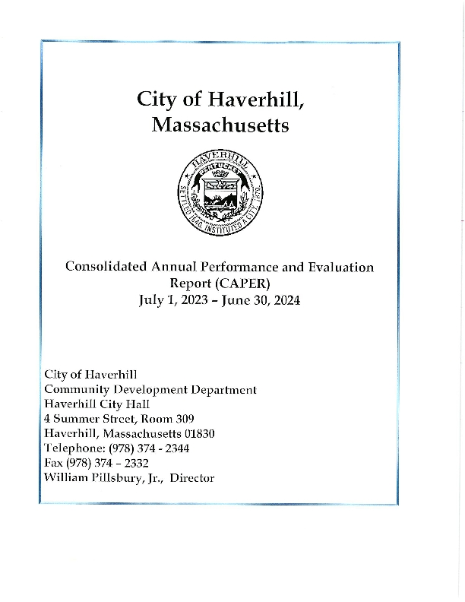
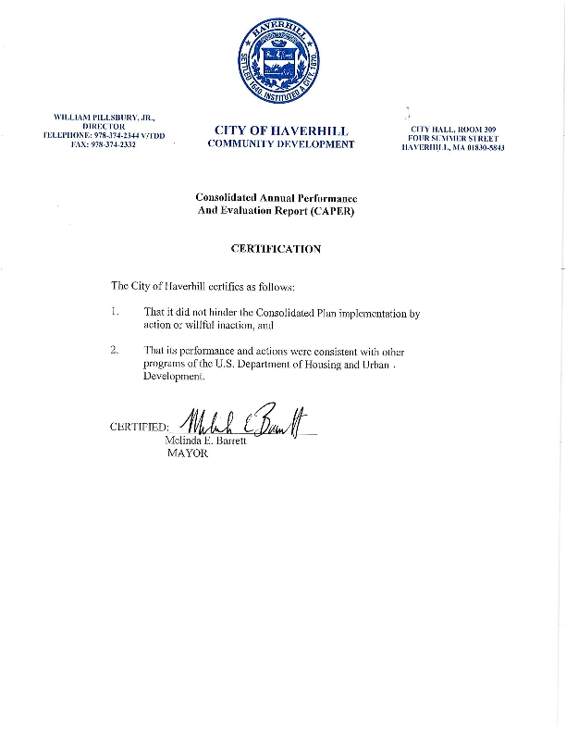
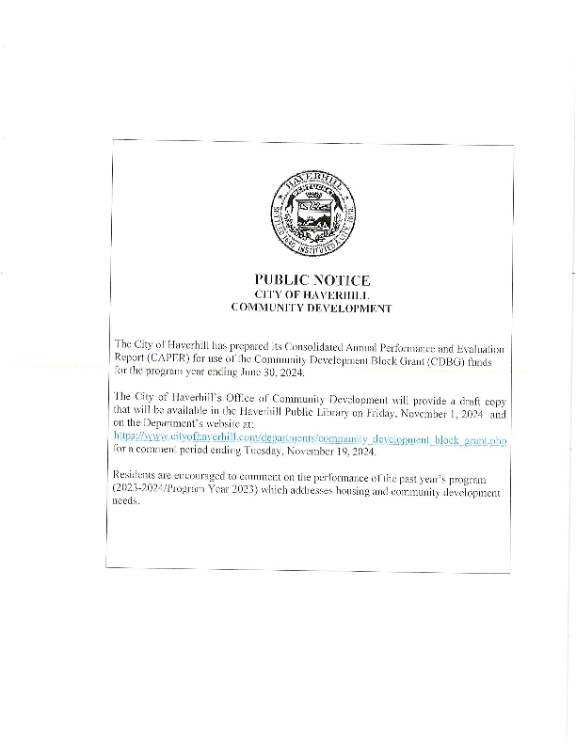
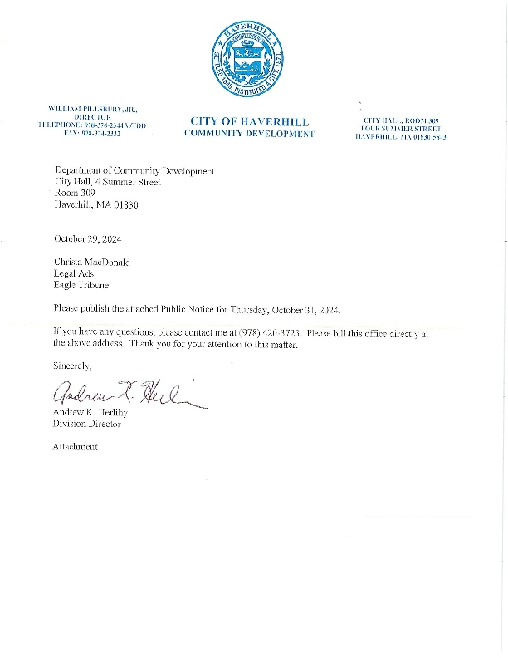

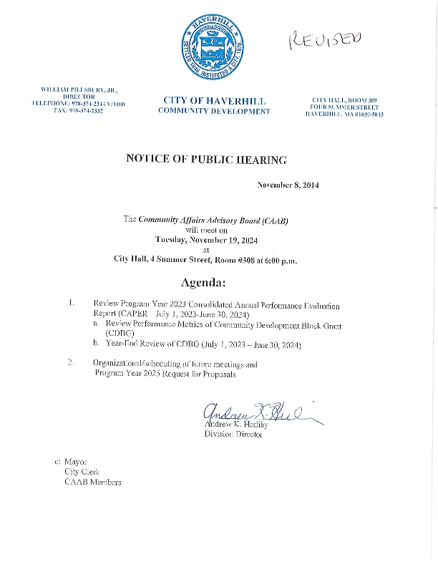
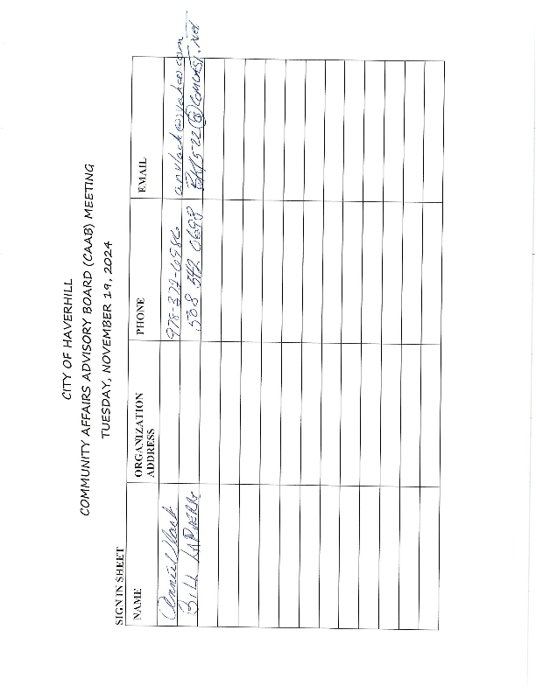
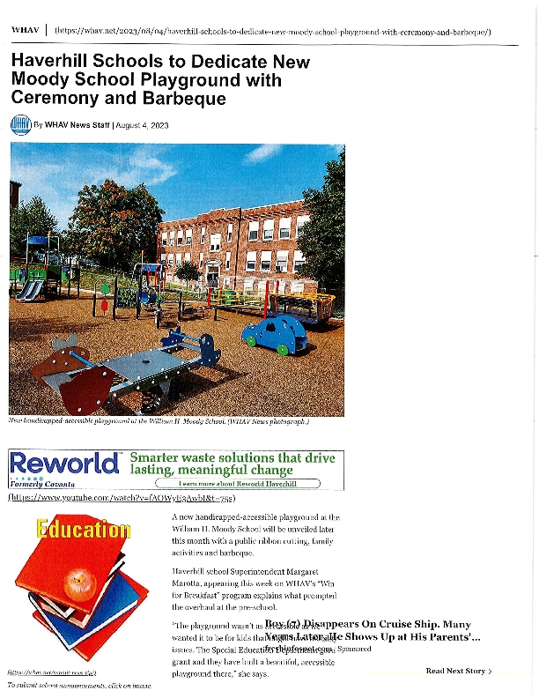

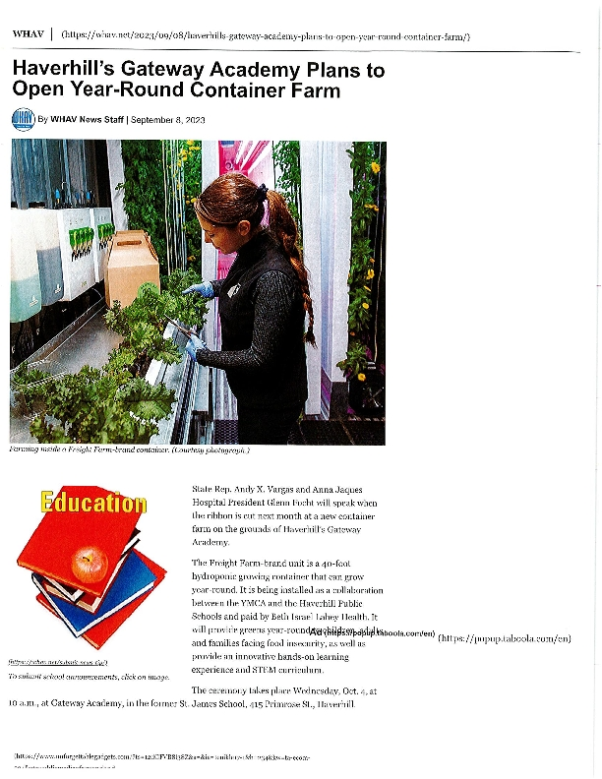
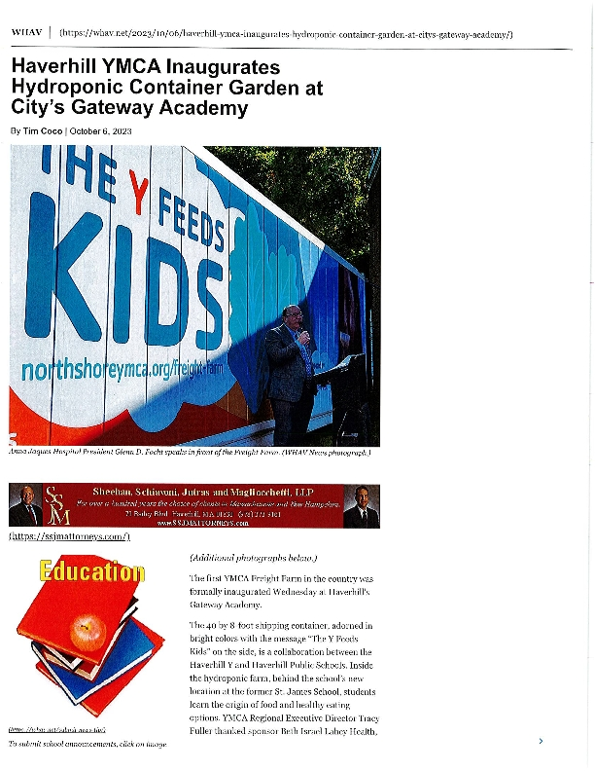
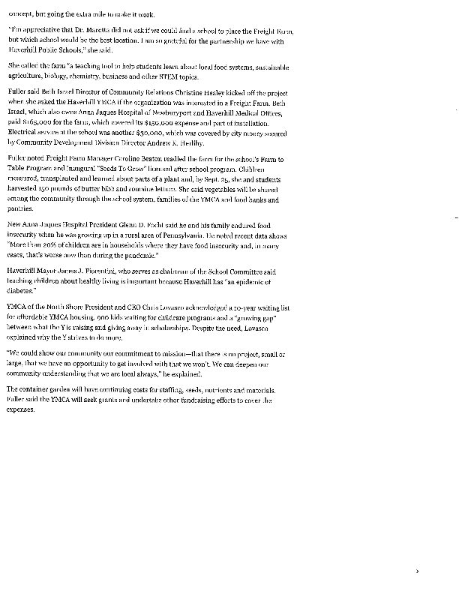
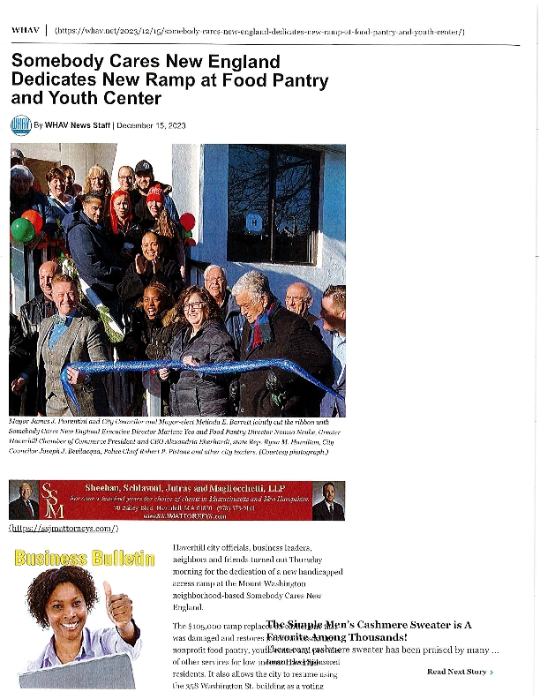
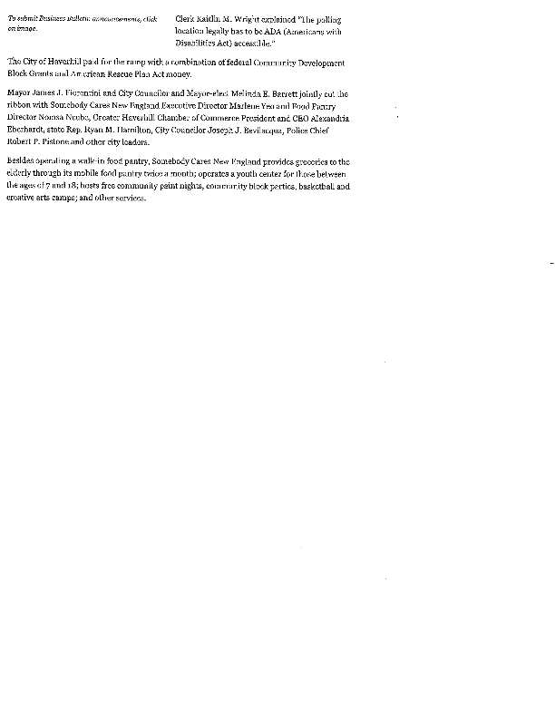
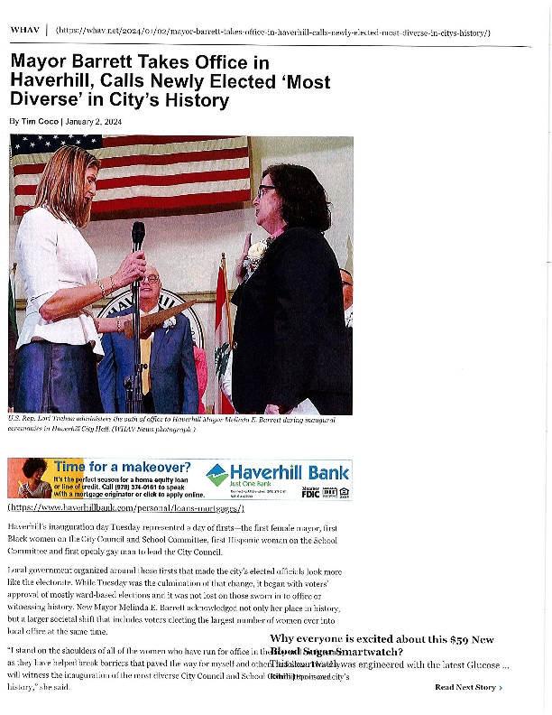
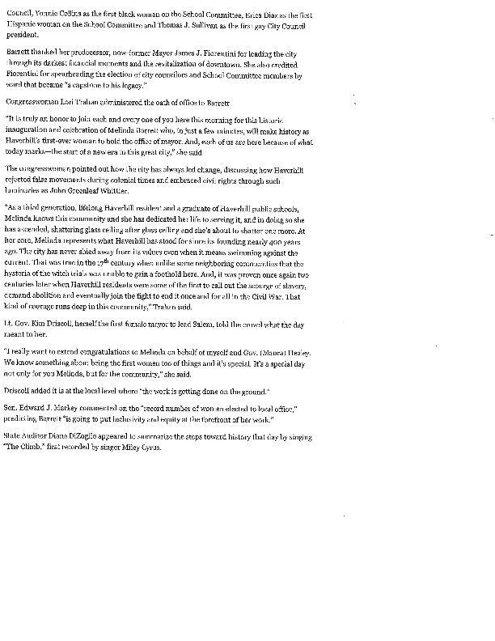
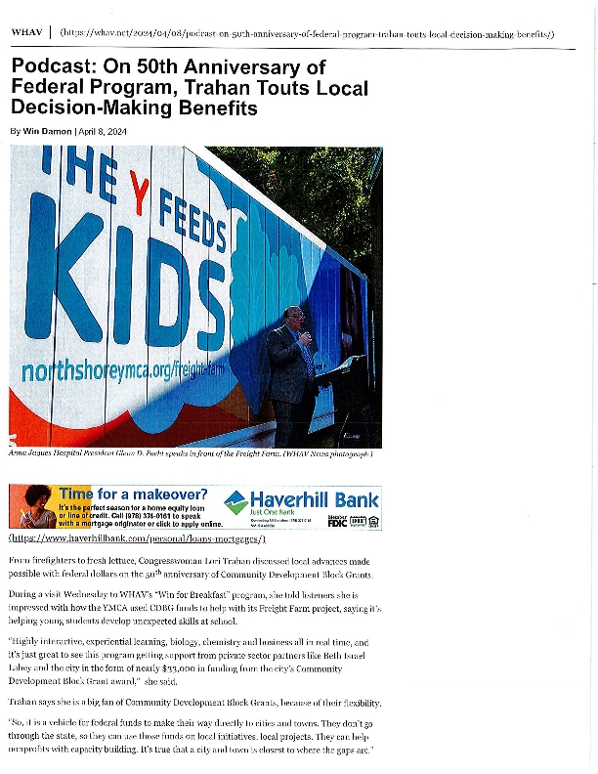
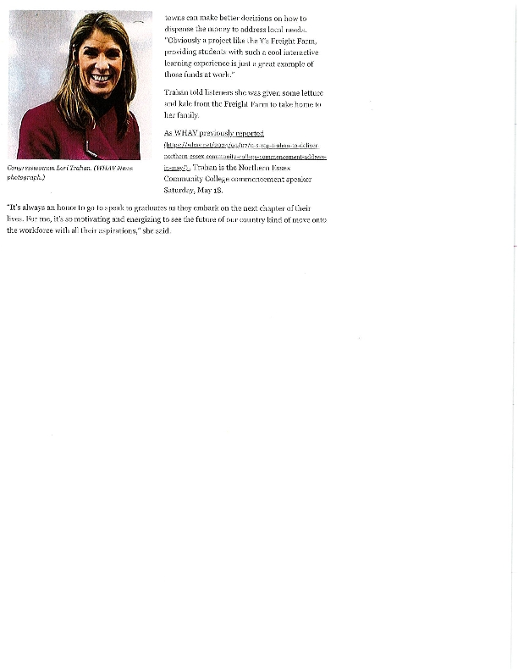
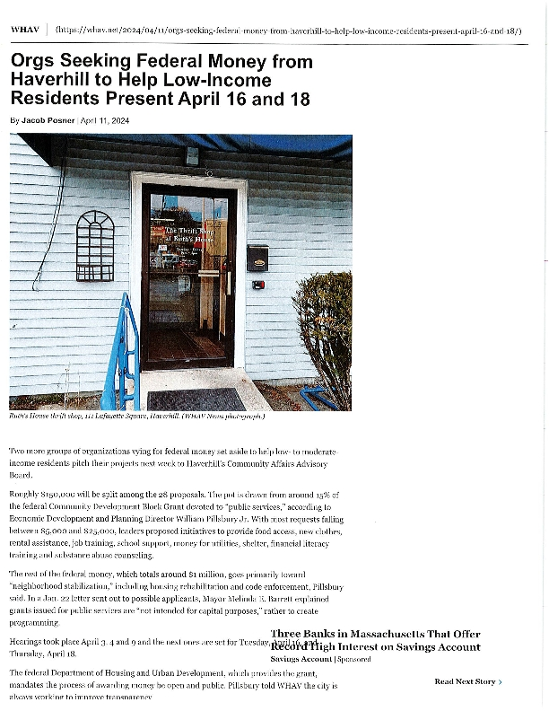
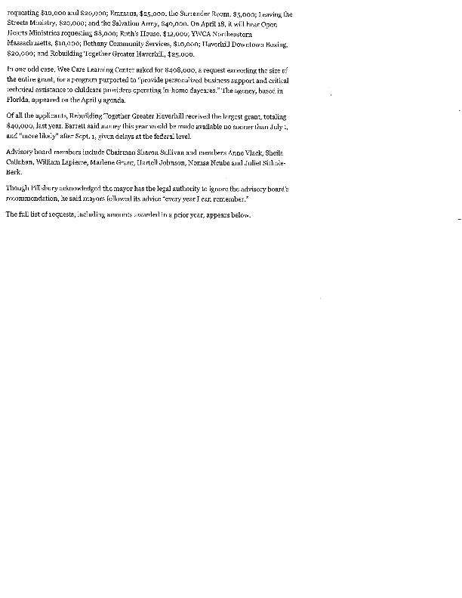
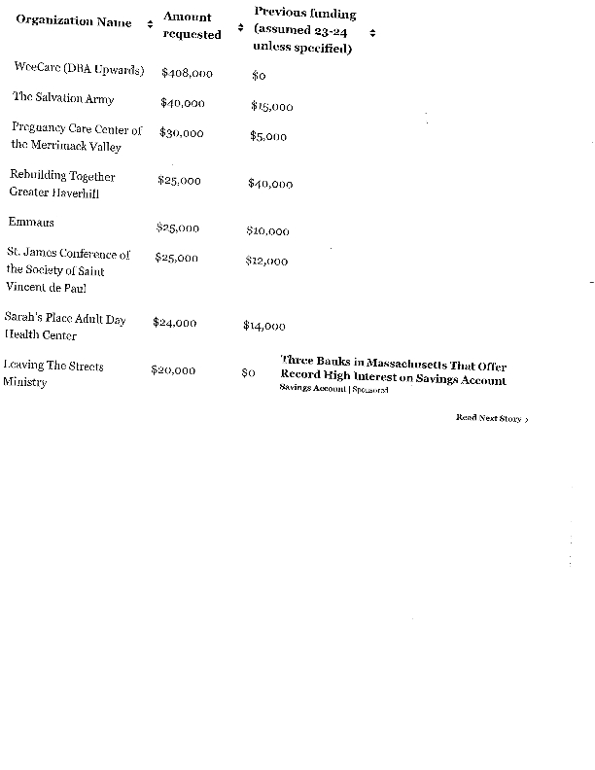
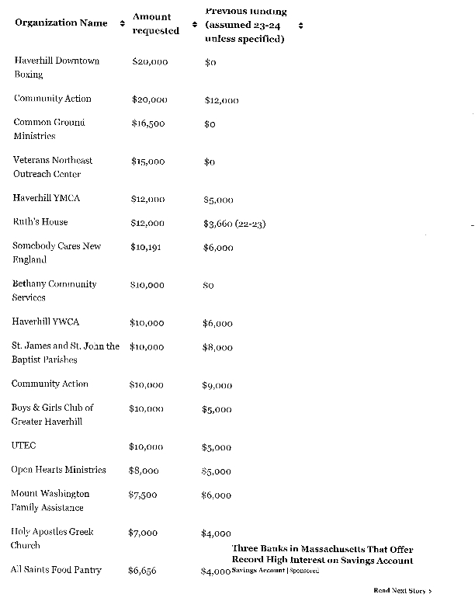
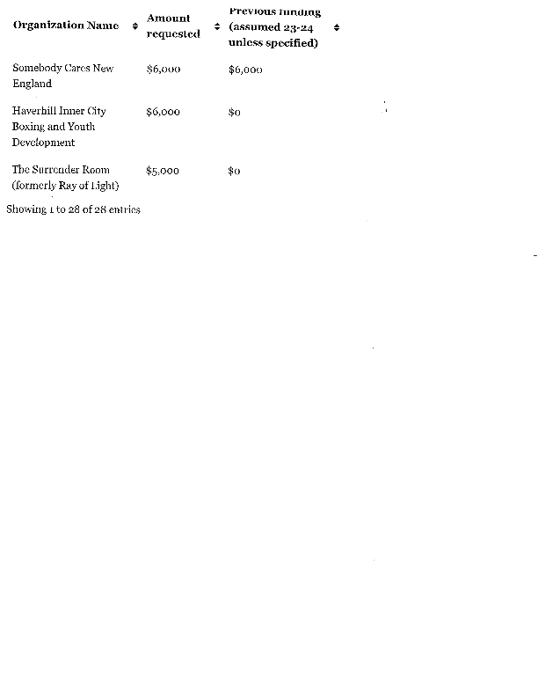
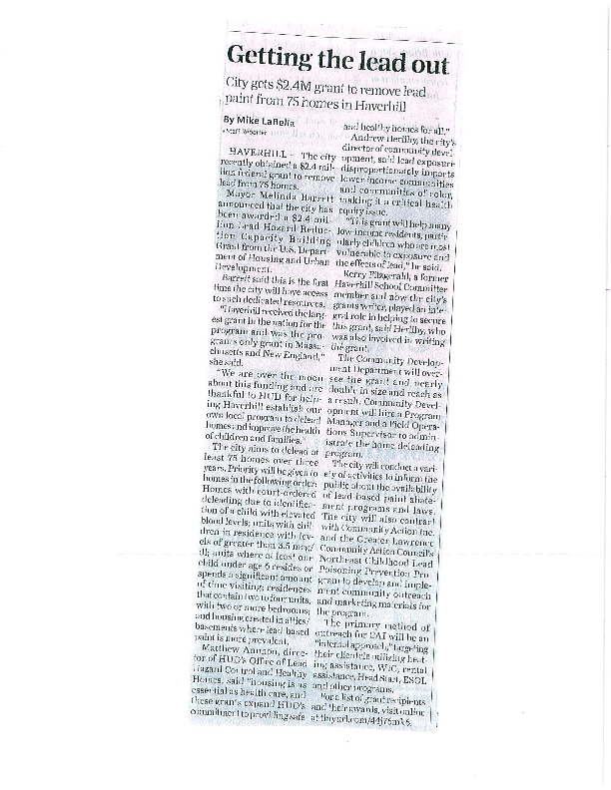
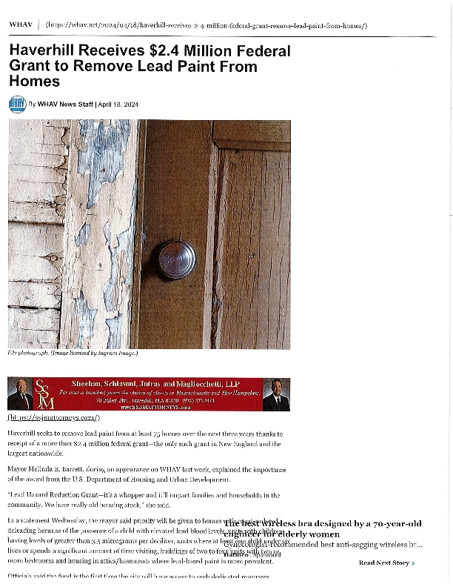

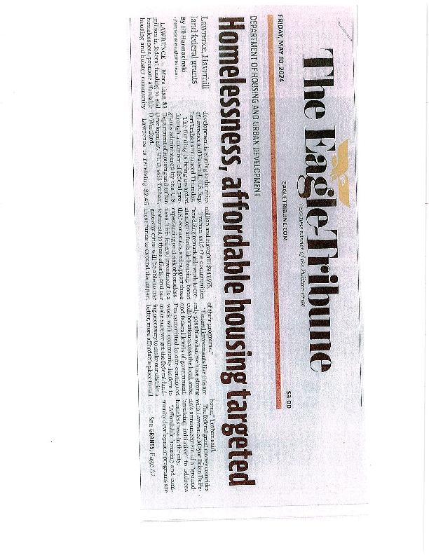

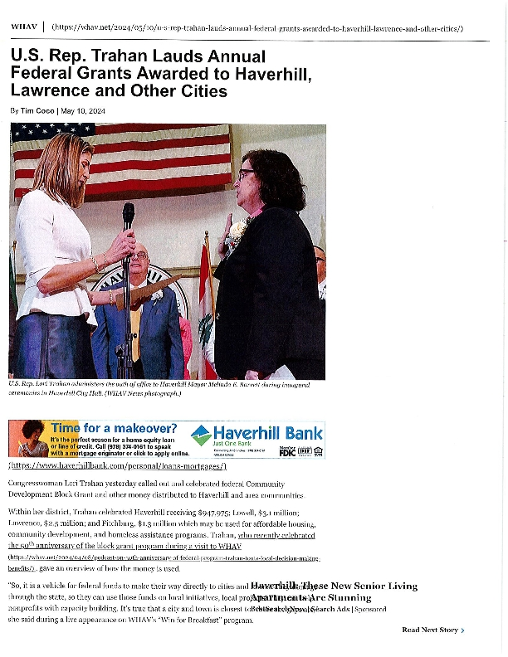
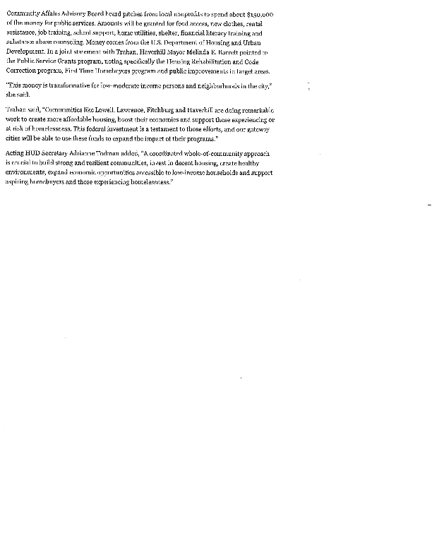
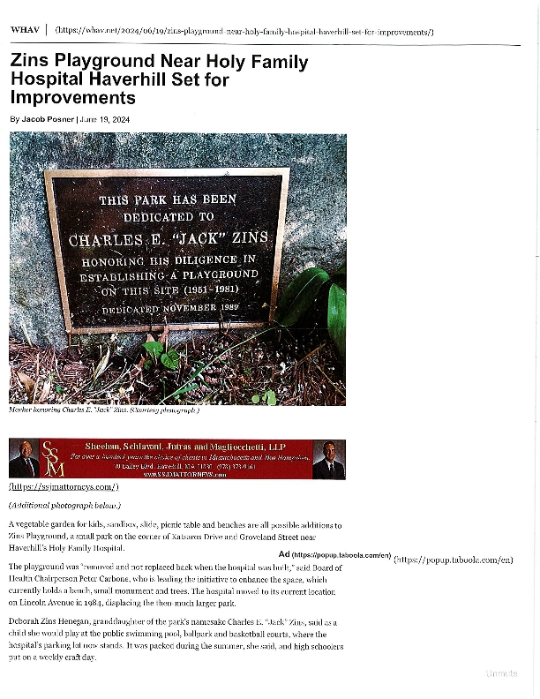
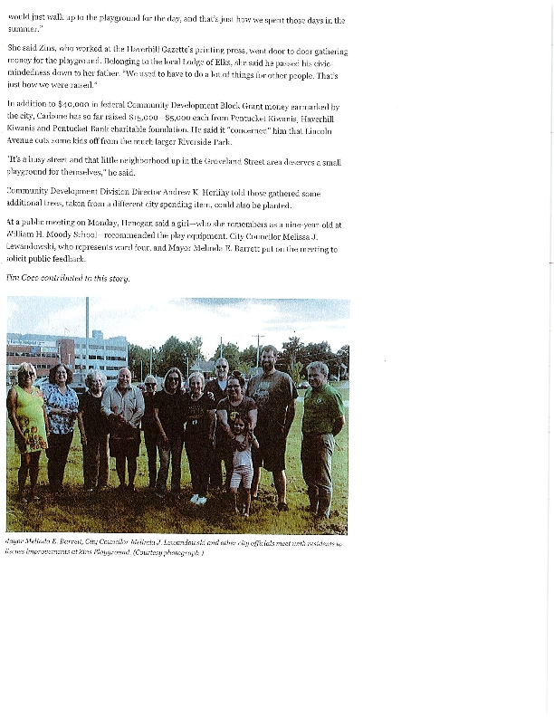
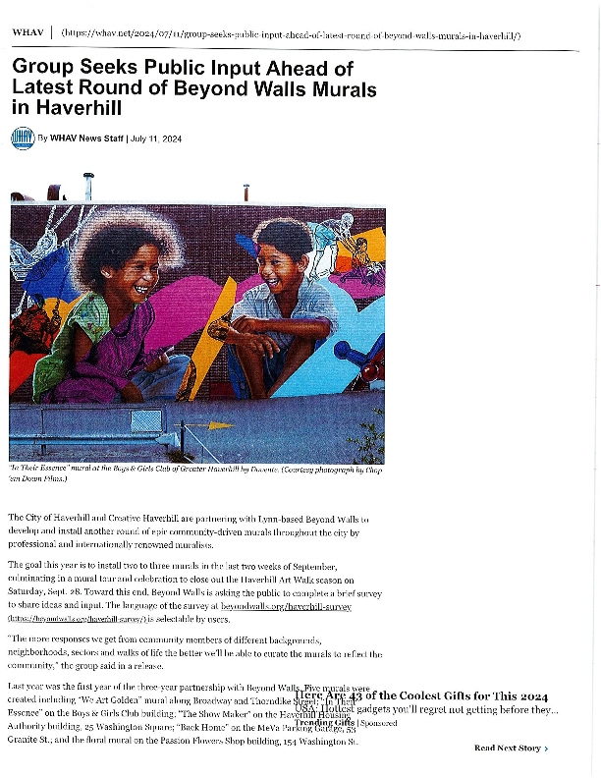
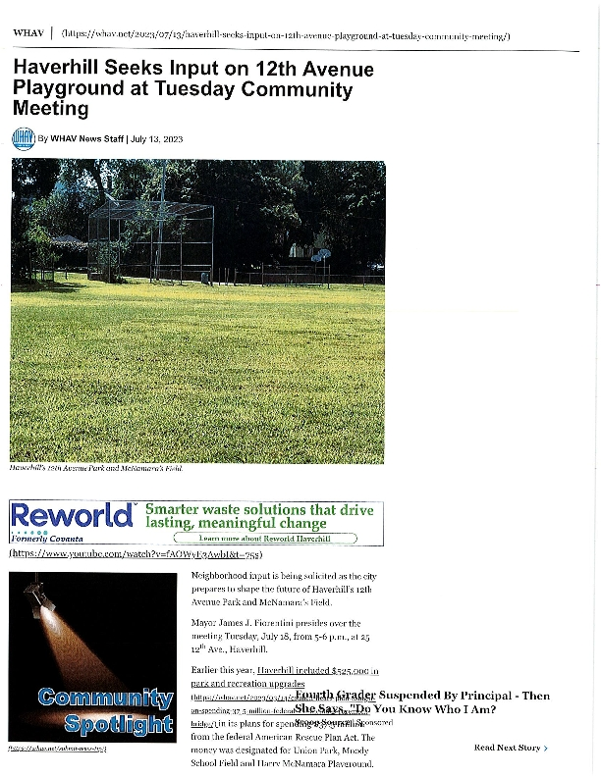
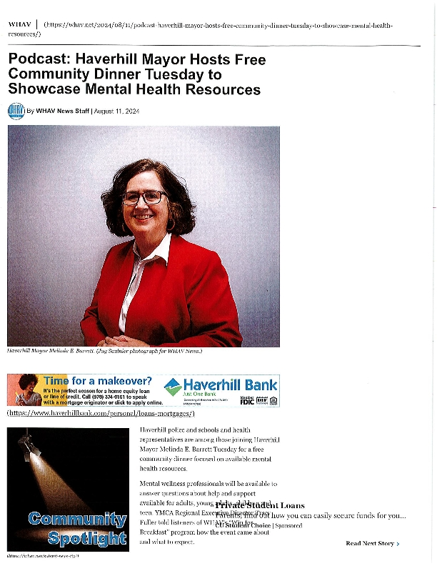
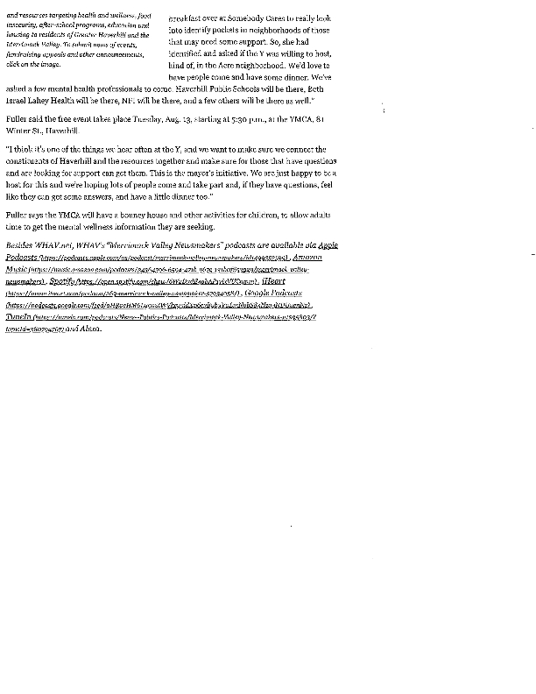
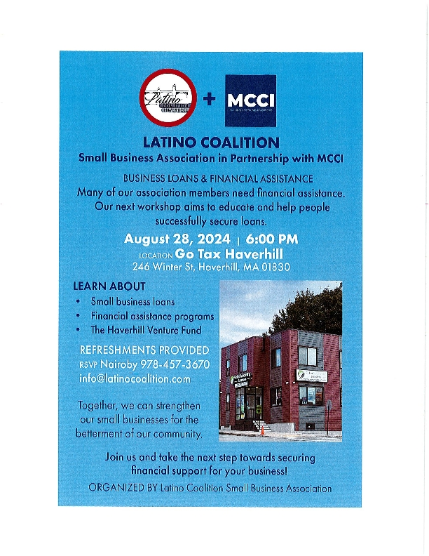
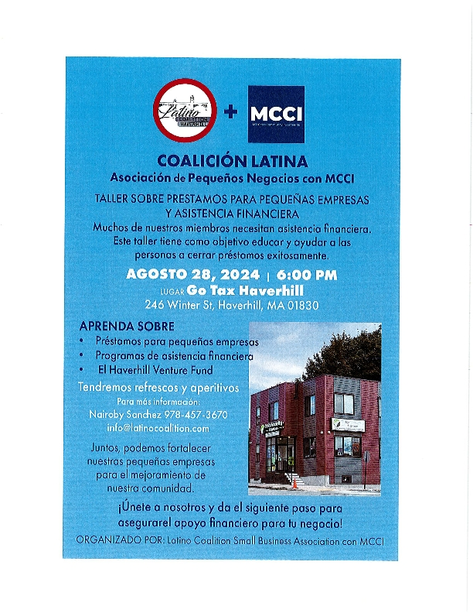
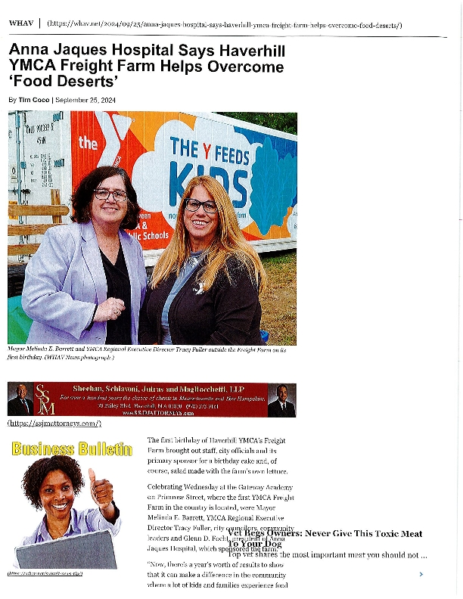
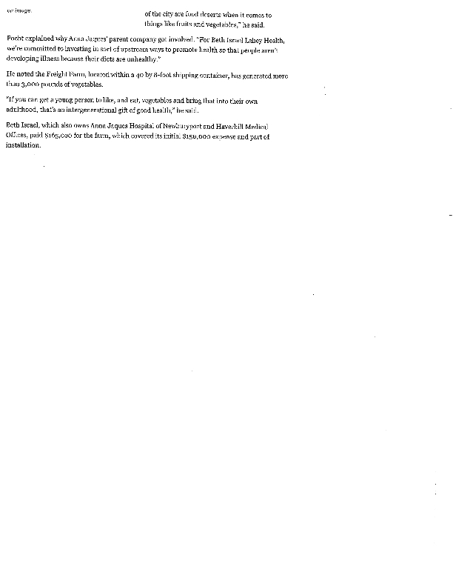
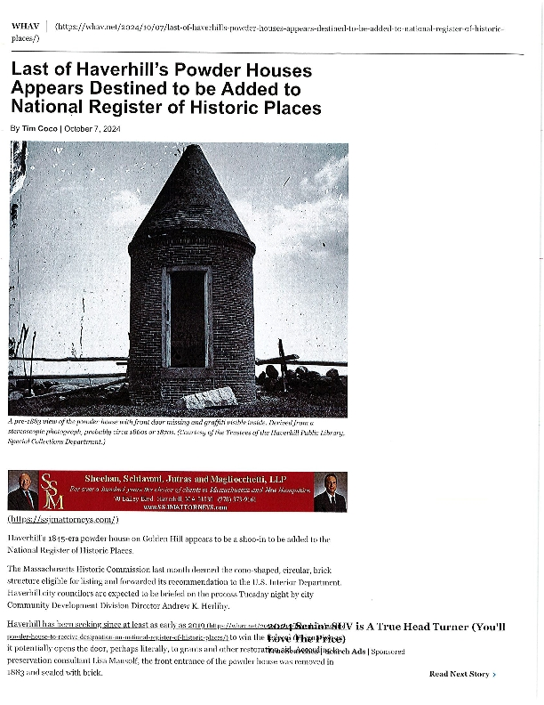
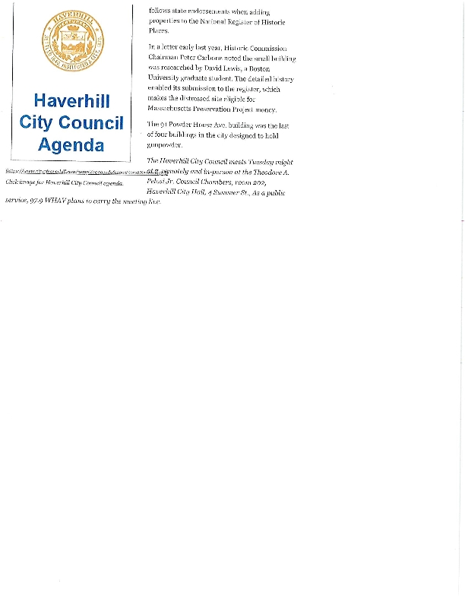
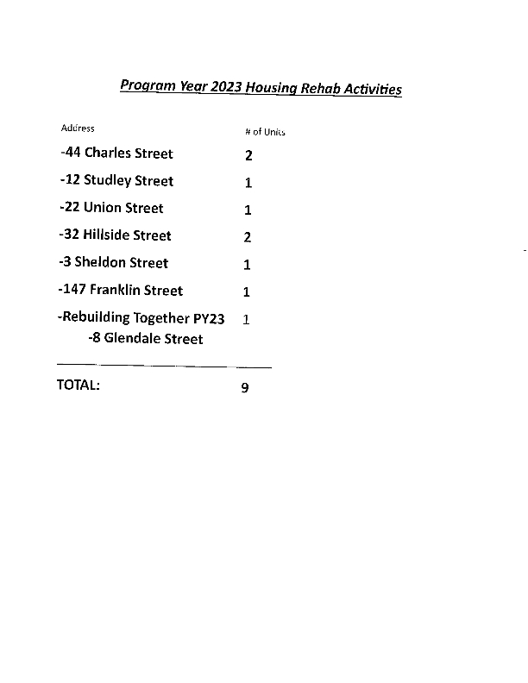
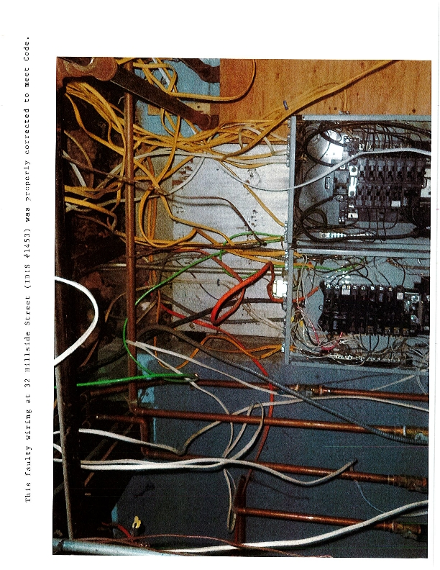
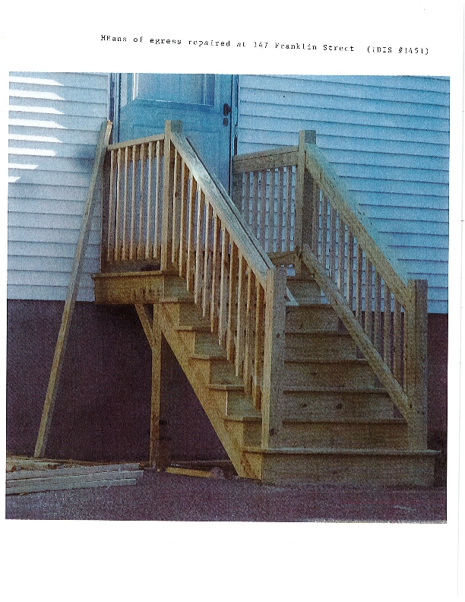
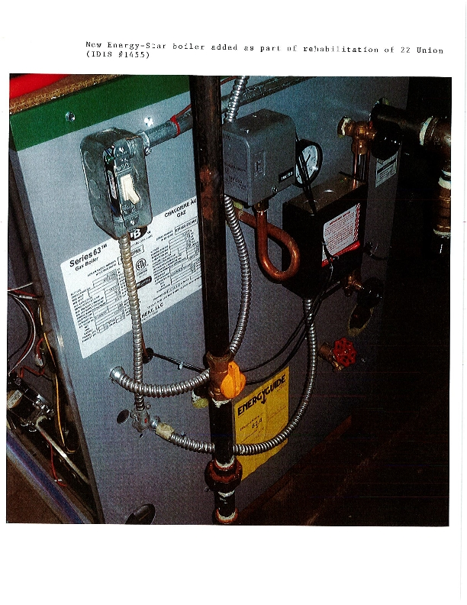
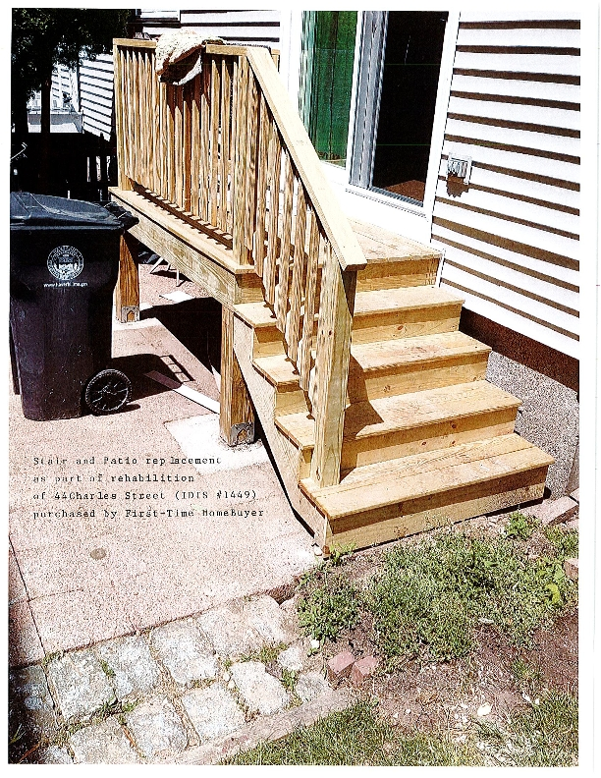

PY2023 CAPER Reports
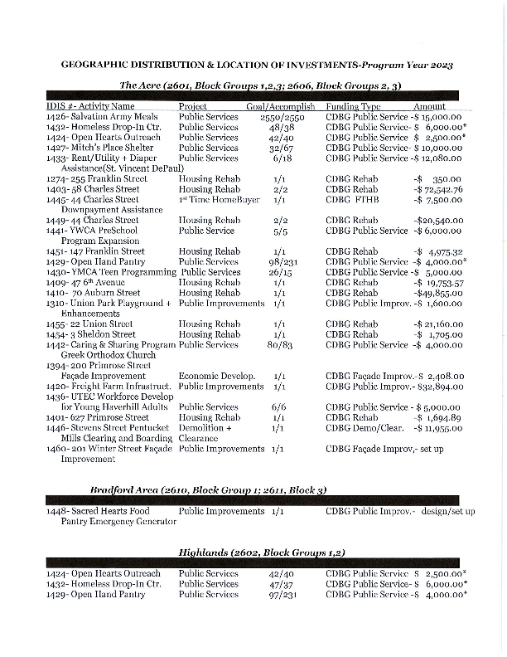
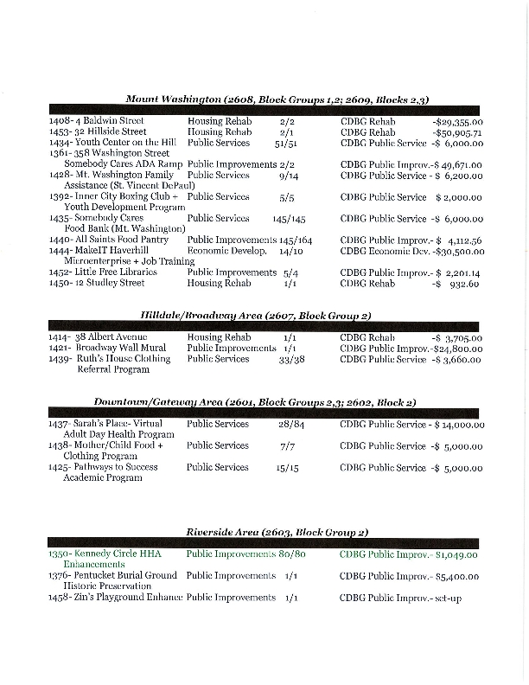
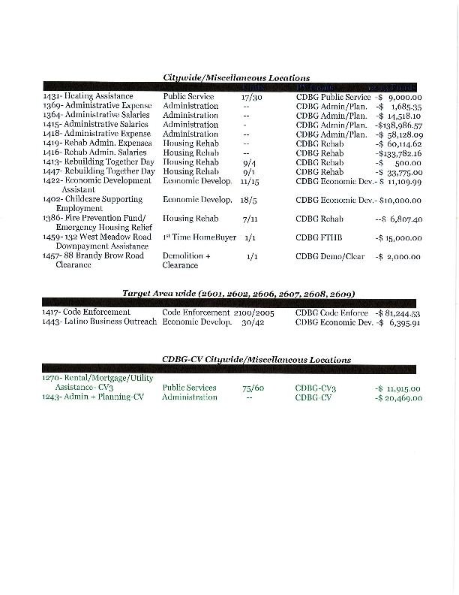
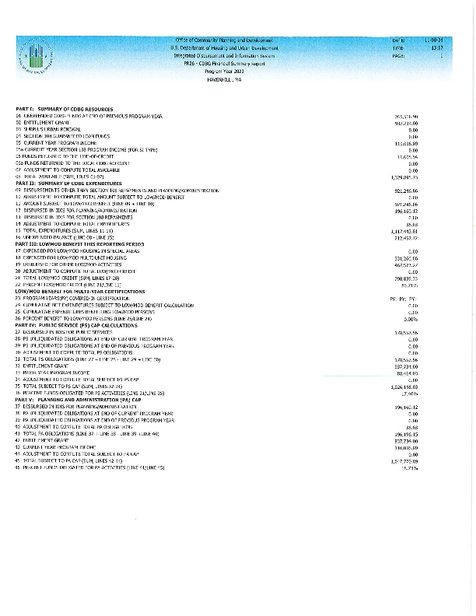
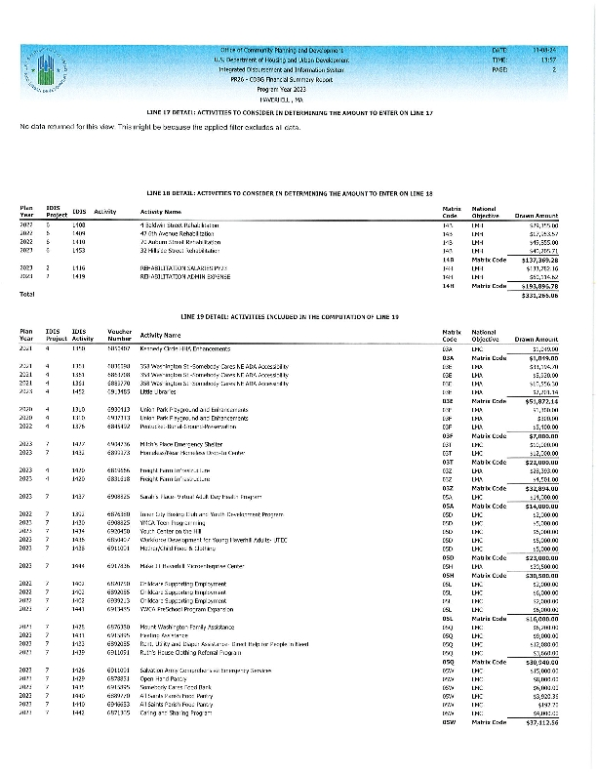
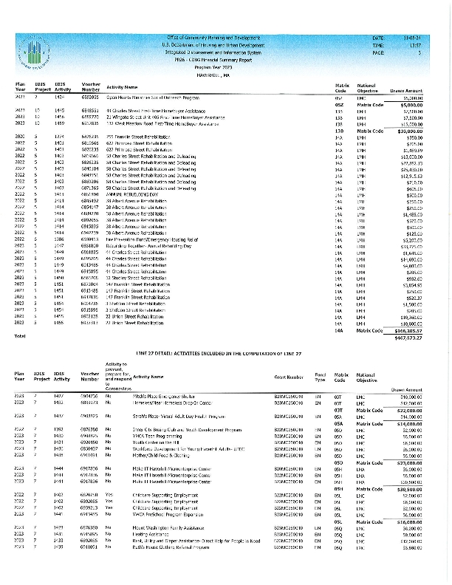
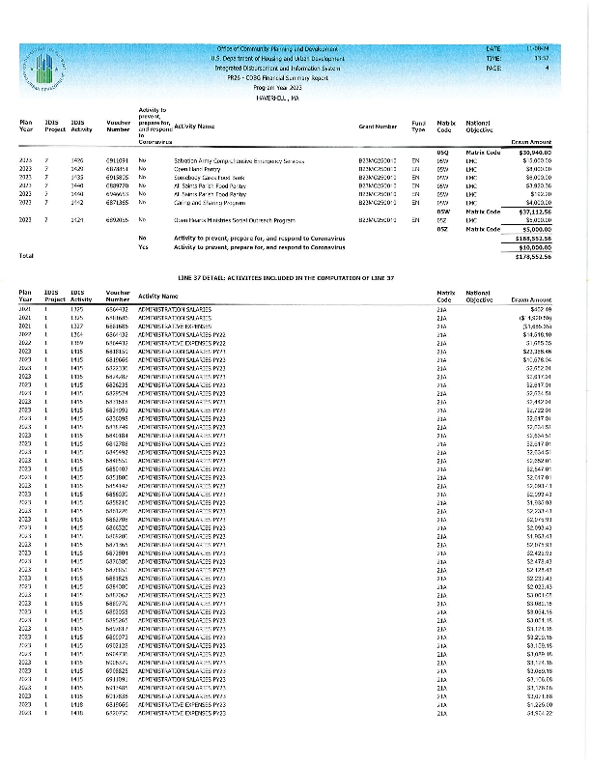
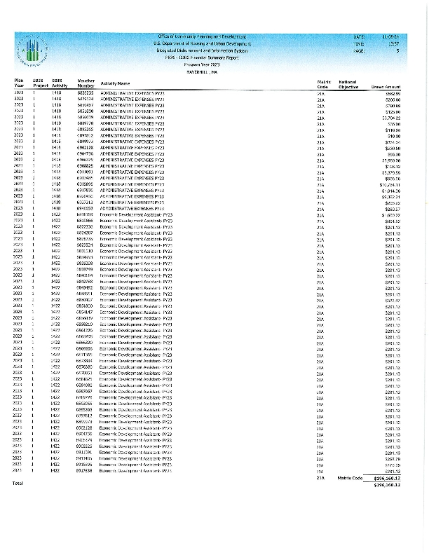
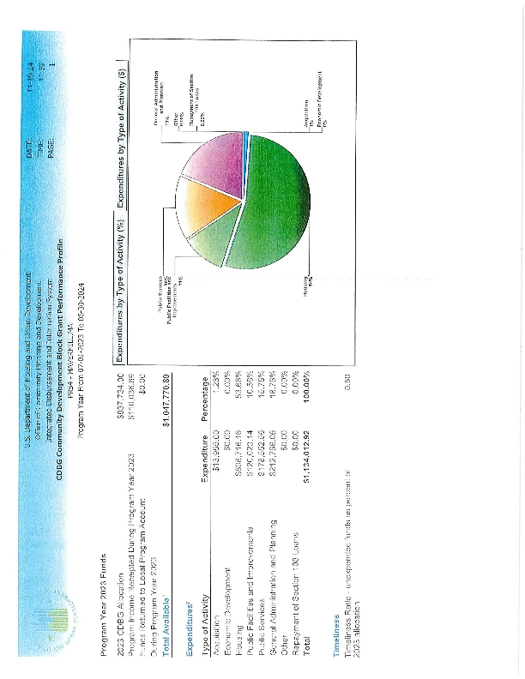
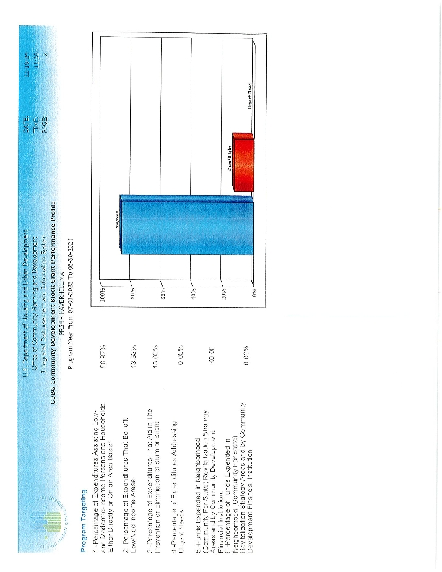
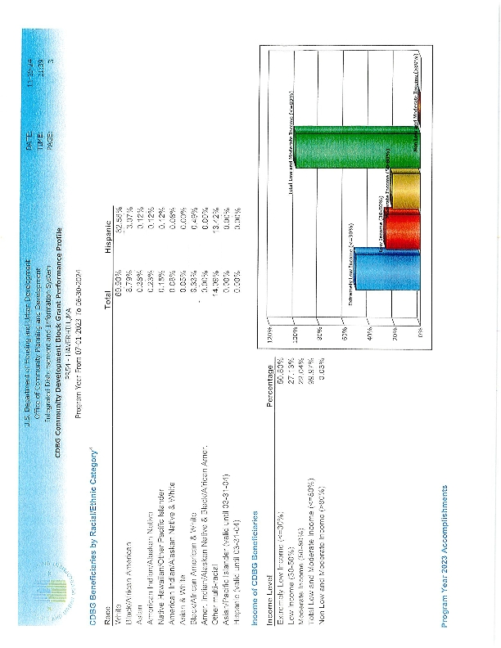
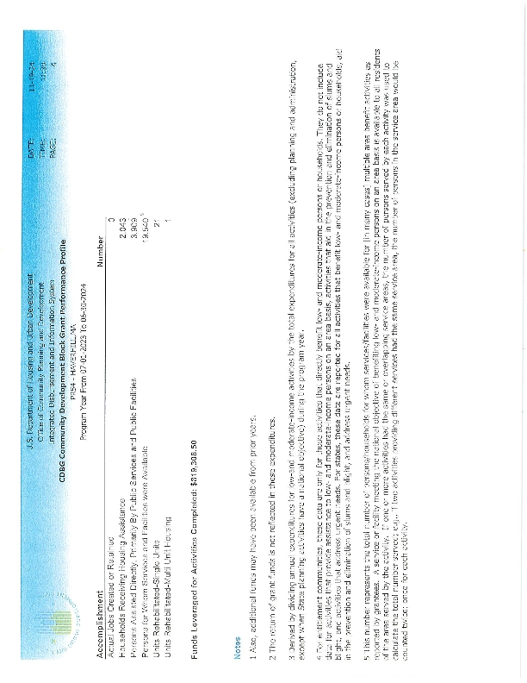
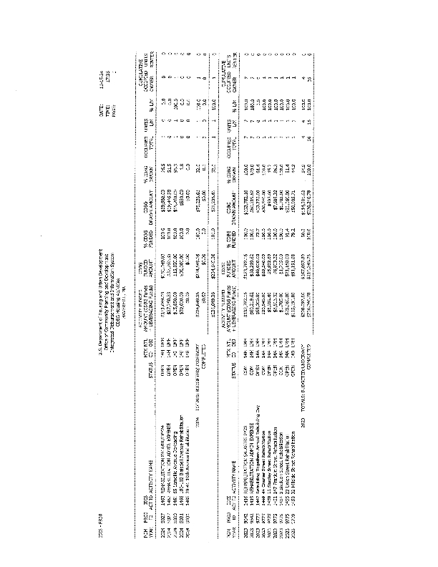
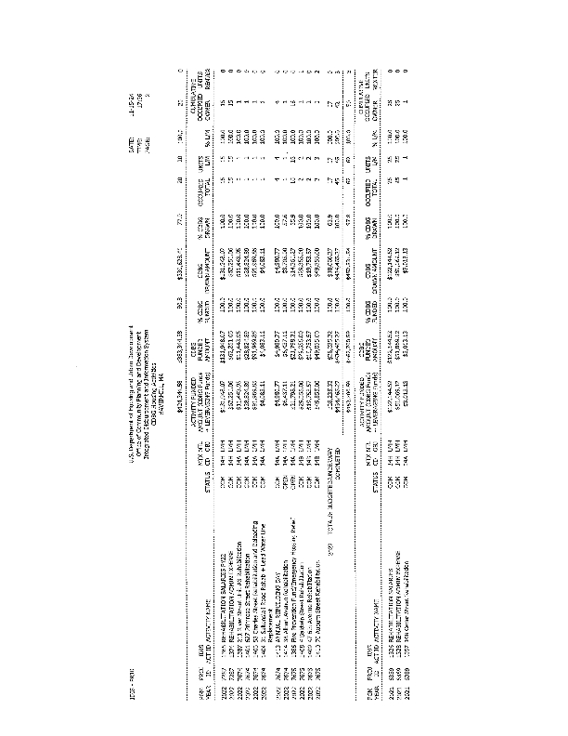
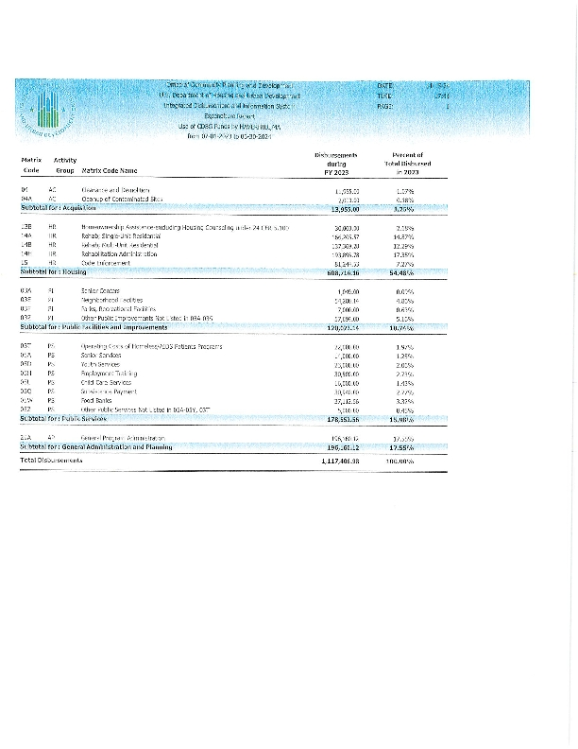
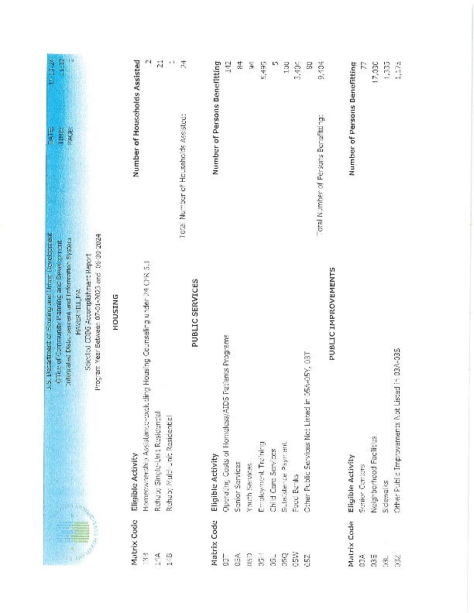
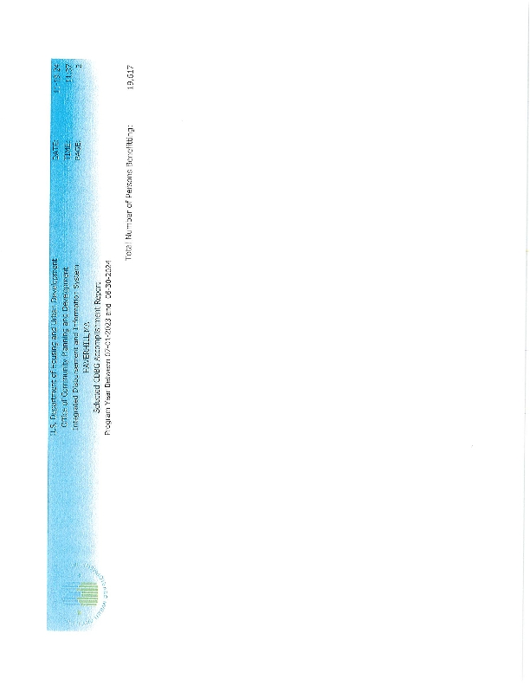
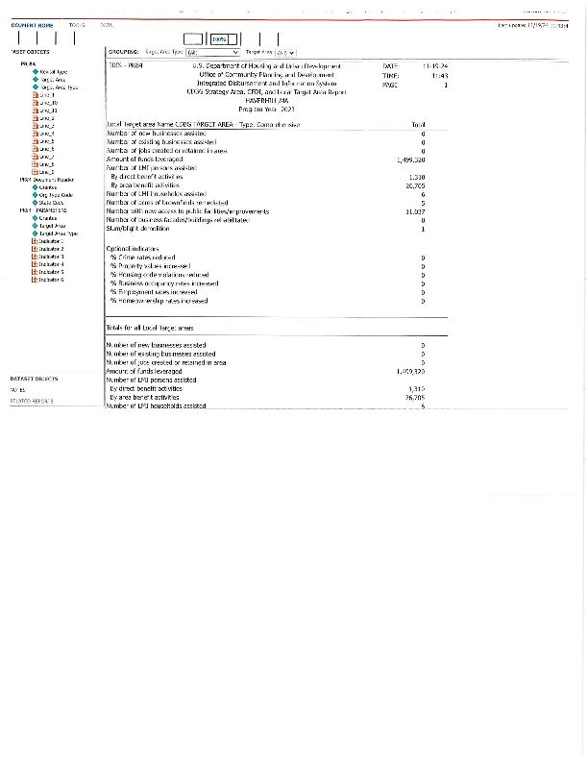
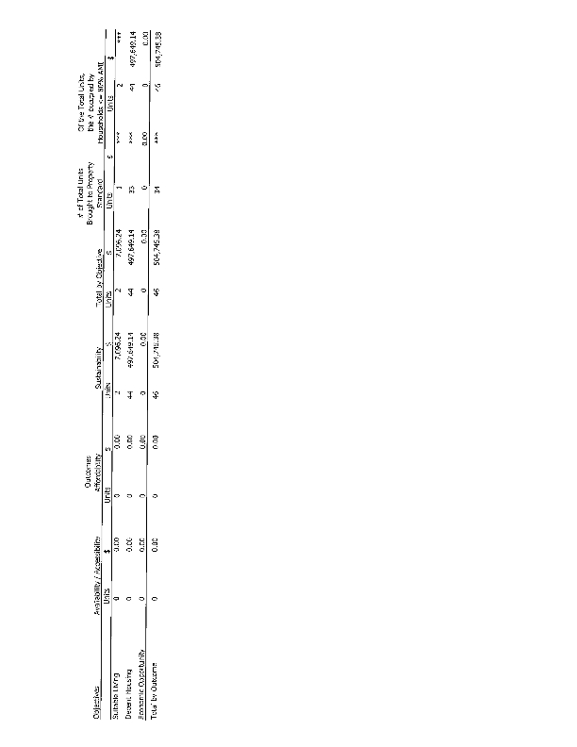
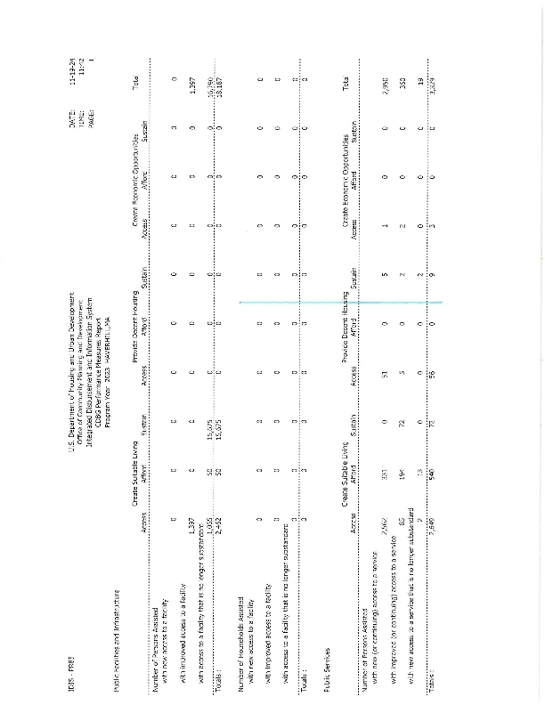
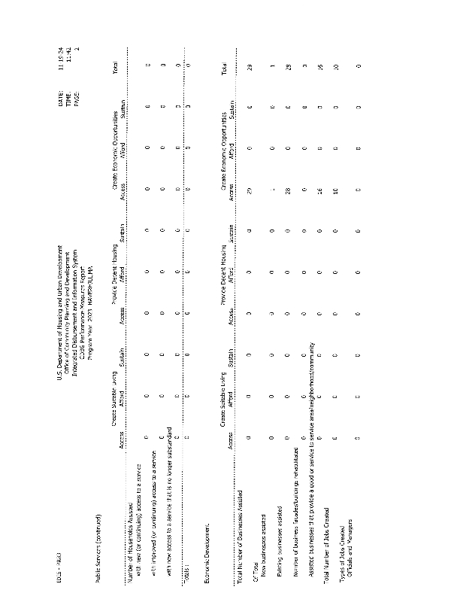
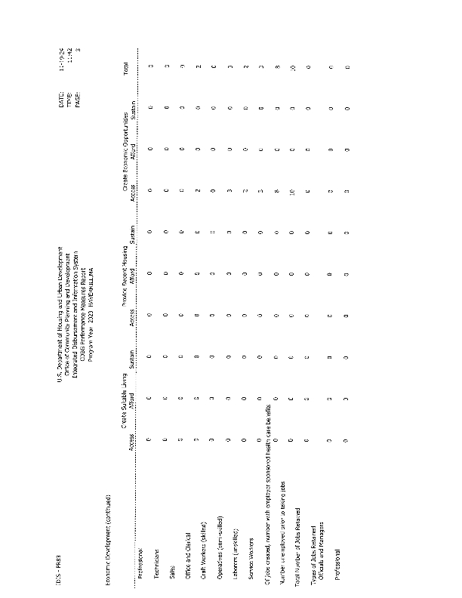
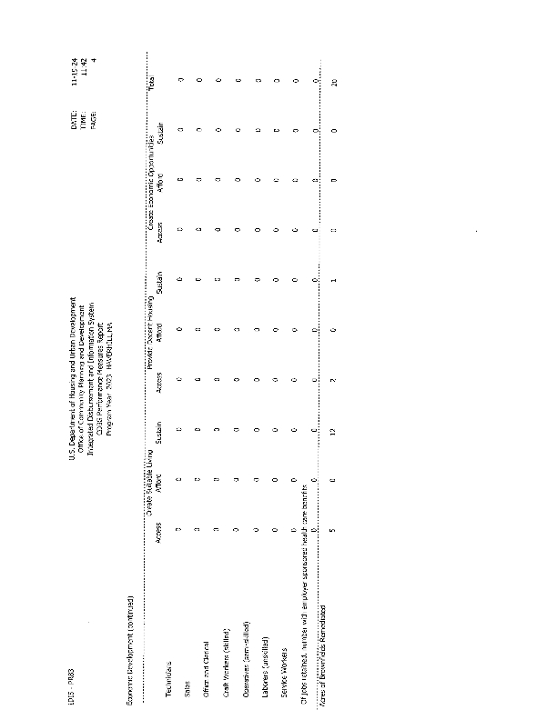
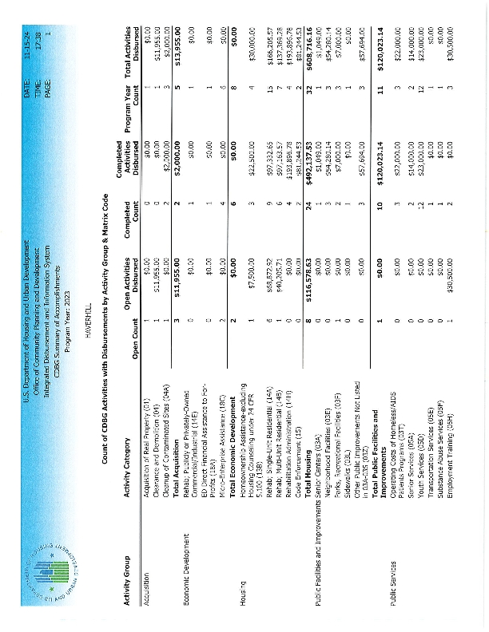
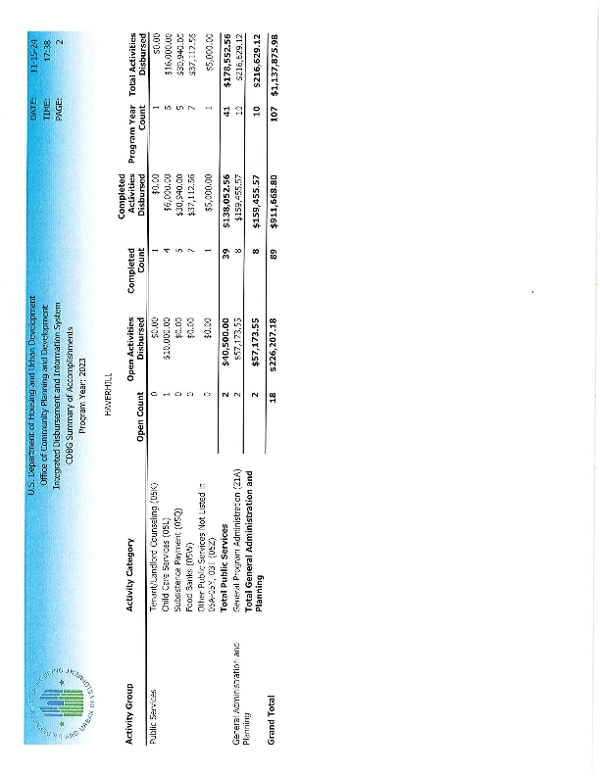
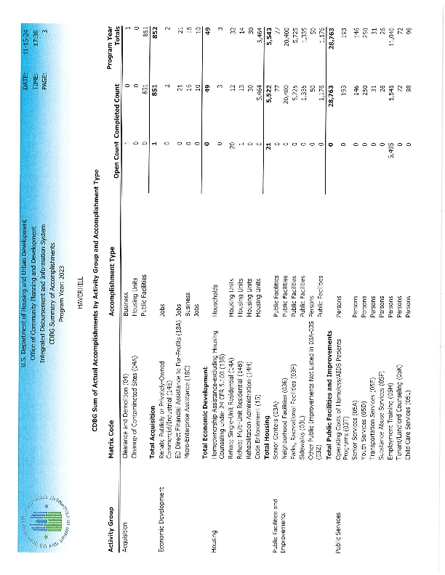
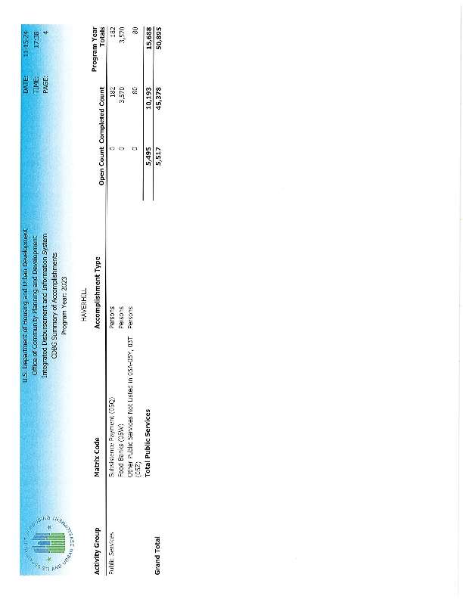
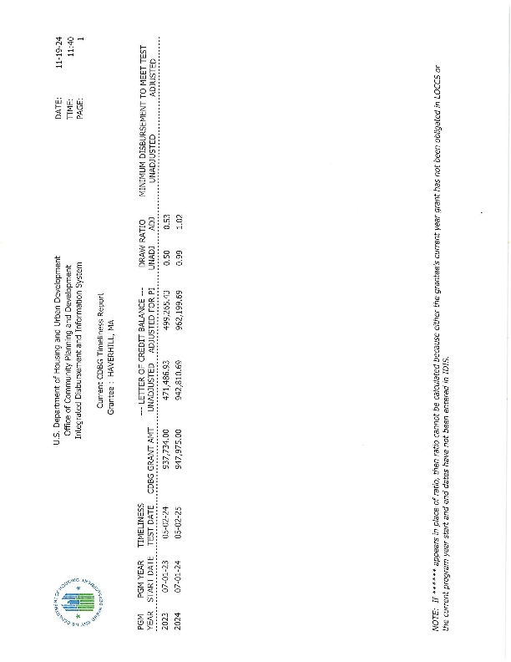
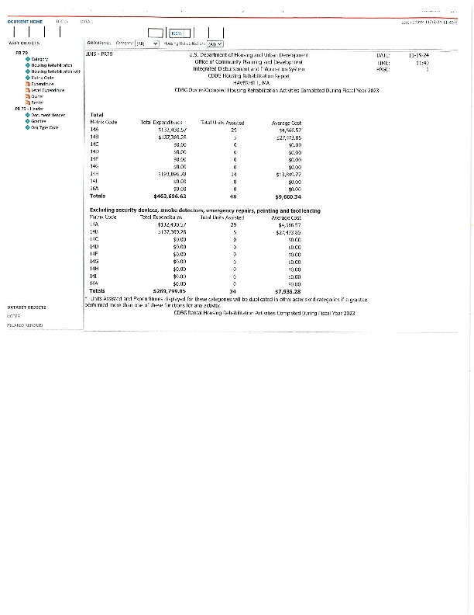
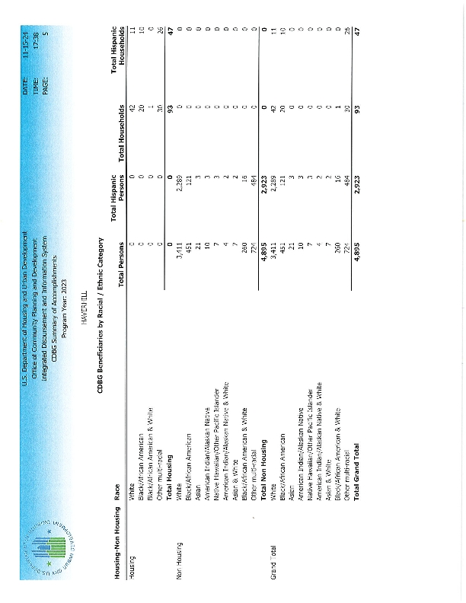
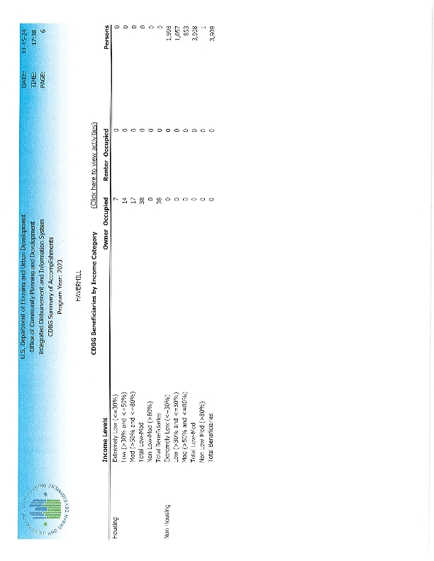

PY2023 CDBG Subrecipient Accomplishments + Leveraging Highlights
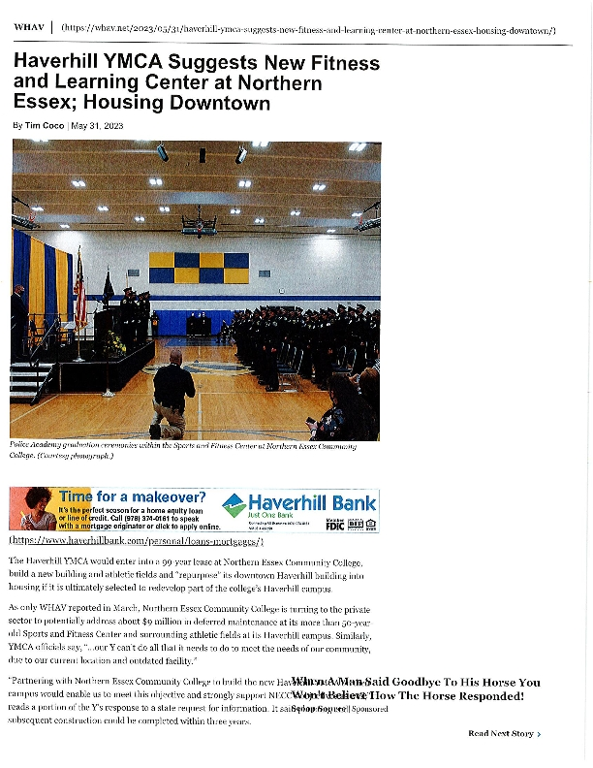
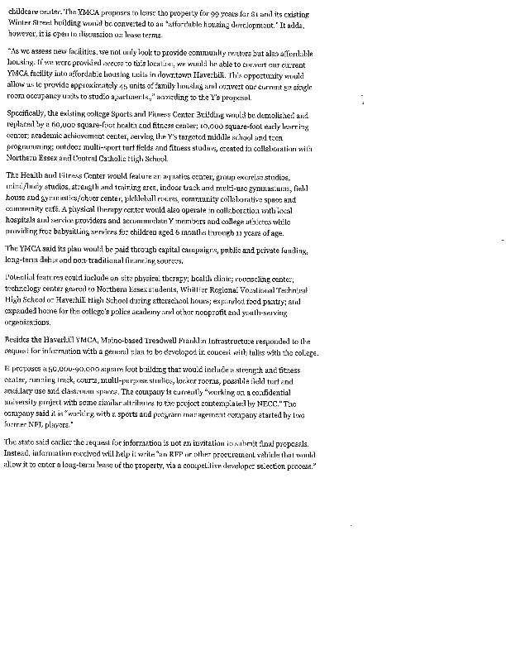
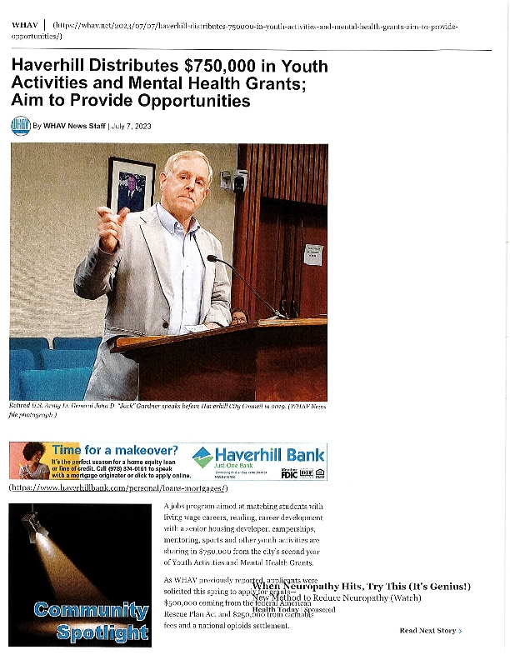
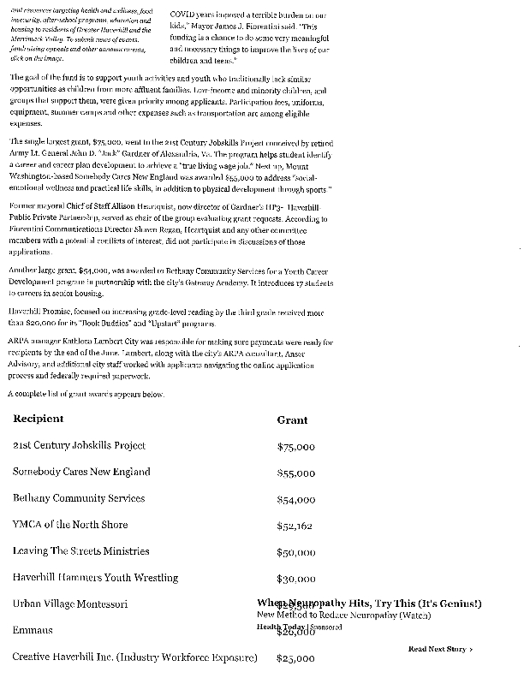
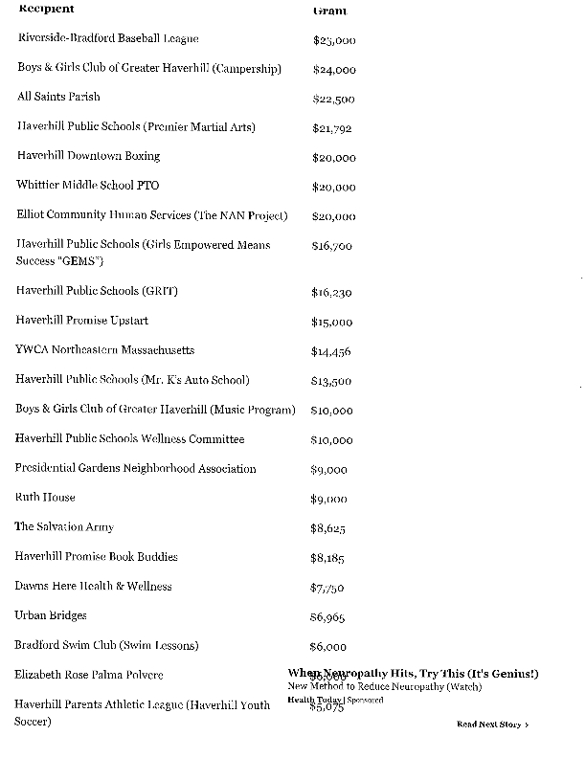
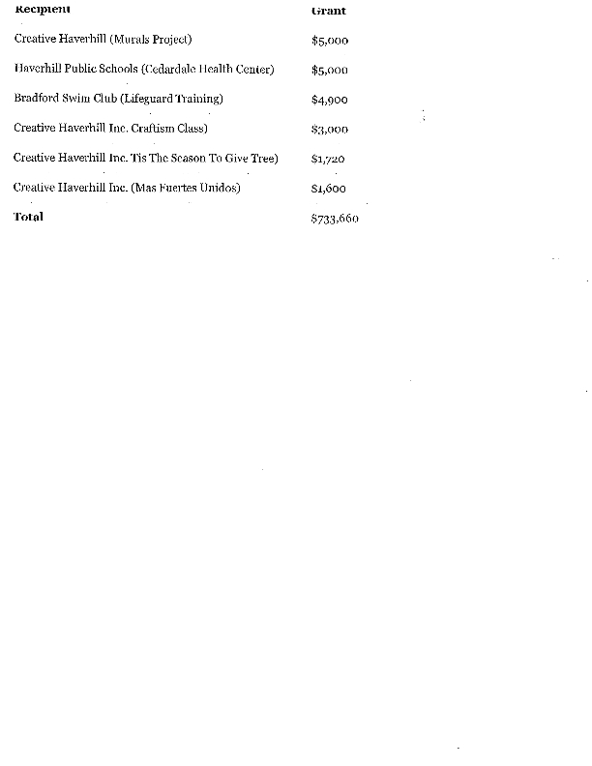
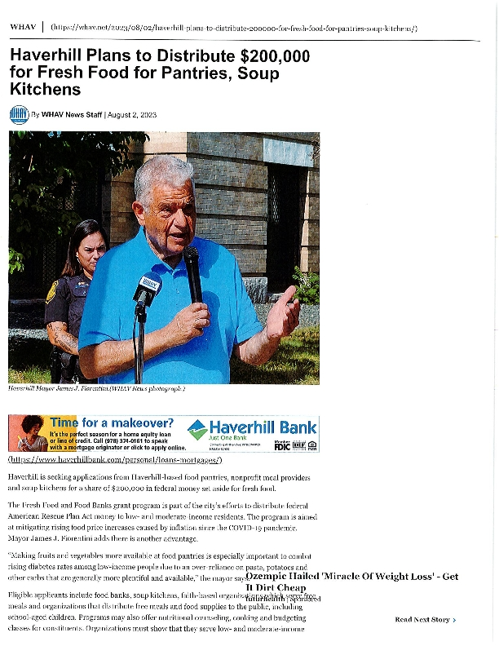

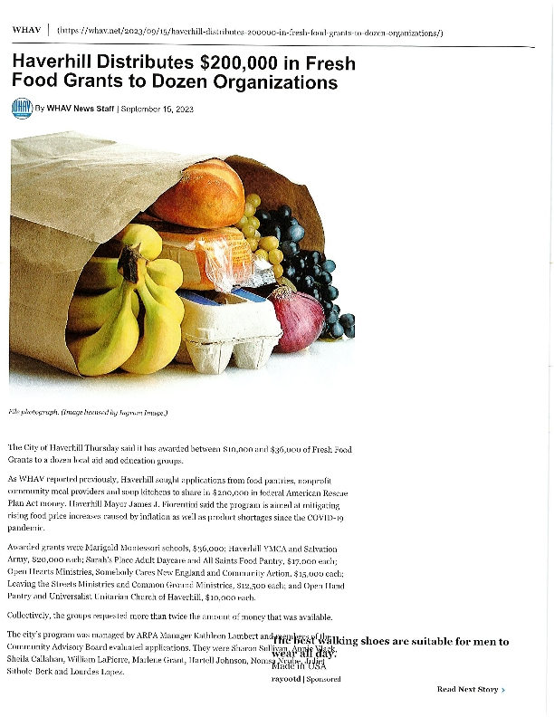
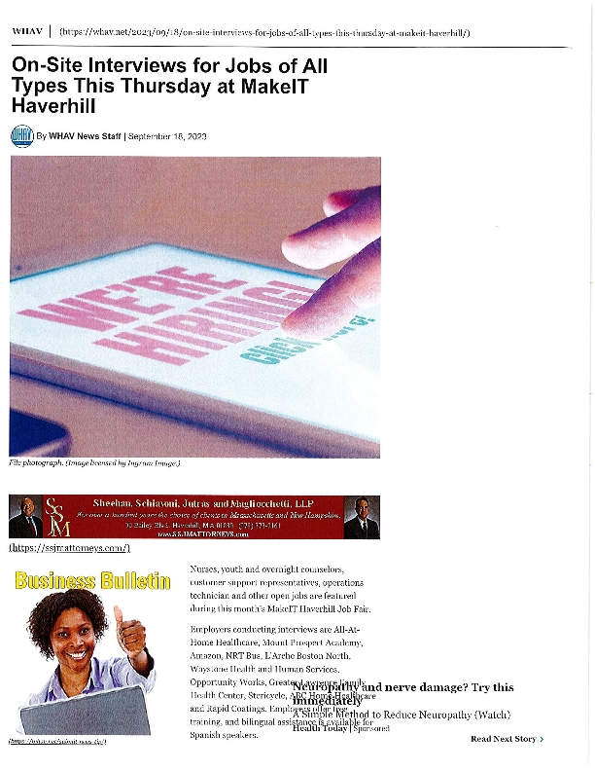
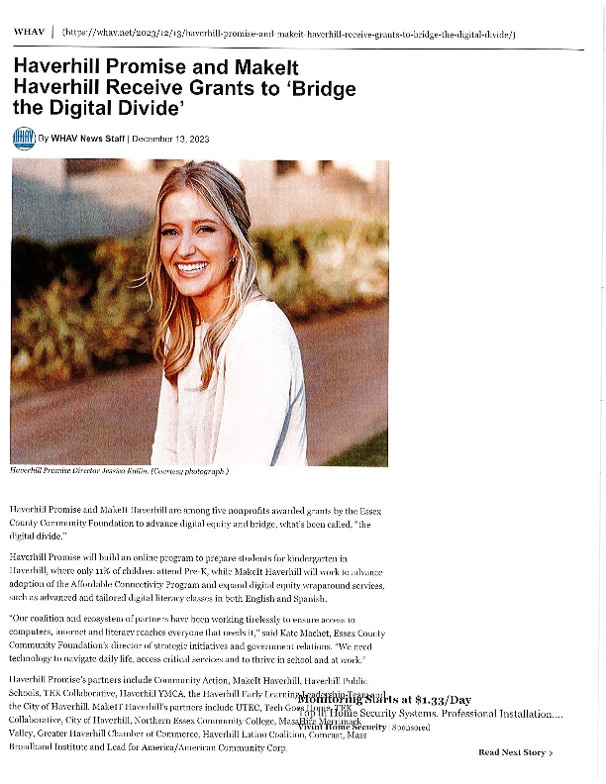
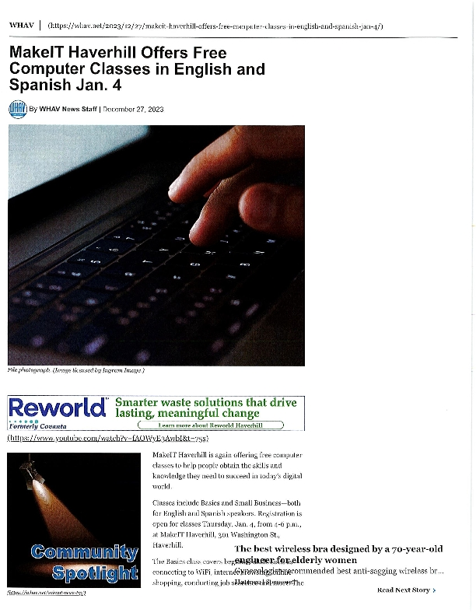
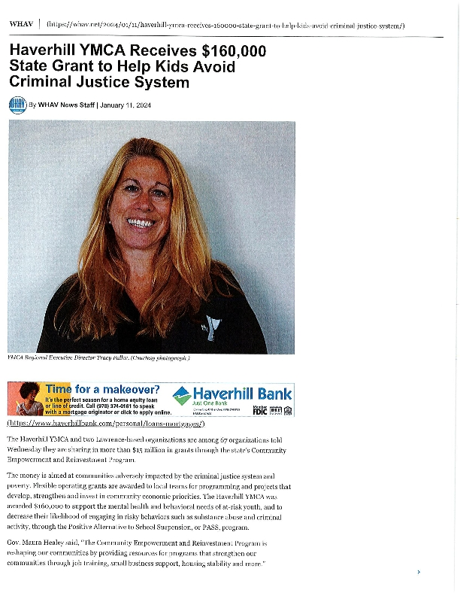
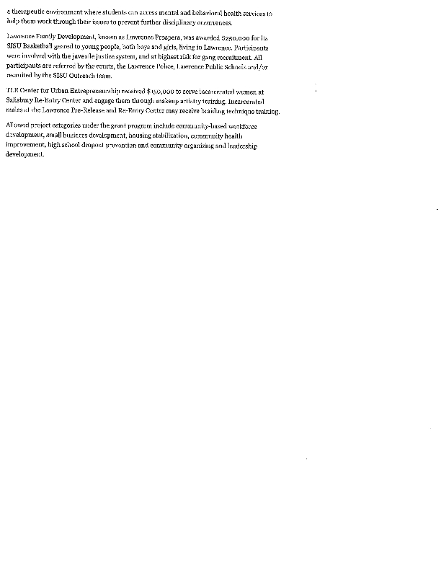
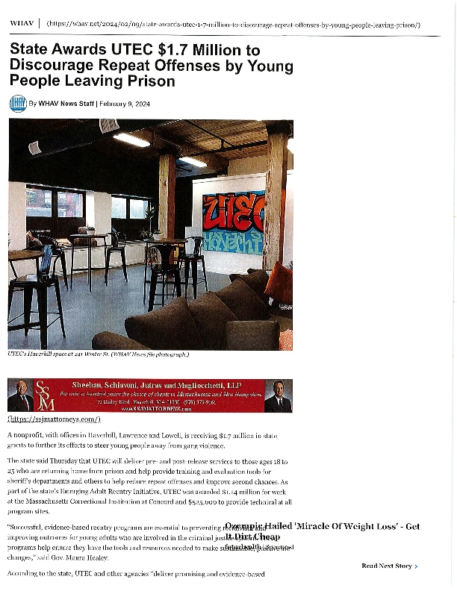

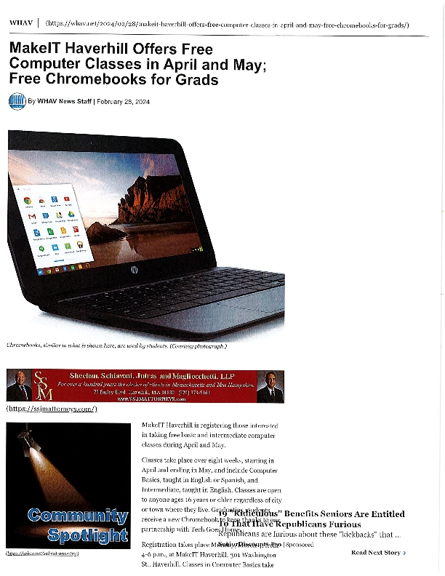
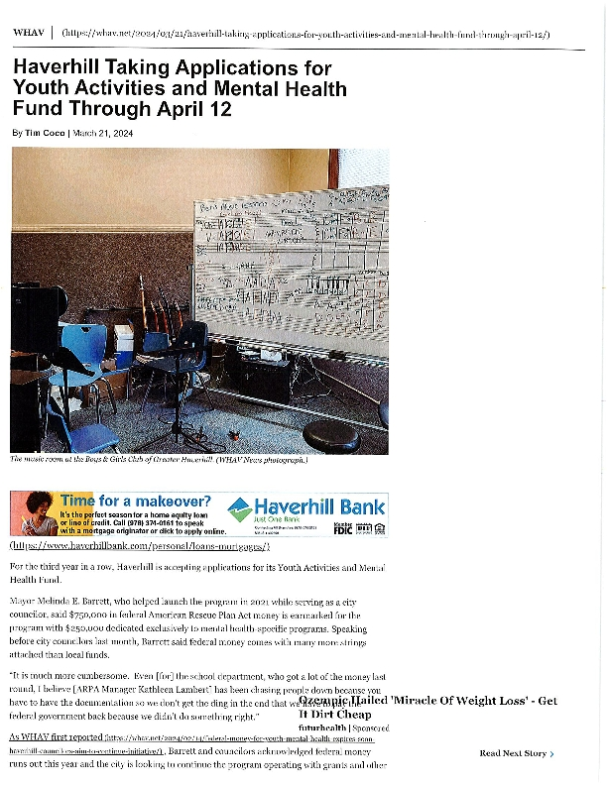
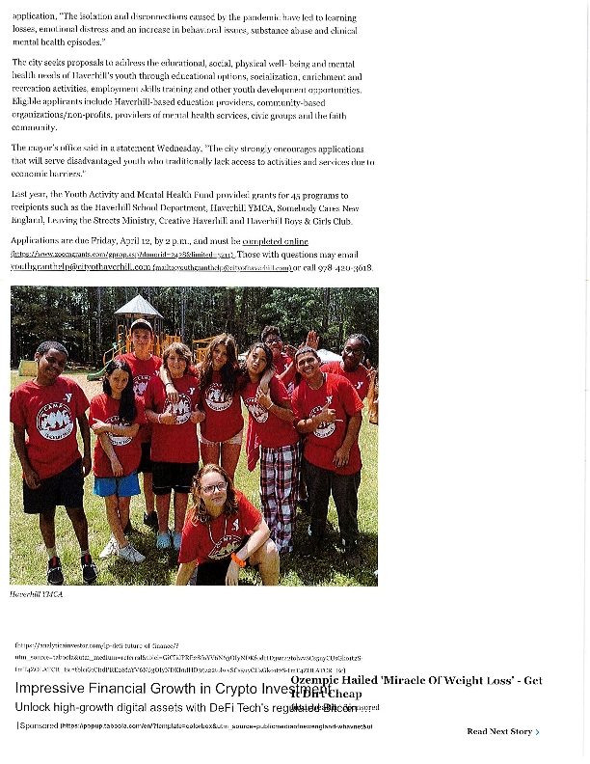
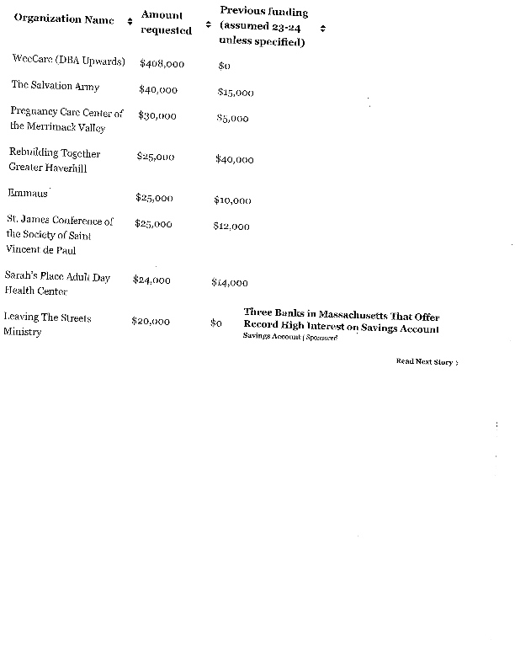
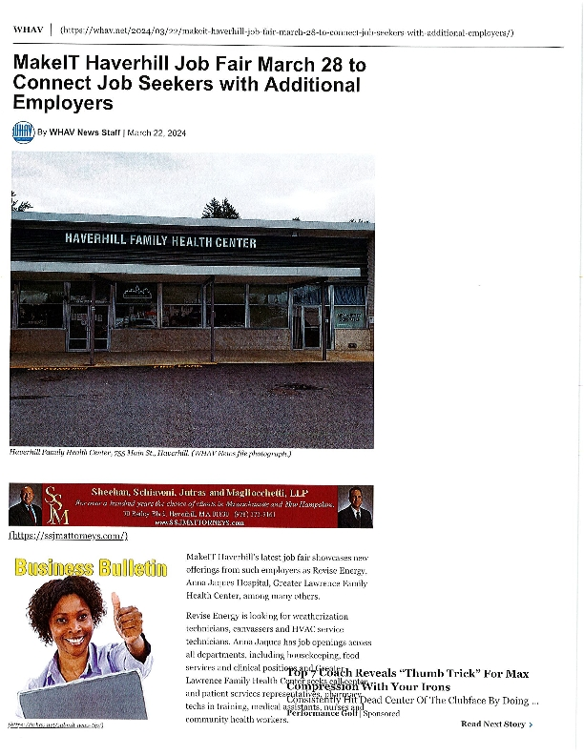
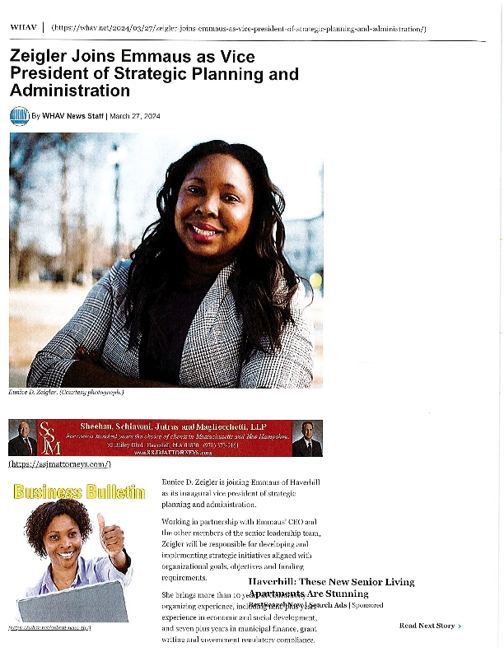

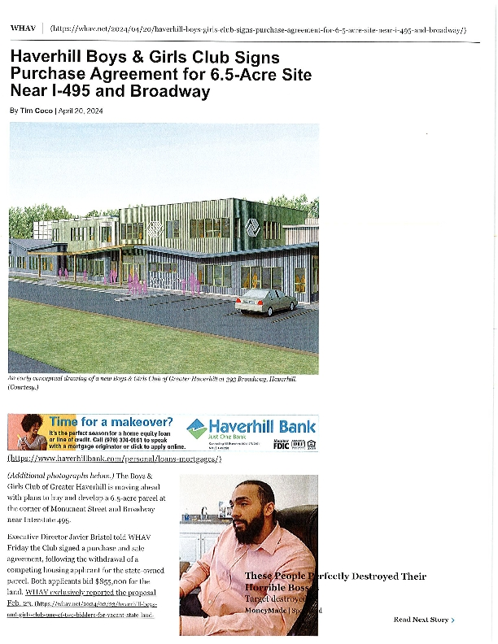
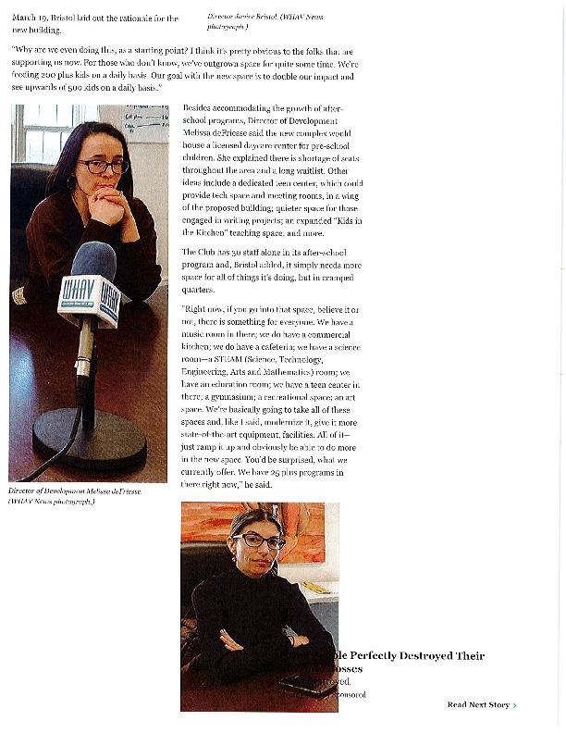
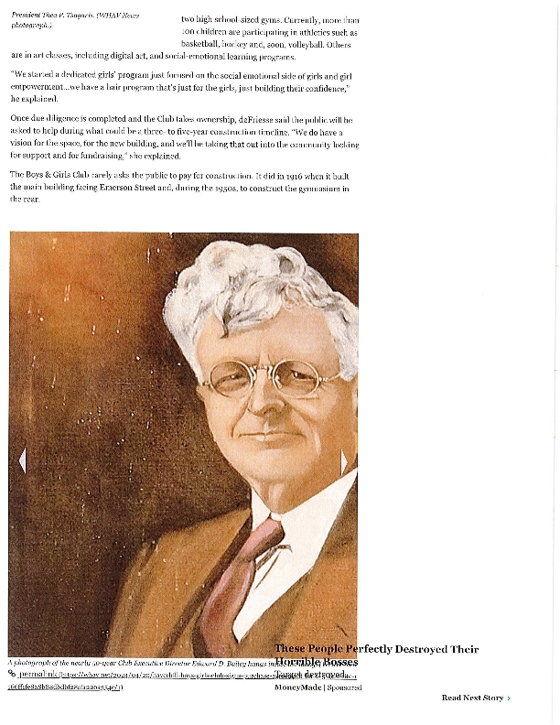
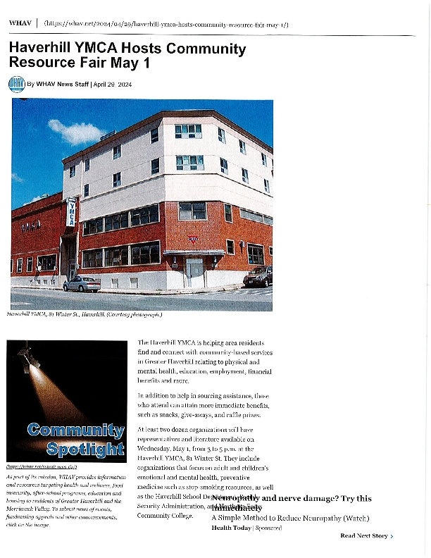
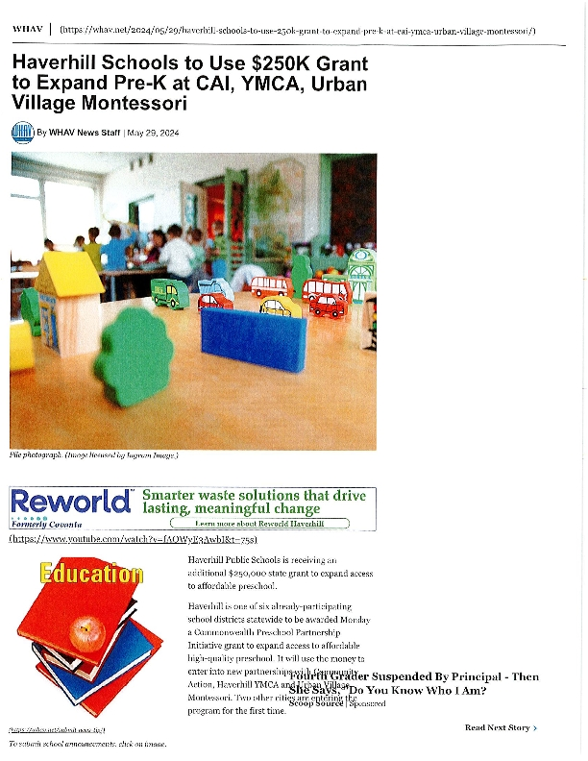
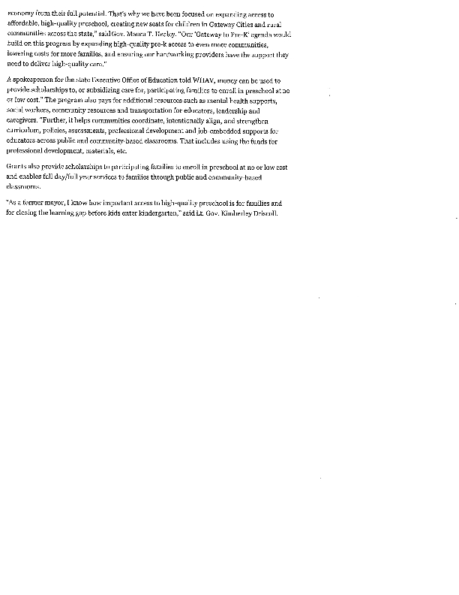

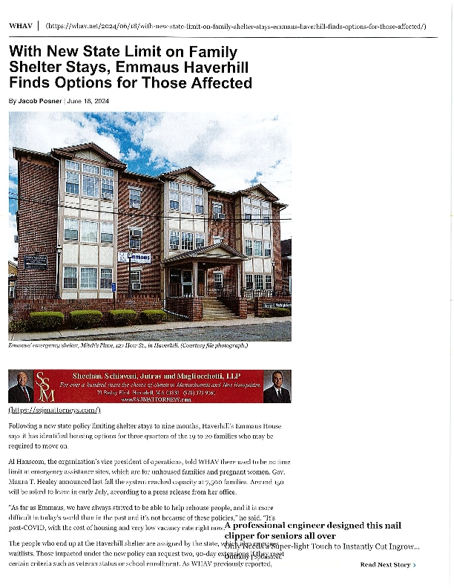

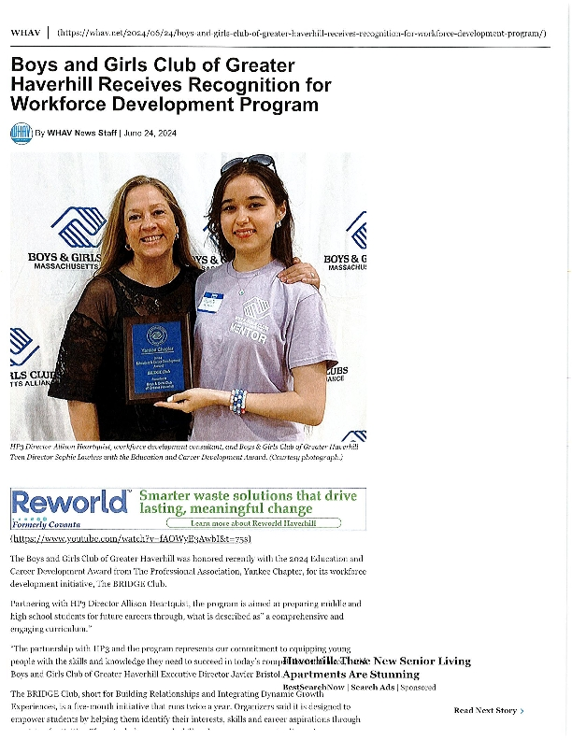

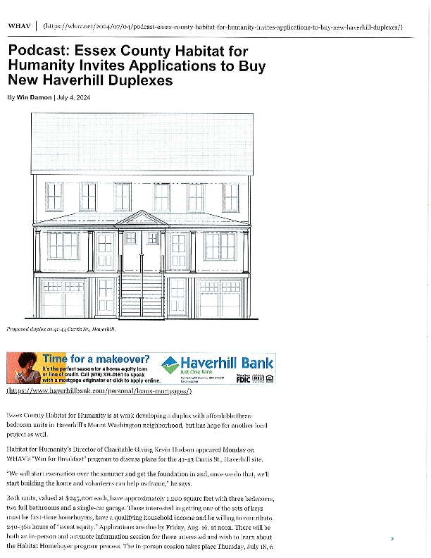
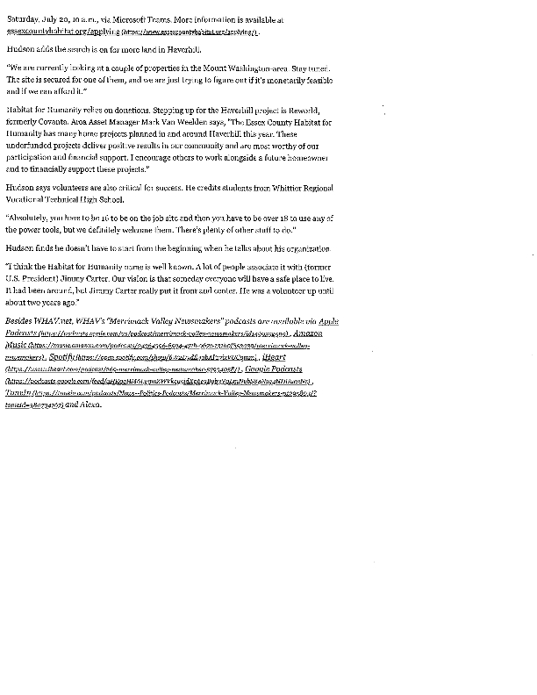
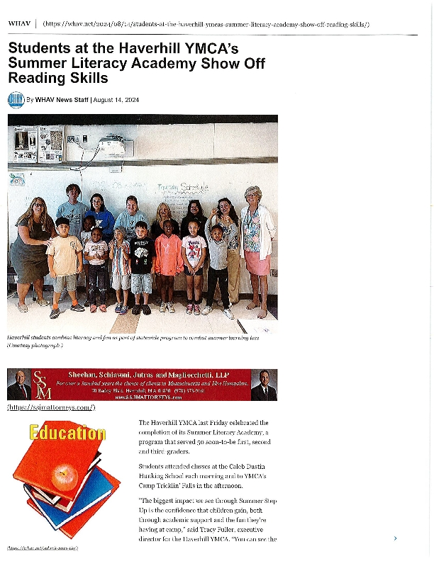
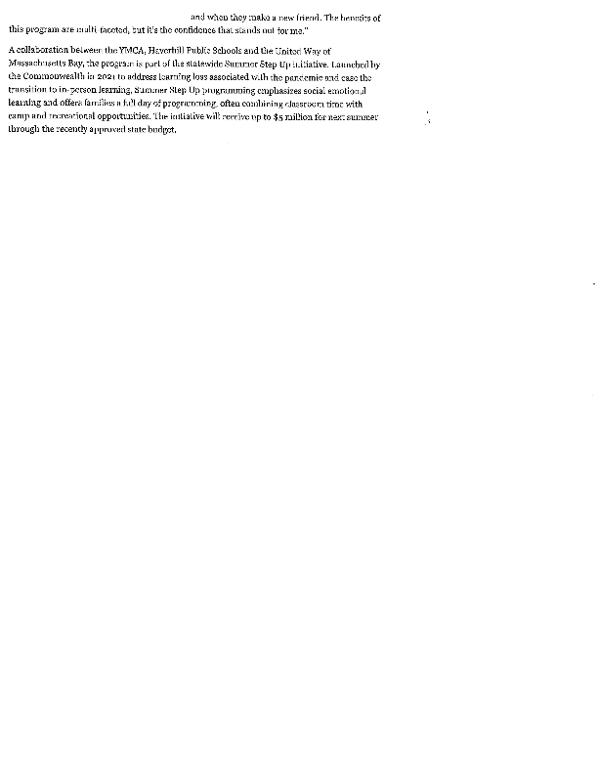
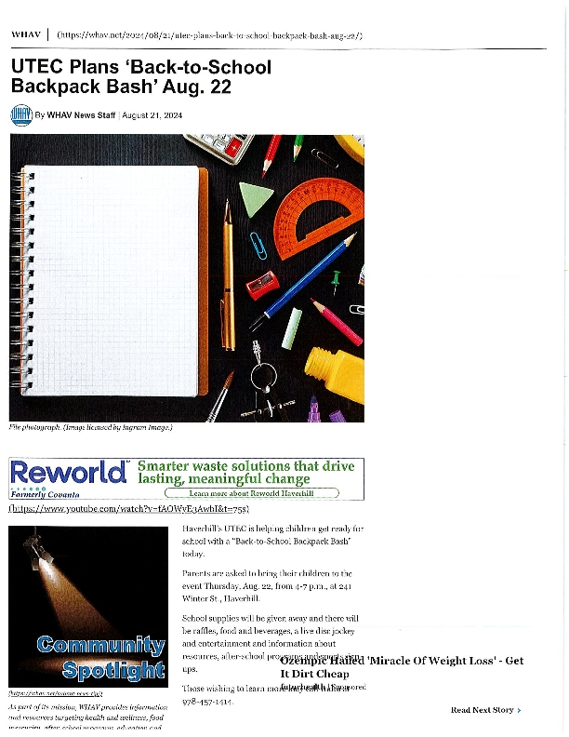
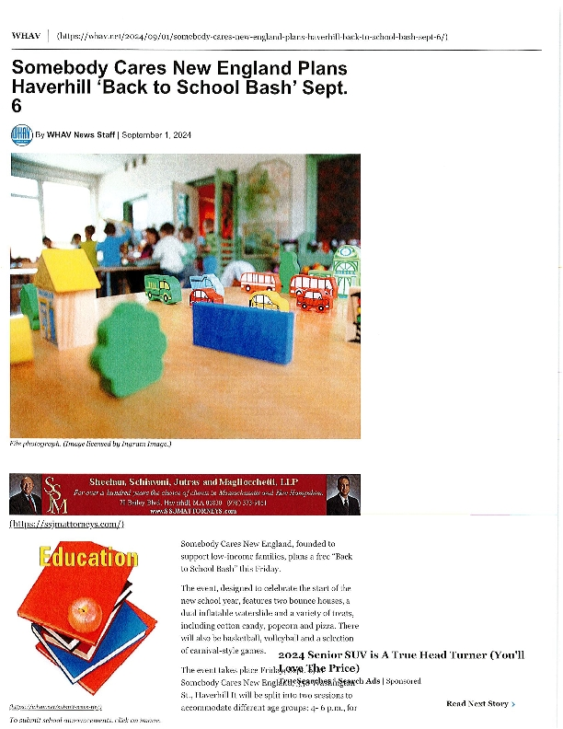
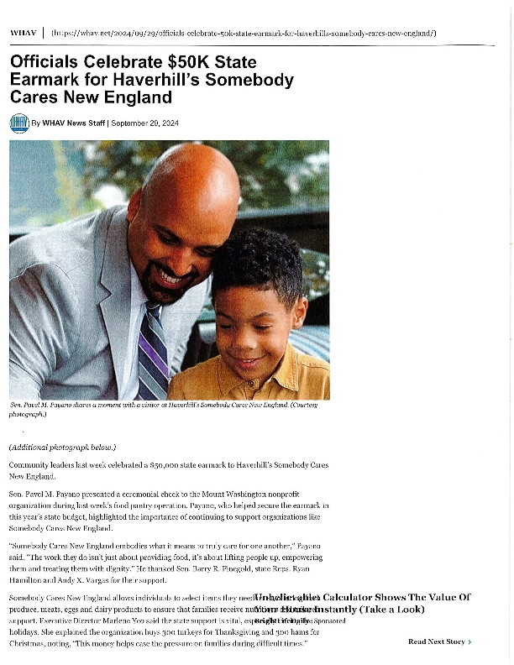
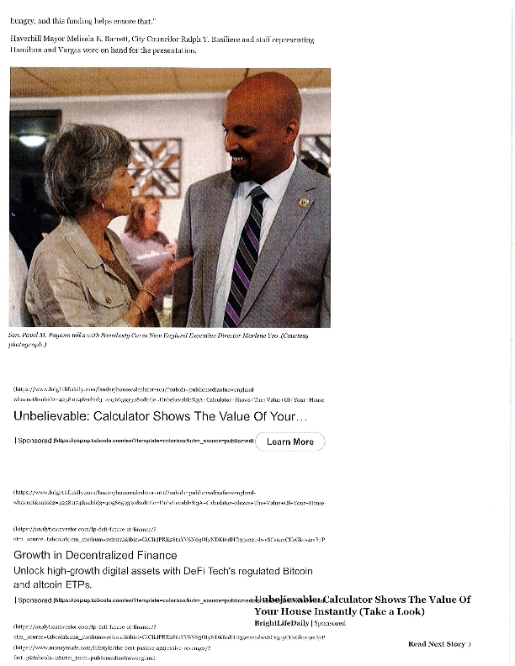
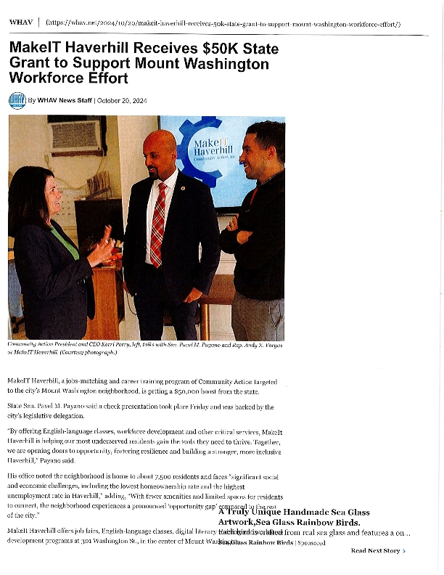


PY2023 Housing and Development Highlights
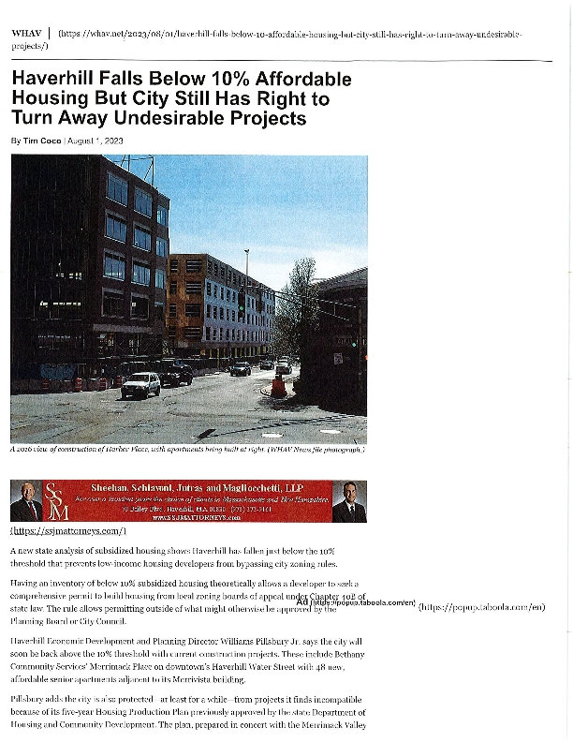
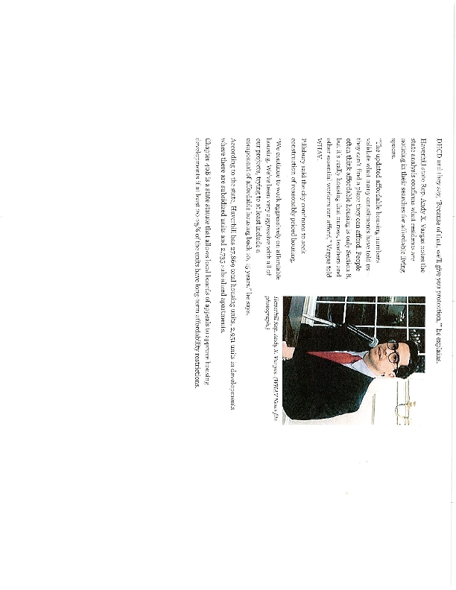
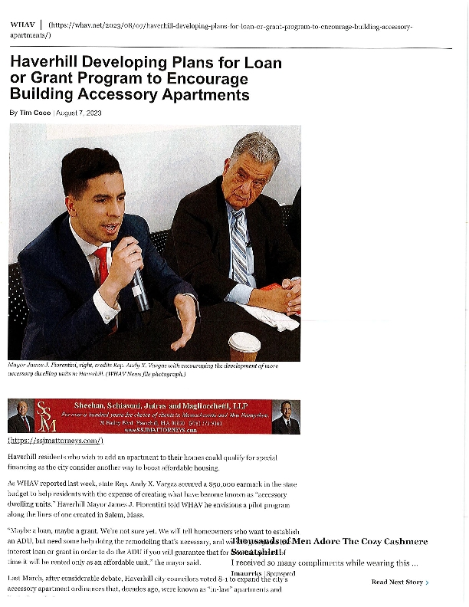

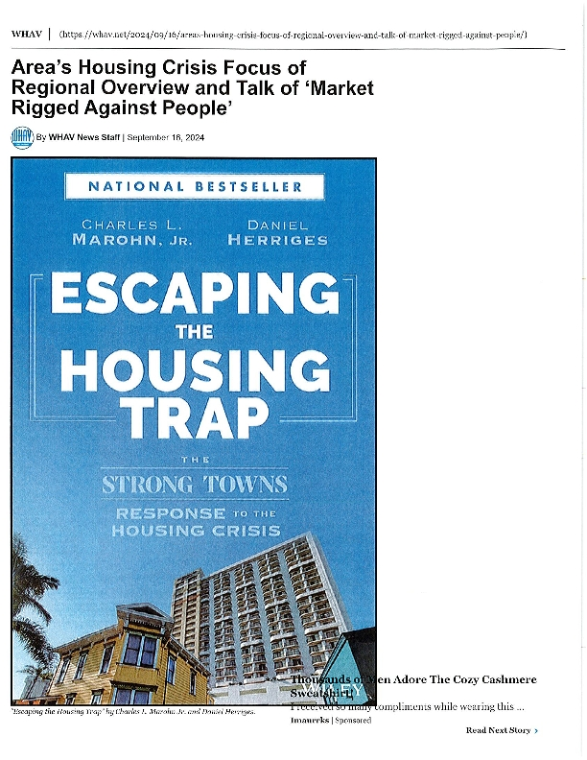
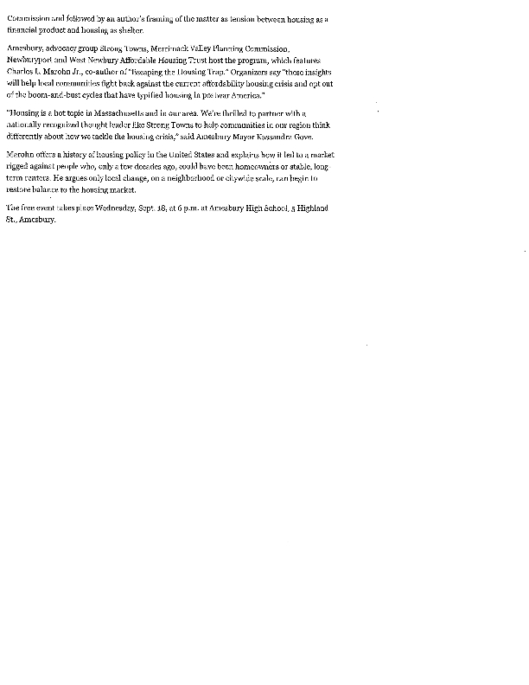
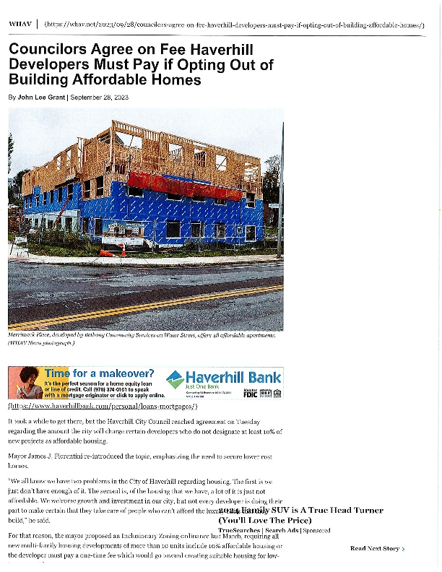
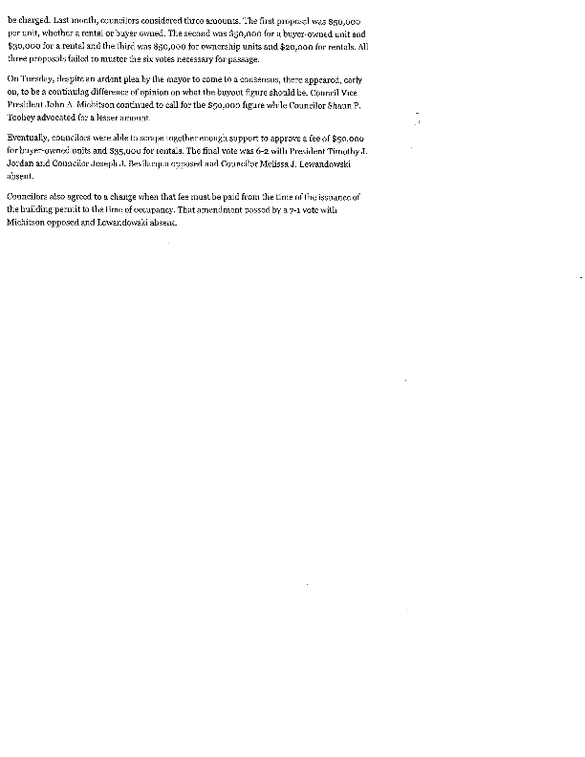
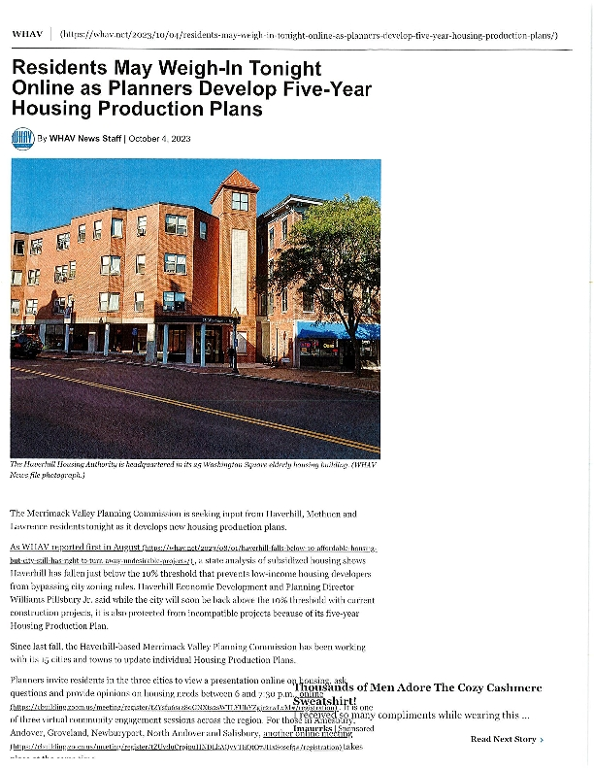
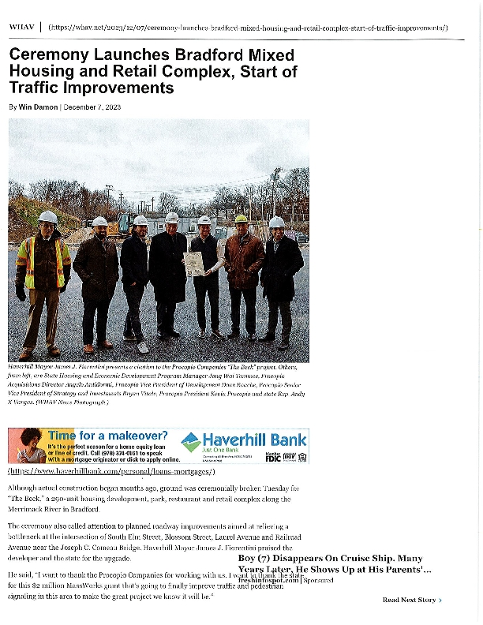
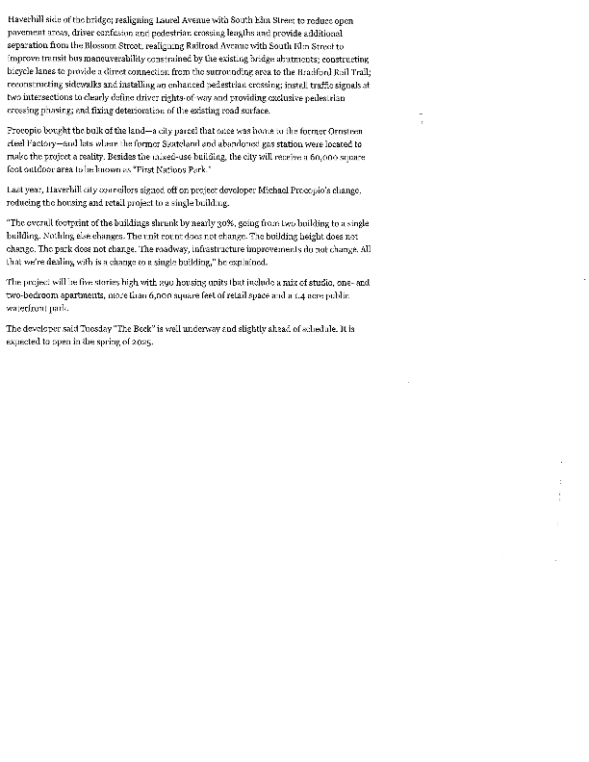
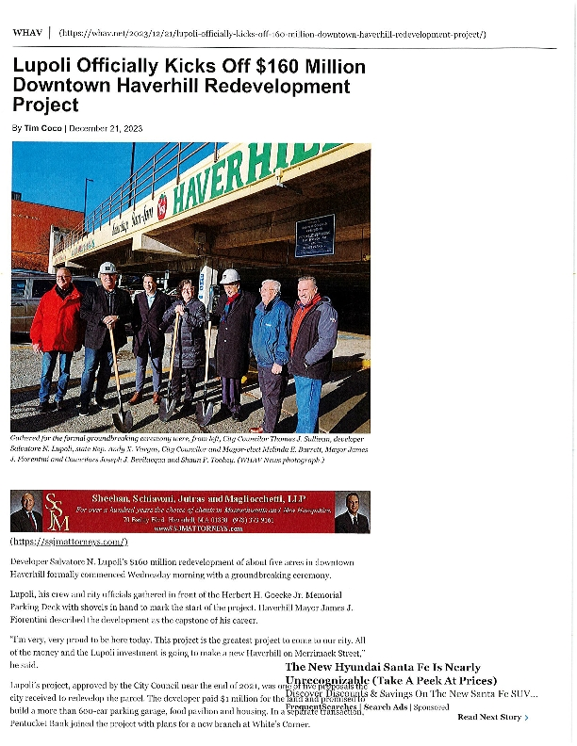
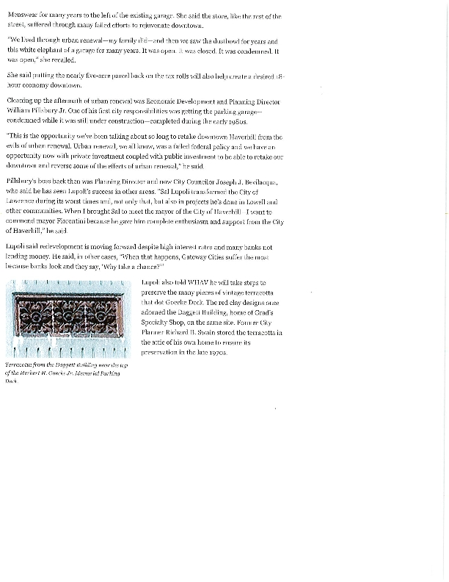
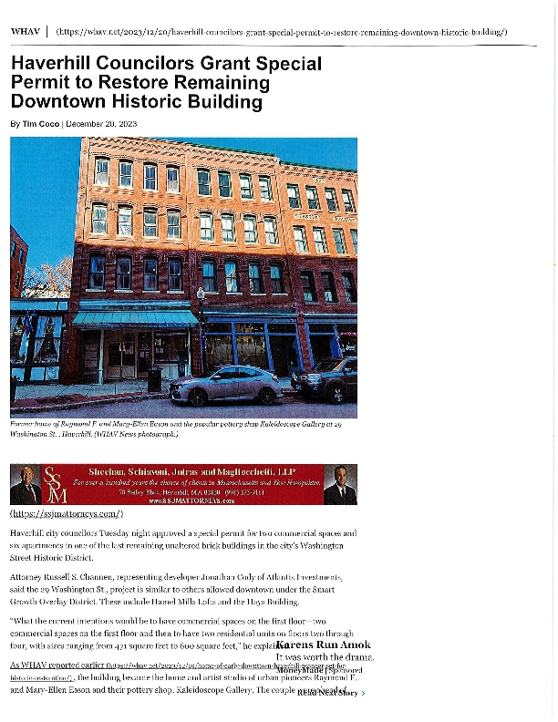
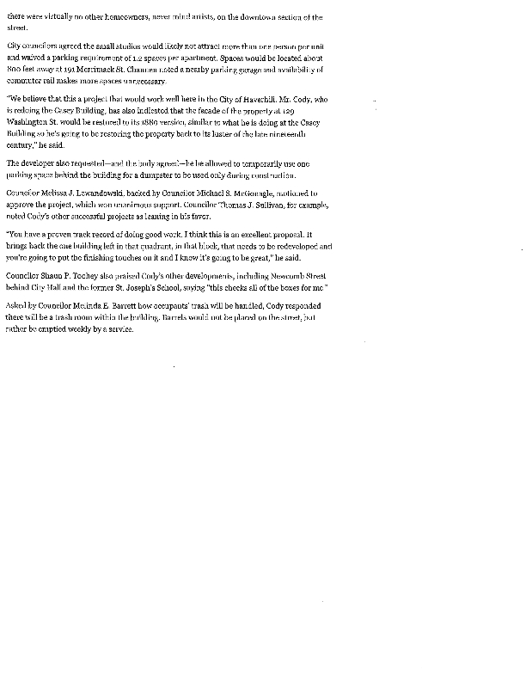
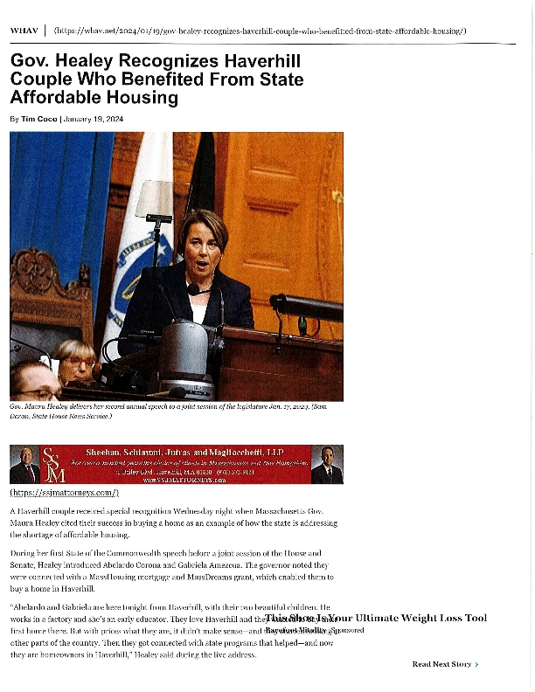
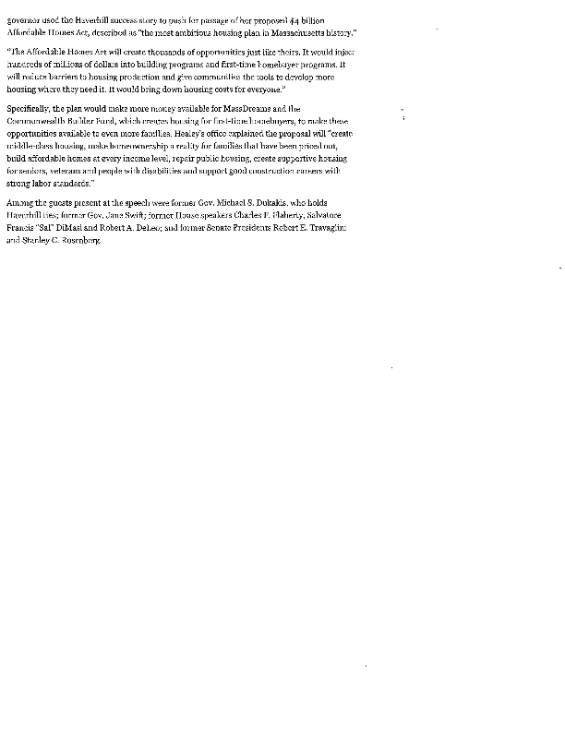
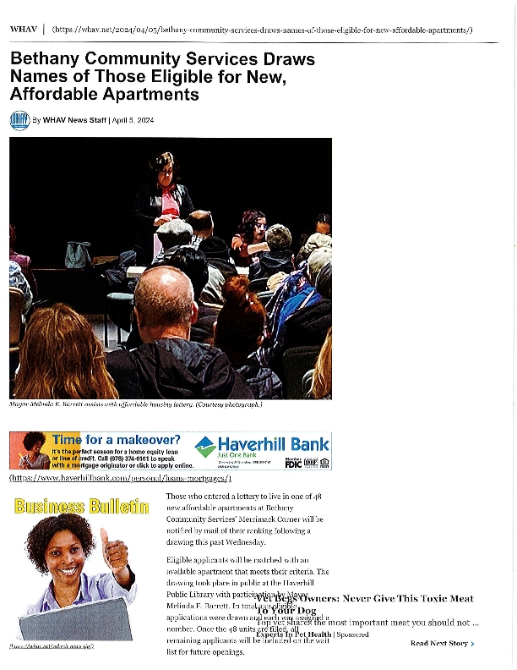

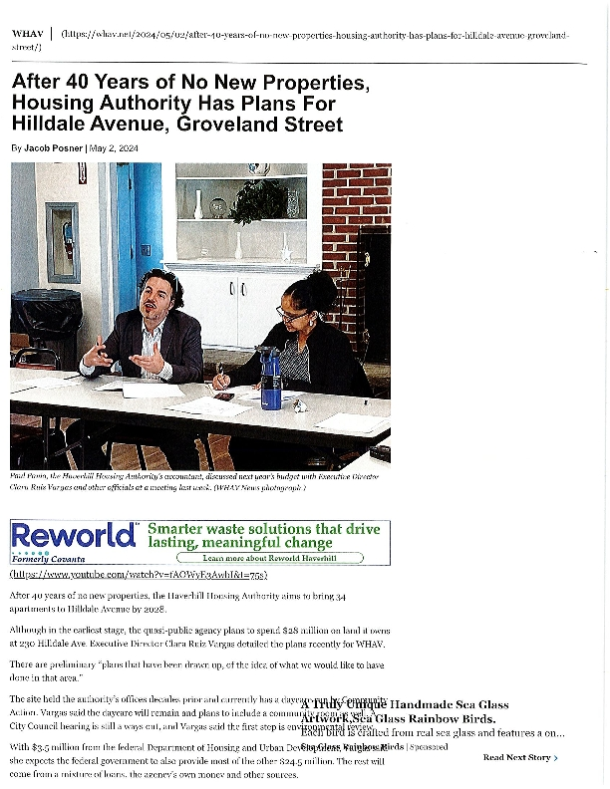
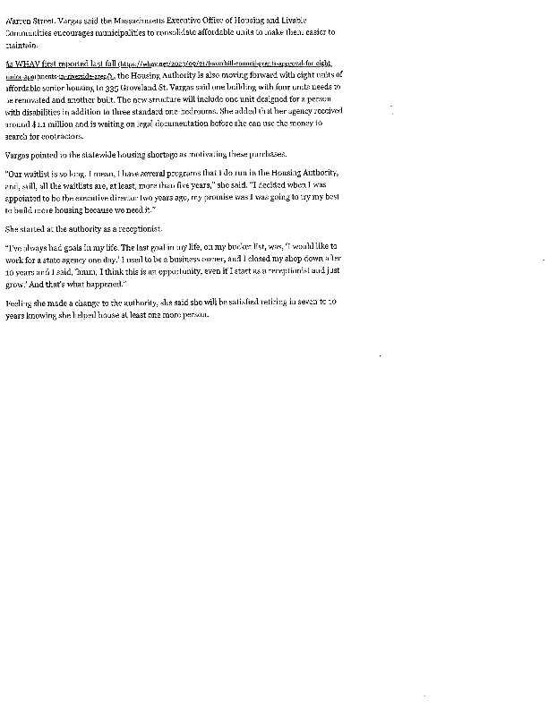
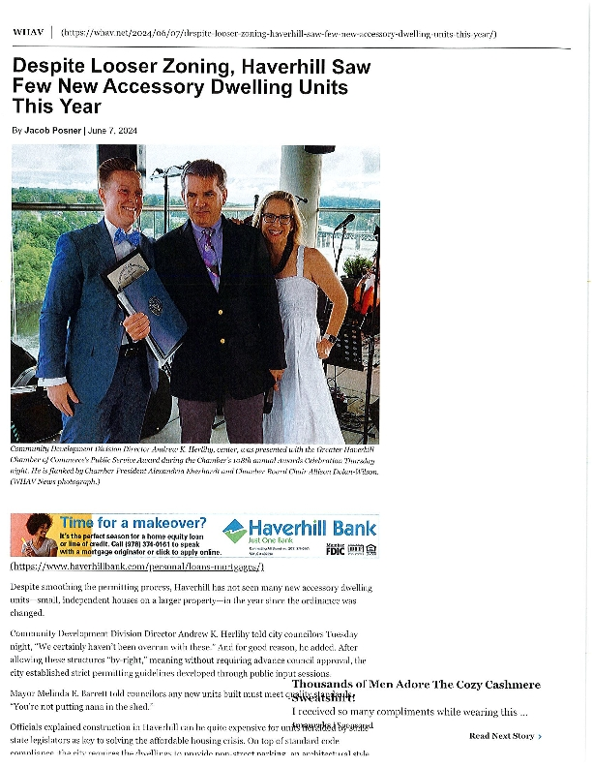
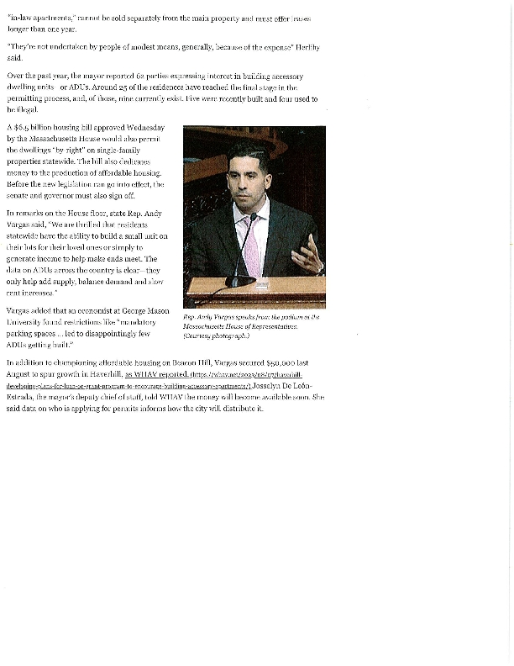
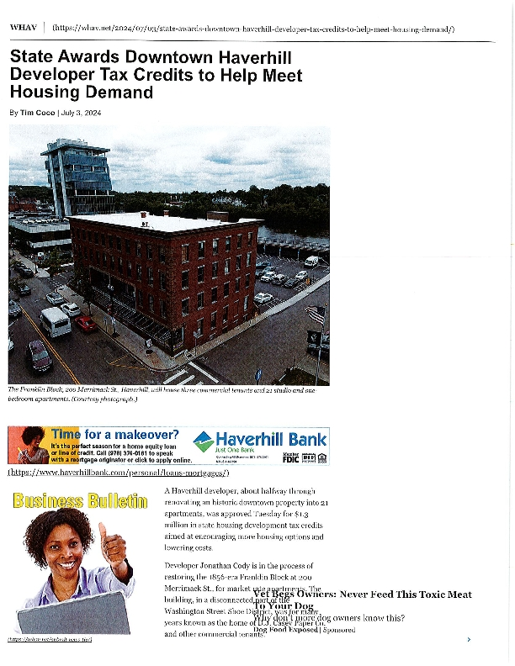
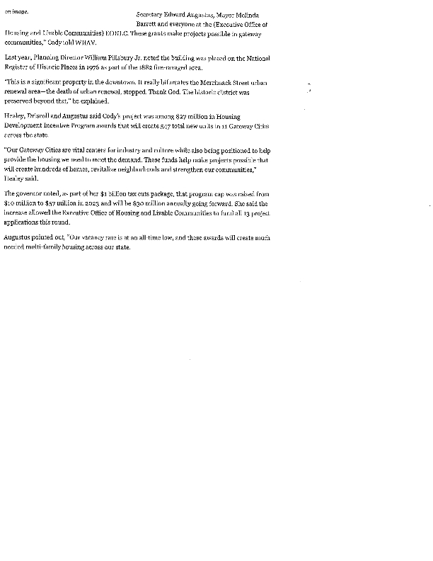
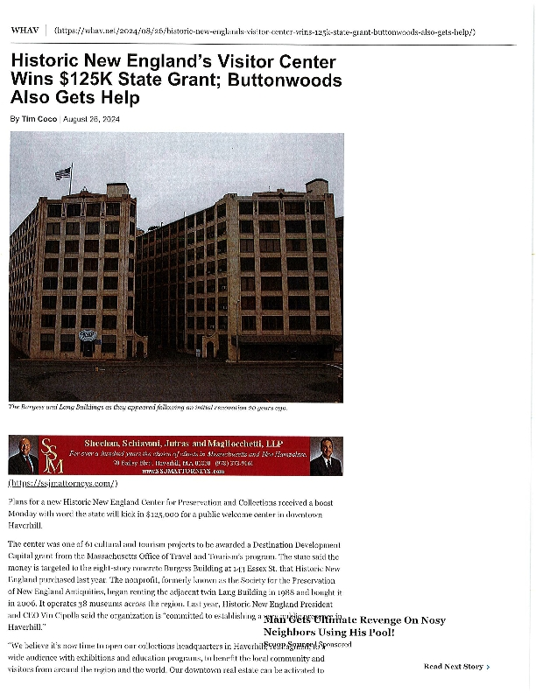
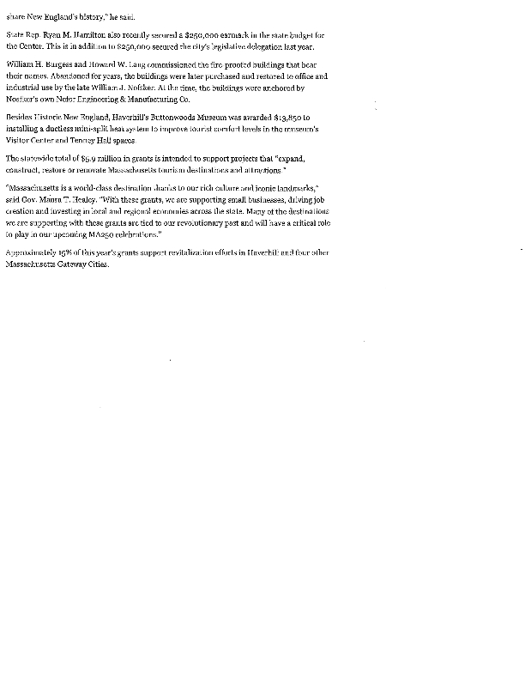
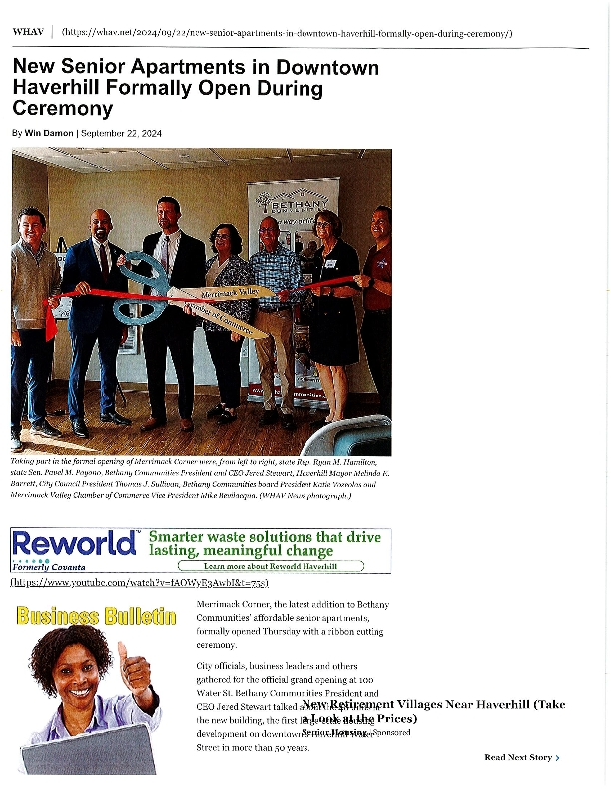
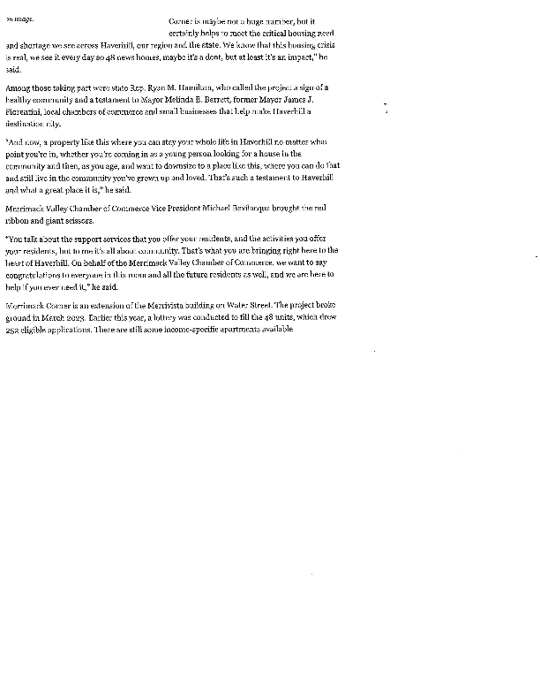
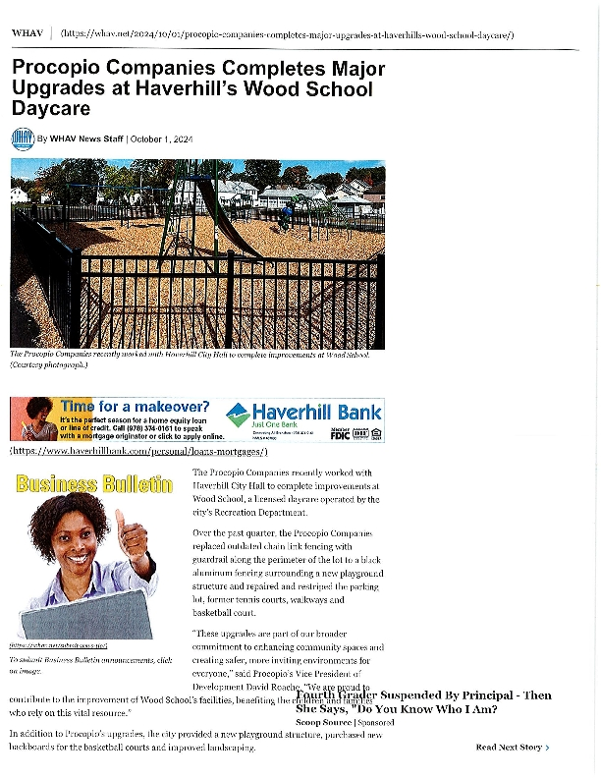


PY2023 Community Development Policy + Leveraging Year in Review
