Executive Summary

AP-05 Executive Summary - 91.200(c), 91.220(b)
1. Introduction
Program Year 2024 constitutes the fifth and final year of an unprecedented five-year Consolidated Plan period, which dominated by the historic after-effects of the Coronavirus pandemic. This year marks a beginning- the first Action Plan under the Haverhill’s first female Mayor, Melinda Barrett. The City embarks of Year One of a change of government—a transition to Ward representation for City Council and School Committee, with new minority leadership in some elected positions.
In terms of the housing crisis. despite a wave of construction from previously delayed approved projects, the supply of housing remains insufficient, and market forces have driven the cost of housing and homeownership out of reach of too many residents. A majority of residents are now housing constrained, with more than 51% or residents spending more than 30% of their income on housing. The constrained housing market is creating a host of problems that this Plan seeks to assist in addressing-- homelessness; a lack of non-housing necessities; need for better job and economic opportunities closer to home; quality recreational outlets in neighborhoods; dealing with a rash of electrical fires caused by overcrowded housing, etc.
Climate change is a condition that requires ever-increasing attention and disaster planning focus, such as the need for emergency generators at critical social safety new facilities, or the need to repair homes damaged by bad weather.
Housing increases are wiping out actual gains in household incomes. Higher energy costs will further constrain budgets for low-income households who are forced to choose between heat/cooling, gasoline, food or other necessities, straining the city's social safety net.
Haverhill’s unemployment rate ticked upwards over the past year, but there were no recorded mass layoffs over 10 people requiring formal notice, so people are losing jobs one by one or they work for failing small businesses.
The Pandemic manifested increasing mental illness and behavioral issues among youth and adults, and it distracted focus from the raging opioid epidemic while spawning additional substance abuse. A rise in hoarding is affecting housing rehabilitation efforts, with mental health a root cause. The murder rate and rate of opioid related overdose death did decline over the past year.
This Plan seeks to build off of impactful CARES Act and CDBG-CV efforts and will incorporate many elements and rolled-over activities. Putting the American Rescue Plan (ARP) funds to use is a huge priority.
This Plan for the City's Community Development Block Grant (CDBG) was the subject of constant revision. A great deal of community input went into the development of this Plan.
2. Summarize the objectives and outcomes identified in the Plan
This could be a restatement of items or a table listed elsewhere in the plan or a reference to another location. It may also contain any essential items from the housing and homeless needs assessment, the housing market analysis or the strategic plan.
The Program Year 2024 Plan follows the Goals and Objectives of the 5-Year Consolidated Plan, which are as follows:
-Expand Supply, Type and Diversity of Housing
-Maintain Housing Stock
-Provide Shelter and Services for Homeless
-Increase Owner-Occupancy and Labor Participation
-Provide Other Non-Housing Necessities
-Promote Neighborhood-Based Economic Development
-Foster Access to Economic Opportunities + Resources
-Stabilize Neighborhoods
3. Evaluation of past performance
This is an evaluation of past performance that helped lead the grantee to choose its goals or projects.

Year-to-Year Carry-over

4. Summary of Citizen Participation Process and consultation process
Summary from citizen participation section of plan.
The public participation process is actually an organic product after months of outreach, information gathering, data analysis--and most importantly--listening, by the City’s Community Development Department and other City officials.
The process officially begins early in the calendar year.
All current CDBG sub-recipients are routinely asked if they are seeing any trends, issues or concerns of which the City should be aware. Every year different issues and phenomena emerge and take shape, such as a focus on youth mental health concerns, challenges with meals programs and food insecurity, for example. On-site subrecipient monitoring visits to CDBG-funded subrecipients are also conducted at least annually. This represents an opportunity for Community Development staff to see first-hand community needs and hear of trends and issues that often emerge during these visits.
Throughout the year, civic groups such as the Merrimack Valley Planning Commission’s (MVPC) Comprehensive Economic Development Strategy (CEDS) Committee, Greater Haverhill Chamber of Commerce, Team Haverhill, clergy groups, and civic partnerships such as the Interfaith Network of Compassion (INC) frequently offer their comments about the direction of the City’s community development plans and strategies sometimes generally, and often times specifically.
The City relies on the viewpoints expressed by its Community Affairs Advisory Board (CAAB) through a series of public meetings. The CAAB is a very diverse board, proudly the most diverse (minority-majority) in City government. The CAAB is comprised of mainly Target Area residents who are familiar with the work of non-profits addressing poverty as well as the needs of their low-to-moderate income neighbors. CAAB feedback is very useful in setting the parameters and priorities for each year’s entire Annual Plan, not just the 15% Public Services share. The City conducted its Public Service Request for Proposals (RFP) hearings in person with call-in availability. RFP applications were ranked by CAAB members independently at home yet exhibited many similarities as a group overall. Combined with input from aforementioned civic groups, it could be stated a consensus revealed that the Mount Washington neighborhood had a special focus, as well as the prescient issues of rising rents, homelessness, food security, and preventing gang involvement violence. The CAAB was able to make its final budget deliberations in mid-late May.
While exclusively CDBG-dedicated public outreach sessions are relatively few in number and not well-attended, overall, the number of public input sessions that provided feedback to this Plan is sufficient.
Finally, elected and city officials are solicited for their input. A formal City Council hearing was held on May 21, 2024 to present the elements, justification and goals of the City’s Annual Action Plan. Councilors were in agreement with the general direction of the City's CDBG program.
5. Summary of public comments
This could be a brief narrative summary or reference an attached document from the Citizen Participation section of the Con Plan.
Only one public comment was received in response to the May 30, 2024 Public Advertisement and posting of the Annual Action Plan on the City website, concerning additional funds for child care.
There were no other public comments received, although some parties have expressed interest in the direction of the next upcoming Five Year Consolidated Plan.
6. Summary of comments or views not accepted and the reasons for not accepting them
Not every applicant or suggested program for funding could be accommodated and/or included in the Plan for Program Year 2024.
For example, in terms of Public Services, given the amount of Youth and Mental Health Activity funds provided through the American Rescue Plan (ARP), there was a deprioritization of youth programs supported by the City's Community Development Block Grant (CDBG). The following youth proposals were not accepted for CDBG funding:
-YMCA of Greater Haverhill- Step Up to K program
-YWCA- Gender Specific Programming Support
-Haverhill Downtown Boxing, Inc.- Inner-City Youth Services
-UTEC, Inc- Paid Job Training for Haverhill Young Adults
-Haverhill Inner City Boxing Club- Boxing and Youth Development Program
-WeeCare (Upwards)- BOOST (Building Operation and Optimization Support Tools) for Child Care
-Leaving the Streets Ministry- Youth Housing program
In addition, the All Saints Food Pantry language Interpretation program was not funded as it was felt that these services could be provided without funding.
Other Public Improvement projects were victims of funding constraints, such as a low-income student-run greenhouse at Tilton Upper (former Saint James Elementary School), Alleyway improvements behind Haverhill Downtown Boxing Club, skate park and bike pump track proposals, mechanized elevated lift replacement at the Universalist Unitarian Church to benefit clients of the Liz Murphy Open Hand Pantry, and other projects.
There was demand for more support for child care and youth career development initiatives that were not able to be supported through this year's CDBG program.
7. Summary
Much of the focus for the upcoming Program Year (PY2024), revolves around providing opportunity.
Improving the housing stock of Haverhill's urban neighborhoods remains the top priority of the City’s CDBG funds and of this Annual Plan. Housing Rehab is the largest budget item in this Plan ($566,400 from all sources), in keeping with this prioritization of safe, decent housing. Due to hoarding, an epidemic of illegal units, inflation and work undertaken without permits, many housing rehab projects are costlier and more complex than ever. Eliminating lead-based water services is an enhanced housing rehabilitation priority based on HUD prioritization, along with de-leading units. The City was successful in receiving a large Lead Hazards Control Capacity Grant from HUD, with the existing CDBG housing rehabilitation program (Housing Rehabilitation and Code Correction Program) serving as a critical source of match over the next three (3) years.
The coronavirus Pandemic affected everyone, but not equally. Economic impacts due to COVID, and recovery from the pandemic, have been uneven and left some people behind. Haverhill is no exception, and this explains continuing high service demand from sub-recipients, charities and non-profits.
The biggest drag on a decent local economy right now is the need to increase Labor Participation, and to promote small business growth in urban neighborhoods and not just downtown. Likewise, there is a need to connect these urban neighborhood residents with economic opportunities found in other parts of the city and region (i.e. business parks desperately seeking workers).
One challenge will be sustaining the focus and momentum the expired Working Cities Challenge grant from the Federal Reserve generated to improve economic outcomes for residents of the Mt. Washington area. This neighborhood comprises statistically the most impoverished census blocks in the city and is a designated Opportunity Zone. There is recent momentum with developers and investors to take advantage of its Opportunity Zone status.
Public Improvements through CDBG will be focused and concentrated on smaller underutilized public parcels in Mount Washington, Riverside and Lower Acre, along with demonstrable improvements Downtown. Increased Chapter 90 allocations, Shared Streets grants and Complete Streets bonus funds, along with a massive influx of American Rescue Plan (ARP) funds will be used for Public Improvements and major sidewalk improvements, with CDBG funds playing only a leveraging role.
This Plan makes the most of available resources, leveraging and partnering wherever possible to make the most of Federal and State grants and ARP funds. Most noteworthy is the $2.4 million, 3-year effort to improve the City’s Lead Based Paint Mitigation efforts.
Extending opportunity for all residents remains the paramount mission of Community Development.
Despite the challenges listed and various uncertainties, there are still numerous reasons for hope in Haverhill in these times, and this Plan is an important tool in providing that needed hope and opportunity.

PR-05 Lead & Responsible Agencies - 91.200(b)
1. Agency/entity responsible for preparing/administering the Consolidated Plan
The following are the agencies/entities responsible for preparing the Consolidated Plan and those responsible for administration of each grant program and funding source.
Agency Role | Name | Department/Agency
Lead Agency | HAVERHILL

CDBG Administrator | HAVERHILL | Community Development Department
HOPWA Administrator
HOME Administrator
HOPWA-C Administrator
Table 1 – Responsible Agencies

Narrative
The City of Haverhill, through its Community Development Department, is the agency responsible for the preparation and execution of the Annual Plan, within the framework of the Five-Year Consolidated Plan.
The Community Development Department is led by William Pillsbury, Jr. The Division Director is Andrew Herlihy.
The City of Haverhill is not a Participating Jurisdiction (PJ) in terms of Home Investment Partnership Program (HOME) funding. The City instead actively participates in the North Shore HOME Consortium; Haverhill is the largest of the North Shore HOME Consortium's 30 member communities. The City of Peabody is the Participating Jurisdiction (PJ) for the North Shore HOME Consortium.
The City contracts with a number of subrecipients in order to undertake its various projects and activities. These subrecipients include local non-profits, other City departments, consultants, contractors and agencies.
Consolidated Plan Public Contact Information
The City of Haverhill Community Development Department is the lead agency responsible for the development, implementation, performance and oversight of the Consolidated Plan.
The City of Haverhill Community Development Department operates out of Haverhill City Hall Room #309, 4 Summer Street, Haverhill, MA 01830, with a telephone number of 978-374-2344 and fax is 978-374-2332.
The City elected a new mayor in 2023. Melinda E. Barrett is the Mayor of Haverhill.

AP-10 Consultation - 91.100, 91.200(b), 91.215(l)
1. Introduction
The Annual Plan is an organic, longstanding process that takes into account feedback and observations over the course of the whole year, working with and among a large group of stakeholders, City Department heads, the new Mayor, non-profit partners and the public.
Outreach was conducted mostly via in-person hearings throughout the year to help. This outreach and feedback generated the Annual Plan, with some remote participation. CAAB hearings were held in-person through April, 2024, with 27 separate Public Service applicants appearing. The Haverhill City Council's Public Hearing on CDBG also occurred in-person for PY2024 in May 2024.
Numerous organizations and entities contribute to the development of the Plan, and they are highlighted below.
Provide a concise summary of the jurisdiction’s activities to enhance coordination between public and assisted housing providers and private and governmental health, mental health and service agencies (91.215(l)).
The City has coordinated and targeted public health and other services offered through CDBG and City taxpayer-funded programs with public and non-profit housing providers, especially those with special populations such as assisted living facilities, senior housing, public housing, housing for developmentally-disabled and those with other special needs. Food insecurity and other challenges affecting health also required coordination between public and assisted housing providers and public entities. The Pandemic revealed that overcrowded housing units were a major factor in spreading COVID and other public health infections.
Post-Pandemic, focus has been placed upon mental health services, especially for youth. The City Council and the Mayor allocated a second $750,000 from both state opioid settlement funds and American Rescue Plan (ARP) funds towards a dedicated Youth/Mental Health fund to support in-person programming for youth struggling with the isolation caused by coronavirus. The Youth and Mental Health Activities fund seeks to connect youth with existing programs and offerings, not to create new ones with large overhead. Community Development personnel and others served on an Advisory Board that reviewed over a million dollars in funding requests. Outreach efforts for this fund were combined with those for CDBG public service applicants and marketed to existing CDBG subrecipients, including every Community Affairs Advisory Board meeting. Based on consultation and feedback to the plan, issues of mental health received extraordinary priority in comparison to pre-COVID years.
In addition, the pandemic did not hit all equally-- lower income and minority groups were affected at disproportionately higher rates, and community development efforts are focused first and foremost on restoring and/or addressing these gaps in resources and services. Further coordination between these public and private entities is needed in order to move the City forward in an equitable manner, with outreach and services targeted to neighborhood events and public housing sites.
The City has formally established a City Department of Public Health in response to the Pandemic, and aggressively promoted enhanced Code enforcement through both CDBG and City funds focused and integrated on health and housing violations.
The City is working hand-in-hand with the Haverhill Housing Authority to create 8 new affordable housing units at 335 Groveland Street and launch new units at the HHA's Hilldale Avenue projects, including a new and improved Head Start facility.
Describe coordination with the Continuum of Care and efforts to address the needs of homeless persons (particularly chronically homeless individuals and families, families with children, veterans, and unaccompanied youth) and persons at risk of homelessness.
Through the Balance of State Continuum of Care (CoC), the City shares information, policy, data and best practices about treatment, care, programming, options and sheltering of homeless individuals and families. For example, thanks to guidance from the CoC, the City coordinates with the Haverhill Police Department, Haverhill High School and service providers such as Emmaus, Eliot Community Services and CAI on the Annual Homeless Count every January.
Homeless Management Information Systems (HMIS) have been better coordinated and improved by the CoC and its sub-recipients such as Emmaus and Veterans Northeast Outreach Center in Haverhill (VNOC), at significant expense. Coordinated Entry (CE) is run by Emmaus for the benefit of the entire region. HMIS/CE support leads to available beds, support services, family reunification, and better client tracking and outcomes. This system locally has been affected, but not overwhelmed, by the influx of asylum seeking migrants, which has so greatly impacted other communities such as Methuen.
The City also participates in an Emmaus-led monthly discussions about the City's unsheltered population, both from a policy and individual case management perspective. These 'Unsheltered Working Group' meetings continue to be valuable.
Another key focus for the CoC will be the housing of homeless veterans, with the new leadership team at VNOC entering a second year.
The Balance of State CoC provides an opportunity, vehicle and forum for the City to learn of effective strategies, funding options, programs and regulations that can help transition homeless families to temporary and permanent housing more seamlessly. Among the priority focus areas include dealing with domestic violence victims, 'couch-surfing,' court-involved or transsexual youth and ex-convicts. Other concerns include housing of registered sex-offenders, substance abusers, immigrant families, resettled refugees, homeless veterans and mentally ill populations. Innovative and cooperative solutions are needed to deal with such issues in a time of constrained budgets, public stigma and parochial pressures against creating such housing.
The City has deployed, in conjunction with CAI, an emergency housing fund that provides first/last rental assistance for rent-paying tenants who lose their units due to fire or other catastrophes not of their causing. In cases of devastating fires or other tragic mishaps, some individuals and households end up in homeless shelters even though they are employed and paying regular rent, due to the lack of having adequate savings to provide a first and last to a new landlord when they are suddenly displaced.
The City continues to monitor the capacity and need for housing for homeless youth, foster kids, and unstably housed 'couch-surfing' youth. The Haverhill Public School's full-time dedicated McKinney liaison is a resource.
The City also gets good intelligence on homeless cases, individual needs and overall trends from the staff of the Homeless/Near Homeless Drop-In Center and Common Ground Ministries through participation in monthly meetings.
A major goal for PY24 is to effectuate the HOME-ARP funds awarded to the Haverhill Housing Authority for its 335 Groveland Street project that creates 8 new units of housing for basically homeless individuals below 30% Area Median Income. Getting this project to construction has proven frustrating.
Describe consultation with the Continuum(s) of Care that serves the jurisdiction’s area in determining how to allocate ESG funds, develop performance standards for and evaluate outcomes of projects and activities assisted by ESG funds, and develop funding, policies and procedures for the operation and administration of HMIS
In Haverhill, Emmaus, Inc. directly manages Emergency Solutions Grant (ESG) funds for the community.
Joining the Balance of State CoC reduced Homeless Management Information Services (HMIS) challenges, workload and expenses for Emmaus, providing more funding for housing for the Greater Haverhill region.
Coordinated Entry (CE) is still being managed for the North Shore subregion by Emmaus, and the North Shore subregion retains its own borders for the purposes of homeless referrals. The BoS governance and other policies have been adopted by the former North Shore Continuum of Care (NSCoC) communities, along with performance standards, outcome evaluations, compliance monitoring, data quality and common definitions of homeless conditions. Emmaus and VNOC get monitored by the CoC separately from the City. The NSCoC's Regional Homeless Action Plan is still being used as a blueprint for how the region tackles homelessness.
Emmaus also successfully manages Rapid Rehousing funds and HOMEBase funds from the Commonwealth.
2. Agencies, groups, organizations and others who participated in the process and consultations

Table 2 – Agencies, groups, organizations who participated
1 | Agency/Group/Organization | Haverhill Housing Authority
 | Agency/Group/Organization Type | Housing  PHA  Services - Housing  Services-Elderly Persons  Services-homeless  Other government - State  Other government - Local
 | What section of the Plan was addressed by Consultation? | Housing Need Assessment  Public Housing Needs  Homeless Needs - Chronically homeless  Homeless Needs - Families with children  Homelessness Strategy
 | Briefly describe how the Agency/Group/Organization was consulted. What are the anticipated outcomes of the consultation or areas for improved coordination? | HHA is the public housing authority for Haverhill but also Groveland, Georgetown and other communities. HHA's input was sought from its Director, Facilities Manager and Board Members in terms of housing issues in general, but also in terms of specific projects to add or more quickly renovate more HHA units, including at 8 HOME-ARP-funded units at 335 Groveland Street and new units at its Hilldale projects. Community Development staff attend numerous HHA Board meetings every year to maintain cooperation and coordination between these separate but related public entities.
2 | Agency/Group/Organization | Emmaus Inc
 | Agency/Group/Organization Type | Housing  Services - Housing  Services-Children  Services-Persons with Disabilities  Services-Persons with HIV/AIDS  Services-Victims of Domestic Violence  Services-homeless  Services-Education  Services-Employment  Service-Fair Housing  Services - Victims  Services - Narrowing the Digital Divide  Agency - Emergency Management  Neighborhood Organization
 | What section of the Plan was addressed by Consultation? | Housing Need Assessment  Homeless Needs - Chronically homeless  Homeless Needs - Families with children  Homelessness Needs - Unaccompanied youth  Homelessness Strategy  HOPWA Strategy  Market Analysis  Anti-poverty Strategy
 | Briefly describe how the Agency/Group/Organization was consulted. What are the anticipated outcomes of the consultation or areas for improved coordination? | Emmaus is the leading homeless agency in the city, operating the only overnight emergency housing shelter (Mitch's Place). Emmaus directly administers HUD funds such as Emergency Solutions Grants (ESG), Rapid Rehousing and HOPWA. Emmaus serves as the Coordinated Entry (CE) contract for the Balance of State Continuum of Care Northeast Region. Emmaus hosts a monthly 'Unsheltered' meeting with various stakeholders including the City. Emmaus quarterbacks the Annual Homeless Point in Time (PIT) Count with the City.Anticipated outcomes include more shelter and services for the homeless (a Consolidated Plan goal), increased shelter capacity, enhanced Homeless Management Information System (HMIS) capacity, Rapid Rehousing Placements, coordination with the Red Cross and others after fires/emergencies, HomeBase funding, and a better understanding of unaccompanied youth and homeless families (as Emmaus operates a family shelter through DTA placement).
3 | Agency/Group/Organization | COMMUNITY ACTION INC.
 | Agency/Group/Organization Type | Housing  Services - Housing  Services-Children  Services-Persons with HIV/AIDS  Services-Victims of Domestic Violence  Services-homeless  Services-Health  Services-Education  Services-Employment  Service-Fair Housing  Services - Narrowing the Digital Divide  Child Welfare Agency  Regional organization  Major Employer  Neighborhood Organization
 | What section of the Plan was addressed by Consultation? | Housing Need Assessment  Homeless Needs - Chronically homeless  Homeless Needs - Families with children  Homelessness Needs - Unaccompanied youth  Homelessness Strategy  Non-Homeless Special Needs  Market Analysis  Economic Development  Anti-poverty Strategy
 | Briefly describe how the Agency/Group/Organization was consulted. What are the anticipated outcomes of the consultation or areas for improved coordination? | CAI is a leading contributor to the Plan, as the region's main anti-poverty organization. CAI is again a double recipient of CDBG funds in PY24 for its Heating Assistance and Homeless Drop-In Center programs. CAI works in close partnership with the City through its housing specialist(s). CAI provides input on affordable and fair housing, homelessness, poverty trends, education and training, Head Start/child care, WIC, English for Speakers of Other Languages (ESOL), First-time Homebuyer and Credit counseling classes. Expected outcomes include enhanced coordination with rental assistance and placements with landlords, smooth fiscal oversight of MakeIT Haverhill, and outreach as a leading partner in the new HUD Lead Hazard Reduction Capacity Grant.
4 | Agency/Group/Organization | SALVATION ARMY
 | Agency/Group/Organization Type | Housing  Services-Persons with Disabilities  Services-homeless  Services - Victims  Regional organization  Neighborhood Organization
 | What section of the Plan was addressed by Consultation? | Homeless Needs - Chronically homeless  Homeless Needs - Families with children  Homelessness Needs - Unaccompanied youth  Homelessness Strategy  Non-Homeless Special Needs  Anti-poverty Strategy
 | Briefly describe how the Agency/Group/Organization was consulted. What are the anticipated outcomes of the consultation or areas for improved coordination? | Salvation Army serves a tremendous volume of low-income individuals, mostly walk-ins from the 01830 area code (Acre neighborhood, etc.) for their meals and food distribution offerings. The Salvation Army is a top CDBG subrecipient in PY24. Outcomes include improved food security and referrals/services/emergency assistance to the homeless as well as families in crisis.
5 | Agency/Group/Organization | Veterans Northeast Outreach Center
 | Agency/Group/Organization Type | Housing  Services - Housing  Services-Persons with Disabilities  Services-homeless  Services-Health  Services-Employment  Regional organization  Neighborhood Organization
 | What section of the Plan was addressed by Consultation? | Housing Need Assessment  Homelessness Needs - Veterans  Homelessness Strategy  Non-Homeless Special Needs  Veterans
 | Briefly describe how the Agency/Group/Organization was consulted. What are the anticipated outcomes of the consultation or areas for improved coordination? | This regional provider headquartered in Haverhill supports and counsels veterans, provides food, housing, job training, VA benefits assistance and more. VNOC operates a growing food pantry for veterans and their families that will be supported by CDBG funds in PY24. VNOC provides Plan input on housing and other veterans needs, especially homeless vets. VNOC may be a candidate for HOME funds as well.
6 | Agency/Group/Organization | PREGNANCY CARE CENTER
 | Agency/Group/Organization Type | Housing  Services-Children  Services-Persons with HIV/AIDS  Services-homeless  Services-Health  Services-Employment  Services - Victims
 | What section of the Plan was addressed by Consultation? | Homelessness Needs - Unaccompanied youth  Non-Homeless Special Needs  Anti-poverty Strategy
 | Briefly describe how the Agency/Group/Organization was consulted. What are the anticipated outcomes of the consultation or areas for improved coordination? | The longest-running CDBG subrecipient provides services to impoverished and at-risk mothers or expecting mothers. PCC provides input to the Plan regarding teen mothers and the cost increases they are experiencing with housing, food, etc. They will be a PY24 subrecipient at their Downtown location.
7 | Agency/Group/Organization | BETHANY HOMES INC
 | Agency/Group/Organization Type | Housing  Services-Elderly Persons  Services-Persons with Disabilities  Services-Health
 | What section of the Plan was addressed by Consultation? | Housing Need Assessment  Non-Homeless Special Needs  Market Analysis
 | Briefly describe how the Agency/Group/Organization was consulted. What are the anticipated outcomes of the consultation or areas for improved coordination? | Bethany Community Services manages a great deal of downtown housing complexes and units for low-income elders on fixed incomes. They provide Plan input on elder and housing issues. Bethany is completing their 48-unit HOME and State-funded expansion of its 50-year old Merrivista housing complex, opening in summer 2024 to residents chosen by a February 2024 housing lottery. Bethany provides food and medical services to its residences, and will be a CDBG subrecipient in PY24 for these services.
8 | Agency/Group/Organization | REBUILDING TOGETHER GREATER HAVERHILL
 | Agency/Group/Organization Type | Housing  Services - Housing  Services-Elderly Persons  Services-Persons with Disabilities  Regional organization
 | What section of the Plan was addressed by Consultation? | Housing Need Assessment
 | Briefly describe how the Agency/Group/Organization was consulted. What are the anticipated outcomes of the consultation or areas for improved coordination? | Rebuilding Together uses volunteers and donated contractor labor and materials to help mostly elderly and disabled low-income homeowners with housing repairs (usually smaller projects than HRCCP projects). CDBG funds are Rebuilding's primary revenue source along with private fundraising. Primary outcomes are the rehab 5 dwellings with PY24 funds. They contribute to the Housing Rehabilitation focus of the Plan.
9 | Agency/Group/Organization | Common Ground Cafe
 | Agency/Group/Organization Type | Services-Persons with Disabilities  Services-Persons with HIV/AIDS  Services-homeless  Services-Health  Services-Education  Services - Victims  Services - Narrowing the Digital Divide  Neighborhood Organization
 | What section of the Plan was addressed by Consultation? | Housing Need Assessment  Homeless Needs - Chronically homeless  Homeless Needs - Families with children  Homelessness Needs - Unaccompanied youth  Homelessness Strategy  Economic Development  Anti-poverty Strategy
 | Briefly describe how the Agency/Group/Organization was consulted. What are the anticipated outcomes of the consultation or areas for improved coordination? | Common Ground Ministries has grown remarkably over the past decade into a mostly volunteer-staffed but professional organization that operates 365 days a year. They provide afternoon meals, socialization, clothing, furniture, ESOL and job training, food pantry and shower and laundry facilities for the homeless and indigent of the community, taking all comers. Common Ground is a key part of a 24-hour triage of services for the homeless with the morning (CAI Drop In Center), afternoons and evenings (Mitch's Place). Common Ground improves hygiene and public health, along with counseling and check-ins for those on the streets or living in tents. Site of a community medical van stop, Common Ground provides input on homelessness, mental health, substance abuse, non-housing necessities and food security issues. They will be a PY24 CDBG subrecipient for their Community Feeding program.
10 | Agency/Group/Organization | Haverhill YMCA
 | Agency/Group/Organization Type | Housing  Services - Housing  Services-Children  Services-Persons with Disabilities  Services-Victims of Domestic Violence  Services-homeless  Services-Health  Services-Education  Services - Narrowing the Digital Divide  Health Agency  Child Welfare Agency  Regional organization  Major Employer  Neighborhood Organization
 | What section of the Plan was addressed by Consultation? | Housing Need Assessment  Homeless Needs - Chronically homeless  Homeless Needs - Families with children  Homelessness Needs - Unaccompanied youth  Homelessness Strategy  Non-Homeless Special Needs  Anti-poverty Strategy
 | Briefly describe how the Agency/Group/Organization was consulted. What are the anticipated outcomes of the consultation or areas for improved coordination? | The YMCA is always a leading contributor to the Plan for youth, housing, child care and food security issues to name a few. The Y coordinates the Early Learning Team of local child care providers that uses public funds and coordinates best practices and waitlists for that system. The Y provides youth and teen services and afterschool enrichment programs and camps. The Y feeds an ever increasing number of low-income school youth and their families, some with food from their innovative hydroponic Freight Farm at the Tilton Upper School. The Y will be an ARPA-funded Youth and Mental Health awardee this upcoming year, but will not be a CDBG subrecipient. With City support, the Y continues to actively advance plans for a new expanded and improved location at the Northern Essex Community College campus, opening up its existing Winter Street location for a teen center and additional affordable housing.
11 | Agency/Group/Organization | St. James Parish
 | Agency/Group/Organization Type | Services-homeless  Services - Victims
 | What section of the Plan was addressed by Consultation? | Homeless Needs - Chronically homeless  Homeless Needs - Families with children  Homelessness Strategy  Non-Homeless Special Needs  Anti-poverty Strategy
 | Briefly describe how the Agency/Group/Organization was consulted. What are the anticipated outcomes of the consultation or areas for improved coordination? | This Roman Catholic parish in the Lower Acre serves as a community anchor, especially in terms of outreach to the growing Latino population in the neighborhood. Along with Saint John the Baptist parish in Riverside, they operate the Liz Murphy Open Hand Food Pantry, an important CDBG subrecipient. In addition, the parish's Saint Vincent DePaul chapter receives CDBG funds to provide emergency rent, utility and diaper assistance to the needy in crisis. The parish will be a double CDBG subrecipient again in PY24. The Parish and their volunteer provide quality input to the Plan in regards to poverty, non-housing needs and Acre conditions. The food pantry needs better physical accessibility, an unmet need for which the City seeks funding assistance in this upcoming year.
12 | Agency/Group/Organization | Somebody Cares New England
 | Agency/Group/Organization Type | Services-Children  Services-Elderly Persons  Services-Persons with Disabilities  Services-Victims of Domestic Violence  Services-homeless  Services - Narrowing the Digital Divide  Neighborhood Organization
 | What section of the Plan was addressed by Consultation? | Housing Need Assessment  Homeless Needs - Chronically homeless  Homeless Needs - Families with children  Homelessness Needs - Unaccompanied youth  Homelessness Strategy  Non-Homeless Special Needs  Anti-poverty Strategy
 | Briefly describe how the Agency/Group/Organization was consulted. What are the anticipated outcomes of the consultation or areas for improved coordination? | This Mount Washington faith-based non-profit has also grown into a stabilizing force in this low-income area. They are a double CDBG subrecipient are ARPA grantee, operating a food distribution program every month, along with a growing youth and teen center. Somebody Cares provides individual counseling and hosts numerous community events, including serving as a polling place for Ward 1, Precinct 1. SCNE provides valuable feedback to the Plan in terms of neighborhood issues, poverty, youth needs and non-housing necessities.
13 | Agency/Group/Organization | Team Haverhill
 | Agency/Group/Organization Type | Civic Leaders
 | What section of the Plan was addressed by Consultation? | Non-Homeless Special Needs  Market Analysis  Economic Development  Public Improvement planning
 | Briefly describe how the Agency/Group/Organization was consulted. What are the anticipated outcomes of the consultation or areas for improved coordination? | Team Haverhill is a local civic group of volunteer residents interesting in making Haverhill a better place to live, work and play. they provide feedback to the Plan through their annual Possible Dreams community visioning event each Spring, which generated possible policy ideas and public improvement projects. This group seeks to champion doable causes that government and volunteers can support, execute and maintain. Team Haverhill manages the increasingly successful Farmers Market on Bradford Common, and provides impetus to projects such as Gale Park renovation, downtown murals and public art projects, playground enhancements, Edible Avenue (spur extension of Riverside Park Connector Trail with edible plants and fruit bearing trees), etc.
14 | Agency/Group/Organization | Mill Cities Community Investments
 | Agency/Group/Organization Type | Housing  Services - Housing  Services-Education  Service-Fair Housing  Business Leaders  Business and Civic Leaders  Community Development Financial Institution  Private Sector Banking / Financing
 | What section of the Plan was addressed by Consultation? | Market Analysis  Economic Development  Lead-based Paint Strategy
 | Briefly describe how the Agency/Group/Organization was consulted. What are the anticipated outcomes of the consultation or areas for improved coordination? | Mill Cities Communities Investments (MCCI) performs as the main lending and banking entity for homeowners utilizing MassHousing's 'Get the Lead Out' (GTLO) program. The Community Development Department serves as an agent for this program and works with MCCI to finance deals that get dwellings de-leaded. MCCI also provides critical funds to support microenterprises and many smaller businesses, especially Spanish-speaking entities, in conjunction with our Latino Business Outreach efforts. MCCI was consulted for the Plan in terms of economic development/small business support, lead paint, and housing issues. Outcomes for PY24 include outreach to 10-15 businesses and 2-3 GTLO de-leading projects.
15 | Agency/Group/Organization | Merrimack Valley Workforce Investment Board
 | Agency/Group/Organization Type | Services-Persons with Disabilities  Services-Education  Services-Employment  Services - Narrowing the Digital Divide  Other government - Local  Regional organization  Business and Civic Leaders
 | What section of the Plan was addressed by Consultation? | Market Analysis  Economic Development  Anti-poverty Strategy
 | Briefly describe how the Agency/Group/Organization was consulted. What are the anticipated outcomes of the consultation or areas for improved coordination? | MassHIRE Merrimack Valley Workforce Board (MMVWB) is a private sector-led public board that oversees Department of Labor and other funding for the regional workforce system, which includes unemployment and job training through the local One-Stop Career Center. MMVWB oversees the MassHIRE centers in Lawrence and a transitioning satellite center in Haverhill, as the main Haverhill center closed in Spring 2024. MMVWB issued an updated regional labor blueprint this past year and MMVWB was also consulted regarding economic development, workforce and job training issues, business development and conditions, and youth and Title I (low-income) adults. MassHire serves employers and jobseekers alike during a historic period of labor shortages. Outcomes for PY24 include more youth placements and training, as well as referrals to Career Technical Institute trainings at Whittier Regional Vocational Technical School, more job placements and closer relationships with Haverhill's leading employers.
16 | Agency/Group/Organization | YWCA of Greater Lawrence
 | Agency/Group/Organization Type | Housing  Services - Housing  Services-Children  Services-Persons with HIV/AIDS  Services-Victims of Domestic Violence  Services-Health  Services-Education  Service-Fair Housing  Services - Victims  Health Agency  Child Welfare Agency  Regional organization
 | What section of the Plan was addressed by Consultation? | Housing Need Assessment  Homeless Needs - Families with children  Non-Homeless Special Needs  HOPWA Strategy  Anti-poverty Strategy  Child care
 | Briefly describe how the Agency/Group/Organization was consulted. What are the anticipated outcomes of the consultation or areas for improved coordination? | The YWCA of Greater Lawrence operates a center on Winter Street in Haverhill's Lower Acre with 10 Single Room Occupancy (SRO) units for women in crisis. The YWCA also provides child care, after school programs and domestic violence prevention and trauma support. YWCA was not selected as a CDBG subrecipient in PY24, but will receive ARPA funds from the City's Youth and Mental Health Activity fund. YWCA input to the Plan included issues such as the needs and challenges of abused women, single mothers, a growing number of homeless women and child care needs.
17 | Agency/Group/Organization | Merrimack Valley Planning Commission
 | Agency/Group/Organization Type | Housing  Services - Narrowing the Digital Divide  Agency - Managing Flood Prone Areas  Regional organization  Planning organization  Community Development Financial Institution
 | What section of the Plan was addressed by Consultation? | Housing Need Assessment  Market Analysis  Economic Development
 | Briefly describe how the Agency/Group/Organization was consulted. What are the anticipated outcomes of the consultation or areas for improved coordination? | MVPC is the regional planning agency that oversees transportation funding through the Merrimack Valley Metropolitan Planning Organization (MVMPO), economic planning with the federal Economic Development Administration (EDA), hazard mitigation planning through the Federal Emergency Management Agency (FEMA), brownfields assessment and remediation efforts with the Environmental Protection Agency (EPA) and other efforts/initiatives. MVPC provides a great deal of input, consultation and research for the Plan around transportation, public improvements, economic development (especially through the Comprehensive Economic Development Strategy [CEDS] process, housing strategy (through the update of the City and regional Housing Production Plan) and the city and regional Hazard Mitigation Plan. MVPC assists with MassWorks projects, Safe Streets planning, Census date and GIS mapping and data. MVPC provides small business support through its 'WeAreMV.com' website. Expected outcomes for PY24 include continuing progress on an EDA application to fund a new business park off Route 110 near Interstate 495.
18 | Agency/Group/Organization | Haverhill Department of Public Works
 | Agency/Group/Organization Type | Agency - Management of Public Land or Water Resources  Other government - Local  Grantee Department
 | What section of the Plan was addressed by Consultation? | Public Improvements
 | Briefly describe how the Agency/Group/Organization was consulted. What are the anticipated outcomes of the consultation or areas for improved coordination? | The City's DPW manages much of the public improvement projects, including some funded through CDBG. DPW was consulted on the Plan in regards to Public Improvements, lead water pipe removal, park and tree work and other issues. American Rescue Plan funds will assume a great deal of infrastructure, paving and sidewalk work over the next year. PY24 public improvements include finishing up Zin's Playground and possibly Washington Square upgrades.
19 | Agency/Group/Organization | Ruth's House
 | Agency/Group/Organization Type | Services-Children  Services-Elderly Persons  Services-homeless  Neighborhood Organization
 | What section of the Plan was addressed by Consultation? | Homeless Needs - Families with children  Non-Homeless Special Needs  Economic Development
 | Briefly describe how the Agency/Group/Organization was consulted. What are the anticipated outcomes of the consultation or areas for improved coordination? | Ruth's House is a thrift store and social services provider centrally located in Lafayette Square that assists families with free clothing and household goods as well as access to other resources and job training. They provide input to the Plan regarding non-housing needs and poverty. Ruth's House, under new leadership, will be a PY24 subrecipient for their free clothing program for the needy.
20 | Agency/Group/Organization | Sarah's Place
 | Agency/Group/Organization Type | Services-Elderly Persons  Services-Persons with Disabilities  Services-Health
 | What section of the Plan was addressed by Consultation? | Housing Need Assessment  Non-Homeless Special Needs
 | Briefly describe how the Agency/Group/Organization was consulted. What are the anticipated outcomes of the consultation or areas for improved coordination? | Sarah's Place is a non-profit elderly day health and habitation program that works to keep seniors in their homes, healthy, well-nourished and engaged. Sarah's Place operates near downtown elderly complexes and operates daily meals and activities for otherwise homebound seniors. They provided input to the Plan regarding elder needs and costs, and the non-housing necessities of this growing elder population. Sarah's Place is a leading CDBG subrecipient in PY24. This program saves substantial Medicaid funds by keeping seniors out of assisted living centers.
21 | Agency/Group/Organization | HAVERHILL CITIZENS CENTER - HUMAN SERVICES
 | Agency/Group/Organization Type | Services-Children  Services-Elderly Persons  Services-Persons with Disabilities  Services-homeless  Services-Health  Health Agency  Agency - Emergency Management  Other government - Local  Grantee Department
 | What section of the Plan was addressed by Consultation? | Housing Need Assessment  Homelessness Needs - Veterans  Non-Homeless Special Needs  Anti-poverty Strategy  COVID and Public Health
 | Briefly describe how the Agency/Group/Organization was consulted. What are the anticipated outcomes of the consultation or areas for improved coordination? | The Human Services Department includes the Council on Aging, Youth Recreation, Veterans Services, Commission on Disabilities, Meals on Wheels, Parks and Recreation and the revamped Public Health Department. The Human Services Department was consulted for this Plan regarding park improvements (Zin's Playground, Moody School grounds, etc.), veterans needs, public health, emergency services and elder issues.
22 | Agency/Group/Organization | OPEN HEARTS MINISTRIES INC
 | Agency/Group/Organization Type | Services-homeless  Neighborhood Organization
 | What section of the Plan was addressed by Consultation? | Housing Need Assessment  Homeless Needs - Chronically homeless  Homelessness Needs - Unaccompanied youth  Homelessness Strategy  Non-Homeless Special Needs  Anti-poverty Strategy
 | Briefly describe how the Agency/Group/Organization was consulted. What are the anticipated outcomes of the consultation or areas for improved coordination? | Open Hearts Ministries is a non-profit run out of the First Baptist Church in the Lower Acre/Highlands neighborhood. The provide services to the homeless and indigent, including preparing ready to eat meals to be distributed to Common Ground Cafe guests. Open Hearts counsels some homeless individuals and provides toiletries and other necessities. Open Hearts will be a CDBG Public Services recipient again in PY24. Open Hearts provided input to the Plan on homelessness issues and the challenges of operating a meals program due to staffing challenges and rising food costs.
23 | Agency/Group/Organization | Boys and Girls Club of Greater Haverhill
 | Agency/Group/Organization Type | Services-Children  Services-Education  Services-Employment  Services - Narrowing the Digital Divide  Child Welfare Agency  Neighborhood Organization
 | What section of the Plan was addressed by Consultation? | Homelessness Needs - Unaccompanied youth  Non-Homeless Special Needs  Anti-poverty Strategy  Educational Equity
 | Briefly describe how the Agency/Group/Organization was consulted. What are the anticipated outcomes of the consultation or areas for improved coordination? | The Haverhill Boys and Girls Club is a leading provider of youth services and after-school programs, with many members from working class or low-income families, many of whom are minorities. The Club will be a CDBG Public Services subrecipient again in PY24, as well as a recipient of ARPA Youth and Mental Health program support. Located on Emerson Street in Downtown, the Club was consulted for the Plan in regards to youth issues, unaccompanied youth strategies, food security, anti-gang activities and improving reading, STEAM (Science, Technology, Engineering, Arts and Math) and academic performance.The Boys and Girls Club has won a procurement to purchase State land along Interstate 495 to create a new expanded and improved facility, which will be a goal for the future Consolidated Plan.
24 | Agency/Group/Organization | Northeast Legal Aid
 | Agency/Group/Organization Type | Housing  Services-Persons with Disabilities  Services-Victims of Domestic Violence  Services-Employment  Service-Fair Housing  Services - Victims  Regional organization
 | What section of the Plan was addressed by Consultation? | Non-Homeless Special Needs  Market Analysis  Economic Development  Anti-poverty Strategy
 | Briefly describe how the Agency/Group/Organization was consulted. What are the anticipated outcomes of the consultation or areas for improved coordination? | NLA provides free 'pro bono' legal assistance in civil matters for low-income residents. Cases generally involve housing matters such as evictions, foreclosure prevention, tenant/landlord disputes, utility shutoffs, etc. The agency also counsels small businesses and entrepreneurs and others on taxation issues, business incorporations and filings. This agency was consulted on the Plan with regards to housing issues, tenancy rights and fair housing. NLA operates a satellite office part-time out of the Citizens Center, utilizing American Rescue Plan Act (ARPA) funds.
25 | Agency/Group/Organization | Greater Haverhill Foundation
 | Agency/Group/Organization Type | Services-Employment  Planning organization  Business and Civic Leaders  Foundation
 | What section of the Plan was addressed by Consultation? | Market Analysis  Economic Development
 | Briefly describe how the Agency/Group/Organization was consulted. What are the anticipated outcomes of the consultation or areas for improved coordination? | The Foundation, which created the Ward Hill Business Park in the 1960s, along with revitalization of the waterfront (i.e. Harbor Place, Rail Trail, etc.) over the last decade, was consulted on economic development and employment matters. The Foundation has assembled property north of Tilton Swamp at the former Dutton's Airfield in the hopes of creating a badly-needed new business/industrial park that could create up to 1,000 new jobs in clean tech/biotech, advanced manufacturing and emerging technologies. Completion and approval of an Endangered Species study of Blandings Turtles at this Site comprises the major outcome of the upcoming year.
26 | Agency/Group/Organization | Haverhill's Brightside
 | Agency/Group/Organization Type | Agency - Management of Public Land or Water Resources  Other government - Local  Grantee Department  Neighborhood Organization
 | What section of the Plan was addressed by Consultation? | Public Improvements
 | Briefly describe how the Agency/Group/Organization was consulted. What are the anticipated outcomes of the consultation or areas for improved coordination? | This City chartered volunteer led organization is committed to public beautification efforts, including administration of adopt-a-parks and increasingly-popular community/urban gardens. Brightside was consulted on neighborhood improvements, clearing vacant lots, trees and flower planting and gateway murals. The City handed over Union Park to Brightside for maintenance after CDBG-funded capital upgrades were completed.
27 | Agency/Group/Organization | HABITAT FOR HUMANITY
 | Agency/Group/Organization Type | Housing  Services - Housing  Service-Fair Housing  Regional organization
 | What section of the Plan was addressed by Consultation? | Housing Need Assessment  homeownership
 | Briefly describe how the Agency/Group/Organization was consulted. What are the anticipated outcomes of the consultation or areas for improved coordination? | Essex Habitat for Humanity is undertaking multiple projects in Haverhill, including a duplex at the end of Curtis Street and other potential project(s) in the low-income Mount Washington neighborhood. These HOME-funded projects are increasing owner-occupancy and neighborhood stability in this area with the lowest owner-occupancy rates. Habitat is a trusted partner that provided Plan input on first-time homebuyers, housing and construction costs in this market and housing lotteries.
28 | Agency/Group/Organization | GroundWork Lawrence
 | Agency/Group/Organization Type | Services-Health  Services-Employment  Agency - Management of Public Land or Water Resources  Regional organization  Civic Leaders  Neighborhood Organization
 | What section of the Plan was addressed by Consultation? | Non-Homeless Special Needs  Economic Development  environmental protection and access
 | Briefly describe how the Agency/Group/Organization was consulted. What are the anticipated outcomes of the consultation or areas for improved coordination? | Groundwork Lawrence has long partnered with the City of Haverhill on various initiatives-- most recently concerning park renovations, hosting the Regional Food System Fellow, energy efficiency efforts though MassSaves, and other programs. They were consulted on the Plan in terms of environmental concerns, food stability, access to public parks and energy conservation programs.
29 | Agency/Group/Organization | Latino Coalition Haverhill
 | Agency/Group/Organization Type | Services-Employment  Services - Narrowing the Digital Divide  Business and Civic Leaders
 | What section of the Plan was addressed by Consultation? | Economic Development
 | Briefly describe how the Agency/Group/Organization was consulted. What are the anticipated outcomes of the consultation or areas for improved coordination? | The Haverhill Latino Coalition is an organization dedicated to assisting Latino businesses and interests in Haverhill. The Coalition is receiving CDBG funds to support outreach to Spanish-speaking and/or Latino business enterprises to make them aware of programs, offerings and support, nurturing a more trusted relationship with the City. The Latino Coalition was consulted on the Plan in terms of neighborhood-based economic development, entrepreneurship and equity issues.
30 | Agency/Group/Organization | All Saints Parish
 | Agency/Group/Organization Type | Services - Housing  Services-Children  Services-Elderly Persons  Services-Health  Neighborhood Organization
 | What section of the Plan was addressed by Consultation? | Non-Homeless Special Needs
 | Briefly describe how the Agency/Group/Organization was consulted. What are the anticipated outcomes of the consultation or areas for improved coordination? | All Saints Parish has been a bulwark in the Mount Washington neighborhood for over a century. The Parish operates many programs, including a food pantry. The parish's Saint Vincent DePaul chapter provides rent and utility assistance to those at risk of eviction or shutoff, and will be a CDBG Public Services sub recipient in PY24. All Saints was consulted on the Plan in terms of food security, Mount Washington neighborhood needs, poverty, housing and non-housing necessities for those who do not speak English fluently.
31 | Agency/Group/Organization | Ray of Light Recovery Center
 | Agency/Group/Organization Type | Services-Persons with HIV/AIDS  Services-homeless  Services-Health  Services - Victims  Regional organization  Neighborhood Organization
 | What section of the Plan was addressed by Consultation? | Homeless Needs - Chronically homeless  Non-Homeless Special Needs  substance abuse counseling
 | Briefly describe how the Agency/Group/Organization was consulted. What are the anticipated outcomes of the consultation or areas for improved coordination? | Ray of Light is a non-profit that provides counseling and support for those recovering for substance abuse, using a defined curriculum provided by Recovery Coaches. This organization has partnered with Just Church and now has merged with Lowell House, a Lowell-based non-profit organization that provides treatment and recovery support for substance use disorders across Merrimack Valley, helping over 2800 clients. Ray of Light will be a CDBG sub recipient in PY24, as addicts made up an often underserved subgroup of low-income individuals in need. This group provided input to the Plan in terms of substance abuse/addiction, homelessness, opioid overdoses and other issues.
32 | Agency/Group/Organization | UMASS LOWELL
 | Agency/Group/Organization Type | Services-Education  Services-Employment  Services - Broadband Internet Service Providers  Services - Narrowing the Digital Divide  Other government - State  Regional organization  Business and Civic Leaders
 | What section of the Plan was addressed by Consultation? | Market Analysis  Economic Development
 | Briefly describe how the Agency/Group/Organization was consulted. What are the anticipated outcomes of the consultation or areas for improved coordination? | The University of Massachusetts-Lowell operates a satellite campus in Haverhill out of the Innovation Hub (iHub) at Harbor Place downtown. This center provides entrepreneurial support, hosts economic development and housing forums and events, provides higher education, and is leading an analysis of digital equity in Haverhill and other Gateway Cities, including broadband access.
33 | Agency/Group/Organization | Massachusetts Housing Partnership
 | Agency/Group/Organization Type | Housing  Service-Fair Housing  Other government - State  Planning organization
 | What section of the Plan was addressed by Consultation? | Housing Need Assessment  Homelessness Strategy  Market Analysis  Economic Development
 | Briefly describe how the Agency/Group/Organization was consulted. What are the anticipated outcomes of the consultation or areas for improved coordination? | MassHousing Partnership promotes affordable housing development around the State, and has selected Haverhill for a Complete Neighborhoods grant for the Essex Street corridor around the train station and Historic New England. MHP provides technical assistance with Housing Trust development and management, housing policies, housing innovations and best practices, especially through its annual MHP Housing Forum every June. MHP provided input to the Plan on housing, smart growth and zoning issues.
34 | Agency/Group/Organization | Essex County Community Foundation (ECCF)
 | Agency/Group/Organization Type | Services - Broadband Internet Service Providers  Services - Narrowing the Digital Divide  Regional organization  Foundation
 | What section of the Plan was addressed by Consultation? | Housing Need Assessment  Non-Homeless Special Needs  Market Analysis  Economic Development
 | Briefly describe how the Agency/Group/Organization was consulted. What are the anticipated outcomes of the consultation or areas for improved coordination? | ECCF provides support for a variety of regional initiatives that benefit Haverhill, including the Merrimack Valley Small Business Center, Comprehensive Economic Development Strategy (CEDS) support, arts and cultural programming and promotion, tourism, and funding to support Digital Literacy and Equity issues (through the Bipartisan Infrastructure Law). ECCF was consulted on this Plan in terms of the creative economy, economic development, small business support, digital equity and other issues. Internal leadership changes at ECCF should have no impact on their effective management and support for the City in PF24.
35 | Agency/Group/Organization | Hellenic Orthodox Community Of Haverhill Inc
 | Agency/Group/Organization Type | Services-Elderly Persons  Services-homeless  Neighborhood Organization
 | What section of the Plan was addressed by Consultation? | Homelessness Strategy  Non-Homeless Special Needs
 | Briefly describe how the Agency/Group/Organization was consulted. What are the anticipated outcomes of the consultation or areas for improved coordination? | The Greek Orthodox Church on Winter Street in the Lower Acre operates the volunteer-led 'Caring and Sharing' Program that provides meals, referrals and support for walk-in indigent and homeless. This fledgling organization will be a repeat CDBG sub recipient in PY24. They were consulted on the Plan in terms of supporting small non-profits, homelessness issues and Lower Acre neighborhood conditions.
36 | Agency/Group/Organization | Creative Haverhill
 | Agency/Group/Organization Type | Services-Education  Services-Employment  Civic Leaders
 | What section of the Plan was addressed by Consultation? | Economic Development  creative economy
 | Briefly describe how the Agency/Group/Organization was consulted. What are the anticipated outcomes of the consultation or areas for improved coordination? | Creative Haverhill is a non-profit arts and cultural clearinghouse for the City that seeks to provide economic and employment opportunities for Haverhill's artists and creative entrepreneurs. Creative Haverhill connects local artists with public arts opportunities such as public works projects, wall murals, sculptures and civic events. Creative Haverhill seeks to operate classes and programming while providing studio and gallery space in the former Cogswell School in Bradford that they purchased. Creative Haverhill was consulted don the plan regarding creative economy and tourism opportunities, economic development and youth workforce development. They will be receiving Youth and Mental Health Funds from the City's ARPA program.
37 | Agency/Group/Organization | Beyond Walls
 | Agency/Group/Organization Type | Services-Education  Services-Employment  Regional organization
 | What section of the Plan was addressed by Consultation? | creative economy
 | Briefly describe how the Agency/Group/Organization was consulted. What are the anticipated outcomes of the consultation or areas for improved coordination? | Beyond Walls is a Lynn-based non-profit that seeks to install a critical mass of public art mural installations (often with a colorful, ethnic minority perspective) that promote discourse, harmony and beautification to a community. Again in Program Year 2024, Beyond Walls will receive CDBG Public Improvement funds for a large scale wall mural in the Downtown. Beyond Walls was consulted on public art, tourism and the creative economy issues.

Identify any Agency Types not consulted and provide rationale for not consulting
No feedback was ignored or dismissed without any consideration.
Seemingly every year there are multiple requests for capital funds or general fundraising campaigns that cannot be accommodated for eligibility or budgetary reasons. Some of these capital requests are for higher-income areas away from the CDBG Target Area. In these cases, requestors are told of ineligibility, prior practices, policies and procedures, and/or budgetary constraints.
Given the $38 million infusion of American Rescue Plan (ARP) funds into Haverhill, many agencies were directed to seek those resources first instead of CDBG. This included many youth-serving applicant organizations for the Youth and Mental Health Activity fund who may or may not be a good fit for CDBG.
Eight (8) CDBG Public Service applicants were denied funding due to Community Affairs Advisory Board (CAAB) rankings and budget constraints. Likewise, some requests for Public Improvement projects will have to wait until next year or future years depending upon Congressional funding.

Other local/regional/state/federal planning efforts considered when preparing the Plan
Name of Plan | Lead Organization | How do the goals of your Strategic Plan overlap with the goals of each plan?
Continuum of Care | Balance of State (Northeast) CoC | The goal of providing Shelter and Services to the Homeless overlaps well with the goals of the Balance of State Continuum of Care Plan, which provides best practices, policies and resources for dealing with the issue of homelessness.
Comprehensive Economic Development Strategy (CEDS) | Merrimack Valley Planning Commission | The Merrimack Valley CEDS was updated in 2023 and is in its first year of implementation with the United State Economic Development Administration (EDA). This 5-year regional economic blueprint guided goal development such as Promoting Neighborhood-Based Economic Development and Fostering Access to Economic Development and Resources (such as small business support). The City remains quite involved in the CEDS process and updates
Haverhill 2035 Master Plan | City of Haverhill and Utile (consultant) | The Master Plan, completed in 2020, creates a blueprint for significant issues such as housing growth and density in various nodes and neighborhoods, quality of life and industrial/job growth. The Master Plan continues to influence housing and economic development sections of the PY23 Plan.
Open Space and Recreation Plan | City of Haverhill | The City's Open Space and Recreation Plan (2023-2029) was updated in concurrence with the production of the PY24 Annual Action Plan. The OSRP detailed strengths, weaknesses, opportunities and threats to preserving, renovating and expanding open space, parks, water resources and natural amenities and species across Haverhill. Community Development staff were actively involved in the production of the OSRP, which featured tremendous community input through a truly citywide survey, which in turn guided the production of the PY24 Plan.
Municipal Vulnerability Plan | City of Haverhill and Fuss + O'Neill (consultants) | The MVP evaluates the risks of climate change in Haverhill, especially in regards to the deficient dam on the Little River near Lafayette Square attached to the Pentucket Mills on Stevens Street. This plan seeks to return Little River to flee-flowing status, adding land along the banks that could become a new trail. Also, the MVP evaluates brownfields risks from this vacant, blighting properties. The MVP also details other climate risks.
Regional Labor Blueprint | MassHIRE Merrimack Valley Workforce Board | The regional labor blueprint was updated in 2024 by the local workforce board working with the One Stop Career Center (MassHIRE). This report detailed critical and emerging industries in the Merrimack Valley region worthy of public workforce funding investment. This blueprint helps craft some of the economic development sections of the Plan.
Housing Production Plan | Merrimack Valley Planning Commission | The 2018-2023 Housing Production Plan analyzed the local housing market, conditions and demographics. That plan highlighted the need to Expand Type, Supply and Diversity of housing stock and the need to Maintain and modernize the existing housing stock. This Plan drives HOME and HRCCP investments in PY24. The Housing Production Plan needs updating and that is in process as an outcome for the upcoming year.
MV Food Systems Resiliency Plan | Groundwork Lawrence | This 2023-24 study analyzed the food stability network throughout the Merrimack Valley, including Haverhill, featuring food pantries, meals programs, farmers markets and restaurant/grocery store surpluses. This study was funded by the Essex County Community Foundation [ECCF] and orchestrated by a Food Resiliency Fellow and 20 organizations (including the Haverhill Community Development Department) through Groundwork Lawrence. This study led to the creation a regional food hub in Salisbury.
Table 3 - Other local / regional / federal planning efforts

Narrative
Other organizations consulted with for the Program Year 2023 Annual Action Plan include in no particular order:
-Centro de Apoyo Familiar (MyCAF), which is merging with Bread and Roses Housing;
-Haverhill Promise- a local campaign for grade-level reading;
-Haverhill Harbor Commission, charged with setting policies and making improvements to access and safe use and enjoyment of the Merrimack River, including tour boats
-Haverhill Police Department
-Haverhill Public Schools
-Haverhill Public Library
-Haverhill Early Literacy Team, including Head Start and Urban Village (Marigold) Montessori
-L'Arche Boston North, providing housing and services for those with developmental disabilities, including employment programs
-Waypoint/Career Resources, providing housing and services for those with developmental disabilities, including employment programs
-UTEC, street outreach to connect at-risk and gang-affiliated youth with employment programs and services
-Leaving the Streets Ministries, street outreach to connect at-risk and gang-affiliated youth with employment programs and services and housing
-ANSER, American Rescue Plan technical consultant
-United Way of MassBay and Merrimack Valley, administrator of Haverhill One Fund and funder of several subrecipients, programs and initiatives that meld with CDBG
-Merrimack Valley Chamber of Commerce, representing businesses in the Merrimack Valley
-Greater Haverhill Chamber of Commerce, representing businesses in Greater Haverhill
-American Red Cross, provider of emergency services (such as house fires and other disasters)
-Mass Housing, funder of Get the Lead Out and Commonwealth Builder (first time homebuyer program), as well as funder/supporter of various affordable housing developments
-Haverhill Housing Task Force, providing policy guidance on housing and affordability issues
-Haverhill Inner City Boxing Club, providing services to youth, especially some at-risk youth
-Haverhill Downtown Boxing Club, providing services to youth, especially some at-risk youth
-Iglesia de Dios Pentecostal, PI, a Hispanic church in the Lower Acre near Emmaus and other Winter Street subrecipients, providing various services to a largely immigrant congregation
-Historic New England, the largest collector and preservationists of New England antiquities, headquartered in Haverhill, and seeking a major cultural showcase expansion in Downtown
-Historic Highlands Group, a neighborhood group interested in preserving the character of the Highlands neighborhood through the completion of creation of a local historic district
-Housing Support Inc., providing affordable housing for individuals with mental illness or DMH referrals
-Consultants including AECOM, Fuss and O'Neil, TRC, TEC and other entities providing technical assistance for environmental, water, brownfields and economic development projects.

AP-12 Participation - 91.401, 91.105, 91.200(c)
1. Summary of citizen participation process/Efforts made to broaden citizen participation
Summarize citizen participation process and how it impacted goal-setting

Post-COVID-19 Pandemic restrictions, the City held mostly in-person meetings, or hybrid meetings with Zoom or call-in options, in order to solicit citizen participation for the Program 2024 Annual Plan.
The 2024 Community Affairs Advisory Board (CAAB), the diverse volunteer board which reviews and makes funding determinations on CDBG and especially Public Services applications, conducted meetings and deliberations in-person format with some call-in options.
Regular virtual meetings such as Department Heads meetings, monthly Unsheltered Group, Early Learning Team, and Interfaith Network of Compassion (INC) meetings provided much 'on the ground' feedback. Multiple HUD and State webinars, along with the Fall 2023 National Community Development Association (NCDA) meeting in Worcester, provided numerous useful opportunities to stay informed and provided data that impacted the setting of goals for Program Year 2024.

Citizen Participation Outreach
Sort Order | Mode of Outreach | Target of Outreach | Summary of  response/attendance | Summary of  comments received | Summary of comments not accepted and reasons | URL (If applicable)
1 | Public Meeting | Non-targeted/broad community  prospective CDBG subrecipients | A CDBG Public Services Request for Proposals (RFP) Technical Assistance Workshop was held on Monday, February 12, 2024 from 4-6PM. All prospective CDBG Public Service subrecipients and applicants were invited to attend. This event provided instruction and helpful hints on how to complete the CDBG Public Services application and Community Affairs Advisory Board (CAAB) priorities.There was attendance from only the YWCA. | There were questions about CDBG funding more child care slots.
2 | Public Hearing | Non-targeted/broad community  Residents of Public and Assisted Housing | The North Shore HOME Consortium and the City of Haverhill co-hosted a Public Hearing on priorities for the upcoming 2024 Program Year on February 8, 2024 from 10:0AM to 11:30AM at the Haverhill City Hall. This meeting discussed HOME and CDBG needs and priorities for the upcoming year, especially in regards to housing. Housing developers, non-profits, the Haverhill Housing Authority and staff attended this meeting. The new Mayor also made an appearance. | This meeting focused on housing, housing affordability, homeownership, inflationary pressures, and the need for additional supportive services for those in or needing affordable housing.
3 | Public Meeting | Non-targeted/broad community | A follow-up joint meeting of the North Shore HOME Consortium and City of Haverhill Community Development Department was held on Wednesday, April 10, 2024 in the Haverhill Public Library. | At this meeting, the HOME Consortium highlighted its priority of more additional rental housing. Haverhill staff and attendees also discussed the need to increase affordable homeownership in a Gateway City such as Haverhill. The need for a seamless combination of continuing housing rehabilitation, de-leading, and supportive services were also areas of focus | The HOME Consortium did not agree to expanded commitment from HOME funds for affordable homeownership, but advocated for the use of CDBG funds instead.
4 | Public Hearing | Minorities  Non-targeted/broad community | The Community Affairs Advisory Board [CAAB] held CDBG budget hearings and Public Services Proposal Review interviews on April 3, April 4, April 9, April 16 and April 18. NOTE: An initial meeting on April 1 was cancelled due to public notice concerns. | Interviews were conducted with 25 (out of a possible 26) PY2024 CDBG Public Services applicants. A few organizations (Community Action, Somebody Cares) presented more than one application, so the total number of applications was 28. | 20 proposals for CDBG Public Services received some sort of award of CDBG funds. 8 proposals were not funded.
6 | Public Hearing | Non-targeted/broad community  elected officials | The Haverhill City Council on Tuesday, May 21, 2024 at 7:00PM held a publicly advertised Hearing on the Annual CDBG Resolution for Program Year 2024. This resolution was unanimously approved.
7 | Newspaper Ad | Non-targeted/broad community | A Public Notice was advertised in the EAGLE-TRIBUNE on May 30, 2024 soliciting Public Comment on the City of Haverhill Program Year 2024 Community Development Block Grant (CDBG) program. | Only one public comment was received, concerning additional funds for child care.
Table 4 – Citizen Participation Outreach

Expected Resources

AP-15 Expected Resources - 91.420(b), 91.220(c)(1,2)
Introduction
The United States Department of Housing and Urban Development (HUD), through its funding formulas based on Congressional appropriation, has allocated $947,975 for the City of Haverhill for its Program Year 2024 Community Development Block Grant (CDBG) program. This represents a scant increase of 0.11% from prior year (Program Year 2023) funding. Future CDBG funding is expected to remain relatively flat or even down based upon Congressional federal debt limit negotiations.
However, the City of Haverhill did receive a historic amount ($38 million combined) from two separate tranches of American Rescue Plan (ARP) funding. Over the past year, City officials, including Community Development staff, have been determining the highest and best eligible use of these ARP funds, in coordination with CDBG and other funds. Over the next couple of years, there are plans to make important investments in water and sewer infrastructure, fix sidewalks, assist youth, and complete capital projects, among other strategies. A consultant has been hired and implementation of ARP plans and strategies is underway, with all ARPA funds to be allocated, procured and under contract before the end of calendar year 2024.
One use of ARP funds already in existence, in combination with funds from local cannabis impact fees, is the Youth and Mental Health Activities Fund. The Youth/Mental Health Advisory Committee, which includes Community Development participation, is providing funds for scholarships for activities and support for arts/sports/enrichment programs that create access for Haverhill youth who have been impacted by social isolation due to coronavirus. The $750,000 RFP for this fund was marketed to CDBG subrecipients and others.
Anticipated Resources
Program | Source of Funds | Uses of Funds | Expected Amount Available Year 1 |  |  |  | Expected Amount Available Remainder of ConPlan  $ | Narrative Description
 |  |  | Annual Allocation: $ | Program Income: $ | Prior Year Resources: $ | Total:  $
CDBG | public - federal | Acquisition  Admin and Planning  Economic Development  Housing  Public Improvements  Public Services | 947,975 | 75,000 | 225,025 | 1,248,000 | 0 | Community Development Block Grant (CDBG)
Table 5 - Expected Resources – Priority Table

Explain how federal funds will leverage those additional resources (private, state and local funds), including a description of how matching requirements will be satisfied
Community Development Block Grant funds are vitally important in leveraging millions of other dollars, through matching other grant funds, complementary and corresponding uses for projects funded through multiple sources, and as seed money for economic development and growth, including:
MassWorks- Some of the most important outside resources are provided by the Commonwealth's Executive Office of Economic Development (EOED). The City won a $1.95 million MassWorks grant to create traffic, infrastructure and pedestrian safety improvements, including traffic signalization, to support transformative construction of 290 new units of market-rate transit-oriented housing, commercial and public park space at the former City-owned Ornsteen Heel factory site in Bradford along the Merrimack River between the Comeau Bridge and the regional transit bus hub and commuter rail station. With construction completion scheduled for Spring 2025, this large number of units will provide some relief across the tight housing market. This project realigns Railroad and Laurel Avenues and Blossom Street with South Elm Street, in coordination with the MBTA's replacement of an overhead railroad bridge.
Two MassWorks grants are providing $6.5 million and $4 million for design and construction of pedestrian, utility and infrastructure improvements related to the controlled demolition and replacement of the Goecke Parking Deck along Merrimack Street in Downtown Haverhill. This MassWorks grant supports the largest redevelopment in the City's history, the Lupoli Companies' $160 million garage and Urban Renewal parcels redevelopment project. CDBG funds may provide finished streetscape amenities along Merrimack Street when the construction is completed. Construction began in June, 2024.
TIP funded activities/Chapter 90- CDBG Public Improvement funds leverage and spread the reach of the City's Ch. 90 Roadway improvement funds, which are local transportation funds provided by the Commonwealth. CDBG funds often add elements of Complete Streets to Chapter 90 roadway projects, adding amenities such as sidewalks, curbs and curb cuts, street trees and other items.
Municipal Vulnerability Program (MVP) is providing funding to analyze and remove the Little River Dam that is attached to the Pentucket Mills complex on Stevens Street near Lafayette Square, a key to redevelopment of this blighted, centralized Target Area brownfields site. Creating a natural, free-flowing river will create new land along the river bank that could become a nature trail, better mitigate climate impacts, and provide other recreational opportunities in this low-income area, through connection to Cashman Field and the Haverhill Depot.
HUD Lead Hazard Reduction Capacity Building Grant- CDBG Housing Rehab funds and Program Income generated from this Rehab program will provide required match over the next 3 years for this $2.4 million HUD grant, which will develop internal capacity to conduct large-scale deleading of properties (around 25 units/year).
See "Discussion' for more resources-
If appropriate, describe publically owned land or property located within the jurisdiction that may be used to address the needs identified in the plan
Tracts of public land and buildings that will be used to address needs identified in this Plan include:
Ornsteen Property- This Riverfront land in Bradford near the Comeau Bridge and Bradford Commuter Rail Station, a former shoe heel factory site, was taken years ago by the City for unpaid taxes. Procopio Companies has purchased and been approved to redevelop this transit-oriented site for 290 new housing units, along with small commercial space, and a significant public recreation space to be called First Nations Park, along with public waterfront access. Construction, which began in late Spring 2023, is fully underway with completion anticipated for Spring 2025. A $1.95 million MassWorks grant is providing traffic and pedestrian improvements within this corridor.
Citizens Center- This structure houses the Human Services Department, which includes the revamped Public Health Department, Council on Aging, Veterans Representative, Meals on Wheels, Parks and Recreation, Youth programs and Disabilities Commission. Many vulnerable populations use this facility, and the services provided here help the City achieve the goals of the Plan. A Northeast Legal Aid satellite office has remained open here since 2022.
Boardwalk/Rail Trail- the City transformed this abandoned railroad corridor that runs along the southern bank of the Merrimack River across from Downtown Haverhill heading east towards Groveland and Georgetown into a non-vehicular pedestrian path (the Bradford Rail Trail). This recreational amenity rings Downtown with the sections of the Downtown Boardwalk at Harbor Place, forming a 2-mile pedestrian loop that will connect residents with the Merrimack River, two commuter rail stations, and additional economic development. Plans are to connect this corridor all the way to the recently-completed Groveland Community Trail, in order to link with the Border to Boston trail network and East Coast Greenway.
Public Docks and Waterfront parks connect residents with the Merrimack River. These facilities will also help to draw and lure economic development towards the many re-developable parcels along the underutilized waterfront. This includes the Slavit Docks behind Washington Street downtown where a tour boat and kayak rental business operate. Washington Landing Park presents an opportunity to convert a boat storage encroachment area on National Grid land into a community asset near the Rail Trail eastern terminus.
Washington Square-- a plaza comprised of rough cobblestones, overgrown and sickly trees, and chipped pavers--needs new surfacing and imagining. It is possible that a Request for Proposals may utilize CDBG Planning funds to develop new concepts for the literal center of the city. Curb cuts and accessibility improvements are needed for the Housing Authority's senior residents living there as well as members of the public, likely in PY2023 with ARPA funds or State HousingWorks funds.
Zin's Playground in Riverside was cited in prior public feedback as a pocket park that needed reinvigoration. Locket next to the Hospital and Haverhill Housing Authority's 335 Groveland Street affordable housing redevelopment, this site will add play structures, shade trees and picnic facilities in 2024 to augment quality of life in this area.
Wall Murals- City retaining walls will make canvasses for highly visible community-led public arts projects this coming year, beautifying and stabilizing neighborhoods.
Moody School- Underused land along the Merrimack River by the Moody Preschool and its playground will be a focus area in PY23, along with 12th Avenue (Harry McNamara) Playground in the Acre.
Discussion
Other grants to leverage CDBG include:
Site Readiness/EDA- MassDevelopment is providing $300,000 for pre-construction/planning activities associated with development of the former Duttons Airfield into a new business park off Route 110 east of Route 108 alongside Interstate 495. Similarly, the City will likely apply to the Department of Commerce's Economic Development Administration for funds for infrastructure (road, water/sewer lines, drainage, utilities, etc.), with CDBG funds as a backup. With Haverhill's industrial/business parks at 99% occupancy, the city needs space to add jobs and support business and manufacturing growth.
MassTrails- $57,000 in State ARPA funds for improvements to the trail linking Plug Pond Recreation Area to Winnekenni Conservation Area;
The City is administering a $700,000 Congressional Directed Spending Economic Development Initiative item through HUD Community Project Funding for outdoor improvements to the Winnekenni area, including playground, trails, drainage, parking and picnic improvements;
Shannon Anti-Gang grants- The Police and local youth-serving non-profits split MA funds to provide productive outlets for youth and gang deterrence and violence prevention efforts, with many CDBG subrecipients;

Annual Goals and Objectives
AP-20 Annual Goals and Objectives - 91.420, 91.220(c)(3)&(e)
Goals Summary Information
Sort Order | Goal Name | Start Year | End Year | Category | Geographic Area | Needs Addressed | Funding | Goal Outcome Indicator
1 | Expand Supply, Type and Diversity of Housing | 2020 | 2024 | Affordable Housing  Public Housing  Homeless | CDBG TARGET AREA  Mount Washington NRSA | Enhance Public Safety and Health  Expand Type, Diversity and Supply of Housing  Increase Owner-Occupancy in Target Neighborhoods  Maintain, Preserve and Improve Housing Stock  Promote Neighborhood Stabilization | CDBG: $67,085 | Rental units constructed: 1 Household Housing Unit  Homeowner Housing Added: 9 Household Housing Unit  Homeowner Housing Rehabilitated: 1 Household Housing Unit
2 | Maintain Housing Stock | 2020 | 2024 | Affordable Housing | CDBG TARGET AREA  Lower Acre NRSA  Mount Washington NRSA | Enhance Public Safety and Health  Expand Type, Diversity and Supply of Housing  Increase Owner-Occupancy in Target Neighborhoods  Maintain, Preserve and Improve Housing Stock  Promote Neighborhood Stabilization | CDBG: $566,400 | Rental units rehabilitated: 7 Household Housing Unit  Homeowner Housing Rehabilitated: 25 Household Housing Unit  Other: 3 Other
3 | Provide Shelter and Services for Homeless | 2020 | 2024 | Homeless | CDBG TARGET AREA  Lower Acre NRSA  Mount Washington NRSA | Enhance Public Safety and Health  Promote Neighborhood Stabilization  Provide Basic Shelter and Services for Homeless | CDBG: $60,785 | Public service activities other than Low/Moderate Income Housing Benefit: 340 Persons Assisted  Homeless Person Overnight Shelter: 38 Persons Assisted  Homelessness Prevention: 50 Persons Assisted  Housing for Homeless added: 5 Household Housing Unit
4 | Increase Owner Occupancy & Labor Participation | 2020 | 2024 | Affordable Housing  Non-Homeless Special Needs | CDBG TARGET AREA  Lower Acre NRSA  Mount Washington NRSA | Encourage Economic + Workforce Development  Increase Owner-Occupancy in Target Neighborhoods  Promote Neighborhood Stabilization  Connection to Resources and Economic Opportunities | CDBG: $84,835 | Direct Financial Assistance to Homebuyers: 3 Households Assisted  Jobs created/retained: 22 Jobs
5 | Provide other non-housing necessities | 2020 | 2024 | Homeless  Non-Homeless Special Needs  Non-Housing Community Development | CDBG TARGET AREA  Lower Acre NRSA  Mount Washington NRSA | Enhance Public Safety and Health  Promote Neighborhood Stabilization  Provide for Non-Housing-related Basic Needs  Connection to Resources and Economic Opportunities | CDBG: $120,580 | Public service activities other than Low/Moderate Income Housing Benefit: 2461 Persons Assisted  Tenant-based rental assistance / Rapid Rehousing: 12 Households Assisted
6 | Promote Neighborhood-Based Economic Development | 2020 | 2024 | Non-Housing Community Development | CDBG TARGET AREA  Lower Acre NRSA  Mount Washington NRSA | Encourage Economic + Workforce Development  Promote Neighborhood Stabilization  Connection to Resources and Economic Opportunities | CDBG: $123,460 | Facade treatment/business building rehabilitation: 3 Business  Jobs created/retained: 10 Jobs  Businesses assisted: 33 Businesses Assisted
7 | Foster Access to Economic Opportunities +Resources | 2020 | 2024 | Non-Homeless Special Needs | CDBG TARGET AREA  Lower Acre NRSA  Mount Washington NRSA | Encourage Economic + Workforce Development  Promote Neighborhood Stabilization  Connection to Resources and Economic Opportunities | CDBG: $57,960 | Jobs created/retained: 4 Jobs  Businesses assisted: 70 Businesses Assisted
8 | Stabilize Neighborhoods | 2020 | 2024 | Affordable Housing  Non-Homeless Special Needs  Non-Housing Community Development | CDBG TARGET AREA  Lower Acre NRSA  Mount Washington NRSA | Enhance Public Safety and Health  Promote Neighborhood Stabilization  Connection to Resources and Economic Opportunities | CDBG: $166,895 | Public Facility or Infrastructure Activities other than Low/Moderate Income Housing Benefit: 1750 Persons Assisted  Public Facility or Infrastructure Activities for Low/Moderate Income Housing Benefit: 1000 Households Assisted  Public service activities other than Low/Moderate Income Housing Benefit: 160 Persons Assisted  Buildings Demolished: 1 Buildings  Housing Code Enforcement/Foreclosed Property Care: 2001 Household Housing Unit  Other: 1 Other
Table 6 – Goals Summary

Goal Descriptions

1 | Goal Name | Expand Supply, Type and Diversity of Housing
 | Goal Description | This goal seeks to add to Haverhill's housing stock with units available for a comprehensive range of household income levels, from very-low income units to upper-end market rate units and every range in between. During the prolonged housing crisis, this demand is necessary given the remarkable socioeconomic diversity of the community, as revealed in the Housing Production Plan. Haverhill has a uniquely even spread of income ranges from rich to poor with housing needs at every strata.  Relief is needed for a historically constrained housing market that is limiting options for many. Record high prices are resulting from a lack of supply, consuming an unhealthy amount of income (30%+ to 50%+ or higher) for too many residents. The high cost of housing affects other dynamics, including putting extreme pressure on demand for social services from the government and non-profit sectors. Eastern Massachusetts remains in the midst of a housing crisis, and that remains true in Haverhill.  In addition, the City seeks to expand upon housing choice options for those at every cycle of life. This includes student housing, apartments, starter homes, larger homes for starting families, downsized units for 'empty nesters,' multi-family housing for extended families, and accessible elder housing and medical-housing options. This diversity of type of housing is needed to provide housing choice and fairness to all in our community, without excluding a particular segment, while attracting newcomers who can bolster our local economy and keep intact the character of our many neighborhoods.  It is planned that $40,000 in Program Income through the Housing Rehabilitation and Code Correction Program [HRCCP] be allocated for recreating a former basement unit as part of the 32 Hilldale Avenue fire rehab project (IDIS #1453) in Mount Washington.  In many cases, this goal is not directly supported with CDBG funds themselves. Rather, CDBG funds are targeted to support and complement the development of these projects, often through quality of life improvements.  **This effort is greatly supported by $223,940 in Federal Fiscal Year 2024 HOME funds for the City via formula funding from the North Shore HOME Consortium.**  The City's new allocation of HOME funds will likely support Essex Habitat for Humanity in their acquisition and development of seven (7) units-- six new-- being converted from a single-family mansion at 512 Washington Street in Mount Washington. Another project at 462 Washington Street has also been approved for three townhouse units at a vacant former neighborhood hair salon.  Other HOME projects are being actively pursued, including low-income family housing at the YMCA facility on Winter Street in the Acre (around 24 possible units) adjacent to its child care center, as well as the Haverhill Housing Authority's repositioning project to add 34 units onto its Hilldale Avenue public housing complex. This HHA project would also rebuild the Head Start center.  NOTE: CDBG Administration funds (totaling $189,595) are disbursed evenly across 7 of the Goals ($27,085 per Goal). Local HOME Administrative funds are included for this goal.
2 | Goal Name | Maintain Housing Stock
 | Goal Description | The goal of maintaining the generally older housing stock in Haverhill is a constant one, with so much of inner-city Haverhill's housing built to accommodate millworkers between 1885-1925, including much of the Target Area's Acre, Broadway and Mount Washington neighborhoods. Post-World War II and 1970s-1980s era housing also shows signs of aging. The need to maintain housing stock from decay and to update to evolving Housing and Stretch Energy Code standards is constant and crucial. Given the housing crunch and demand, the city cannot afford to lose units off-line.  This goal will be primarily accomplished through the Housing Rehabilitation and Code Correction Program (HRCCP), which provides Housing Code corrections for low-moderate income owner-occupied dwellings. HRCCP assistance generally takes the form of no-interest deferred loans repayable upon sale or transfer of the property. HRCCP activities are prioritized for the low-moderate income CDBG Target Area neighborhoods of Haverhill. In addition to Target Area properties, homes owned by the elderly throughout the city are prioritized. Keeping older residents in their homes represents a significant priority and it will greatly save public Medicare dollars being spent in long-term care facilities, while simultaneously preserving neighborhood character. Aging neighborhoods such as Riverside are now included in the Target Area as many residents are retired or on fixed incomes. Another priority will be helping lower-income residents replace lead water service lines as the City is under mandate to eliminate these by 2024.  $200,200 in new hard rehabilitation construction costs are allocated in Program Year 2024 (PY24) for HRCCP. Another $188,800 is allocated for administrative costs relative to the HRCCP and other programs, with $138,919 for City Housing Rehabilitation staff salaries and $49,881 in Rehab Administrative Costs. In PY24, around 20 HRCCP activities are anticipated. There is also anticipated Program Income for repayments of prior HRCCP activities, estimated at $75,000 ($40,000 allocated to a previous goal, with $35,000 towards this goal). Nearly all program income is derived from--and dedicated to-- housing rehab activities. When this income and a sizable amount of rehab funds unspent from prior Pandemic years ($133,900) are factored, the rehab/admin ratio equates to two dollars in hard costs for every dollar of rehab administration ($377,600 to $188,800).  In addition, Rebuilding Together of Greater Haverhill provides housing rehabilitation to primarily elderly and disabled homeowners around the city through the donated services of professional contractors and volunteers. These are usually smaller one-day projects in comparison to larger HRCCP projects. In PY24, 5 such dwellings are anticipated to be undertaken by Rebuilding Together; a budget of $8,000 is established. In total, 25 homeownership units are estimated for rehabilitation, with approximately 7 rental units (from owner-occupied multi-family dwellings ) are estimated to be rehabbed.  A fund for emergency housing rehab after fires or disasters has helped stabilize households affected by these crises. With some leftover PY23 funds, this program is proposed to assist multiple properties in PY24 (with $500 in new PY24 funds toward this goal). In addition, State programs such as MassHousing's 'Get the Lead Out' (deleading) and MA Rehabilitation Commission's 'Home Loan Modification Program' (accessibility improvements for residents with disabilities) also help in achieving this goal. 3 such State-funded projects are anticipated in Haverhill this Program Year.
3 | Goal Name | Provide Shelter and Services for Homeless
 | Goal Description | This goal prioritizes provision of shelter to homeless individuals and families, including referrals and connections to services such as health care and mental health care, substance abuse treatment, counseling, personal hygiene and other needed emergency assistance.  This goal is largely abetted by the activities of the Balance of State Continuum of Care (CoC), and through its Coordinated Entry (CE) system administered regionally by Haverhill-based Emmaus, Inc.  In PY24, CDBG activities to support this goal include:  Emmaus, Inc.'s 'Mitch's Place' Shelter- $10,000 to support operation of the city's main overnight emergency shelter for 38 unduplicated individuals. This is a 'wet' day shelter that will take individuals who are not sober when they arrive. This facility turns over daily and has expanded since the Pandemic to 40 beds, which are essentially full every night.  Community Action's Homeless Drop-In Center- At least $10,700 in CDBG to this facility, which provides coffee, breakfast, socialization, referrals, medical care and financial guardianship for several street people as well as the near homeless and indigent. This Activity, operating weekday mornings out of the basement of the Universalist Unitarian Church near the Highlands and Lower Acre neighborhoods, will serve 125 unduplicated individuals, some transient moving through town, other chronically homeless locals.  Common Ground Ministries' Cafe Feeding Program- In the afternoons, after the Drop-In Center closes, and up until Mitch's Place reopens in the early evening, the Common Ground Cafe completes a continuum of care for homeless and indigent to keep them off the streets. $10,000 will be provided to assist 225 homeless and extremely low-income residents with lunches, coffee, socialization, medical care, showers and laundry facilities. Common Ground also operates a large monthly food giveway and operates a thrift store providing clothing and furniture.  More of Open Hearts Ministries efforts are dedicated to providing cooked, ready to eat, nutritious meals for the homeless that are transported from the First Baptist Church on Main Street over to Common Ground on Winter Street. Half of their $6,000 in PY24 CDBG Public Service funds are allocated towards this goal of serving the homeless ($3,000).  In addition, the City's Fire Relief fund is anticipated to assist five (5) families made homeless by house fires this year, mostly with unspent prior year funds.  NOTE: CDBG Administration funds (totaling $189,595) are disbursed evenly across 7 of the Goals ($27,085 per Goal). Local HOME Administrative funds are included for this goal.
4 | Goal Name | Increase Owner Occupancy & Labor Participation
 | Goal Description | This Goal seeks to increase owner-occupancy in certain distressed neighborhoods, most notably the Lower Acre and Mount Washington neighborhoods. Low-income, jobless renters are at higher risk of intergenerational poverty, and are frequently inhabitants of these neighborhoods. On the other hand, homeownership often equates to permanent generational wealth.  First-Time HomeBuyer (FTHB) Program- $15,000 in new PY2024 funds are proposed for this program. First Time Home Buyer (FTHB) support will be prioritized but not limited to targeted low owner-occupancy neighborhoods, in order to stabilize these CDBG Target Areas. Starting this year, the program will offer up to $15,000 to eligible participants (at or below 80% Area Median Income). The reason for this small budget figure is that approximately $22,500 in prior years unused funds are available for these activities. The CDBG FTHB program has been rendered nearly unworkable or irrelevant due to the surge in home prices due to the housing crisis. Most households at or below 80% of the Area Median Income (AMI) can no longer afford to buy a home or get an offer qualified in the Haverhill real estate market. Therefore, while interest in this program remains high, actual participation rates are low to none. With another large annual jump in AMI in 2024, there is hope that more households could take advantage of the CDBG FTHB program (3 estimated for $37,500 in total CDBG). Other State programs-- such as Commonwealth Builders Program-- and offerings from local banks, may be a better option for prospective homeowners. Many applicants also need credit counseling or credit rating increases, which are very problematic barriers.  It is hoped that the recent creation of a Housing Trust Fund through Inclusionary Zoning may provide more flexible funds to assist potential homebuyers.  The other primary activity that naturally leads to wealth generation is employment. One of the most significant identified barriers to our historic labor participation crisis is affordable child care. $500 in new PY24 funds is planned here (again as a placeholder) to help parents access initial child care through $2,000 scholarships per child. This Activity helps parents get a jump start on reentering employment by providing assistance through a choice of Haverhill Early Learning Team partners, a coalition of various early education providers in Haverhill. This group works to share best practices and curricula that align with Haverhill Promise, an initiative focused on getting children ready to read by Kindergarten and having all Haverhill 4th graders reading at grade level. Parents would be required to seek employment and/or job training to participate. $6,000 of unused prior year CDBG funds remain to be carried over for this activity, largely due to significant previous child care investments through other means such as CDBG-CV (CARES Act) funds. Around 4 families are estimated to be supported through these funds ($6,500).  MakeIT Haverhill offers opportunities for local residents in Mount Washington to increase their incomes by offering connections to employers through successful job fairs, building off their skills training courses, digital equity (computer training and access) efforts, and English classes. They offer career development and financial literacy programs as well in English and Spanish. They are estimated to provide connections to employment for 18 residents in PY2024, with this goal accounting for half of their CDBG investment (50% of 27,500 or $13,750). In PY24, the One Stop Career Center will partially co-locate at MakeIT Haverhill.  NOTE: CDBG Administration funds (totaling $189,595) are disbursed evenly across 7 of the Goals ($27,085 per Goal).
5 | Goal Name | Provide other non-housing necessities
 | Goal Description | This goal seeks to address many residents' need for necessities that are too often not being met due to the high and rising costs of housing, such as food, heat, utilities, clothing, counseling, etc. For many homeowners and renters alike spending more than 50% of their monthly budget on housing, the end of the month means sacrificing without these items and necessities, to great detriment. This goal seeks to provide support for these households:  In Program Year 2024, various CDBG-funded Public Service activities advancing this goal include:  -Community Action, Inc.- Heating Assistance program will utilize $6,000 in CDBG funds to help 20 households just above federal Low-Income Home Energy Assistance Program (LIHEAP) limits, but still struggling with soaring energy costs;  -Pregnancy Care Center- Mother/Child Food + Clothing Program will expend $5,000 in PY24 CDBG funds to assist 7 low-income pregnant or parenting teens and/or single mothers with baby formula, food, diapers, baby clothing, pregnancy garb, housing referrals, counseling, and other necessities, out of their center on Merrimack Street downtown;  -Open Hearts Ministries- Community Meals Program will use $6,000 in CDBG funds to provide Sunday meals, toiletries, referrals, and deliveries to 80 near-homeless individuals. This social program is focusing less on outreach but is preparing and bringing ready to eat nutritious meals to street people congregating at the Common Ground Cafe (half of this activity attributed to this goal or $3,000 and 40 clients);  -St. James and St. John the Baptist Parishes- Liz Murphy Open Hand Pantry will utilize $8,000 in CDBG funds to address food insecurity for 200 needy households. This professional but mostly volunteer-staffed pantry operates out of the basement of the Universalist Unitarian Church in the Lower Acre and Highlands neighborhoods. The City is seeking funds to repair their balky mechanized lift which is beyond repair;  -St. James Parish Chapter of the Saint Vincent dePaul- Direct Help for People in Need program will expend $11,000 from CDBG to prevent utility shutoffs, rental evictions, and provide diapers for 6 households and mothers in the Acre neighborhood;  -Sarah's Place- Focusing on Keeping Elderly Participants Active program will serve 28 otherwise homebound seniors through $13,000 in CDBG providing transport to elder day care, meals/nutrition, socialization, enrichment and health care checkups;  -All Saints Parish St. Vincent dePaul chapter- Mount Washington Family Assistance will utilize $6,500 providing rent and utility assistance to prevent evictions and shutoffs for 15 Mount Washington families;  -Salvation Army- their large Emergency Services Program will provide meals, food bank services, referrals, programs and emergency cash assistance to 1,500 Acre area residents with $13,000 in CDBG funds;  -Somebody Cares New England- Food Pantry will fight food insecurity for an additional 500 Mount Washington residents using $4,995 in CDBG funds;  -Holy Apostles Greek Orthodox Church Caring and Sharing Program will use $5,000 in CDBG funds to feed 25 Lower Acre walk-ins and provide clothing and toiletries;  -Ruth's House in Lafayette Square will receive at least $4,000 to provide free clothing and housewares to 44 needy clients;  -Veterans Northeast Outreach Center's Food Pantry and Service Center in Mount Washington will provide support to 55 low-income veterans utilizing $9,000 in PY24 CDBG funds;  -Bethany Community Services' Serving Senior Meals Program will receive $5,000 in PY24 CDBG funds to support 33 elders;  NOTE: CDBG Administration funds (totaling $189,595) are disbursed evenly across 7 of the Goals ($27,085 per Goal).
6 | Goal Name | Promote Neighborhood-Based Economic Development
 | Goal Description
7 | Goal Name | Foster Access to Economic Opportunities +Resources
 | Goal Description | This goal reflects the prioritization of connecting and encouraging residents, especially lower income residents in the Target Area neighborhoods, to participate in the workforce and to avail themselves of various economic opportunities in the community and the 21st century economy. Accordingly, this goal seeks to connect the workforce of the Target Areas with economic opportunities in the Downtown and business/industrial parks. Labor participation has emerged as a huge issue coming out of the Pandemic, as it was immediately prior. Supporting this Goal includes careful alignment with the work of the MassHire One-Stop Career Centers in Lawrence and Haverhill. In PY24, this goal will merge with Digital Equity efforts being supported by State and Federal grants being administered regionally by Essex County Community Foundation and the University of Massachusetts-Lowell.  This goal includes the following in PY24:  -Support for MakeIT Haverhill (25% of $27,500 or $6,875 towards this goal), a maker space and job training and access center working with MassHire and affiliated with Community Action, providing English classes (ESOL), job fairs, job coaching and facility rentals for firms, in the heart of the Mount Washington neighborhood at 301 Washington Street. Towards this goal, 3 new jobs for low-income Mt. Washington residents will be created through PY24 CDBG support (26 in all), with 24 businesses assisted (possibly Section 3 Certified), spread across the city and in its industrial parks (half of 24 or 12 counted towards this goal).  --Salary for the City's Economic Development Assistant ($10,000), who is serving as a liaison visiting the business community, providing connections to federal, state and private resources, luring employers to the city, and making connections between the business community and public officials. This position has proven particularly valuable communicating about Small Business Support, assisting with forms and paperwork, and notifying businesses (through 'News You Can Use' newsletters) about incentives and programs and other services that are critical matters of survival for many businesses. A key facet this upcoming year will be working with Downtown businesses affected by the demolition of the Goecke Municipal Parking Deck through the Massworks program, as part of the Lupoli Companies transformative redevelopment of the former Urban Renewal district. About 40 total businesses will be directly assisted through these PY24 CDBG funds.  -Support for a (part-time) Latino Business Outreach Liaison who will network with Spanish speaking bodegas, shops and entrepreneurs to connect them to local, state and federal economic incentives, programs and support ($18,000 in PY24 CDBG funds (half or $9,000 toward this goal, plus $5,000 in prior year unspent funds). This position seeks to operate from a position of earned trust to forge relationships to connect these growing neighborhood enterprises with existing grants, loans, rebates and resources offered by public and business entities. A PY24 goal is to connect with 36 of the Latino and other minority enterprises identified in the City's new Latino Business directory (half of 36 or 18 attributed to this goal, along with 1 new job anticipated).  NOTE: CDBG Administration funds (totaling $189,595) are disbursed evenly across 7 of the Goals ($27,085 per Goal).
8 | Goal Name | Stabilize Neighborhoods
 | Goal Description | This 'catch-all' goal ensures stability and heightened quality of life in Target Area neighborhoods. This broader category features PY24 activities that include public improvements such as:  Washington Square Improvements and Resurfacing- $10,000 in CDBG funds are allocated to support this larger scale resurfacing project that will enhance the city's true center, Washington Square. American Rescue Plan funds and Housing Works applications from the State will likely provide the bulk of the funding for this project, which will improve walkability, safety and tree health in this hardscaped plaza.  Beyond Walls Mural- the second year of Beyond Walls' public art initiative in Haverhill will utilize $24,485 in CDBG funds for another colorful mural crated on a public wall canvas by a professional artist paired with a local team of artists and contributors;  The City plans to continue supporting the sustainability of its food security network by adding emergency electrical generators to critical facilities, such as the extremely busy Sacred Hearts drive-up Food Pantry in Bradford. $10,000 in PY24 funds are allocated for this activity.  If additional funds are needed for this PY2023 project, a placeholder of $100 in new PY24 CDBG funds, plus $2,125 in outstanding prior year unused funds, will complete this Riverside neighborhood pocket park enhancements project.  Similarly, a placeholder of $100 is allocated for improvements to the Moody School playground and school grounds, an underused publicly-owned riverside location that is in the ARP Qualified Census Tract as well as CEBG Target Area, likely receiving funds from ARPA for upgrades.  Heightened Code Enforcement activity in Target Area neighborhoods is a key component of this goal (reduced to $76,000 in PY24 CDBG funds), with additional staffing maintaining health and safety standards for Target Area residents and businesses. During the housing crisis, many issues have emerged due to overcrowded housing units. This often requires extra night and weekend activity by City inspectors and staff.  Demolition and Clearance activities on a spot basis, as/if needed ($2,000 CDBG placeholder in PY24). Maintaining the Stevens Street (Pentucket) Mill site near Lafayette Square, until its dam on Little River can be safely removed, is critical. Keeping this centralized mill property location safely boarded up from intrusion by gangs and the homeless is again a key strategy in PY24. The City's Vacant Property Registry funds are the primary source of funding for these needs.  Many CDBG Public Service activities support the goal of neighborhood stabilization, most notably Anti-Gang/Youth Enrichment activities such as:  -Somebody Cares New England's Youth Center on the Hill- This Mount Washington-based program will be supported with $6,000 in PY24 CDBG funds to work with 100 youth in enriching activities (field trips), personal skill building and development.  -The Haverhill Boys + Girls Club's Pathways to Success Program is a successful and proven after-school program that will serve at least 15 youth through $5,000 in PY24 CDBG funds.  Additionally, in terms of adults:  -The Surrender Room was created from the Ray of Light and Just Church organizations to work with addicts in their recovery at a Downtown location. In PY24, the Pathways to Sobriety and Recovery from Substance Abuse Disorders program will receive $4,000 in CDBG funds to assist 45 addicts in their recovery efforts.

AP-35 Projects - 91.420, 91.220(d)
Introduction
The City has 10 Projects that are similar in scope to last Program Year (PY2023), but the allocations in PY2024 have changed to reflect new demands, community priorities, and fiscal realities, trends and constraints.
# | Project Name
1 | GENERAL ADMINISTRATION + PLANNING
2 | REHABILITATION ADMINISTRATION
3 | CODE ENFORCEMENT
4 | Public Improvements
5 | Single Family Rehabilitation
6 | Multi-Family Rehabilitation
7 | Public Services
8 | Demolition and Clearance
9 | Economic Development
10 | First-Time Home Buyer Assistance
Table 7 – Project Information

Describe the reasons for allocation priorities and any obstacles to addressing underserved needs
Housing Rehabilitation remains the paramount funding priority, with the largest share of funds being allocated for those activities. Targeted Economic Development Activities also will be increase in Program Year 2024.
American Rescue Plan Act (ARPA) funds reduced the priority for investment in certain Public Infrastructure Improvements as well as certain Public Service categories (i.e. Youth programs covered by ARPA). The CDBG share of Code Enforcement continues to decline post-Pandemic as well. Public Services and Administration figures are kept within statutory limits.
The City will support the development of at least approximately 11 units of affordable housing in PY24 with its formula HOME funds, mostly affordable homeownership units in Mount Washington. Not included in these numbers is a project by the YMCA to construct around 24 multi-unit housing for very low-income (below 30% Area Median Income) families onto their current facility on Winter Street. The YMCA is actively seeking to create a new YMCA facility and convert its existing property into badly-needed family housing units. Similarly, the Haverhill Housing Authority [HHA] is planning to build a 34 units extension onto its Hilldale Avenue property.
HOME-ARP funds are being used for construction of HHA's project to open 8 new public housing units via rehabilitation of a vacant 4-unit property at 335 Groveland Street in Riverside. These will be for homeless and extremely low-income families. This represents the HHA's first new housing units in over four decades. Other potential HOME projects are to be determined. The City received a more than $53,000 decrease in its HOME allocation in Program Year 2024.

AP-38 Project Summary
Project Summary Information

1 | Project Name | GENERAL ADMINISTRATION + PLANNING
 | Target Area | CDBG TARGET AREA  Lower Acre NRSA  Mount Washington NRSA
 | Goals Supported | Expand Supply, Type and Diversity of Housing  Maintain Housing Stock  Provide Shelter and Services for Homeless  Increase Owner Occupancy & Labor Participation  Provide other non-housing necessities  Promote Neighborhood-Based Economic Development  Foster Access to Economic Opportunities +Resources  Stabilize Neighborhoods
 | Needs Addressed | Maintain, Preserve and Improve Housing Stock  Expand Type, Diversity and Supply of Housing  Provide Basic Shelter and Services for Homeless  Increase Owner-Occupancy in Target Neighborhoods  Enhance Public Safety and Health  Provide for Non-Housing-related Basic Needs  Encourage Economic + Workforce Development  Promote Neighborhood Stabilization  Connection to Resources and Economic Opportunities
 | Funding | CDBG: $189,595
 | Description | General Program Administration, Oversight and Planning of the Community Development Block Grant (CDBG) and other Community Development programs, including Community Development Department Staff Salaries/Benefits, as well as office supplies and consultants. This Project is limited to not more than 20% of the overall Program Year 2024 CDBG funding allocation or less than $189,595 (plus Program Income).HOME administrative allowance equates to 3% of the formula funded amount received through regional allocation.
 | Target Date | 6/30/2025
 | Estimate the number and type of families that will benefit from the proposed activities | While this question is not entirely applicable, the City of Haverhill Community Development Department Office/Staff interacts with hundreds of members of the public (many of them families) that come to City Hall seeking housing or other assistance.
 | Location Description | Citywide, with priority on the CDBG Target Areas.  The Community Development Staff work out of Haverhill City Hall, Room #309 at 4 Summer Street, Haverhill, MA 01830.
 | Planned Activities | Aside from general Program Administration, this Project includes the following activities:  -Housing studies, including updating the Housing Production Plan with the Merrimack Valley Planning Commission (MVPC), implementing Inclusionary Zoning and the administration of the Haverhill Housing Partnership;  -Promoting the development of affordable housing working with the North Shore HOME Consortium  -Economic Development assistance;  -Historical research to get properties listed on the National Register of Historic Places, in order to qualify these locations for historic rehabilitation programs, incentives and grants. This includes working with a group seeking to re-create and officially certify a Highlands Neighborhood Historic District.
2 | Project Name | REHABILITATION ADMINISTRATION
 | Target Area | CDBG TARGET AREA  Lower Acre NRSA  Mount Washington NRSA
 | Goals Supported | Expand Supply, Type and Diversity of Housing  Maintain Housing Stock  Provide Shelter and Services for Homeless  Stabilize Neighborhoods
 | Needs Addressed | Maintain, Preserve and Improve Housing Stock  Expand Type, Diversity and Supply of Housing  Provide Basic Shelter and Services for Homeless  Increase Owner-Occupancy in Target Neighborhoods  Promote Neighborhood Stabilization
 | Funding | CDBG: $188,800
 | Description | Administration of Housing Rehabilitation Activities, including the in-house Housing Rehabilitation and Code Correction Program (HRCCP) and other relevant programs and activities. This Project comprises salaries and benefits of City Housing Rehab Staff as well as relevant equipment, lien filing/discharge fees and supplies.
 | Target Date | 6/30/2025
 | Estimate the number and type of families that will benefit from the proposed activities | In PY2024, this Project will help 35 families directly through the administration of housing rehabilitation projects (25 homeowners and 7 renters) plus 3 families from the State's Get the Lead Out and Home Loan Modification (accessibility improvements for residents with disabilities) programs.  Any families assisted from the Fire Prevention/Emergency Relief fund are not counted toward these totals.
 | Location Description | Most Housing Rehabilitation Activities are prioritized for the CDBG Target Area neighborhoods, but can occur across the city, especially where hazards are concerned (i.e. lead, etc.).  CDBG Housing Rehab Administrative Staff operate out of Haverhill City Hall, Room #309, 4 Summer Street, Haverhill, MA.
 | Planned Activities | $138,919 in Rehabilitation Administrative Staff Salaries are funded through this Project budget. Benefits, Supplies and other administrative expenses account for $49,881 as part of this budget, totaling $188,800.  Planned Activities include:  -Housing Rehabilitation and Code Correction Program (HRCCP) Activities; Program Administration and Oversight of HRCCP;  -Oversight and cross-referrals of Rebuilding Together and ACTION, Inc. (Department of Energy-funded energy efficiency improvements) activities in the city;  -Administration of Massachusetts 'Get the Lead Out' program, as the City serves as a local agent regionally for this program. {NOTE: The City is reimbursed for its time on a case-by-case basis by MassHousing, so CDBG funds are not used on these activities);  -Inspection of prospective First-Time Homebuyer properties;  -Housing referrals--dealing with constituent housing issues and problems as necessary;  -Discharging Liens for HRCCP and old Local Initiative Program (LIP) properties with Southern Essex Registry of Deeds.
3 | Project Name | CODE ENFORCEMENT
 | Target Area | CDBG TARGET AREA  Lower Acre NRSA  Mount Washington NRSA
 | Goals Supported | Maintain Housing Stock  Stabilize Neighborhoods
 | Needs Addressed | Maintain, Preserve and Improve Housing Stock  Expand Type, Diversity and Supply of Housing  Enhance Public Safety and Health  Promote Neighborhood Stabilization
 | Funding | CDBG: $76,000
 | Description | Enhanced Enforcement of Housing, Building, Health, Sanitary and Safety codes throughout the CDBG Target Area.
 | Target Date | 6/30/2025
 | Estimate the number and type of families that will benefit from the proposed activities | Some 2,000 Target Area properties will be inspected during the upcoming year, mostly residential. This extra, enhanced Code Enforcement will benefit roughly 1,900 families/households to ensure that they are living in safe, decent housing conditions. About 100 Target Area businesses will be evaluated to maintain and ensure their safe operation.
 | Location Description | These enhanced CDBG-funded Code Enforcement activities will occur exclusively in CDBG Target Area neighborhoods and locations.
 | Planned Activities | This Project mostly involves inspections of housing and rental units, but can include Building, Health, Sanitary and Safety codes as well.
4 | Project Name | Public Improvements
 | Target Area | CDBG TARGET AREA
 | Goals Supported | Foster Access to Economic Opportunities +Resources  Stabilize Neighborhoods
 | Needs Addressed | Enhance Public Safety and Health  Promote Neighborhood Stabilization
 | Funding | CDBG: $46,810
 | Description | Public Improvements can include roadway work, sidewalks, street trees, benches, curbing, ramps, playgrounds, utility relocations and park improvements, all in lower-income neighborhoods. In PY2024, some innovative Public Improvements will be undertaken, including installation of public art (a mural) and emergency generator(s). In PY2024, CDBG Public Services will be backup for American Rescue Plan Act (ARPA) funded infrastructure such as at Washington Square and the Moody School Area.
 | Target Date | 6/30/2025
 | Estimate the number and type of families that will benefit from the proposed activities | It is nearly impossible to exactly quantify the number of people who will benefit from public improvements.  All Public Improvements through CDBG are targeted in low-moderate income neighborhoods where a majority of local residents are at or below 80% Area Median Income (AMI). Therefore, it is fair to say that a majority of the type of residents to be supported through Public Services are of low-to-moderate incomes.  It is estimated that roughly 2,750 residents will directly benefit from these public improvements, thousands more indirectly.  The Broadway mural alone will be seen by 18,000 vehicles per day. Several hundreds of Mount Washington residents will use the Somebody Cares access and entry ramps, especially on Election Day and during food distribution events. Several hundreds more will utilize the Freight Farm and Little Libraries. Hundreds will utilize enhancements at the former Zinn's Playground pocket park, and it will directly benefit and enhance the quality of life at the 8 new Haverhill Housing Authority units across the street at 335 Groveland Street.
 | Location Description | These Public Improvement Activities will occur exclusively in the CDBG Target Area.  Zinn's Playground is an underutilized City pocket park in the Riverside neighborhood, along Groveland Street near the Merrimack Valley Hospital and Haverhill Housing Authority's Kennedy Circle senior housing complex.  A new public art project, a community-involved mural along a City-owned retaining wall, is slated for PY24 as part of the Beyond Walls initiative. This will occur at a Target Area location to be determined.  CDBG funds are in place to support American Rescue Plan Act funds and pending State HousingWorks grants to replace uneven cobblestone surfacing and add new trees, street furniture and electrical upgrades to Washington Square in the heart of Downtown.  Placeholder budgets are in place for (likely American Rescue Plan Act funded) projects next to public land along the Merrimack River by Moody School (off River Street at Margin Street near Mount Washington).  CDBG will likely support emergency electrical generator installations at food pantries in the Target Area, with the Sacred Hearts Food Pantry on S. Carleton Avenue in Bradford on deck.
 | Planned Activities | Scheduled PY2024 Public Improvement projects include:  -Renovations and enhancements to the former Zinn's Playground site in Riverside ($100 in PY24 CDBG funds plus $2,125 in unused prior year funds)- this site once housed a pool and playground prior to the development of the hospital in the late 1970s. Based on community feedback to the Plan, there are plans to add additional seating and/or picnic facilities as well as a small play structure and shade trees to this site. These new funds will augment PY23 funds to complete the project, along with privately raised funds from community groups;  -$24,485 in PY24 CDBG funds to install a mural on a designated City-owned retaining wall-- this project will be part of non-profit Beyond Walls' efforts to site multiple murals in Haverhill, developed through community feedback and involvement. Leading artists will work alongside aspiring local artists and community members of these public art and beautification projects;  -$10,000 in PY24 CDBG funds are reserved for enhancements to Washington Square, in order to support American Rescue Plan Act [ARPA] funds and pending State HousingWorks grants to replace uneven cobblestone surfacing and add new trees, street furniture and electrical upgrades to the plaza in the heart of Downtown.  -Additional installation of emergency electrical generators at food pantries ($10,000 in PY24 funds for an installation at the busy Sacred Hearts Food Pantry in Bradford; some of these projects were undertaken successfully in PY21 and PY22;  -Enhancements at Moody School Playground and riverfront lot across the street ($100 placeholder--likely to be funded through or supplement ARPA funds).
5 | Project Name | Single Family Rehabilitation
 | Target Area | CDBG TARGET AREA  Lower Acre NRSA  Mount Washington NRSA
 | Goals Supported | Maintain Housing Stock  Stabilize Neighborhoods
 | Needs Addressed | Maintain, Preserve and Improve Housing Stock  Promote Neighborhood Stabilization
 | Funding | CDBG: $193,250
 | Description | Housing Rehabilitation to address code deficiencies (as well as energy efficiency and ADA accessibility issues) in single-family dwellings owned by low-to-moderate income homeowners.
 | Target Date | 6/30/2025
 | Estimate the number and type of families that will benefit from the proposed activities | It is estimated that 13 single-family dwellings will be rehabilitated through this Project, which features the in-house Housing Rehabilitation and Code Correction Program (HRCCP). All HRCCP participants are qualified low-to-moderate income homeowners at or below 80% of the Area Median Income (AMI).  It is estimated that the HRCCP will rehabilitate eight (8) single family dwellings during PY2024. Rebuilding Together Greater Haverhill will tackle five (5) smaller rehabilitation projects as well, all for single-family homeowners (most elderly). With inflationary cost increases and more complex rehab situations and caseloads, fewer projects are anticipated.  The Fire Relief Program will assist multiple single-family dwellings through installation of basic smoke/carbon monoxide detectors installation. These units are not included in rehab unit counts.  City administration of MassHousing's 'Get the Lead Out' program will yield at least one (1) estimated single-family dwelling for deleading.
 | Location Description | This Activity will occur primarily in the CDBG Target Area, at various scattered sites to be determined. HRCCP projects occur nearly exclusively in the Target Area, with some exceptions made on a case-by-case basis, depending upon applications received. De-leading of dwellings and/or water service lines is not restricted within the city limits.  Rebuilding Together targets elderly and disabled resident homeowners scattered around the city, often are smaller-type projects that can often be undertaken by volunteers. These applications also have address locations to be determined.
 | Planned Activities | This Project includes HRCCP activities, which are undertaken through an in-house rehabilitation program that is estimated to improve 8 single-family dwellings. Included in Housing Rehabilitation now are removal of lead water pipes, which are being phased out of existence.  The City seeks to dedicate nearly all of its CDBG-originated Program Income back into housing rehabilitation activities, from which nearly all CDBG program income derives. This Program Income is divided between single and multi-family projects. Therefore, this Project's budget includes $35,000 in projected PY24 Program Income. In addition, this Project budget estimates $50,000 in unspent prior year funds.  Rebuilding Together Greater Haverhill is slowly getting back on track after being curtailed by the COVID-19 Pandemic. $8,000 in CDBG funds are allocated for this Project. This program is realizing fewer volunteers and higher building costs due to inflation, but still hopes to rehabilitate 5 projects during this upcoming Program Year. Rebuilding Together focuses exclusively on single-family dwellings, usually for elderly clients, with volunteers that donate labor and services. Rebuilding also provides paid roof repairs in certain cases.  The Fire Prevention and Emergency Relief fund will utilize unspent prior year funding combined with $250 in PY24 CDBG funds to assist single-family dwellings with short-term hotel stays or installation of smoke detectors that allow for re-occupancy of households who cannot afford them otherwise in the aftermath of a house fire.  The City serves as an agent for the Commonwealth's 'Get the Lead Out' program, usually a low-interest loan program designed to assist low-to-moderate-income homeowners (up to 110% AMI) de-lead their properties. At least one single-family dwelling is anticipated to be deleaded through this program in PY23, without using any CDBG funds.
6 | Project Name | Multi-Family Rehabilitation
 | Target Area | CDBG TARGET AREA  Lower Acre NRSA  Mount Washington NRSA
 | Goals Supported | Expand Supply, Type and Diversity of Housing  Maintain Housing Stock  Stabilize Neighborhoods
 | Needs Addressed | Maintain, Preserve and Improve Housing Stock  Expand Type, Diversity and Supply of Housing  Increase Owner-Occupancy in Target Neighborhoods  Promote Neighborhood Stabilization
 | Funding | CDBG: $224,350
 | Description | Housing Rehabilitation to address code deficiencies (as well as energy efficiency and ADA accessibility issues) in multi-family dwellings owned by low-to-moderate income owner occupants/landlords.
 | Target Date | 6/30/2025
 | Estimate the number and type of families that will benefit from the proposed activities | The HRCCP anticipates benefitting around 19 to 20 low-to-moderate income families in total, approximately 12 multi-family housing owners while rehabilitating approximately 7 rental units (these number could fluctuate).  The Fire Relief Program will assist several multi-family dwelling units with basic smoke/carbon monoxide detectors installation. NOTE: These units are not factored in the calculations for this Project.  City administration of MassHousing's 'Get the Lead Out' program will yield around 1 to 2 estimated multi-family dwellings for deleading. One multi-family project through the Massachusetts Rehabilitation Commission's Home Loan Modification program is also anticipated (no CDBG funds involved outside of Admin costs).  One new unit is estimated to be returned to habitability as part of the 32 Hillside Street HRCCP project.
 | Location Description | These locations are undetermined, although the vast majority of multi-family dwellings are found within the CDBG Target Area, which corresponds with the HRCCP's geographic priorities. Exact locations will be determined on a case-by-case basis per application.
 | Planned Activities | The City's in-house Housing Rehabilitation and Code Correction Program (HRCCP) is a longtime staple of its CDBG program. HRCCP undertakes Housing Code correction activities (such as roof replacements, plumbing, electrical and carpentry upgrades) on essentially an open application basis. It is unknown from where exactly the upcoming year's rehabilitation activities will originate. All projects are inspected to official Housing Quality Standards (HQS), and soon the new REAC/NSPIRE standards being released by HUD. In some cases, especially with rental units, de-leading activities are also undertaken as part of HRCCP. Facets of this Project include: Housing Rehabilitation to address HQS Code violations; energy efficiency efforts; modifying housing to Americans with Disabilities Act (ADA) standards; Deleading units where practical and/or necessary.  The City seeks to dedicate nearly all of its CDBG-originated Program Income back into housing rehabilitation activities, from which nearly all CDBG program income derives. This Program Income is divided between single and multi-family projects. Therefore, this Project's budget includes $40,000 in projected PY24 Program Income, to be used for the 432 Hillside Street house fire rehabilitation activity in order to fix both the main dwelling and a previously vacant basement apartment. In addition, this Project budget estimates $83,900 in unspent prior year funds to be used for the HRCCP, reaching a 2:1 rehab to rehab admin threshold.  The Fire Prevention and Emergency Relief fund will utilize unspent prior year funding combined with $250 in PY24 CDBG funds to assist multi-family dwellings with short-term hotel stays and crisis support, along with installation of smoke detectors that allow for re-occupancy of households who cannot afford them otherwise in the aftermath of a house fire. This program was created two years ago based on the number of homeless being created from modest house fires for properties that could be salvaged and reoccupied but for the presence of smoke detectors. Overcrowded multi-family dwellings have spawned numerous electrical fires due to overloaded circuits and overheated panels.  The City serves as an agent for the Commonwealth's 'Get the Lead Out' program, usually a low-interest loan program designed to assist low-to-moderate-income homeowners (up to 110% AMI) de-lead their properties. At least one to two multifamily dwellings is/are anticipated to be deleaded through this program in PY24, without using any CDBG funds.  It is estimated that at least one multifamily property will use the City to connect with the Massachusetts Rehabilitation Commission's Home Loan Modification Program to retrofit housing to meet ADA standards for residents with physical disabilities.
7 | Project Name | Public Services
 | Target Area | CDBG TARGET AREA  Lower Acre NRSA  Mount Washington NRSA
 | Goals Supported | Provide Shelter and Services for Homeless  Provide other non-housing necessities  Foster Access to Economic Opportunities +Resources  Stabilize Neighborhoods
 | Needs Addressed | Provide Basic Shelter and Services for Homeless  Enhance Public Safety and Health  Provide for Non-Housing-related Basic Needs  Encourage Economic + Workforce Development  Promote Neighborhood Stabilization  Connection to Resources and Economic Opportunities
 | Funding | CDBG: $142,195
 | Description | Provision of goods, necessities and supportive services through charitable endeavors benefitting low-to-moderate income individuals, families and households in the community. These activities are primarily conducted by non-profit subrecipient organizations working with low-income clientele or referrals.This Project is set at $142,195 (under 15% of total CDBG PY 2024 budget) with possible overage due to Program Income amounts.
 | Target Date | 6/30/2025
 | Estimate the number and type of families that will benefit from the proposed activities | 3,061 families/households will benefit from these proposed Public Service Activities in Program Year 2024, when the sum of all Public Services activities is totaled.  Some Public Service activities are geared exclusively for the homeless/near-homeless. These include:  -Community Action's Homeless Drop-In Center- which plans to serve 125 indigent individuals at its basement location in the UU Church every weekday morning with $10,700 in PY24 CDBG funds;  -Common Ground Cafe's Feeding Program, which intends to serve 225 extremely low income and/or homeless individuals through meals and food bank distribution offerings at its Winter Street location, with $10,000 in PY24 CDBG funds;  -Emmaus' Mitch's Place, the city's main overnight and emergency shelter, will provide beds for 38 individuals with support of $10,000 in PY24 CDBG funds at its Lower Acre location on How Street.
 | Location Description | Citywide, but primarily in the CDBG Target Area, especially the Lower Acre and Downtown, with a growing amount being focused on the chronically disinvested and underserved Mount Washington area, which traditionally has had few non-profits and providers in that neighborhood.  Breakdown by neighborhood reveals the following:  Lower Acre- Homeless Drop In Center and Liz Murphy Food Pantry (Universalist Unitarian Church on Ashland Street); Mitch's Place (How Street); Common Ground, St. James St. Vincent dePaul, Holy Apostles Caring and Sharing Program (all on Winter Street); Open Hearts, Salvation Army (Main Street);  Mount Washington- All Saints Parish St. Vincent dePaul (Bellevue Avenue); Somebody Cares Food Pantry and Youth Center (Washington Street); Veterans Northeast Outreach Center (Reed Street);  Lafayette Square- Ruth House;  Downtown- Pregnancy Care Center, Surrender Room (Ray of Light) Pathways to Sobriety (Merrimack Street); Boys and Girls Club (Emerson Street); Sarah's Place, Bethany Community Services (Water Street);  Citywide/scattered site- Heating Assistance
 | Planned Activities | In Program Year 2024, various CDBG-funded Public Service activities advancing this goal include:  -Community Action, Inc.- Heating Assistance program will utilize $6,000 in CDBG funds to help 20 households just above federal Low-Income Home Energy Assistance Program (LIHEAP) limits, but still struggling with soaring energy costs;  -Pregnancy Care Center- Mother/Child Food + Clothing Program will expend $5,000 in PY24 CDBG funds to assist 7 low-income pregnant or parenting teens and/or single mothers with baby formula, food, diapers, baby clothing, pregnancy garb, housing referrals, counseling, and other necessities, out of their center on Merrimack Street downtown;  -Open Hearts Ministries- Community Meals Program will use $6,000 in CDBG funds to provide Sunday meals, toiletries, referrals, and deliveries to 80 near-homeless individuals. This social program is focusing less on outreach but is preparing and bringing ready to eat nutritious meals to street people congregating at the Common Ground Cafe (half of this activity attributed to this goal or $3,000 and 40 clients);  -St. James and St. John the Baptist Parishes- Liz Murphy Open Hand Pantry will utilize $8,000 in CDBG funds to address food insecurity for 200 needy households. This professional but mostly volunteer-staffed pantry operates out of the basement of the Universalist Unitarian Church in the Lower Acre and Highlands neighborhoods. The City is seeking funds to repair their balky mechanized lift which is beyond repair;  -St. James Parish Chapter of the Saint Vincent dePaul- Direct Help for People in Need program will expend $11,000 from CDBG to prevent utility shutoffs, rental evictions, and provide diapers for 6 households and mothers in the Acre neighborhood;  -Sarah's Place- Focusing on Keeping Elderly Participants Active program will serve 28 otherwise homebound seniors through $13,000 in CDBG providing transport to elder day care, meals/nutrition, socialization, enrichment and health care checkups;  -All Saints Parish St. Vincent dePaul chapter- Mount Washington Family Assistance will utilize $6,500 providing rent and utility assistance to prevent evictions and shutoffs for 15 Mount Washington families;  -Salvation Army- their large Emergency Services Program will provide meals, food bank services, referrals, programs and emergency cash assistance to 1,500 Acre area residents with $13,000 in CDBG funds;  -Somebody Cares New England- Food Pantry will fight food insecurity for an additional 500 Mount Washington residents using $4,995 in CDBG funds;  -Holy Apostles Greek Orthodox Church Caring and Sharing Program will use $5,000 in CDBG funds to feed 25 Lower Acre walk-ins and provide clothing and toiletries;  -Ruth's House in Lafayette Square will receive at least $4,000 to provide free clothing and housewares to 44 needy clients;  -Veterans Northeast Outreach Center's Food Pantry and Service Center in Mount Washington will provide support to 55 low-income veterans utilizing $9,000 in PY24 CDBG funds;  -Bethany Community Services' Serving Senior Meals Program will receive $5,000 in PY24 CDBG funds to support 33 elders;  -Somebody Cares New England's Youth Center on the Hill will provide services to 100 low-income youth in the Mount Washington neighborhood with $6,000 in PY24 CDBG funds;  -The Boys and Girls Club will assist 15 students from low-income families through its Pathways to Success afterschool program with $5,000 in PY24 CDBG funds;  -The Surrender Room (formerly known as Ray of Light) will receive $4,000 in PY24 CDBG funds to help with operations costs to help 45 low-income and/or homeless addicts recover from substance abuse and associated issues.
8 | Project Name | Demolition and Clearance
 | Target Area | CDBG TARGET AREA  Lower Acre NRSA  Mount Washington NRSA
 | Goals Supported | Promote Neighborhood-Based Economic Development  Stabilize Neighborhoods
 | Needs Addressed | Enhance Public Safety and Health  Promote Neighborhood Stabilization  Connection to Resources and Economic Opportunities
 | Funding | CDBG: $2,000
 | Description | Demolition and Clearance of condemned and/or dangerous structures (if needed)
 | Target Date | 6/30/2025
 | Estimate the number and type of families that will benefit from the proposed activities | This Project provides benefits for the general public rather than families directly.
 | Location Description | Locations are to be determined on a case-by-case basis-- anywhere citywide is possible.  The Pentucket Mills on Stevens Street near Lafayette Square is the main likely target for these funds.
 | Planned Activities | CDBG funds are a placeholder, to be used only if needed-- it is anticipated that the City will use its Vacant Property Registry funds, which continue as a recurring funding stream, to offset demolition costs. Property owners (primarily banks, property management and holding companies) are required to register unoccupied and foreclosed properties after 6 months. If needed, CDBG funds could be used to augment these funds to undertake the boarding of vacant properties that pose a public safety or public health threat due to vacancy and/or intrusion by squatters and vandals. Boarding will also occur on distressed, abandoned properties that present an active fire risk. CDBG funds may be used to undertake asbestos or hazardous materials assessment as well as rodent baiting on vacant, abandoned, dilapidated, burnt or condemned properties prior to demolition.
9 | Project Name | Economic Development
 | Target Area | CDBG TARGET AREA  Lower Acre NRSA  Mount Washington NRSA
 | Goals Supported | Increase Owner Occupancy & Labor Participation  Promote Neighborhood-Based Economic Development  Foster Access to Economic Opportunities +Resources  Stabilize Neighborhoods
 | Needs Addressed | Encourage Economic + Workforce Development  Promote Neighborhood Stabilization  Connection to Resources and Economic Opportunities
 | Funding | CDBG: $147,500
 | Description | Economic Development Activities, including support of micro-enterprises and manufacturers, facade improvement for commercial storefronts, and outreach and support for minority-owned businesses. This Project will also support outreach and connections to economic and workforce development resources, including childcare that allows parents to reenter or expand participation in the workforce.
 | Target Date | 6/30/2025
 | Estimate the number and type of families that will benefit from the proposed activities | At least 140 low-to moderate income families will benefit from this activity from jobs or business support. It is not the quantity, but rather the depth of economic opportunity provided by this Project that truly matters. The key is to provide economic opportunity to low-moderate and minority community members who have been historically and/or systematically excluded from such opportunities and resources.  It is anticipated that 36 jobs were be created from these Activities and over 106 businesses assisted, many family-run enterprises.
 | Location Description | This Project will occur Citywide, including in industrial parks such as Ward Hill Business Park, Computer Drive and Creek Brook Drive off Broadway/Route 97, Upper Hilldale area and Newark Street. This Project will give special attention to economic development Downtown and in urban neighborhood centers, in order to promote neighborhood-based economic development in Mount Washington, Lafayette Square, Bradford Central Square, and the Lower Acre.
 | Planned Activities | In PY24, there are several Economic Development activities that focus on neighborhoods, including:  -Facade Improvement ($25,000 in PY24 CDBG funds, plus $50,500 in unused prior year funds totaling $75,500)- this activity enhances commercial storefronts of Target Area neighborhood properties, via low-interest loans to for-profit businesses, in order to promote employment, foot traffic and commercial activity. At least three business entities and 5 new jobs are expected to be created through this Activity in PY24;  -Mount Washington Maker Space ($27,500 in PY24 CDBG funds)- MakeIT Haverhill, an outgrowth of the Mount Washington Alliance, is a job fair facility, training center and microenterprise support space in the heart of the low-income and minority-majority Mount Washington neighborhood. 24 new jobs are estimated to be created with 24 Haverhill employers supported in PY24. MassHIRE Merrimack Valley One Stop Career Center will co-located two days a week out of this location this upcoming year;  -Economic Development Assistant ($10,000 in PY24 CDBG funds)- this 'boots on the ground' position serves as a liaison to current and prospective businesses, supporting them and connecting them to public resources. This position also searches real estate databases to find spaces for businesses to site, start or expand. At least 40 businesses are anticipated to be assisted in PY24. One area of focus will be promoting downtown parking resources for businesses during the disruptive demolition of the former Goecke Municipal Parking Deck during redevelopment of the Urban Renewal district.  -Latino/Minority Business Outreach Specialist ($18,000 in PY24 CDBG funds, abetted by $10,000 in unused prior year funds)- This Activity will support bilingual/bicultural outreach by the Haverhill Latino Coalition and Mill Cities Communities Investments (MCCI) to at least 36 minority and Spanish-speaking businesses that operate outside of traditional business resources, in order to connect these enterprises to existing public and private programs and benefits. 3 new jobs are anticipated from this Activity;  -Childcare Supporting Employment ($500 in PY24 CDBG funds, augmented by $6,000 in prior year funds)- this ongoing program provides up to $2,000 in initial scholarships to low/moderate income parents of pre-school children who cannot access the workforce without childcare, but cannot afford childcare because they are not working. These funds will support 4 new jobs in PY24 by breaking this vicious financial cycle. Parents can access childcare from a variety of Early Learning Team consortium partner providers across the city. This Activity also gets youth ready to read by Kindergarten, a staple of the Haverhill Promise movement to support grade-level reading and its long-term economic consequences.
10 | Project Name | First-Time Home Buyer Assistance
 | Target Area | CDBG TARGET AREA  Lower Acre NRSA  Mount Washington NRSA
 | Goals Supported | Increase Owner Occupancy & Labor Participation  Foster Access to Economic Opportunities +Resources  Stabilize Neighborhoods
 | Needs Addressed | Maintain, Preserve and Improve Housing Stock  Increase Owner-Occupancy in Target Neighborhoods  Promote Neighborhood Stabilization
 | Funding | CDBG: $37,500
 | Description | Downpayment and/or closing cost assistance to aid qualified First-Time Homebuyers with the purchase of a home.
 | Target Date | 6/30/2025
 | Estimate the number and type of families that will benefit from the proposed activities | It is estimated that two to three families/households will be able to take advantage of this opportunity.  However, finding qualified applicants poor enough to qualify under 80% of Area Median Income and wealthy enough to get a mortgage offer accepted by a bank, given the state of housing prices now in excess of $600,000 in Haverhill on average, has been nearly impossible.  With affordable homeownership projects from Habitat for Humanity being developed at the end of Curtis Street (and other proposed sites in the Mount Washington neighborhood), it is hoped that a couple of additional first-time homebuyers may be served this upcoming year.
 | Location Description | This Program is now offered citywide due to the challenges of financial eligibility and qualifications-- however, priority will be given to Target Areas where owner-occupancy is comparatively lagging (such as Mount Washington).
 | Planned Activities | First-Time Homebuyers will receive up to $15,000 in assistance for purchasing a dwelling, with a priority on low owner-occupancy Target Area neighborhoods. NOTE: Only $1500 in new PY24 CDBG funds are proposed, as over $22,500 in prior year unused funds are available for these activities, so up to $37,500 in First-Time Homebuyer (FTHB) activities could be accommodated using these older funds as well. With the surge in home prices due to the housing crisis, many households at or below 80% of the Area Median Income (AMI) cannot afford to qualify to buy a new home, so while interest in this program remains high, actual participation rates have been nearly zero over the last three years. For this reason, the catchment area for FTHB has been expanded citywide. With a large annual jump in Area Median Income in 2024, there is hope that more households might be able to take advantage of the CDBG FTHB program.  Therefore, we are anticipating around 2-3 qualified applicants over the year. The City's new Housing Trust Fund may be able to assist those at the higher incomes needed to qualify for mortgage in this housing market and lending climate.  FTHB loans amortize to zero after five years of residency and require completion of a certified FTHB Course, as well as meeting federal income requirements.  This program has failed in recent years due to federal income limits keeping up with skyrocketing housing prices, so finding qualified income-eligible applicants has been nearly impossible in this housing market.

AP-50 Geographic Distribution - 91.420, 91.220(f)
Description of the geographic areas of the entitlement (including areas of low-income and minority concentration) where assistance will be directed
The CDBG Target Area is comprised of those Census tracts where 51% or more of resident households are at or below 80% of the Area Median Income (AMI). The map detailing CDBG Target Areas reveals poverty spreading geographically across Haverhill, while overall household income generally went up in the city at the same time. This demonstrates growing income inequality. Parts of Riverside, Bradford, Ward Hill and census tracts west and north of Downtown Haverhill are now included in the CDBG Target Area. This data also reveals a congregation of housing where a number of rental units are clustered and expanding (overcrowding in some cases) in comparison to rural areas that are actually shrinking in terms of population growth.
In terms of where CDBG assistance will be directed, the Mount Washington neighborhood remains a priority- a local strategy area along with the Lower Acre. Various CDBG and other community and economic investments are starting to make positive changes in this neighborhood, which benefitted from a completed Working Cities initiative from the Federal Reserve that left behind some engaged neighborhood leaders, a renewed focus on this chronically-disinvested area as well as a comprehensive needs analysis. This neighborhood was also the prime target of intensive COVID relief/public health efforts. One question is whether Opportunity Zone investments will make a difference in this Census tract.
Likewise, the Lower Acre and Lower Hilldale Area, which meet Mount Washington in Lafayette Square, remain areas of targeted focus and investment as well, These neighborhoods along with Mount Washington feature the greatest percentages of minority (especially Hispanic/Latino) residents and people of color, living in some of the densest, non-owner occupied housing with the greatest number of housing concerns from code, safety and quality of life metrics.
Downtown remains a focus area as well, despite great changes that some dub a 'renaissance.' Deliberate strategic efforts to move focus away from Downtown and into the urban neighborhoods of the city were challenged by the negative economic effects of the COVID pandemic. Nevertheless, the post-COVID period has been challenging for retail storefronts. New developments along the Merrimack River, including the Lupoli Companies transformation of the decrepit Goecke Parking Deck, will be a point of emphasis for the remainder of the ConPlan period.
There are hopes of creating vibrant Neighborhood Revitalization Strategy Areas (NRSA) in the Lower Acre and/or Mount Washington through an amended Consolidated Plan (ConPlan). At least one-third of CDBG funds will be directed towards Mount Washington and the Lower Acre in this upcoming Program Year.
In addition to Mount Washington, the part of the Highlands district east of Downtown is the second of Haverhill's 2 designated Opportunity Zones, presenting leveraging opportunities with CDBG.
Likewise, these two neighborhoods are incorporated in the new American Rescue Plan (ARP)-eligible Low-Income Qualified Census Tracts (QCT), which is similar but distinct from the CDBG Target Area. Where CDBG and ARP funds can be combined for greater impact, those projects will be prioritized.
Geographic Distribution
Target Area | Percentage of Funds
CDBG TARGET AREA | 80
Lower Acre NRSA
Mount Washington NRSA
Table 8 - Geographic Distribution

Rationale for the priorities for allocating investments geographically
The greatest needs are present in the CDBG Target Area, particular the urban neighborhoods ringing Downtown. Target Area expansion has granted the City an opportunity to deliver CDBG resources to neighborhoods previously unable to be served, such as Riverside and parts of Ward Hill.
The priority is to bring resources to underserved neighborhoods, such as Mount Washington, and not just where the community's service providers are primarily located (Downtown and Lower Acre predominantly). These Target Area neighborhoods feature the greatest number of inferior housing units, the highest numbers of impoverished residents, lowest homeownership rates, highest incidence of crime and the lowest quality of life indicators. The Target Area has the greatest need for economic redevelopment opportunities, safe/decent housing and enhanced quality of life that CDBG funds can address.
In PY2024, the intent is to spend more than 4 of every 5 dollars in the Target Area, or at least 80%. The above 'Geographic Distribution' chart reveals this split, as both the Lower Acre and Mount Washington areas are local strategy areas that partially comprise the overall Target Area-- about 50% of CDBG funds are estimated to be spent in these low-income neighborhoods. In addition, 30% of CDBG funds are assumed for the various other neighborhoods of the Target Area not in Mount Washington or the Lower Acre. 20% is planned for eligible activities outside of the Target Area.
The focus on eliminating lead water lines continues all over the City for low-moderate income homeowners; this may dilute some of the CDBG allocation in the Target Area.
PY24 also presents a dwindling opportunity to leverage CDBG funds within American Rescue Plan (ARP) high-poverty districts (Qualified Census Tracts), as well as the City's two designated Opportunity Zones (Census tracts 2601 and 2608) in the Highlands and Mount Washington respectively. This increases the priority for allocating CDBG investments through a geographic lens in particular.
Discussion
Most Haverhill residents live in an area where everyone around them owns their own house, or nobody around them owns their own house. Those two Haverhills are dramatically different, and bridging these gaps remains a key policy aim of our Community Development Block Grant (CDBG) program. For these reasons, the Program Year 2024 Plan seeks to connect residents of these low owner-occupancy neighborhoods with opportunity-- starting a business, growing economic development in their own neighborhoods, providing them child care, fixing their sidewalk or local park, rehabilitating their properties, prioritizing service delivery to their neighborhood by non-profit subrecipients, or helping them buy a home. In a community as physically large and socioeconomically diverse as Haverhill, geography matters, and geographic distribution of CDBG resources will be closely monitored to ensure equity and progress in chronically underserved areas.
This year marks the second year of a dramatic political transformation, as the City changed its form of government from an all at-large City Council to a ward-based system of Council representation. This should ensure more minority representation, especially in Wards 1,2 and 3 in the CDBG Target Area.

AP-75 Barriers to affordable housing -91.420, 91.220(j)
Introduction
Rising housing costs may well be the single greatest issue in the City. For a vast majority, housing is the number one expense in their lives. Affording rents, staying in one's home, having the independence to move out on one's own, dealing with not having any money left after mortgage or rent payment-- these are all issues that Haverhill residents grapple with every day. The city needs more housing, of all types and at all socioeconomic levels.
The biggest single barrier to people obtaining affordable housing is a lack of supply--period. The historically tight housing market is at crisis proportions for far too many Haverhill residents, who are spending well in excess of 30% of their annual gross income on housing. In 2000, Merrimack Valley residents spent 28% of their income on housing on average (source: MVPC). The 2020 Census reveals that now those same residents spent 38% of their entire incomes on housing. Many are spending in excess of 50-60%+ of their monthly income on housing. These costs are erasing and eroding significant personal income gains and general economic growth being experienced. Housing production of all types must be increased in the city, region and state to keep up with demand and to support our economy and house a labor force. Lack of housing growth threatens the long-term economic viability of the city, and Haverhill's affordability advantage has significantly eroded.
Actions it planned to remove or ameliorate the negative effects of public policies that serve as barriers to affordable housing such as land use controls, tax policies affecting land, zoning ordinances, building codes, fees and charges, growth limitations, and policies affecting the return on residential investment
Federal Policies- A lack of new federal public housing has contributed to this squeeze on units that low-to-moderate income individuals and families can afford. A massive increase in HOME funding through the American Rescue Plan (HOME-ARP) presented an opportunity for the Haverhill Housing Authority to develop eight (8) new affordable housing units at the vacant 335 Groveland Street multifamily site in Riverside. However, the Federal Fiscal Year 2024 budget makes cuts to the HOME program nationwide, which will obviously affect Haverhill's allotment of these important funds.
Federal and State lead-based paint prevention laws, controls, and regulations undeniably and unintentionally create a situation in which some property owners are discouraged from renting or renovating housing units for fear of being sued or cited under lead-based paint violations. Discrimination on this basis-- while illegal-- is still practiced by many rental property owners. More CDBG funds are being used to reduce lead-based paint hazards, and a major application for Lead Hazard Controls grant was awarded to the City by HUD in 2024.
State and Local Policies-The City’s Overlay districts allow for increased density and state funding supports and enables affordable units within mixed income developments. The Riverfront Overlay District allows for multifamily housing by-right, automatically qualifying Haverhill under the Commonwealth’s high-profile ‘MBTA Communities 3A’ zoning law.
The City enters Program Year 2024 with 9.89% of its housing stock as being certified by the Commonwealth as affordable and/or subsidized, under the 10% threshold established by 40B. This is due to the adoption of the new 2020 Census Total Housing Unit figure. Since 2007, over 650 new units have previously been created in Downtown from old shoe mills and are fully occupied. Expected new units are needed to offset the potential loss of expiring units. One problem that has arisen due to, or since, the Pandemic is the exorbitant cost of building materials due to shortages of steel, lumber, and concrete as well as labor. Many of the 500+ housing units approved in Haverhill since 2020 have not been constructed due to cost increases projected over $1 million per project. This lack of construction occurred as the city needed it most. While there are many large housing projects under development now in the city, this actually represents a backlog of 3-4 years’ worth of approved projects dating back to the onset of the Coronavirus Pandemic.
In addition, the City is analyzing its high permitting costs and charges for installing water services and piping at developments. This factor has been cited as discouraging needed residential development, as noted in the City's Housing Production Plan.
The implementation of State Historic Tax credits, notably the process and the schedule, are not at all aligned with typical development timeframes. This has definitely delayed the completion of many housing development projects in the city.
In addition, the City has been very successful with the development of downtown market-rate housing projects through the Housing Development Incentive Program (HDIP). In 2023 this popular program finally received additional funding from the State Legislature in order to reduce a backlog of delayed housing projects that had stalled or cancelled some Haverhill developments.
Discussion
The City, through its Affordable Housing Task Force, developed new Inclusionary Zoning policies, based on other municipalities, that enable developers to either construct 10% or more of their project as affordable housing or provide the City a payment in lieu of this affordability requirement, supplementing the City’s HOME allocation used to develop affordable housing. These changes were approved by the City Council in 2023.
The 2018-2023 Housing Production Plan (HPP), produced by City and the MVPC, tackles many of the barriers to constructing more affordable and market rate housing in Haverhill, and aligns closely with the City's Consolidated Plan goals, influencing this PY24 Plan as well. An effort to update the HPP is well underway and will be a major priority this upcoming Program Year. The HPP reveals Haverhill's over 65-year old population will double (104% increase) in less than 15 years (prior to 2035). This emphasizes the need for additional senior and elderly housing units. The City proudly supported Bethany Community Homes in its efforts to add 44 affordable units in a new wing onto the existing Merrivista senior housing development. Delayed by unexpectedly high construction costs, this exciting project will complete construction and open in 2024, after a popular housing lottery was conducted in March, 2024.
Climate change and mitigating increased flood risks could also be a barrier to certain development.
The City loosened rules relative to the production of Accessory Dwelling Units (ADUs) in early 2023. This will make it easier for families to add attached or detached housing units (of no more than two bedrooms) onto their properties, without having to go through a legalistic Board of Appeals process. These reforms will also more efficiently use existing building stock (i.e. barns, carriage houses and garages) into upgraded, code-compliant housing units. A State earmark is covering permit costs for certain applicants as a pilot program.

AP-85 Other Actions - 91.420, 91.220(k)
Introduction
As the City moves on from the Pandemic, it faces multiple challenges seen throughout the region and state, including a growing housing affordability and availability crisis, inflationary costs pressures, a labor shortage, and constrained business and industrial job growth due to limited vacancies and lack of capacity to accommodate new growth. There is a need to expand certain infrastructure such as water, wastewater and broadband; at the same time, there is a need to repair aging water, sewer and bridge infrastructure (such as removing lead water pipes, reducing combined sewer overflows, and replacing the Basiliere Bridge over the Merrimack River as well as other smaller bridges). Inflation, supply chain disruptions, and the rising cost of materials are all affecting construction, which affects growth which thus affects the City's revenues. Climate change effects globally are also being felt locally in Haverhill.
Promoting economic development connections to the critical and emerging industries of the future is critical. The University of Massachusetts’ satellite campus at Harbor Place provides a unique opportunity to invest, leverage and connect to certain industries and research opportunities. The recent phenomenon of the presence of post-secondary education in Downtown Haverhill is key to ongoing success.
Haverhill does not have as many jobs as other communities its size. The community exports more workers than it imports, a change from Haverhill's industrial heyday. Furthermore, the wages of Haverhill jobs are lower than other job-importing communities. Many residents need to travel to work elsewhere to earn higher wages, averaging an all-time high of a 27-minute commute to work per the 2020 Census.
At the same time, Haverhill's business parks are now essentially built out, with little space available. Such high business occupancy rates in the Ward Hill Industrial Park are stifling new employment opportunities and possibilities. The City is actively working to build a new industrial park space at the vacant former Duttons airfield site between Routes 110 and 108 next to Interstate 495.
Aligning the new UMass presence in Haverhill to growth opportunities and new emerging industries such as BioTech, Advanced Manufacturing, Clean/Green Tech, Executive Education, advanced food production, robotics, and Research and Development represents a critical pathway for the future success of the City and regional economy. The fate of the Steward owner and operated Holy Family Merrimack Valley Hospital in Haverhill is a grave concern given Steward’s well publicized woes and subsequent bankruptcy filings.
The American Rescue Plan offers a once in a generation opportunity to make certain investments to propel Haverhill, its economy and our citizens forward.
Actions planned to address obstacles to meeting underserved needs
Underserved needs that emerged post-Pandemic, such as youth mental health issues due to the effects of COVID-era social isolation, or the scarcity of workers returning to the workforce, continued to be a point of emphasis in Program Year 2024. This Plan attempts to make inroads into these areas (continuing focus on economic development, youth enrichment, food security, encouraging labor participation through child care, etc.). For example, linking CDBG investments with the City’s Youth and Mental Fund is a key strategy.
Geographically, Mount Washington remains the area of primary focus, along with the Lower Acre neighborhood. Such narrowed geographic focus concentrates Code Enforcement resources to address dilapidated, code-deficient, and overcrowded housing in these areas. These neighborhoods converge in Lafayette Square, where a stalled development of the sprawling and blighted Pentucket Mills complex on Stevens Street is linked to the complicated removal of a connected failing private dam on the Little River. A State grant makes plans for the City to assume and eliminate this privately-owned dam and the contaminated sediment behind it. Keeping this high-profile brownfields site safe, secure and redeveloped is of highest concern in this critical lynchpin of an area.
Gang activity and recruitment, food insecurity, housing assistance, safe streets and sidewalks, access to child care, mental health needs and drug abuse issues in these two neighborhoods (Mt. Washington and the Acre) represent the most salient unmet needs, according to various community feedback, after the paramount concern of housing affordability.
Additional community policing, gang prevention/eradication efforts, and substance abuse treatment options are critical. Opioid abuse continues to affect Haverhill residents, with highest numbers in the CDBG Target Area, although overdoses and deaths were down over the past year.
Better equipped, supplied and organized food banks, pantries and meals programs, with support from the United Way and private donors and volunteers, are working hard and collectively to address food insecurity still worse than pre-pandemic levels. In PY24, plans continue to obtain additional emergency electric generators for these facilities if funding allows, addressing an unmet need to ensure sustainability in an era of climate change volatility and extreme weather.
There is an unmet need to assist burned-out families after Red Cross resources are exhausted after fires, which seemingly involve displacement of more residents at every occurrence.
Connecting small and minority owned business and entrepreneurs with assistance is another unmet need being met with CDBG assistance to MakeIT Haverhill and the Latino Coalition, etc.
Communication in the social media age, with emerging online community groups and an increasingly reclusive, non-English speaking, and misinformed populace, presents a major obstacle to meeting underserved needs. The City does not and cannot assume those in need are actually aware of how to request services. The City’s 3-1-1 constituent management system provides one centralized phone number for all City requests, staffed by cross-trained bilingual operators.
Actions planned to foster and maintain affordable housing
The City will strategically deploy its FFY2024 HOME allocation to foster affordable housing and prevent Expiring Uses of affordable units. In addition, the City will realize this upcoming year the first funds into the Affordable Housing Trust created after the 2023 Inclusionary Zoning reforms, which can augment local HOME funds, which are down over $50K this year.
With the loss of Bread + Roses Housing, the City will work more aggressively with Essex Habitat for Humanity to develop affordable housing opportunities, especially in Mount Washington. Likewise, the City is excited to partner with a more aggressive Housing Authority (and its Shoe City Development arm) for its Hilldale Avenue relocation and expansion project (which includes a new, enlarged and improved Head Start facility).
With HHA, the City will be evaluating ways in which to make the plaza at Washington Square, which is mostly uneven cobblestone, more accommodating and welcoming for the HHA seniors who live in front of it. A reimagined plan for this central public space is likely needed, with possible commencement of design occurring in PY23, most likely with ARPA funding. This is also the subject of a Housing Works grant application. Similar to HousingWorks, the City will evaluate Neighborhood Stabllization Program (NSP) grants and other offerings and opportunities from the State.
The City is actively supporting the efforts of the HHA to create 8 new units of housing from a vacant 4-unit residence at 335 Groveland Street in Riverside, using $1 million in HOME-ARP funds and City HOME funds. Aside this property across Katsaros Drive, PY24 funds will complete enhancement of the former Zin's Playground pocket park site to support these new affordable units as well as this neighborhood. Through this and other efforts, the City will build off enhancements at HHA’s Kennedy Circle complex.
Actions planned to reduce lead-based paint hazards
The City continues to strategically undertake some de-leading activities through its Housing Rehabilitation programs (notably HRCCP). However, given the expenses and complexities of lead-based paint removal, such activities are targeted and limited, occurring when needed and practical as part of other code correction work.
Additionally, the City serves as an agent to MassHousing's Get the Lead Out program, which administers low-interest loans for low-moderate income homeowners up to 110% of Area Median Income (AMI). The City averages 2-3 projects a year through this program to reduce lead-based paint hazards in the community.
Obviously, such small measures are not sufficient to combat the hazards of lead-based paint. This is especially true during the Housing Crisis, during which childhood lead poisoning rates have increased as more families live in illegal units in attics, basements and other areas that more greatly expose them to lead based paint hazards.
In response to this shortcoming, the City applied for and was awarded in 2024 a $2.4 million 3-year Lead Hazards Control Capacity Building grant from HUD immediately prior to the submittal of this Annual Plan. This grant funded initiative would establish a comprehensive citywide lead removal program through Community Development (with dedicated new staff) seeking to eventually de-lead 25 properties a year on average. Significant CDBG housing rehab and Program Income funds would serve as critical match for this program. This grant represents a quantum leap in terms of the ability of the City to reduce lead-based paint hazards.
Actions planned to reduce the number of poverty-level families
The City is committed to preventing cyclical, intergenerational poverty in families. The face of poverty is predominantly single mothers, many of whom are in various states of crisis, according to Community Action. Haverhill has more than double the state average of female-led no spouse family households (31% vs. 13%). Through CDBG and other resources, the City allocates resources and programming for this vulnerable subpopulation in order to have a profound impact on reducing poverty. Many CDBG Public Services in PY24 are geared towards this particular cohort, which some have described as 'the face of poverty' in Haverhill.
Other actions planned to reduce the number of poverty-level families include:
-working with adult basic education providers to expand access and availability to ensure that households are literate and can speak fluent English, in order to earn higher wages in this economy. This includes non-traditional ESOL providers such as employers. This is directly funded in PY24 through CDBG for non-educational based non-profits such as Make It Haverhill/Community Action as well as Common Ground and others. Increasing literacy, including financial literacy and digital equity for parents and adults (a key facet of Haverhill Promise), helps break intergenerational poverty. Supporting the efforts of Haverhill Promise (a campaign for grade level reading) also supports long-term family financial stability in the Information Economy;
-coordinating transportation options around employment opportunities to more easily connect people with work. This is particularly true for a growing cohort of second-shift workers in manufacturing, healthcare, retail, food services, and other fields. NRT Bus is coordinating with MakeIT Haverhill clients to offer rides to work, for example. Merrimack Valley Transit (MEVA) is offering fare-free bus service throughout the community, although the long-term funding of this ARP-funded idea is dubious;
-providing adequate, flexible childcare that allows families to work and achieve more income than they could with public assistance benefits. In PY24, the City through CDBG continues to offer child care subsidies in exchange for reentering employment, which is allowing more parents to escape poverty in an era of rising wages;
-increasing household awareness of various social services, including more outreach through social media and where people are at, as well as translating materials/forms into Spanish;
-coordinating services between, across and amongst various social service providers, such as Haverhill’s Interfaith Network of Compassion INC) that includes the Community Development Department;
-promoting permanent housing options and homeownership wherever possible. Key to this is helping residents build up their credit ratings, through programs such as 'Budget Buddies' at CAI. Similarly, support for financial literacy efforts and the establishment of savings accounts help increase creditworthiness. The Haverhill Housing Authority has such a Sufficiency program;
-enhancing access to job training and Individual Training Accounts (ITAs) in relevant, critical and emerging fields and available jobs with career ladders of growth and opportunity, through diverse training offerings, such as blue-collar training opportunities offer through the State's Career Technical Institute at Whittier Vocational Tech School. The City is an active member of the MassHire Merrimack Valley Workforce Board to support such training and career ladders. Recruiting people into these quality training programs have proven challenging as many empty seats have occurred in recent years.
Actions planned to develop institutional structure
The City's planning capacity is enhanced through partnerships with the Merrimack Valley Planning Commission (MVPC). In 2023-24 there was need to update several major plans and strategies with MVPC, such as the Comprehensive Economic Development Strategy (CEDS) to EDA, the Hazard Mitigation Strategy to FEMA, and the Housing Production Plan to the Commonwealth's Housing and Livable Communities office (HLC). Major transportation planning is undertaken by the MVPC's Metropolitan Planning Organization (MPO). Planning capacity is also bolstered by Northern Essex Community College (NECC), the United Way, the MassHire Merrimack Valley Workforce Board, MA Municipal Association (MMA), Massachusetts Housing Partnership (MHP), Creative Haverhill, Haverhill Early Learning Team, and other partners. These entities are evaluating ways in which to develop a 21st-century economy and more streamlined service delivery, and enhanced quality of life. The goal is attracting, growing and nurturing critical and emerging industries and cultural sectors often flourishing in Greater Boston but not necessarily here. The City and CDD also retain services of a local zoning consultant (Utile), historic consultant, engineering consultants and landscape architect as needed.
Outside of City Hall, new neighborhood groups and associations, church groups and non-profits are organizing to enhance quality of life in various aspects. In PY24, the City aims to assist these newer entities, such as newer subrecipients in their growth and development. More Community Housing Development Organizations (CHDOs) are needed in the region, and the City seeks to cultivate more of these entities, including Eamonn's Heart, Lowell House/Ray of Light and other non-profit start-ups that bubble up in the community.
Another action to develop institutional structure is to connect more sub-recipients and non-profits with technical assistance provided through Lawrence-based Community Inroads. They have expertise in providing Board training, diversification and outreach training, visioning, and financial compliance assistance among other tools. They have been providing services to newer Haverhill non-profits.
CDD staff themselves take advantage of training opportunities provided by and through HUD on a host of topics, often through HUD Exchange webinars and/or other channels. A series of HUD webinars have been viewed by CDD staff during the past year, and these trainings are anticipated for the future. Membership in the National Community Development Association (NCDA), funded through CDBG Administration, provides great benefits for the City as well in terms of CDBG and similar programs/topics.
Actions planned to enhance coordination between public and private housing and social service agencies
The City is committed to continue developing coalitions and relationships between the Haverhill Housing Authority (HHA), housing developers/managers, and the City's strong network of social service agencies. The City's CDBG-funded annual Request for Proposals incentivizes such interagency partnerships. These connections and coordination can make a major difference in the lives of low-income residents in both public and private housing. A key is to connect those in public or private housing with the array of social services that the City offers, so that residents do not suffer silently in their own homes.
The HHA’s Self-Sufficiency program is one such example. Another example is the connection between HHA's elderly housing and the City’s Council on Aging programming and transportation offerings. Sarah's Place (senior day habilitation) is another outlet that provides programming for some HHA Seniors and other elders in subsidized housing; they are a CDBG-funded sub-recipient again in PY24.
Fostering a more relevant Section 3 Program would be another useful step with the HHA. A planned activity in PY24 is to work with MakeIT Haverhill and the Latino Coalition in developing a pipeline of Section 3 qualified entities.
Throughout the development of this Plan, the need for additional support services for residents of public housing and affordable private housing developments was repeatedly emphasized.
Discussion
Code Enforcement- The CDD's funding of Code Enforcement officers leverages the City's funding of similar positions, to provide more effective and aggressive enforcement of quality of life, health and safety issues in the CDBG Target Area.
EDA- The City will likely apply to the Department of Commerce's Economic Development Administration for funds for infrastructure to create a new business park off Route 110 east of Route 108 alongside Interstate 495. With Haverhill's industrial/business parks at 99% occupancy, the city needs space to add jobs and support business and manufacturing growth. Funds are needed for a road, water/sewer lines, drainage, utilities, etc. at this former small airport landing strip site, with CDBG funds as a backup.
Brownfields- The Merrimack Valley region has already obtained $1.5 million in assessment and remediation funds. The City may pursue its own grants for closing out the old Railroad Square Parking Garage Release Tracking Numbers (RTNs), and remediating the Pentucket Mills complex on Stevens Street near Lafayette Square;
LAND and Land + Water Conservation Fund (LWCF) grant- These State programs provide 68% reimbursement for park improvements and open space programs. Acquisition and preservation of woodlands, wetlands and watershed near Brandy Brow and Millvale Reservoir is a priority;
RAISE Infrastructure Grant- Federal Infrastructure Law grants for River and Water Streets (Route 113) corridor improvements along the Merrimack, which the City will likely resubmit with possible CDBG involvement;
Small Bridge/Intersection Grants- With the high costs of repairing small bridges, the City will seek state and federal assistance to repair these structures recently at risk due to climate change.
Safe Streets For All- The MVPC is creating a Regional Road Safety Plan through a Planning Grant the Region won; the City may apply for its own Implementation grant to provide pedestrian and vehicular safety;
Other leveraging includes:
The CDD's funding of Code Enforcement officers leverages the City's funding of similar positions, to provide more effective and aggressive enforcement of quality of life, health and safety issues in the CDBG Target Area.
MA Office of Disability project funds
State Budget earmarks
As the City routinely acquires parcels of land through unpaid tax title, every effort is made to sell off the land to provide additional revenues for the City to meet its goals.

Program Specific Requirements
AP-90 Program Specific Requirements - 91.420, 91.220(l)(1,2,4)
Introduction
-
Community Development Block Grant Program (CDBG)
Reference 24 CFR 91.220(l)(1)
Projects planned with all CDBG funds expected to be available during the year are identified in the Projects Table. The following identifies program income that is available for use that is included in projects to be carried out.

1. The total amount of program income that will have been received before the start of the next program year and that has not yet been reprogrammed | 0
2. The amount of proceeds from section 108 loan guarantees that will be used during the year to address the priority needs and specific objectives identified in the grantee's strategic plan. | 0
3. The amount of surplus funds from urban renewal settlements | 0
4. The amount of any grant funds returned to the line of credit for which the planned use has not been included in a prior statement or plan | 0
5. The amount of income from float-funded activities | 0
Total Program Income: | 0

Other CDBG Requirements
1. The amount of urgent need activities | 0

2. The estimated percentage of CDBG funds that will be used for activities that benefit persons of low and moderate income.Overall Benefit - A consecutive period of one, two or three years may be used to determine that a minimum overall benefit of 70% of CDBG funds is used to benefit persons of low and moderate income. Specify the years covered that include this Annual Action Plan. | 80.00%

Discussion
Urgent Need activities were undertaken during the height of the coronavirus pandemic. While no Urgent Need activities are anticipated in PY24, the chances for needing such Urgent Need resources to deal with climate change related events are not nil.
The City determines its Low-Moderate Income percentages on an Annual basis. Given the difficulty in eligibility and use of funds, First-Time Homebuyer Activities have been expanded Citywide rather than just on targeted neighborhoods. Furthermore, Housing Rehab activities may be expanded geographically to eliminate lead-water services or lead, although the assistance will still be reserved primarily for Low-Moderate income Target Area residents. At least 4 out of every 5 CDBG dollars --80%--are expected to benefit low-moderate income residents or low-moderate income locations.

Attachments

Citizen Participation Comments
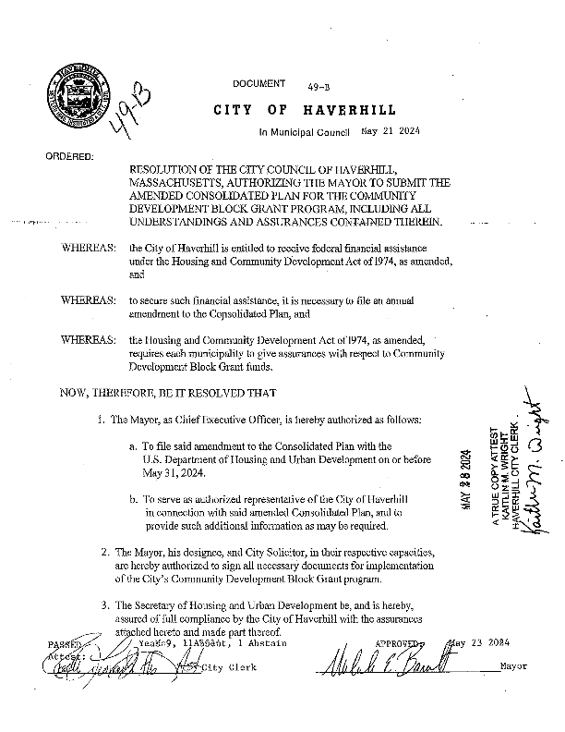
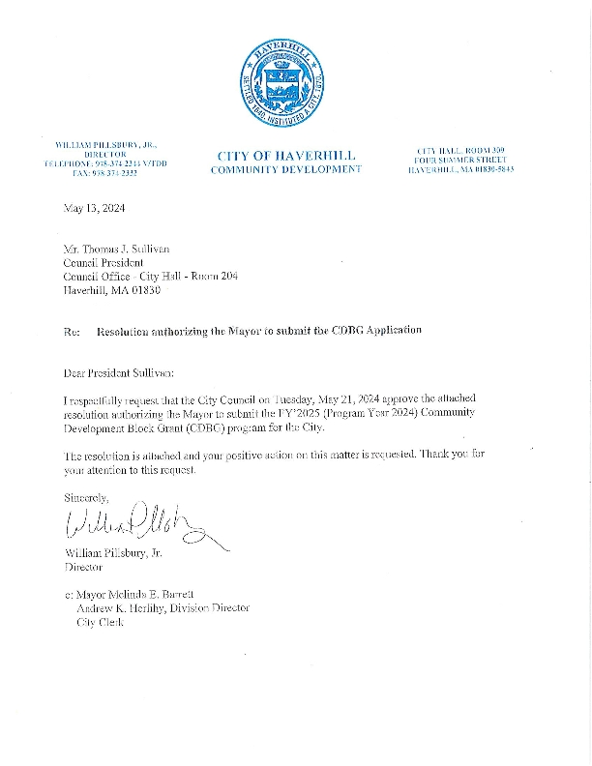
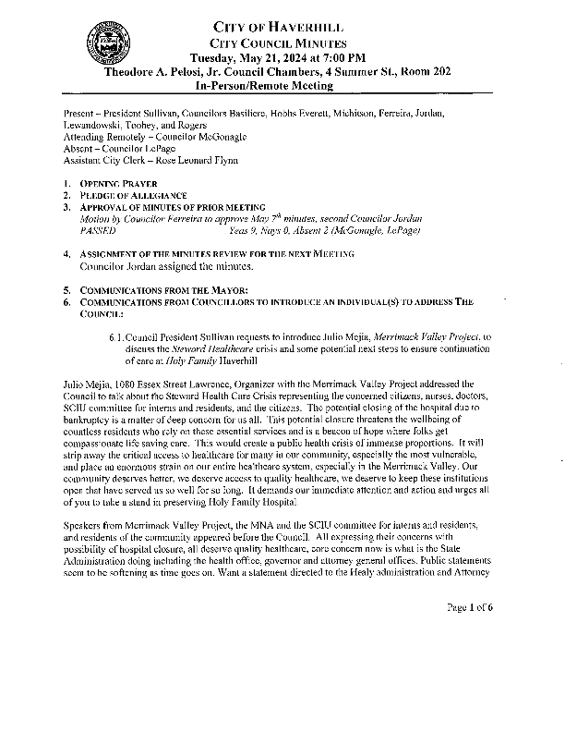
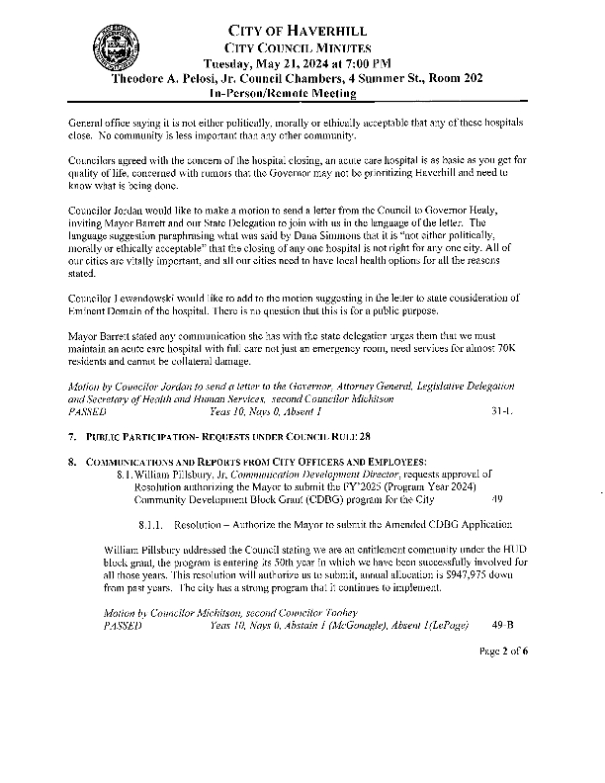
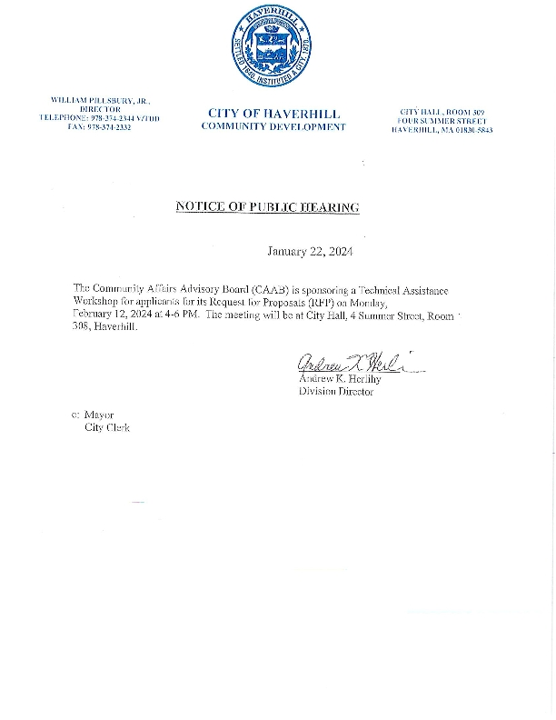
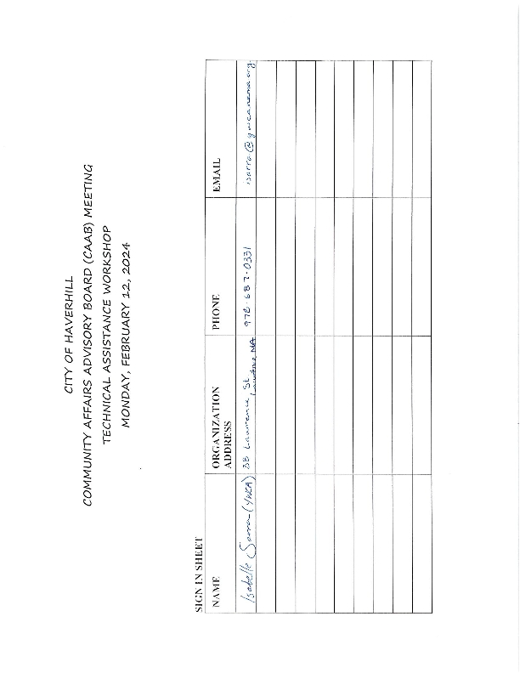
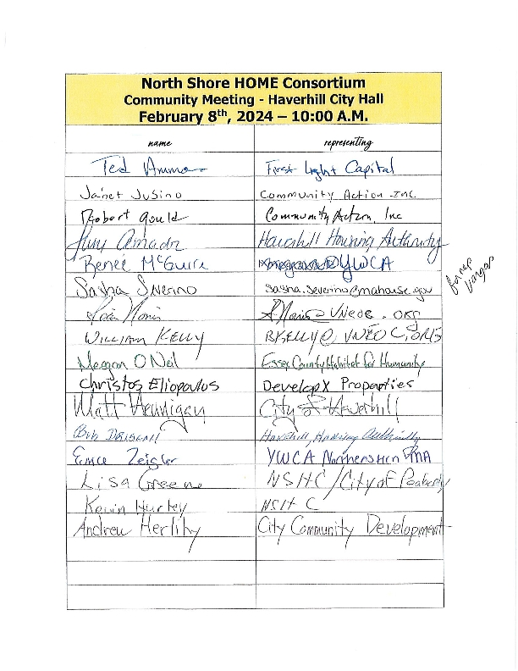
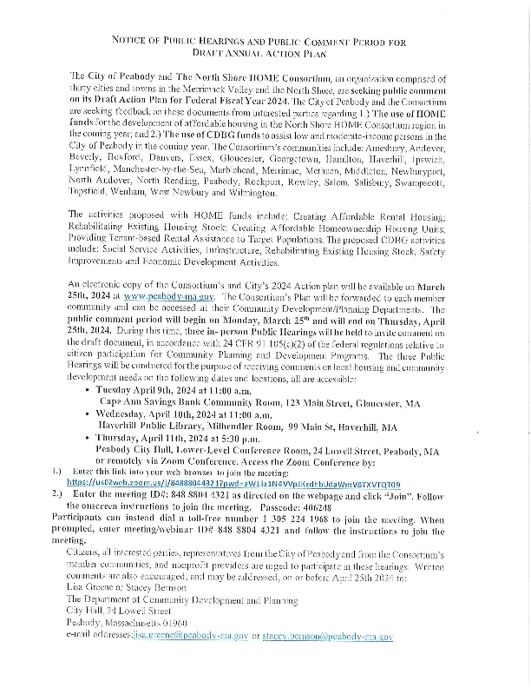
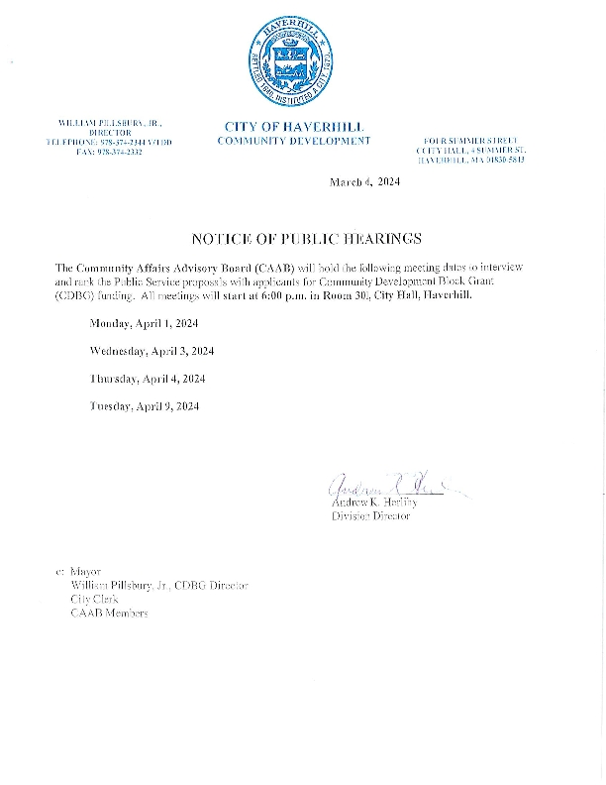
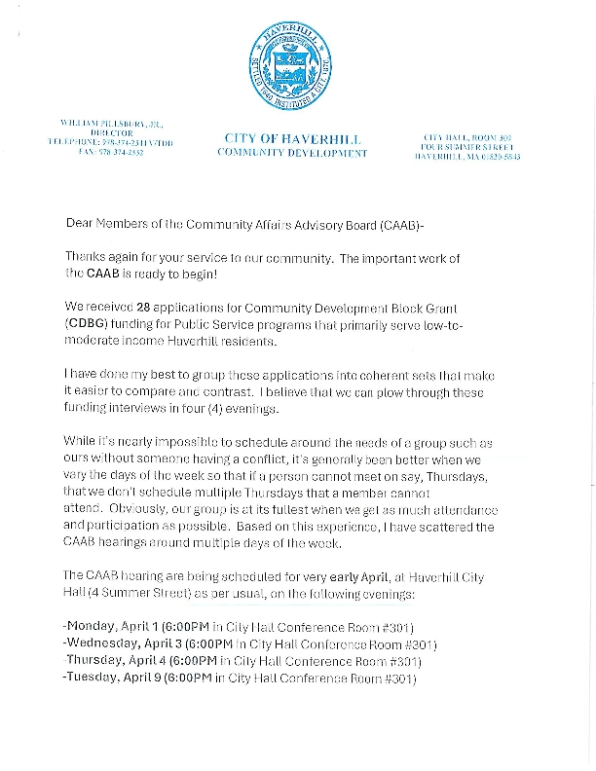
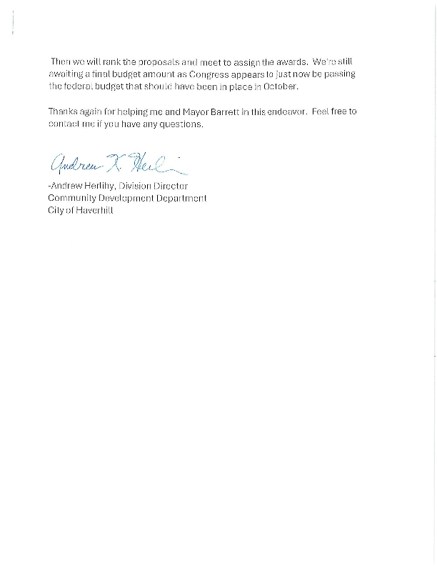
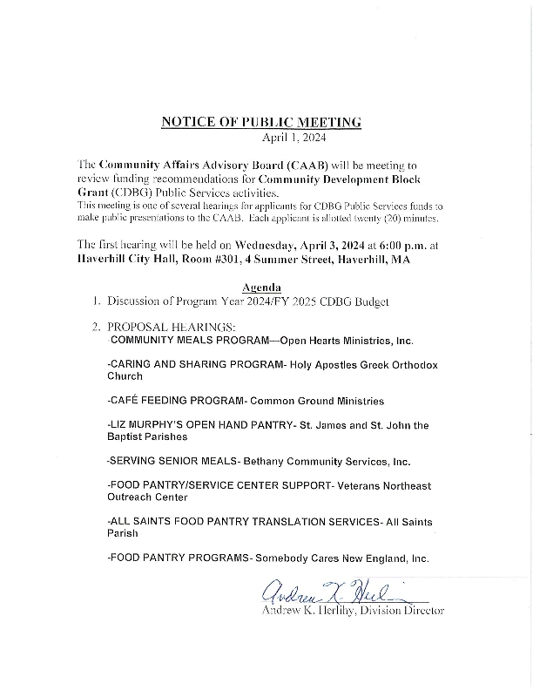
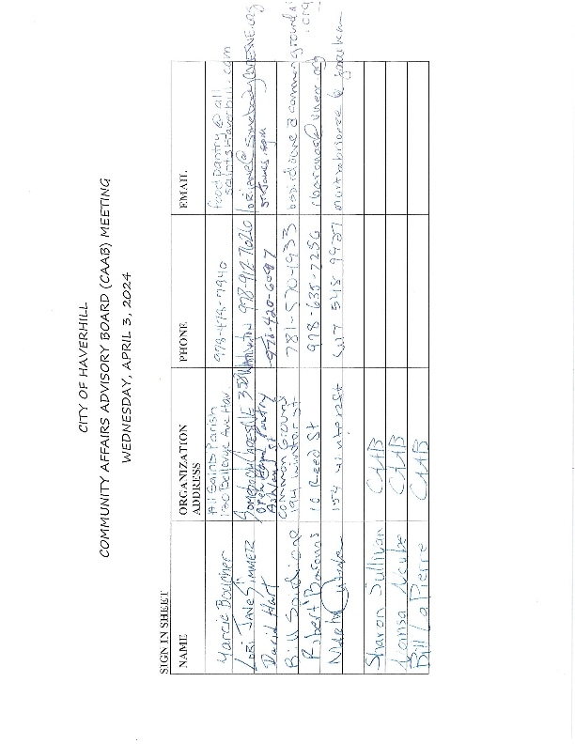
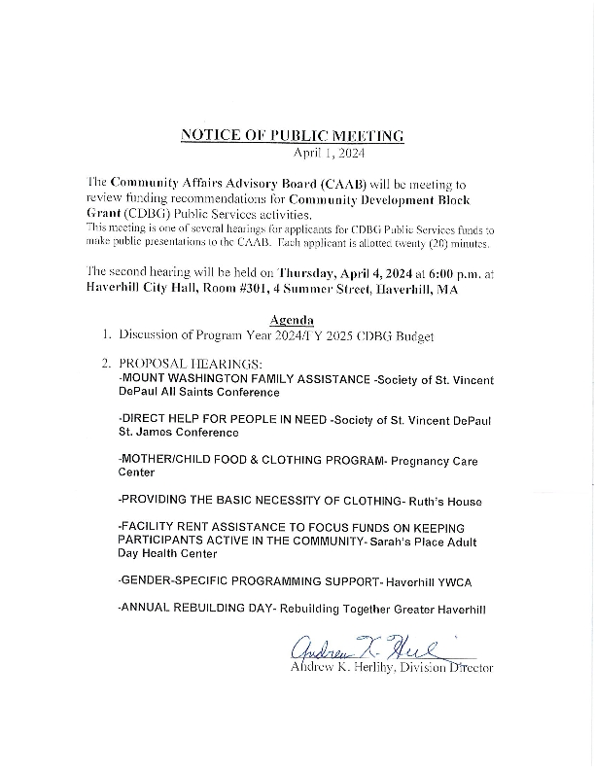
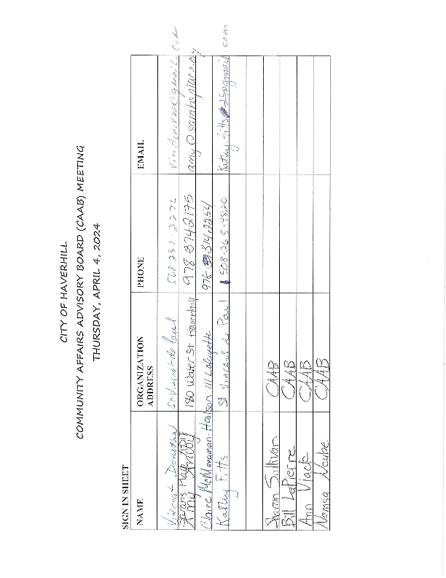
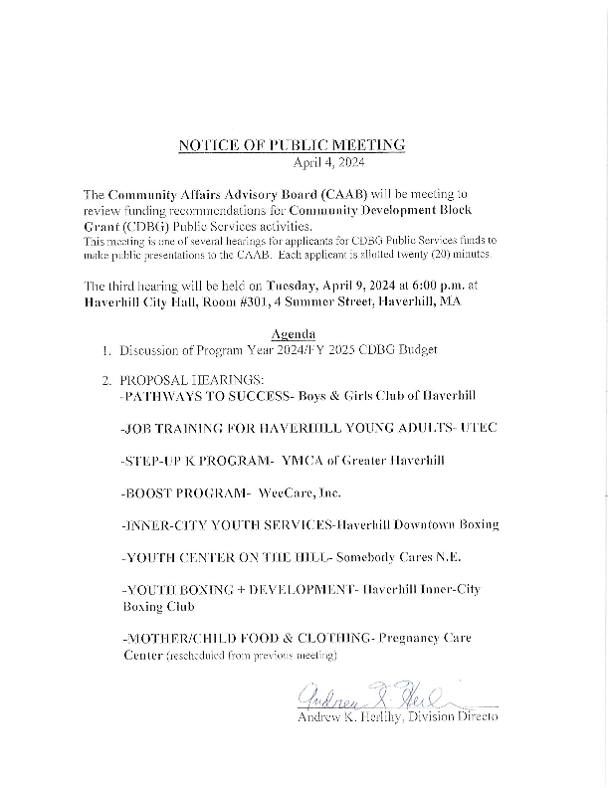
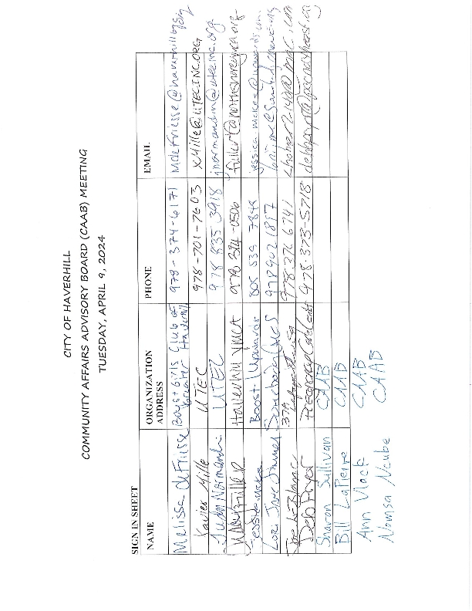
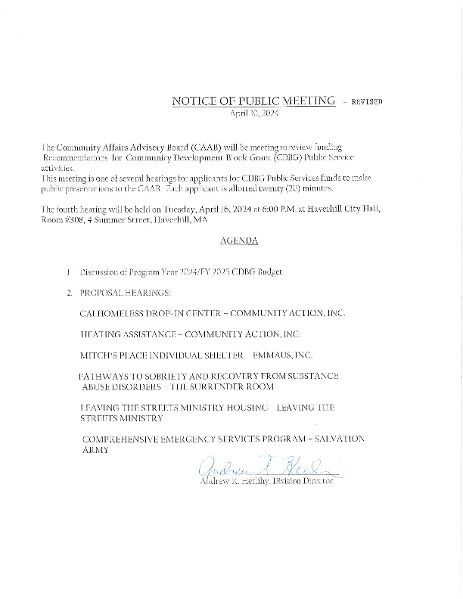
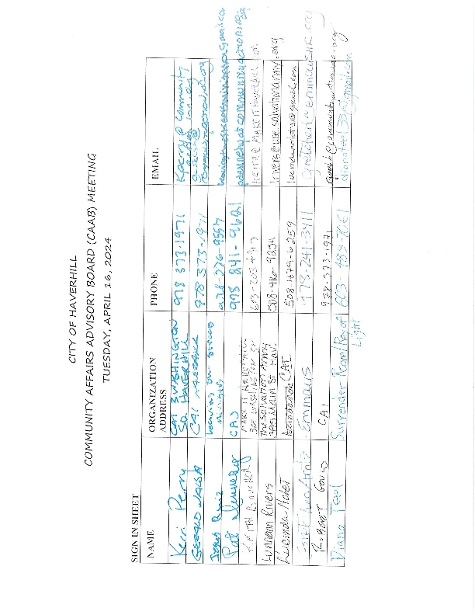
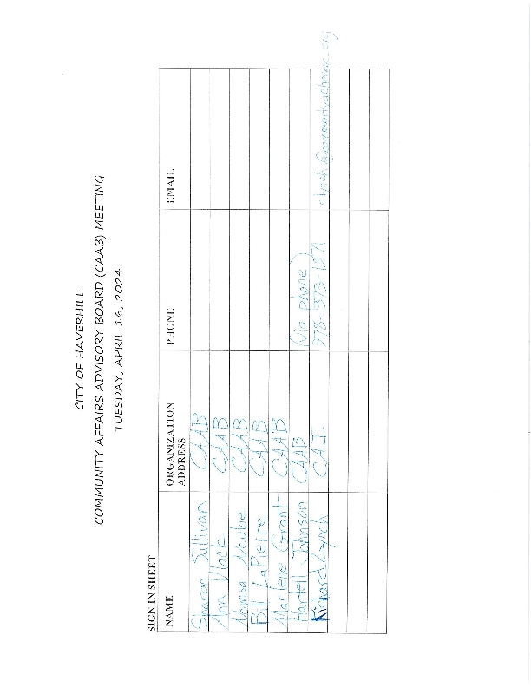
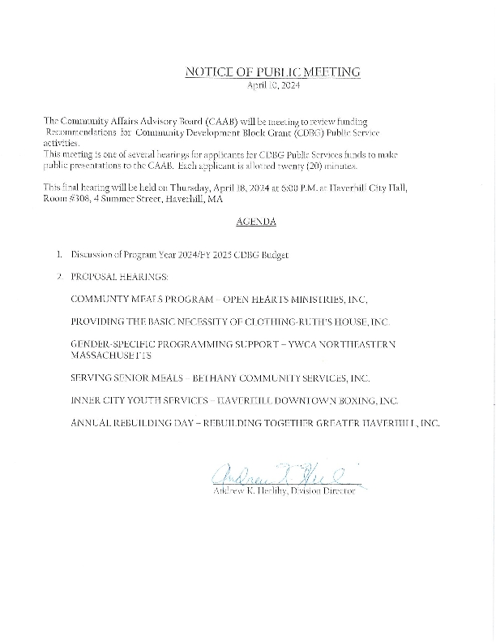
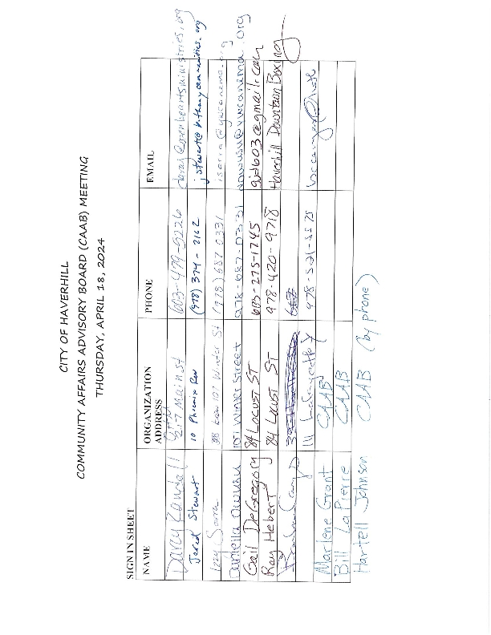
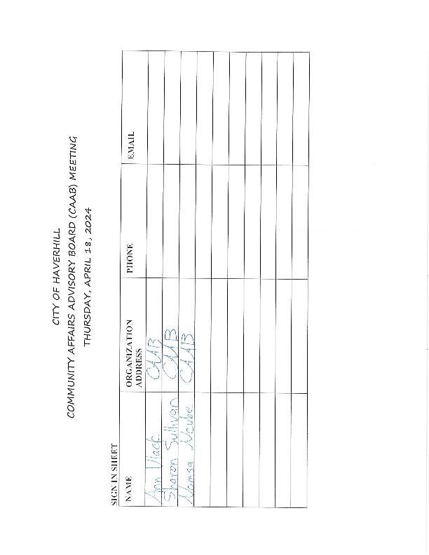
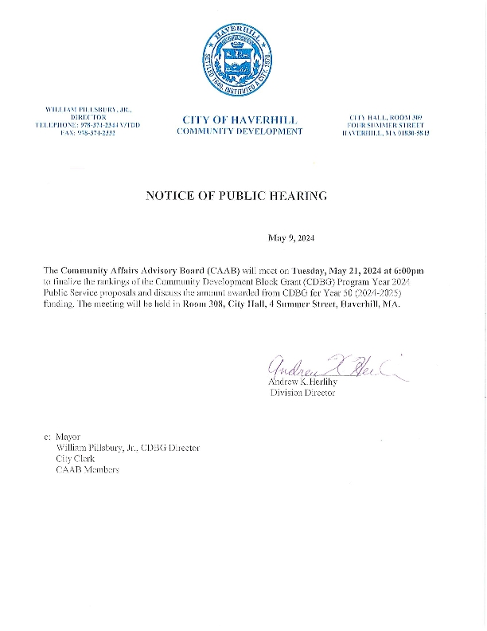
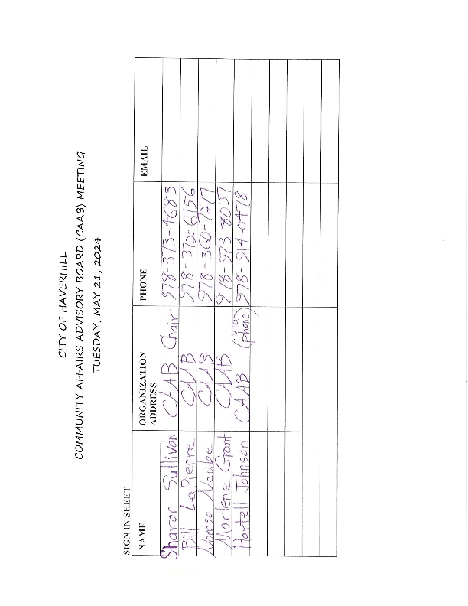
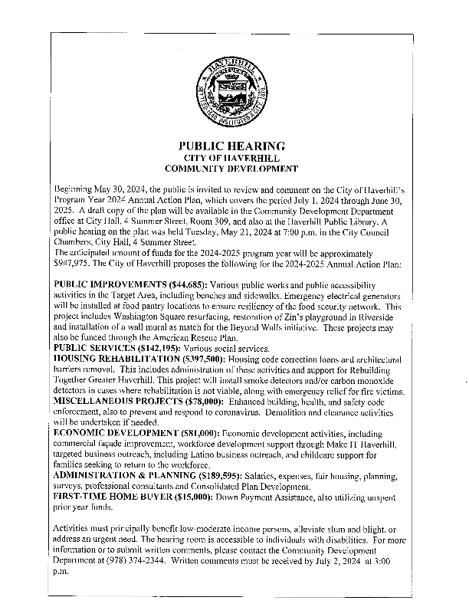
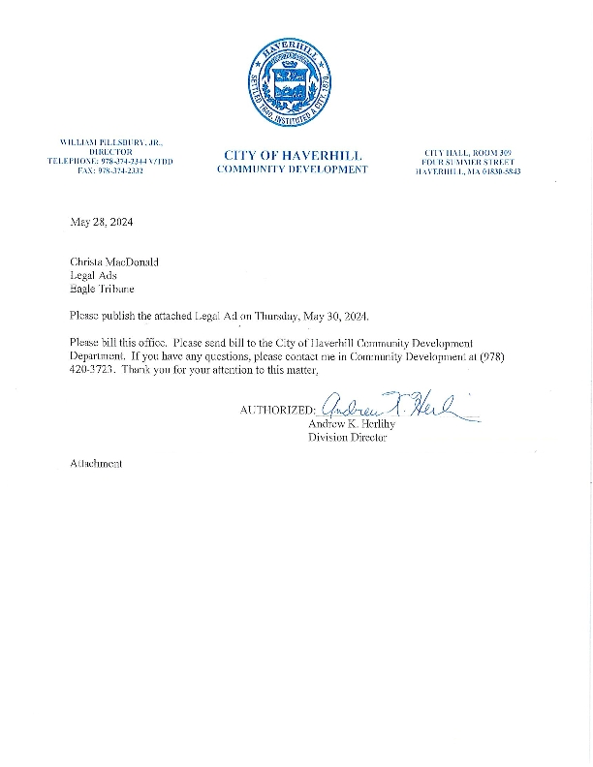
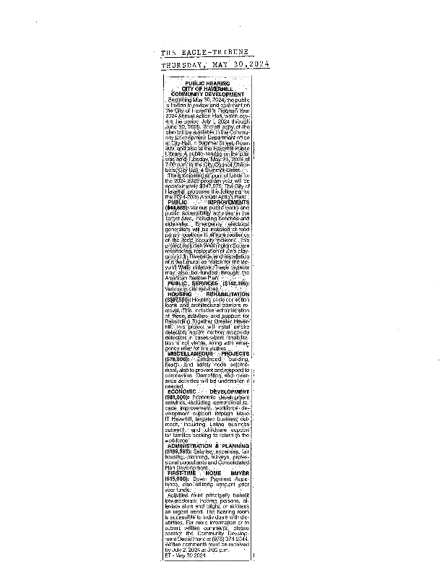
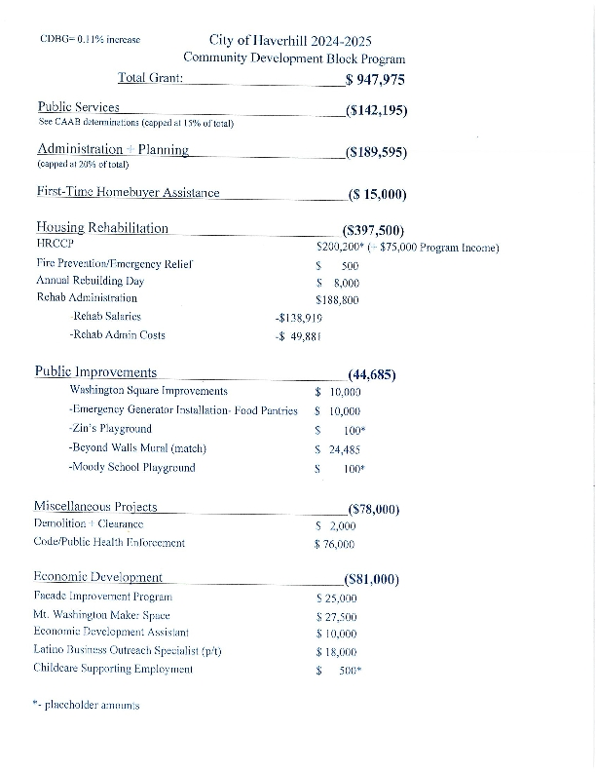

Grantee SF-424's and Certification(s)
