**Before Woolly Adelgid Woolly Adelgid**

[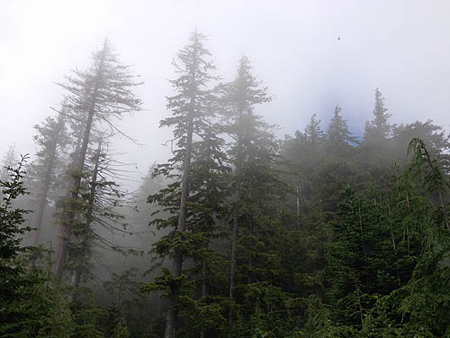](http://www.google.com/url?sa=i&rct=j&q=&esrc=s&frm=1&source=images&cd=&cad=rja&docid=V52v2VGVOduRCM&tbnid=f6mMKmwwy8lVeM:&ved=0CAUQjRw&url=http://crawford.tardigrade.net/journal/album7531.html&ei=_3ZNUqiwJZH09gTbpIGYBg&bvm=bv.53537100,d.eWU&psig=AFQjCNGeEzcv_PjhGhXmLzg7FyssweJcKw&ust=1380894598616465) [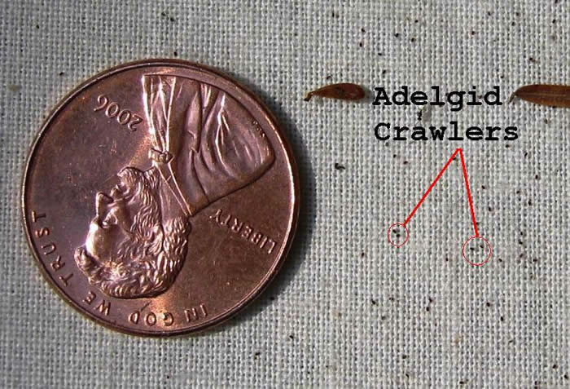](http://www.google.com/url?sa=i&rct=j&q=&esrc=s&frm=1&source=images&cd=&cad=rja&docid=SPqhZWbbTGnCLM&tbnid=Nmnii3jtzMthxM:&ved=0CAUQjRw&url=http://www.maine.gov/doc/mfs/HWALifeStages.htm&ei=H3VNUvmRLJTi9gTp2oHYBg&bvm=bv.53537100,d.eWU&psig=AFQjCNHO7GSoFesUsfNSJm-F2o6oekuLeQ&ust=1380894291866840)

**After Woolly Adelgid Underside of Infested Branch**

